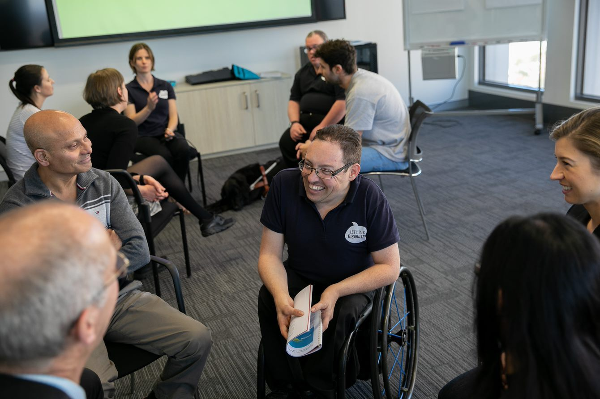

Let’s Talk Disability Bundle

Updated: June 2023

Contents

About 3
Courses available as part of this package 4
Myths and Misconceptions 4
How to Foster True and Meaningful Inclusion 4
The Impact of Barriers for People with Disability 5
The Landscape of Disability in Australia 5
Pricing 6

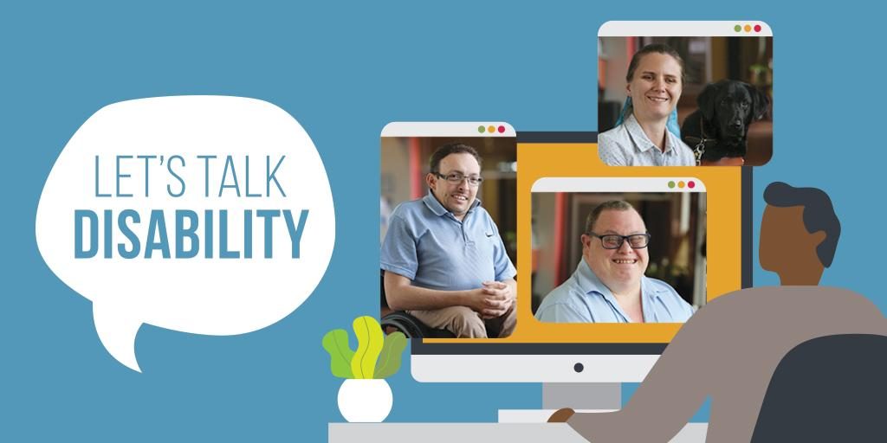

Developed by etrainu, National Disability Services (NDS) and projectABLE, the Let’s Talk Disability Bundle covers online training for disability awareness. These eLearning courses cover a variety of topics to ensure that everyone is part of the conversation.

If you are interested in other training options, including face-to-face training or live, online workshops, then please contact Info@letstalkdisability.com.au for further information.

Courses available as part of this package

Myths and Misconceptions
- 20 minutes (self-paced)
- eLearning

The first course in the Disability Awareness course, Myths and Misconceptions, dismantles common stereotypes and misbeliefs about people with disability.

Learners will see how they can be better allies to people with disability.

How to Foster True and Meaningful Inclusion
- 20 minutes (self-paced)
- eLearning

What does true and meaningful inclusion mean?

The second course in the Disability Awareness training looks at how we are responsible for inclusion—and what we can do to build a more inclusive world.

The Impact of Barriers for People with Disability
- 20 minutes (self-paced)
- eLearning

People with disability often face societal, environmental/physical, attitudinal, and communication barriers.

This course examines what these barriers are and how we can all work towards removing them.

The Landscape of Disability in Australia
- 20 minutes (self-paced)
- eLearning

Disability support and the way disability is viewed in Australia has changed over time.

Course 4, the last module, chronicles the history of disability in Australia, how it has changed and what people with disability are looking for when it comes to support.

Pricing

Add-on Pricing*

Pricing is inclusive of access to Let’s Talk Disability Bundle and platform fees via the etrainu or NDS Learning Management System. Additional fees apply for custom Learning Management Systems and SCORM files.

 | NDS Member |  |  | Non NDS Member
No. of Users | 4 Year Licence | 2 Year Licence | 1 Year Licence | 4 Year Licence | 2 Year Licence | 1 Year Licence
251+ | P.O.A | P.O.A | P.O.A | P.O.A | P.O.A | P.O.A
201 - 250 | $3,000  per year | $3,350  per year | $3,850  per year | $3,650  per year | $4,300  per year | $4,950  per year
151 - 200 | $2,700  per year | $3,025  per year | $3,480  per year | $3,300  per year | $3,900  per year | $4,480  per year
101 - 150 | $2,400  per year | $2,760  per year | $3,170  per year | $3,000  per year | $3,450  per year | $3,960  per year
76 - 100 | $2,050  per year | $2,420  per year | $2,780  per year | $2,600  per year | $3,000  per year | $3,450  per year
51 - 75 | $1,750  per year | $2,000  per year | $2,300  per year | $2,200  per year | $2,500  per year | $2,875  per year
26 - 50 | $1,440  per year | $1,640  per year | $1,880  per year | $1,800  per year | $2,050  per year | $2,360  per year

*This pricing applies when purchasing another training package from etrainu.
Prices above exclude GST.
Standalone Pricing

Pricing is inclusive of access to Let’s Talk Disability Bundle and platform fees via the etrainu or NDS Learning Management System. Additional fees apply for custom Learning Management Systems and SCORM files.

 | NDS Member |  |  | Non NDS Member
No. of Users | 4 Year Licence | 2 Year Licence | 1 Year Licence | 4 Year Licence | 2 Year Licence | 1 Year Licence
251+ | P.O.A | P.O.A | P.O.A | P.O.A | P.O.A | P.O.A
201 - 250 | $4,400  per year | $5,050  per year | $5,800  per year | $5,600  per year | $6,450  per year | $7,410  per year
151 - 200 | $4,000  per year | $4,600  per year | $5,290  per year | $5,050  per year | $5,900  per year | $6,780  per year
101 - 150 | $3,600  per year | $4,140  per year | $4,760  per year | $4,500  per year | $5,175  per year | $5,950  per year
76 - 100 | $3,200  per year | $3,550  per year | $4,080  per year | $4,000  per year | $4,450  per year | $5,100  per year
51 - 75 | $2,700  per year | $3,000  per year | $3,450  per year | $3,400  per year | $3,800  per year | $4,370  per year
26 - 50 | $2,160  per year | $2,460  per year | $2,830  per year | $2,700  per year | $3,075  per year | $3,500  per year

Prices above exclude GST.

building exceptional communities through education

07 3114 2958 | sales@etrainu.com | etrainu.com

