etrainu

Learning Management System

Easy Read version

Overview

NDS Member Benefits…………………………………………….3
Training Page………………………………………………………4
Accreditations………………………………………………………5
Reporting……………………………………………………………6
Hierarchy……………………………………………………………7
Custom Look and Feel……………………………………………8
Course Library……………………………………………………..9
Training Event Calendar…………………………………………10
Assessor and Assessment………………………………………11
Integration…………………………………………………………12
Costings…………………………………………………………...13
Contact…………………………………………………………….14

NDS Member Benefits

Purchased the NDS Workforce Essentials suite?
NDS members receive a 20% discount from etrainu for your own branded LMS.
What is included:
- Your own branded LMS with a custom look & feel
- Custom email notifications
- Administrative functions
- Access to the NDS Workforce Essentials library
- Access to the etrainu catalogue
- Ability to add your own assets
- Integration* with your Resource Management System
- Bespoke course development**

*Integration is scoped separately
**Course development is scoped separately

Training Page

Participants will have access to their own personal training page, known as “My Training”.

Under the current access and set up, you will be able to assign training to users either individually or as a group.

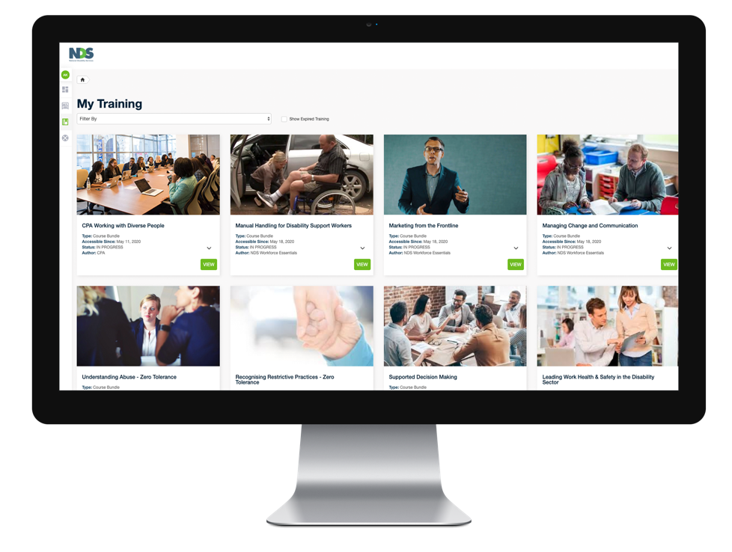

Accreditations

Participants will have access to their own personal accreditations page, known as “My Accreditations”.

This page displays a list of completed training, qualifications obtained or CPD points gained. Participants will also be able to view and download
their certificates.

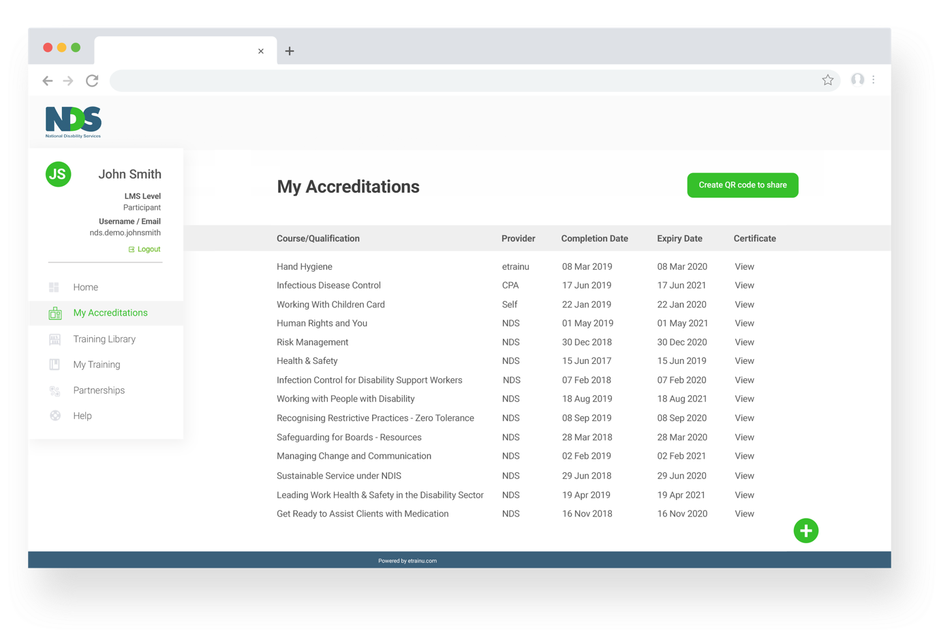

Reporting

etrainu has a comprehensive range of existing system reports that will support the management of training.

The LMS has the ability to report by:
- State
- Course
- Bundle (group of courses)
- Individual participant
- Group of participants
- Current and historical courses
- Completion status e.g. complete, in progress, or not started

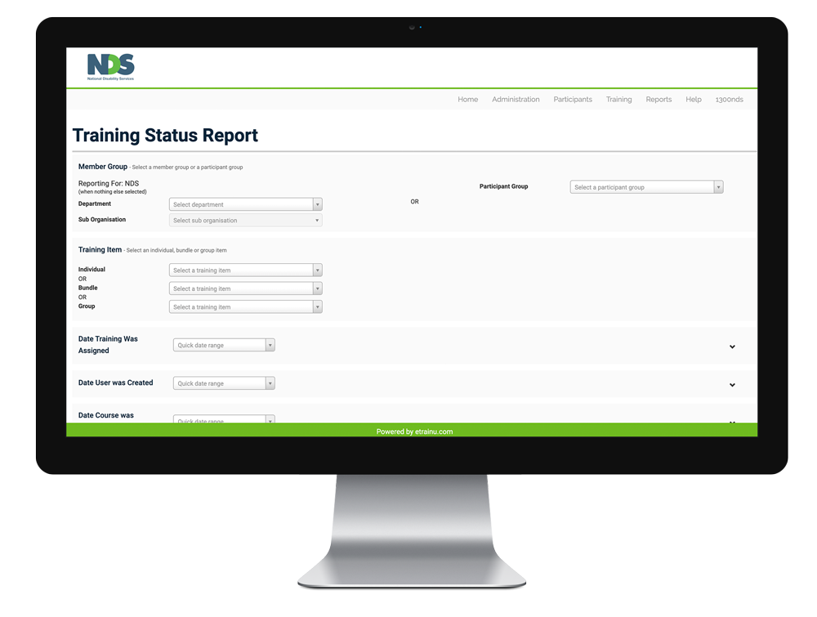

Hierarchy

- Tier down from the organisation level through to business areas to sites and employees.
- Integrate training from other training suppliers and have automated results and certificates show in their profile.
- Allows for transparent management and reporting for administrators at their approved level & below.
- Allows for self-management and review by employees through their “My Training” page.

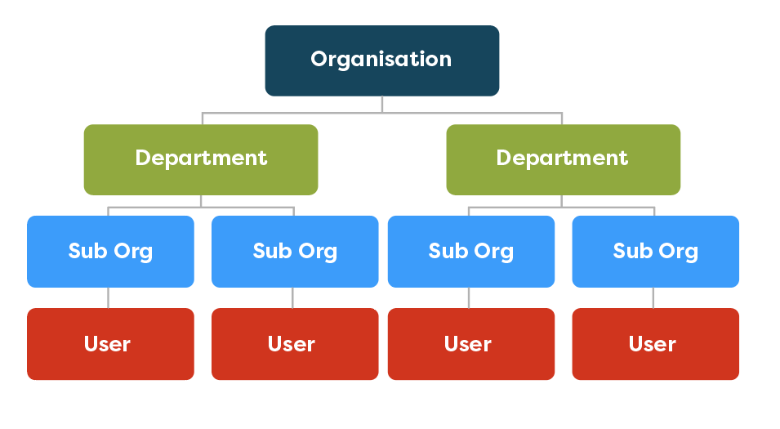

Custom Look and Feel

etrainu will configure your platform to look and feel like your organisation with a customised domain.
We can also white-label your domain.

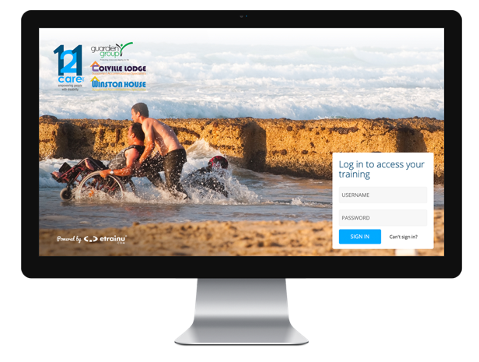

Course Library

Content is aggregated and grouped according to your organisation’s requirements, such as specific learning pathways or course structures.

etrainu will set up and update the content and design of the Course Category pages. This will include the release of any new training.

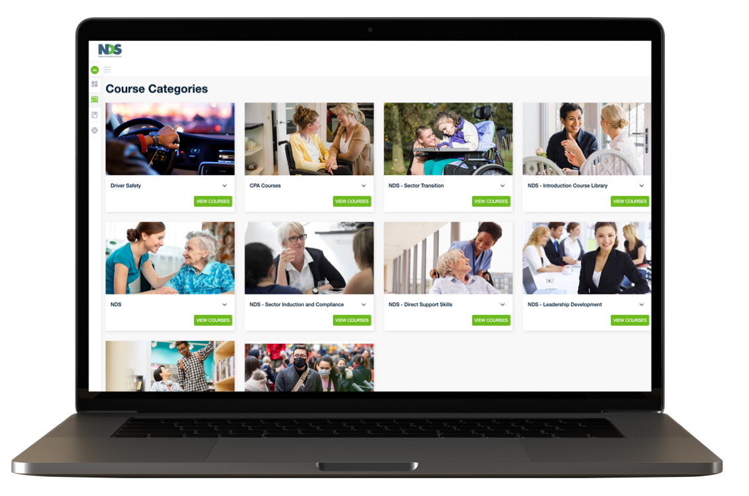

Training Event Calendar

The Training Event Calendar is a simple method of setting up face-to-face training, assessment, and refreshers.

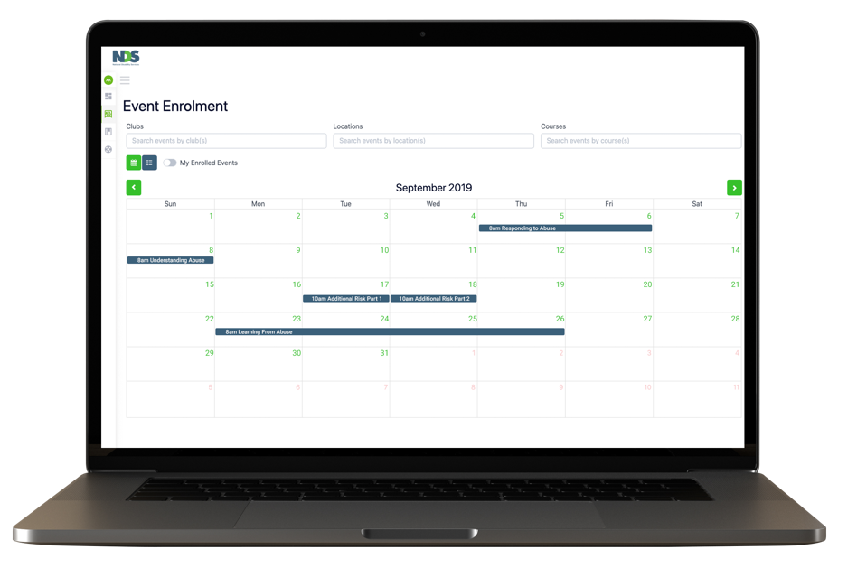

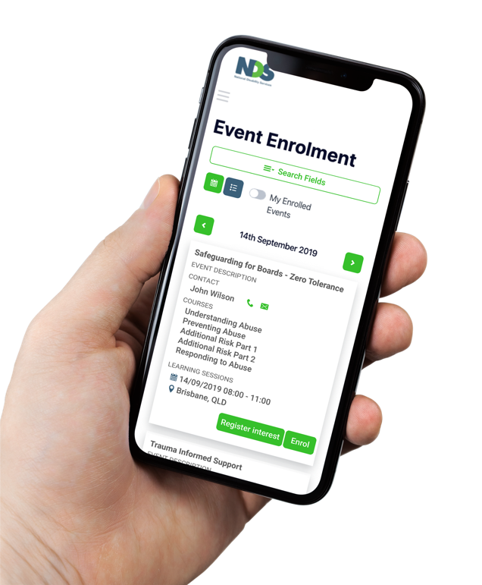

Assessor and Assessment

Assessor:
- Set up face-to-face training, assessment, and refresher events
- Intuitive interface to create & search for events across organisations
- Participants can enroll in specific courses in an event
- Completion of criteria within course can be marked off one at a time
- Once the event is marked complete, successful participants automatically marked as complete for enrolled courses on the LMS

Assessment:
- LMS assessments link directly to completion for their course
- Variety of assessment types: multiple choice, multiple response, short answer, essay, and file upload
- Assessments are marked by designated assessors at Org, Department, or SubOrg level
- Multiple choice, multiple response questions can be auto-marked

Integration

The etrainu LMS has the ability to integrate with your Employee Management System.

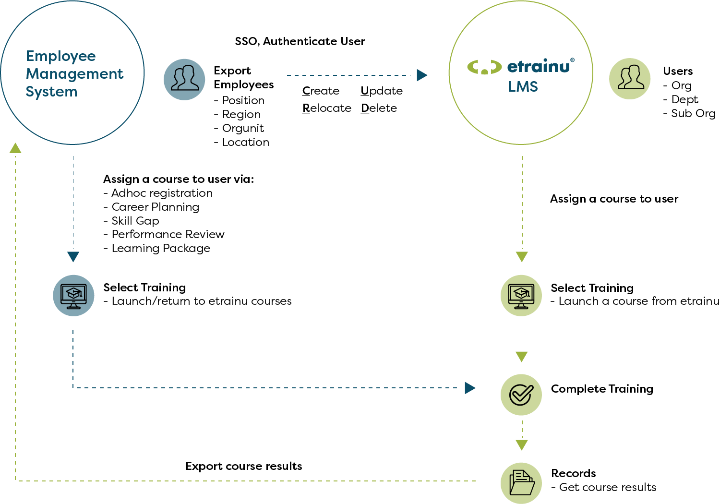

Costings

Licence Tiers | No. of Users | Annual LMS Licence Fee |  | Implementation Fee | Compliance Suite
NDS members receive a 20% discount
Tier 1 | 701-2500 | Discuss for a quote |  | Discuss for a quote | Discuss for a quote
Tier 2 | 551-700 | $16,800 |  | $5,000 | $35,000
Tier 3 | 401-550 | $13,200 |  | $5,000 | $27,500
Tier 4 | 251-400 | $9,600 |  | $5,000 | $20,000
Tier 5 | 101-250 | $6,000 |  | $5,000 | $12,500
Tier 6 | 45-100 | $2,400 |  | $5,000 | $5,000

Contact
For more information, please contact:
Paul Hoon
CEO
Email: paul@etrainu.com
Mobile: 0418 282 496

