State of the Disability Sector Report 2018
The NDIS has ushered in a new era for disability service providers. It can be like an ocean; sometimes stormy, with a dangerous undertow; at other times extending our horizons and carrying us forward. The challenge before us is how we navigate this journey of change and collectively create the best possible NDIS.

Contents
The State of Play 3
The State of the Operating Environment 7
Case study – Tasmania 22
Case study – Western Australia 25
The state of the NDIS 28
Case study – Australian Capital Territory 33
Case study – New South Wales 35
The State of Broader Policy Environment 38
Case study – South Australia 39
Case study – Queensland 41
The State of Disability Employment 44
Case study – Victoria 47
Case study – Northern Territory 49
The State of the Workforce 52

The State of Play
The disability sector is immersed in complex, difficult and large-scale reform. The major part of that is the National Disability Insurance Scheme (NDIS), but Disability Employment Services (DES) – which sit outside the NDIS – are also in the midst of significant change.
Disability service providers support the NDIS reform principles. They welcome the major boost in funding in response to the chronic unmet need for services, the expansion of choice and control for people with disability and their families, the investment in early intervention, and the goal of equitable access to services across Australia.
However, the road to reform is rough, and many service providers are under stress. Their sense of uncertainty is exacerbated by frequent process changes, inconsistent advice, new regulations and difficulty getting the market data they need to make growth decisions.
At the core of NDS’s 2018 State of the Disability Sector Report are findings from a survey of 626 service providers. They include providers of all sizes, from every state and territory, that collectively span the full range of disability service provision.
Providers’ experiences of the NDIS are mixed, but more than half see the operating conditions in the disability sector as worsening: 80 per cent say that the disability policy environment is uncertain.

NDIS red tape imposes costs
Providers are frustrated with NDIS systems and processes. Over the past year, many have experienced long delays in payments; the NDIS portal is not user-friendly; and the quality of NDIS plans is uneven.
Providers are expending unpaid effort on untangling red tape, resolving payment issues and helping people with disability to get plans that properly reflect their needs and goals. All of this imposes costs on providers at a time when they are under pressure to reduce their costs.
The impact of very tight NDIS prices on service quality is a significant concern. Some of the prices stretch supervision ratios and don’t allow for investment in staff training. They impede the recruitment and retention of experienced and qualified staff.

Some solutions are emerging
NDS is working with the National Disability Insurance Agency (NDIA) on solutions to these problems, and incremental improvements are occurring. While we remain critical of inadequate NDIS prices, the price increases announced following the Independent Pricing Review provided some relief. Further work is under way to set higher prices to support people with complex needs. Having been a strong critic of the planning process and the NDIS portal, we are pleased to see improvements coming to the planning process (albeit gradually) and fixes to the portal (although more are needed).
Accelerating these and other solutions should be a priority. While problems persist, the NDIS will not deliver on its great promise to Australians with disability.

Employment is lagging
Many Australians with disability want to work, yet the employment rate of Australians with disability is low and static. This must change. The exclusion of people with disability from the workforce is bad for the Australian economy and a cause of poverty and social isolation.
Economic participation is a goal of the NDIS, but only a tiny proportion of participant plans currently include employment supports. In NDS’s view, all participants of working age should have employment in their plan unless they specifically refuse it.
Stronger disability employment support is a key part of the answer to the low employment rate of people with disability. Reforms to Disability Employment Services, introduced in July 2018, expand choice and competition; but they also apply a new and untested funding model that appears to be disadvantaging some cohorts of job seekers. Whether the new DES program boosts employment outcomes for job seekers is yet to be seen.
Disability Enterprises provide employment to 21,000 Australians with significant disability. Their future depends on resolving the financial uncertainty they face. This will require a satisfactory outcome to the long-running dispute over wage-setting before the Fair Work Commission, a viable funding and pricing model under the NDIS, and increased commercial income boosted by government procurement of goods and services.

Social inclusion strategy requires renewal
The National Disability Strategy is due to expire in 2020. It is a 10-year strategy, signed off by the heads of all Australian governments, that is designed to give practical effect to the United Nations Convention on the Rights of Persons with Disabilities. The Strategy’s ambitions are admirable, but its capacity to drive change has been very limited. The Strategy is a critical companion of the NDIS and it needs reinvigoration.
As well as bringing issues, such as those outlined above, to the attention of government, NDS is committed to working with government to find answers. We are determined to do all we can to make the NDIS work for all stakeholders, to increase employment opportunities for people with disability, and to inject new life into the National Disability Strategy.
Solutions must include drawing more on the great passion, expertise and experience that lies in the disability community among service providers, people with disability and their families and carers. This should extend to policy advice, the identification and testing of process changes before they’re introduced, and the provision of some key functions. For example, we believe the quality of plans would improve if participants and their families could choose to construct their plans with service providers and with Disabled Persons Organisations, not just with Local Area Coordinators.
A Federal Parliamentary report on the NDIS released in October 2018 recommended additional resources to assist the disability sector to implement the large-scale reforms that are under way. NDS agrees. Increasingly, governments are turning to the non-government sector to deliver disability services, and there are good reasons for this. Boosting the capacity of the sector to deliver services when and where they are required – and in ways that are responsive to people’s needs, goals and differences – is an essential investment.

The Way Forward

Proposals we’d like to see implemented

- A fully-funded NDIS
Governments have committed funding to the NDIS, but this must be renewed annually and reflect evolving evidence of costs of disability support.
- Prices to stimulate growth and quality
Prices set by the NDIA are insufficient to sustain some services and threaten quality. Prices should reflect realistic costs and be progressively deregulated.
- Market stewardship that responds to warning signals of market failure
Pricing, workforce shortages and uncertainty are impeding growth of NDIS supports. To prevent market failure, improved data, clarity about market interventions and a systematic response to emergencies are needed.
- NDIS processes informed by experience
Providers are under pressure to reduce costs, but they can only be as efficient as NDIA systems allow. Participants should be able to develop their plans with people who have knowledge of disability supports.
- Flexibility that reflects national diversity
NDIS planning, funding and service models must respond to local conditions, particularly in rural and remote Australia.
- Complex design problems resolved
The NDIS is struggling with complex design problems, such as employment, transport and the interface with other service systems. Solutions can be found by working closely with the sector.
- Sector development that supports transition and progress
A reform as large as the NDIS needs significant investment in workforce development and service capacity, including an industry assistance fund.
- Investment in quality and safeguarding
Investment in organisational cultures and staff development is critical to complement the new NDIS quality and safeguarding regulations.
- More open employment opportunities
Action should be taken to ensure that no job seekers are disadvantaged by the new Disability Employment Services model of risk-adjusted funding.
- Extended school-to-work support
Connecting young people at school with jobs vastly improves their chances of working post-school. NDIS School Leaver Employment Supports should be open to people before they finish Year 12.
- More jobs in supported employment
The government must work with the sector to resolve the wage determination dispute, develop a viable supported employment funding model, and expand procurement from Disability Enterprises.
- Renew National Disability Strategy
A renewed National Disability Strategy must have strong performance measures, access to resources, a prominent public profile and ownership across government and the disability community.

The State of the Operating Environment

About the Annual Market Survey
The following data is produced from the sixth wave of NDS’s Annual Market Survey. The survey was conducted by the Centre for Social Impact at the University of New South Wales in partnership with NDS’s Centre for Applied Disability Research (CADR).

Who responded to the survey
626 disability service providers responded to this wave of the survey. Forty-two per cent had income of less than $1M, 23 per cent between $1M and $5M, 20 per cent between $5M and $20M and 14 per cent had income of $20M or more. Twenty-three per cent were sole traders, up from 12 per cent in 2017. The inclusion of this cohort did not skew results, except where noted. Seventy-three per cent of respondents were not-for-profit organisations and 24 per cent were for-profit organisations. Three per cent were not classified.
Ninety-seven per cent of respondents were registered NDIS providers and 90 per cent were registered and currently provide services under the NDIS.

NDIS policy environment remains uncertain
Service providers continue to be frustrated with NDIS systems and processes. Nearly three quarters (73 per cent) of respondents either disagreed or strongly disagreed that the systems and processes of the NDIS were working well.
Figure 1: NDIS systems and processes
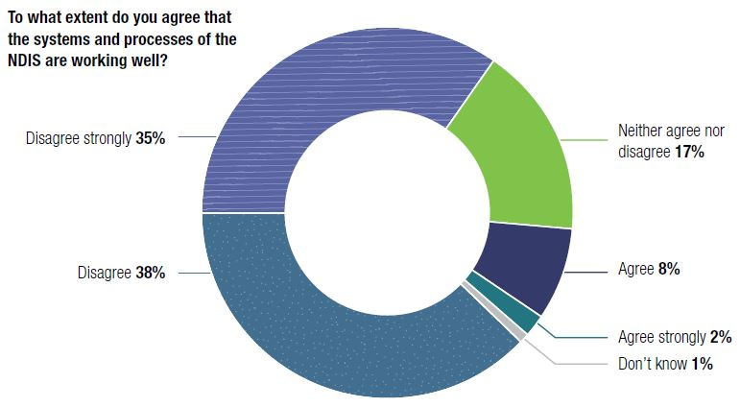
Comments about NDIS systems and processes reflect key concerns about policy uncertainty, lack of meaningful service provider engagement by government, and pricing and administrative burdens. Provider views on NDIS policy directions and implementation remain consistent. This year, responses were split over whether NDIS implementation should be slowed down – 39 per cent agreed or strongly agreed and 25 per cent were neutral. This represents a decrease from the 2017 survey, where 46 per cent of the providers who responded felt implementation should be slowed. As NDIS implementation proceeds, nearly half (47 per cent) feel that policy implementation is heading in the right direction. However, a significant majority (80 per cent) continue to agree that the NDIS policy environment is uncertain. This number has increased since 2016 and 2017.
Figure 2: Satisfaction with policy and implementation
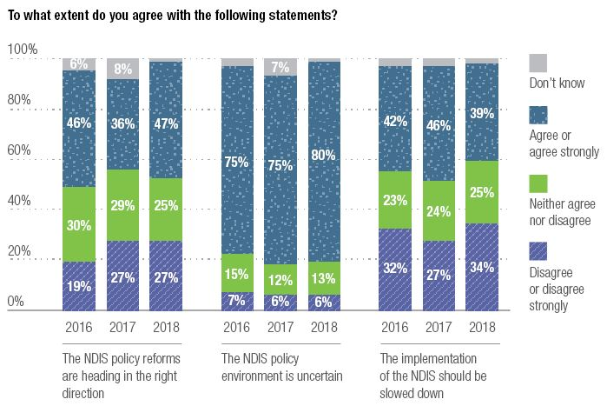
There is consensus among providers about which actions by the government would have the greatest positive impact on their organisation’s capacity to deliver good services in the next year:
1. Adjust NDIS pricing
2. Improve communications and engagement between providers and government
3. Fix the NDIS participant pathways and portal
Figure 3: Top five market stewardship priorities for government
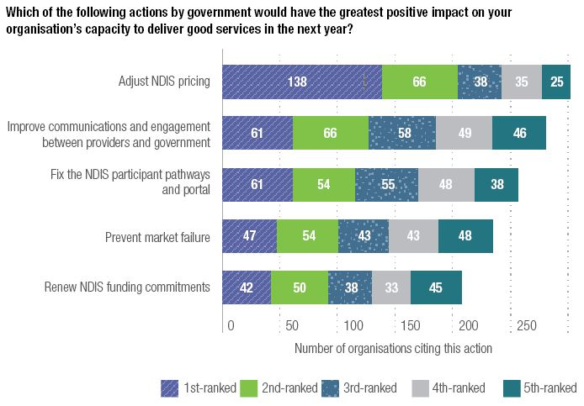
Pricing concerns generated the most comments and 46 per cent ranked ‘Adjust NDIS pricing’ as their top action for government. Two major themes emerged from the survey: providers’ views that central price setting is disconnected from service delivery realities; and concern that financial losses will lead to market failure.
Service providers appeared to be largely dissatisfied with their relationship with the NDIA. Only 15 per cent said they agreed or agreed strongly that the NDIA is working well with the sector to implement the NDIS. Similarly, 15 per cent agreed or agreed strongly that the NDIA has a high level of respect for service providers. Most (71 per cent) said they disagreed or disagreed strongly that Australian governments are anticipating or responding well to the needs of organisations such as theirs.
Quotes:
- “It is challenging to continue to conduct a profitable enterprise when [the NDIS] sets the fee for our company’s services – particularly without any prior knowledge of the services we provide and associated costs involved. Not all services are created ‘equal’.”
- “No matter the size of a [participant’s care] package there is significant time invested into case development, review, maintenance, and provision which is in excess of an hour’s support for capacity building.”
Figure 4: Provider views on government relations
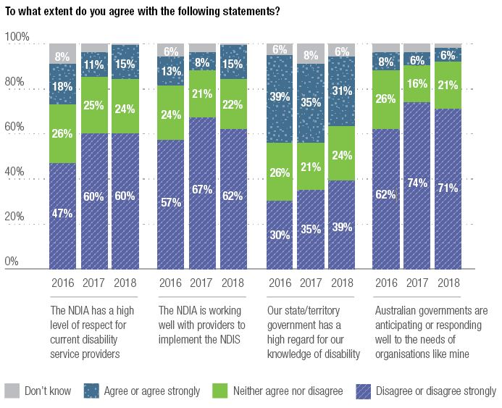
Fifty-eight per cent of disability service providers agreed or agreed strongly that they were worried they wouldn’t be able to provide NDIS services at their current prices. Just under one in four respondents (24 per cent) disagreed or disagreed strongly with this statement. Service providers expressed concern at the costs of compliance with regulation and costs to properly support families and clients beyond the funded service transaction:
Quote: “It costs money to be able to meet all the requirements of government, but we aren’t able to set the actual pricing to be able to recover the true cost of support. We are a price taker, and government set all the rules and processes that are administratively burdensome … Providers can’t actually charge what it really costs to deliver good services.”
Other quotes:
“NDIS keep changing the rules and there is no consistency between planners, areas and local offices.”
“Incorrect information given to participants by planners and LACs is compromising service delivery and problems are then blamed on providers.”
“Despite the length of time we have been delivering services via NDIS funding there is still an incredible inconsistency in the planning processes that clients/families are attempting to manage.”
Figure 5: Pricing, service quality and administrative burden
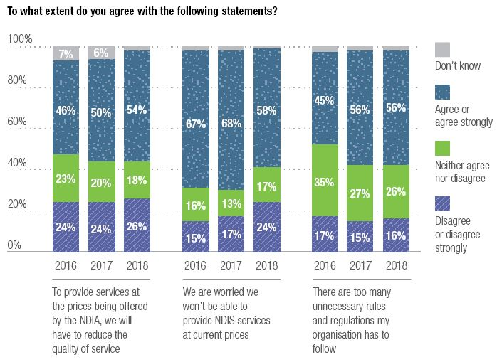
Over half of respondents (54 per cent) said that they either agreed or agreed strongly with the statement ‘In order to provide the services at the prices being offered by the NDIA, the quality of care would have be reduced’. For some services, prices were regarded as being too low to continue service delivery.
Respondents were acutely concerned with the emergence of thin markets and the impact for NDIS participants, noting this posed a particular threat for groups with complex needs.
Concerns about pricing and its impact on services varied by provider size (financial turnover). Very small service providers (less than $1M last financial year - including a high proportion of sole traders) were significantly less likely to agree that they would have to reduce the quality of service to provide services at the prices being offered by the NDIA.
Quotes:
“Market failure is a current reality. We are having to restrict community access services delivered one-on-one, even though demand is growing. Some participants are only being offered supports in groups with a 1:5 support ratio, even though they could benefit from supports delivered in smaller groups or 1:1. This is undermining choice and control.”
Figure 6: Concerns about NDIS pricing by organisation size (financial turnover)
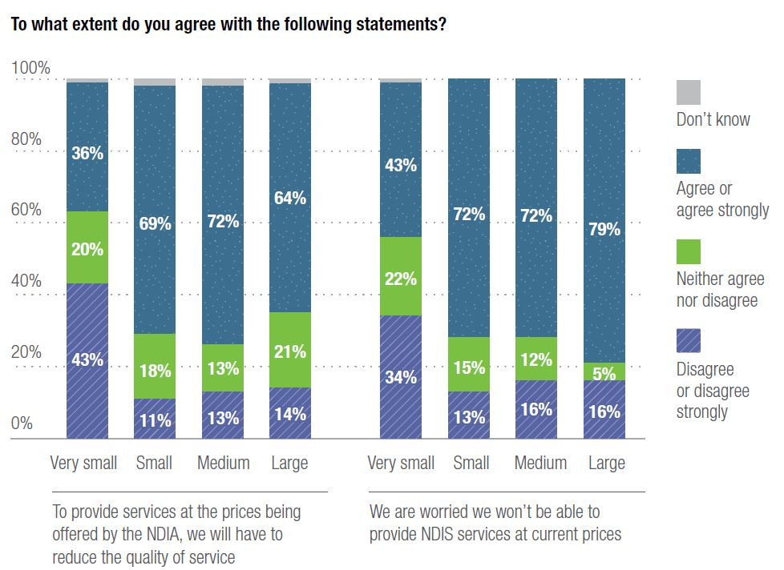
Organisational size classified by annual income:
Very small* – Less than $1M
Small – Less than $5M
Medium – Less than $20M
Large – More than $20M
*These results could reflect a high proportion of sole traders.
Disability service providers were asked to identify operational areas for improvement or where additional support and investment are required. Key areas for improvement were consistent with previous years and related to administration (information, communications and technology; HR strategy; costing and pricing; and market research). Providers continue to struggle with costing and pricing (and related financial controls); back office systems and data about opportunities to make a difference.
Table 1: Business capability areas for improvement
Which of the following business capability areas does your organisation need to improve most in the next 12 months?
2016 | 2017 | 2018
- Costing and pricing | - Costing and pricing | - Information, communications and tech strategy
- Information, communications, and tech strategy | - Marketing practice | - Costing and pricing
- Marketing practice | - HR strategy and workforce planning | - HR strategy and workforce planning

Operating conditions remain tough
Since 2016, there has been a sharp decrease in the perceived operating conditions of the disability sector – in 2018, 55 per cent of respondents said that they perceived conditions to have worsened. In contrast, the broader economic environment was seen as stable for the past two years.
Figure 7 Perceptions of disability sector operating conditions and wider Australian economy
Over the last 12 months, do you believe that the overall operating conditions of the disability sector have changed?
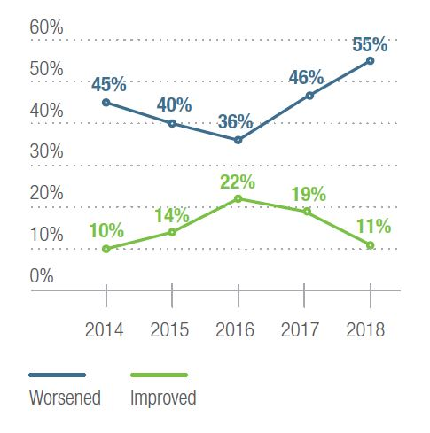
Over the last 12 months, do you believe that the overall operating conditions of the Australian economy have changed?

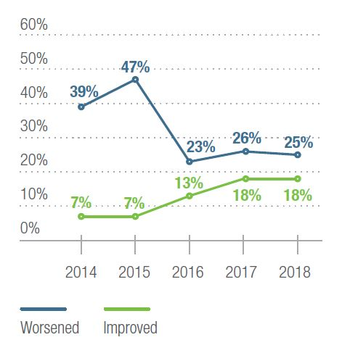
As in previous years, providers were asked to indicate whether they had any plans to change the range and scale of services offered. The overall picture remains one of growth, with most providers indicating an intention to increase their service volume.
“NDIS has provided opportunities for clients who could not manage to fund their needs before the NDIS.”
“While the NDIS can at times be difficult to navigate, our experience is that if you establish positive working relationships you can generally get a positive outcome for participants.”
The most commonly-cited service types that service providers indicated they were planning to reduce or stop providing were plan management, assistance with travel and transport arrangements, and behaviour support.
Figure 8 Intentions to change service volume
In the next 12 months, do you plan to stop providing, reduce, increase the volume of services or make no changes to your services?
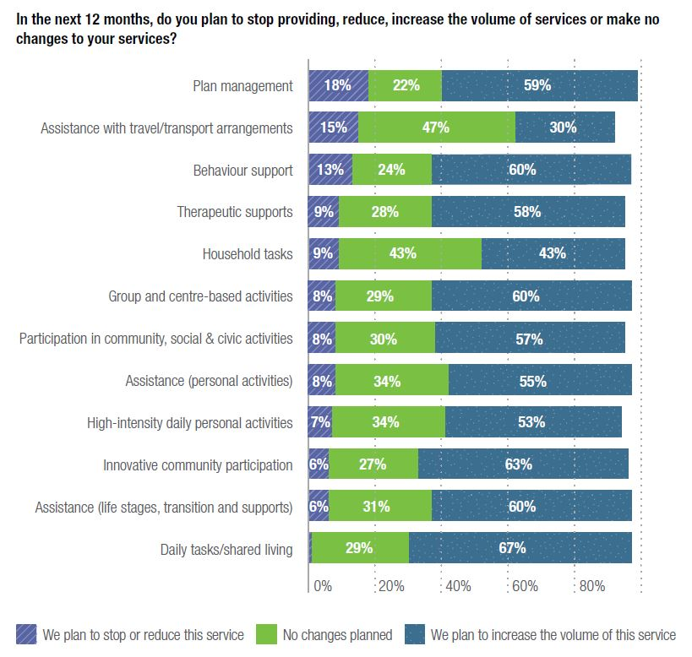
Providers were asked to indicate plans to introduce new NDIS-funded services in the next 12 months. Less than 10 per cent of the providers that responded indicated they planned to do so.
Merger activity remains significant over the three-year period for which data has been collected. Of the providers that responded, close to three in 10 organisations indicated that merger discussions had occurred in the last 12 months.
Figure 9 Mergers and market exits
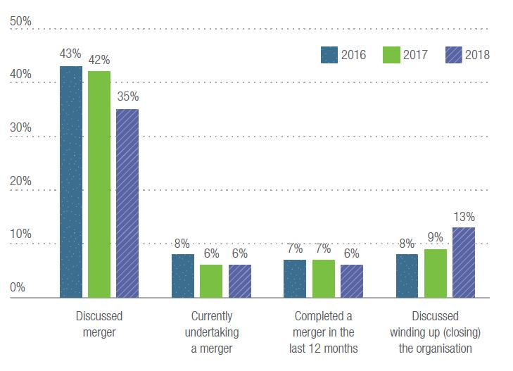
Of the providers that had indicated they had discussed or were currently undergoing a merger, their most-cited reasons for doing so include improving service efficiency and broadening the range of services available to clients.
Figure 10 Reasons for mergers
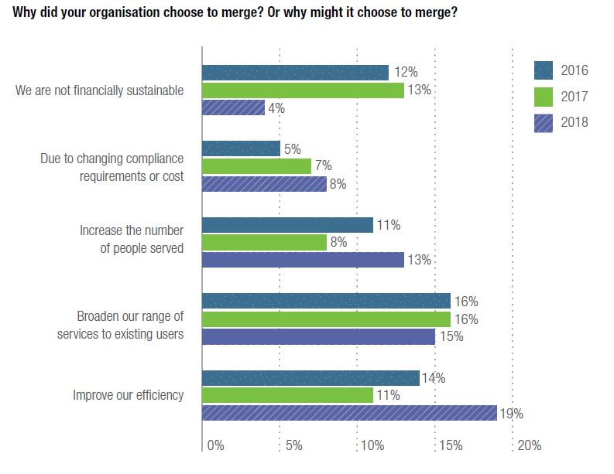
Close to 80 per cent of providers reported that they were not receiving any monetary, organisational, or other help from other disability service providers. This could reflect a lack of connection and collaboration with other services – consistent with international research which shows that as competition for services increase, collaboration across services decreases. Providers seem to be disconnected from each other rather than working together for mutually-agreed goals.
This also reflects research on changes to the sector since the implementation of the NDIS. A recent report from the Centre for Social Impact on collaboration in the sector found that organisations were collaborating and sharing information less as implementation rolled out. This warrants further investigation.
Figure 11 Are disability service providers helping each other?
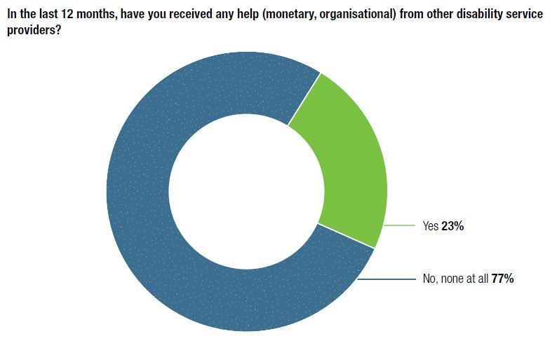
According to our survey, 28 per cent report operating at a loss, up from the previous year, and close to half (48 per cent) reports operating at a profit. However, for many, this profit was not meaningful in terms of its relation to Consumer Price Index or CPI (2.1 per cent according to the Australian Bureau of Statistics between 2017-18).

Figure 12 Financial sustainability
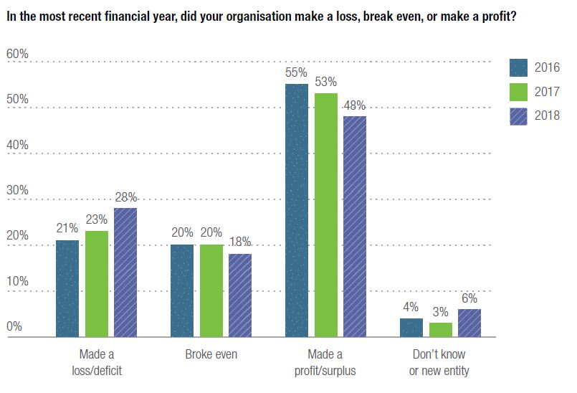

Figure 13 Past year financial performance
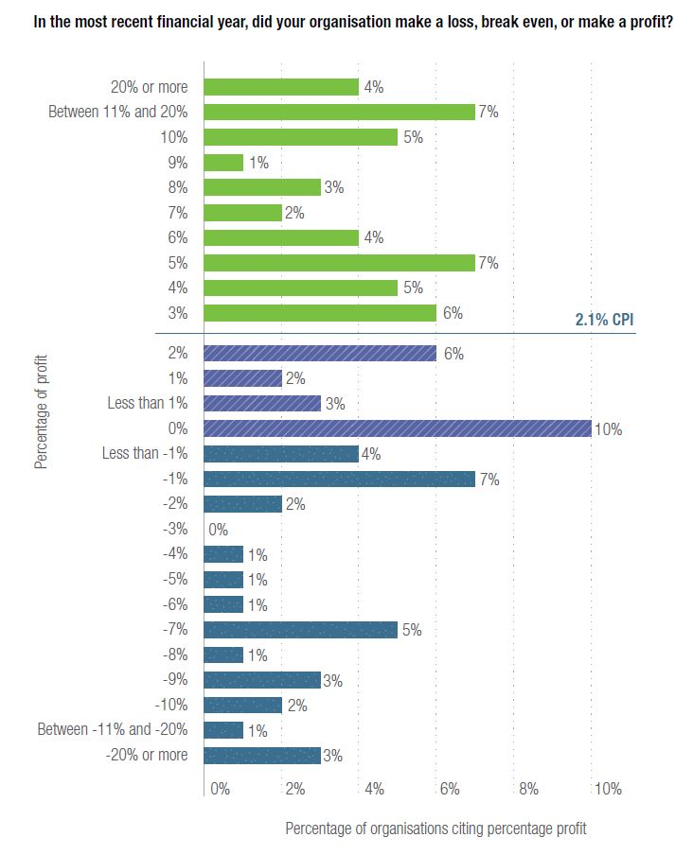
Looking at profit margins by organisation size, significantly more medium and large organisations reported making a profit with their disability services in the last 12 months compared to very small and small organisations. A higher proportion (13 per cent) of very small organisations responded that they don’t know/were a new entity, which likely reflects the growth in small organisations offering disability services.
Figure 14 Financial sustainability by organisation size
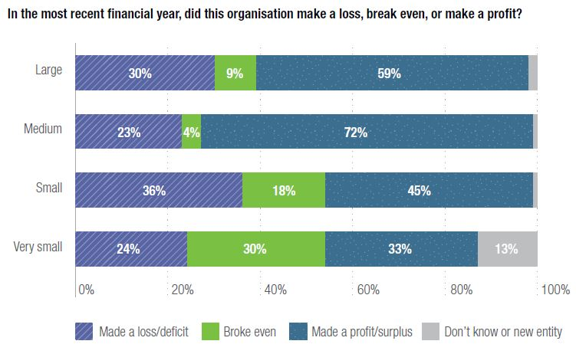
Change in net assets in the last financial year varied by organisation size. Very small providers (less than $1M) were significantly more likely to indicate that their organisation’s net assets had not changed in the last year, while significantly more medium-sized organisations reported that their net assets had increased.
With regards to changes in organisational income, the majority of providers (68 per cent) anticipated that their income from the NDIA would increase in the coming financial year. Thirty-four per cent of providers anticipated that their income from private fees for service would also increase.
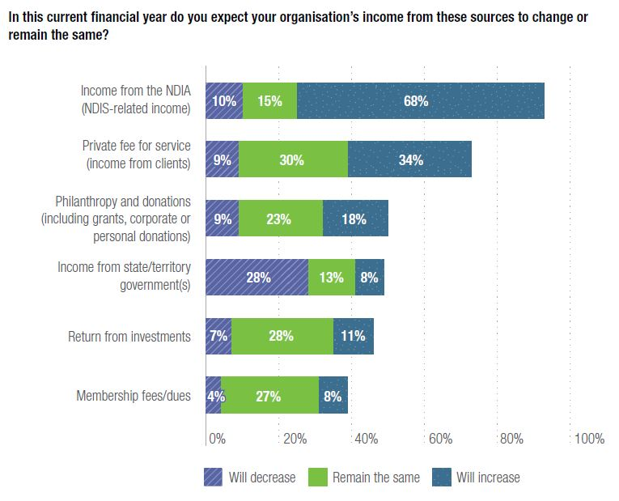
Although sources of funding were not predicted to change drastically, disability service providers are concerned about the costs of their organisation’s service provision. Close to half (42 per cent) of providers said that they thought direct labour expenses would grow at a rate faster than service volume growth, and 50 per cent said the same about administration expenses.

Research contact
For details about the survey data, please contact: Gordon Duff, General Manager - Sector Development & Research, gordon.duff@nds.org.au

Case study - Tasmania

Mark Jessop, CEO, Nexus
Tell us a bit about Nexus.
Nexus started out because of the wave of deinstitutionalisation in Tasmania in the late 1980s. It was formed in 1998 when two smaller services merged. We then perfected our craft of running group homes and introduced things like Active Support in the mid-2000s. This was all in a fairly traditional model of accommodation and day service providers ‘sharing’ support of people with disability within a tightly-managed block funding model. Most of our clients had congenital conditions with strong intellectual and physical support needs.
How has the NDIS transition affected your operations?
I joined Nexus as CEO in 2013, just as the NDIS trial for younger people started in Tasmania. I’ve been hanging onto the dragon ever since and we are slowly coming to an accommodation on how to ride it! We went from a static group of 36 clients for 15 years to ending up with close to 200 clients today – and the NDIS is not yet fully rolled out here. I remember saying to the Board that we’d need to try hard not to grow over the next few years, but I didn’t really think it would be quite the ride we are having.
What’s been your greatest achievement this year?
Transitioning all of our group homes into Supported Independent Living (SIL). The sector had been planning on a gradual age-based roll out, but at the beginning of the year, we were told by the state that it was all in this year! Not only did we have to wait for the SIL quoting tool to be rolled out by the NDIS, but we really needed to accelerate the knowledge of our key workers and team leaders. It was a great opportunity to go back to person-centred planning principles and look at what people needed and what evidence we had. It was a bit of a scramble, but we got there with a week to spare and all were approved with only minor negotiations. At the end of the process, we were able to offer over 1,000 hours a month extra support under NDIS funding than under the state model – a great win for clients. My role was making sure I had the team ready to ‘think NDIS’ and put together really meaningful SIL quotes – a great team effort.
What’s the most valuable lesson you’ve learned?
There are so many. All the lessons about change and managing staff reactions to change have been really important. I was lucky to have spent a few years consulting in this area so I’ve seen a lot of good and bad change processes. Lesson one has been: “Take staff on your journey, too.” The other big lesson has been about corporate decision-making and backing your well-researched judgment. There is no doubt that the changes with the introduction of the NDIS have forced providers to make high-risk decisions. At the end of the day, I looked into the crystal ball, got as much insight as I could, and then just made the decision. (There are still people looking into the crystal ball waiting for the fog to clear.) A good example of this decision-making was moving to a new integrated client management and finance IT package. Had we not done that, we would be absolutely stuck now, but when I did it, I was committing to a best guess of least $250K when I knew we had less than $100K in equity.
If you could go back in time, what would you do differently?
From one perspective, we’ve done reasonably well, but it’s been such a rollercoaster ride, with changing models and systems – I don’t think there’s any wrong way of doing it! It’s such a dynamic change in the sector. To think that there’s one path to go down would be a mistake. I think we’ve taken each day at a time, we’ve anticipated what we could and we’ve adjusted on an ongoing basis.
Can you share a case study where you achieved a positive outcome for one of your service users?
During the trial, we were approached by the NDIS and Housing Choices Tasmania who had some units they wanted to fill. Because only younger people had come into the NDIS at this stage, we developed a model to support young people moving out of home, who would have been destined for SIL or group home models. We were able to work with this group, and, of the original four who came into the program, two moved to more independent living models and two moved into low support shared housing. We have since expanded the model to different sites and achieved about 15 units for people wanting to make a transition to a more independent lifestyle. It’s been full of challenges, but great to take the journey to adulthood and independence with people.
What are your NDIS goals for the next few years?
There are four main goals. We still need to grow to have a sustainable business, particularly with the Quality and Safeguarding costs. Tasmania has had a fairly laissez-faire standards model so many in the sector here will need to ramp up our evidentiary processes, and this will cost. We still need to reduce our transactional costs – doing business with the NDIS is still clunky, much better than 12 months ago, but still too expensive. We need to become a more visible organisation in the new NDIS marketplace, which is a skillset many not-for-profits struggle with, so a bit of thinking is needed for it. Finally, I really want to push the NDIS’s potential to its limits. The Agency talks about fostering innovation, but it seems that, whenever you try to be innovative, they struggle to fit it into a line item. We are just not clicking with the Agency in this innovation area, so I want to come up with lots of examples to give my colleagues in the Agency a headache!

Statistics
3,879 NDIS plans approved in Tas
91% of bilateral estimate
8% NDIS participants are Indigenous
2% Culturally and linguistically diverse
1,159 registered disability service providers

Key issues
Providers struggling under centralised payment centre of the NDIS
Providers in Tasmania are now joining long queues with other, larger states (notably New South Wales and Victoria). Where payment delays were improving in Tasmania comparatively, they have begun to blow out again, causing service providers to carry the costs of continuing to provide supports without being able to claim for their provision. This must be addressed to ensure their ongoing financial viability.
Inadequate prices for travel
Given the limited number of allied health professionals in Tasmania, funding the travel of workers continues to be a problem for providers. The introduction of up to 45 minutes of travel for therapists to provide services in MM4 and 5 regions assists but does not cover all travel costs. This issue requires urgent resolution so that people with disability living in regional and remote areas are not disadvantaged.
Addressing the housing crisis
Shortages of accommodation mean that even those who receive funding for supported living need to join the community housing queue. The State Government has committed $20M to disability housing for Tasmania. Unfortunately, that is projected to be inadequate. Considerable work is still required to improve the supply and diversity of accessible and affordable housing for people with disability.

Case study – Western Australia

Marina Re, CEO, IdentityWA
Tell us a bit about IdentityWA.
IdentityWA has been providing services to people with disabilities in Western Australia for over 40 years. We provide a range of services including Supported Independent Living, family support, and a whole range of other individual supports.
How has the NDIS transition affected your operations?
The Western Australian experience has been a little different. We’ve had both the national NDIS and the WA NDIS. At one stage, we had two pilot programs operating with trial sites, so that added a level of complication, because we were working with the national, working with the state, and we had the existing disability services that were provided through the state government.
Transition to the NDIS has been quite challenging in terms of that level of complexity. We’re now involved in the roll out of the national NDIS across WA, and also the transfer of people involved in the WA NDIS to the national program. There are challenges around financial arrangements, reporting requirements, providing individuals and families with good, clear information – that hasn’t always been available – and then, of course, working with our staff to ensure that they’re well-trained and up-to-date to be able to deliver what they want to deliver.
What’s been your greatest achievement this year?
One of the most important things for service providers is workforce, and ensuring that we have a workforce that’s able to deliver what individuals and families want. We’re currently in partnership with LaTrobe University, delivering a series of research projects around person-centred active support, and that’s been very successful in improving the ability of our staff to be focused on achieving great outcomes for the people we support.
What’s the most valuable lesson you’ve learned?
The most valuable lesson is that our support workers are great people with really good values. With exposure to excellent training opportunities, they’re able to move from being good support workers to excellent support workers.
If you could go back in time, what would you do differently?
I don’t know that we’d do anything differently. The environment has been so full of change that all we can aspire to do is be responsive and continuously looking at our operations to ensure that we’re offering the best opportunities to the people we support. From a WA perspective, it’s really only been in the last 12 months that we’ve had any clarity on how the Scheme would roll out here.
Can you share a case study where you achieved a positive outcome for one of your service users?
The work that we’re doing around citizenship, in particular, is really important. We’re implementing a citizenship framework throughout the organisation, which draws on Simon Duffy’s key principles. That means that we’re challenging our staff to look at all of those domains when they’re working with individuals. [Simon Duffy’s keys to citizenship include: freedom, direction, money, home, help, life and love.] There are a number of examples within that of people being supported to access TAFE, get their driver’s licence, be able to live independently – a whole range of things. That support has further developed the culture of the organisation, and the way that framework is being implemented is having a much broader impact on the lives of the people we support rather than just focusing on any one aspect.
What are your NDIS goals for the next few years?
As an organisation, we think the NDIS provides lots of challenges but also lots of opportunities. The goal is to look at how we go forward, particularly around how we develop some partnerships both within the sector and across sectors to further benefit the people we support. Our goal is to maintain high-quality services while being able to scale up to meet the future demands coming through the NDIS.
For many agencies, there’s a huge focus on maintaining operations and being able to sustain the quality of services they’re providing within a very tight financial framework. What I think is equally important, going forward, is trying to maintain the focus on innovation. Those relationships with universities and industry partnerships and whatever else are absolutely key in terms of building up that capacity, moving forward.
At the end of the day, as service providers, we work in partnership with families, so the emphasis on co-design and being responsive to what individuals and families are telling us they want in terms of future design of services is absolutely critical.

Statistics
4,508 NDIS plans approved in WA
78% of bilateral estimate
4% NDIS participants are Indigenous
7% Culturally and linguistically diverse
1,048 registered disability service providers

Key issues
NDIS transfer and transition
In December 2017, a Bilateral Agreement was announced for WA to transition to the nationally-administered NDIS. The challenge of transfer and transition is compounded by geographical issues associated with regional, remote and very remote communities. It is critical that service disruption and detrimental outcomes for people with disability are minimised and that sustainable support services are delivered and built over the bilateral transition period.
Rural and remote communities
WA has distinct characteristics that mean regional strategies in other locations may not be readily transferable. This includes very long distances between communities, diverse language groups, competition for staff from diverse sectors and significant regional differences in the availability of other services or infrastructure. NDIS pricing for disability supports must be based on the current costs of delivering supports in regional, remote and thin markets and also consider the cost of delivering supports to people with high and complex needs.
Building workforce capacity
While the State Government’s funding of $20M for NDIS transition announced in May 2018 is a welcome down payment, more investment is needed in workforce development, given that the sector workforce is expected to double over the next three years. Additional investment should focus on implementing strategic initiatives of the WA Disability Services Sector Industry Plan.

The state of the NDIS
Transition to the full NDIS started in mid-2016 and is due to be completed by 2020. Now – more than half way through the transition period – disability service providers are still bearing a heavy burden associated with systems that are not well-designed for the large volume of plans and payments that the NDIS must process.
Inadequate prices are threatening the supply of some supports and there is a paucity of information on some critical services such as providers of last resort.
Ongoing negotiation between NDS and the NDIA has resulted in progress on a range of issues, but more is needed.

Pathways and portal developments
After frequent feedback about the shortcomings of NDIS plans, the participant pathway was redesigned and trialled in three regions of Victoria. The revised pathway, now being implemented progressively across Australia, offers all participants face-to-face planning meetings and increases the focus on pre-planning and on post-plan implementation. An increase in the NDIA’s staffing cap is supporting this initiative.
For providers, pathway improvements have included the establishment of a National Provider Payments Team to try to resolve payment delays; the introduction of an improved quoting tool for Supported Independent Living; and enhancements to the Provider Finder function.
Over recent months, a number of improvements to the portal have eased some of the pain experienced by providers. NDS anticipates further changes over the coming year.

Pricing progress amid the pain
Some NDIS prices have improved over the past year. From July, the price limits for standard intensity assistance with daily personal activities and community access increased by 7.64 per cent. This welcome increase included a 2.5 per cent loading as a temporary support for overheads (TSO), which reduces to 1.25 per cent in 2019-20.
The TSO is a welcome but insufficient addition to the prices for standard intensity supports and partial recognition of the high costs of operating within the NDIS. Substantial improvements to NDIS systems and processes must be seen over the next two years. NDS is urging the NDIA to apply the TSO to higher-intensity supports.
The NDIA has not yet completed its research on defining complexity and pricing supports for participants with the most complex support needs.
NDS continues to argue that a substantial and permanent increase to the one-to-one attendant care support price is necessary (and the group prices that flow from it). There are worrying signs that a growing number of providers are reducing – or not growing – their provision of community access supports. The possibility of some market failure is emerging.
A pilot project on pricing and service delivery in remote areas has begun and a review of pricing in Western Australia is planned.

Market stewardship is lacking
In two reports over the past year, the Federal Parliament’s Joint Standing Committee on the NDIS has been critical of the flawed approach taken by the Department of Social Services (DSS) and the NDIA to support transition to the NDIS and the lack of market stewardship. Drawing heavily from NDS’s input, the reports call for the immediate development of an NDIS market stewardship strategy, the establishment of a disability sector assistance fund and the transfer of responsibility for NDIS price-setting to an agency that is independent of the NDIA.
The Committee was concerned to hear of the inability of many service providers to operate at even modest profit levels and that inadequate pricing was resulting in providers discontinuing services to some participants. As argued by NDS, the Committee called for the immediate release of information on provider of last resort arrangements.
The lack of a systematic approach to market stewardship should be a concern to all NDIS stakeholders – governments, the NDIA, the NDIS Quality and Safeguards Commission, disability service providers, and participants and their families and carers. Over the coming year, stewardship activities need to be implemented and their effectiveness ensured.

Participant transport and provider travel are inadequately supported
Assisting participants with moving around in their communities is a support that many providers are struggling to sustain. Portal limitations mean that some participants are not able to use their core funds flexibly to purchase additional transport support, even if that is their wish. Removing this portal limitation is one of several recommendations that NDS has issued in a policy paper on transport and the NDIS.
A welcome development is the new travel guide that allows providers to charge up to 45 minutes of travel time between clients in rural areas (up from 20 minutes). While this is an improvement, NDS has continued to alert the NDIA to situations where provider transport is inadequately covered (such as being the sole provider of a specialist support located in a major city but having a participant residing hundreds of kilometres away). Providers in remote and very remote areas are still not adequately compensated for the travel they incur.

Work in progress: The NDIS Quality and Safeguards Framework
The NDIS (Quality and Safeguards) Commission commenced operations in NSW and SA in July 2018. Its main aim is to achieve a nationally consistent approach to quality and safeguards. Until the NDIS Commission is in place in their jurisdiction, NDIS participants, providers and workers will continue to be covered by their state or territory’s existing quality and safeguards systems, and providers remain registered with the NDIA. Early feedback from service providers in NSW and SA highlights the following issues:
- The unknown cost of compliance associated with the quality and safeguards framework. Until national consistency is achieved, this is the case especially for providers that are operating across multiple jurisdictions.
- There will be additional costs in ensuring that all workers are familiar with the new NDIS Codes of Conduct and the mandatory worker orientation program.
- Ensuring that there is a sufficient supply of suitably trained and experienced quality auditors that are familiar with the new NDIS Practice Standards, especially the new emphasis on proportionate treatment of evidence.
- Lack of clarity on the arrangements for the reduction and elimination of restrictive practices. The NDIS Commission confirmed in early October that the national competency framework for behaviour support remains under development.
In order to build confidence in the new arrangements, the NDIS Commission must move quickly to assess the efficacy of its regulatory instruments, ensure consistent advice and guidance are available to service providers, and engage all key stakeholders – especially NDIS participants, their families and carers – in an assessment of the impact of the Quality and Safeguards Framework.

How NDS is taking action:
- Presenting arguments to government about the critical need for market stewardship
- Advising the NDIA on how complexity should be defined and funded
- Assisting providers to understand the requirements of the NDIS Quality and Safeguards Commission
- Collecting and analysing workforce data through the NDS Workforce Wizard survey
- Raising sector concerns about inadequate funding for worker travel and participant transport by providing examples to the NDIA
- Negotiating portal enhancements with the NDIA
- Informing the NDIA about providers exiting parts of the market
- Giving providers, people with disability and their families an opportunity to voice concerns at the Make It Work community forums in partnership with Every Australian Counts
- Hosting provider forums and communities of practice to share information and support the spread of good practice in quality and safeguarding
- Launching an ongoing series of webinars, webcasts and podcasts on matters relating to quality and safeguarding
- Providing tools and resources to support effective and efficient quality management systems, including the Standards and Performance Pathways standards assessment tool
- Established the national NDS Helpdesk to accelerate answers to questions about the NDIS
- Submitted a paper to the Joint Standing Committee on the NDIS inquiry into the ICT system
- Urged the NDIA to streamline quoting for Supported Independent Living
- Published ‘Getting Transport on Track’ and ‘Making Employment a Priority’; the first in a series of NDIS Essential Issues papers
- Provided information to disability service providers at the NDIS Essential Briefing series in every capital city
- Put forward evidence for re-pricing community access (for one-to-one and group supports)
- Establishment of positions at NDS at the national and state level with specific focus on building organisational capability on quality and safeguards

NDIS transition arrangements
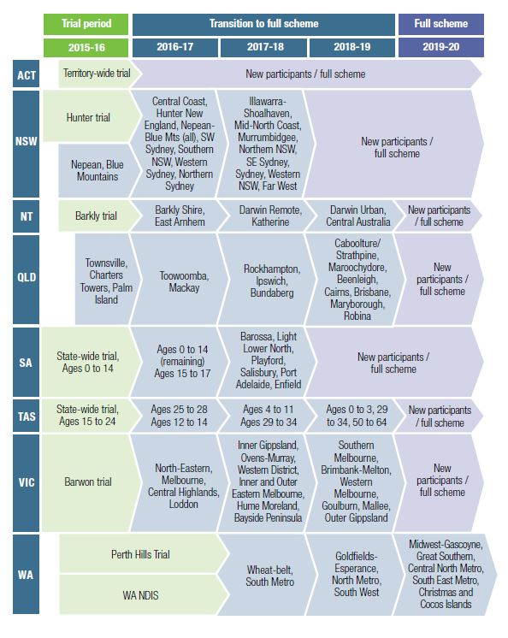

Case study – Australian Capital Territory

Mary-Ann Kal, Program Manager, Sharing Places
Tell us a bit about Sharing Places.
Sharing Places is a specialist organisation in the ACT that provides services to adults with high and complex support needs to participate in community, social and recreational activities. We assist people to work towards their personal goals and improve their quality of life through the development of daily living and life skills, communication strategies and positive behaviour supports, promoting a person-centred culture.
We are currently supporting around 160 people across the ACT, ranging in age from 18 to 65 years.
How have you found the NDIS so far?
In the ACT, with the transition from trial to full Scheme, there has been less flexibility, and the reality of ‘reasonable and necessary supports’ has decreased funding in many people’s plans. There are still inconsistencies in the plans.
The back office pressure has increased to capture all the information for invoicing, processing claims and ensuring we stay within budgets as agreed in the individual’s Service Agreement; keeping on top of outstanding payments and chasing payments from the NDIS. There are still gaps between plans and shortfalls in funding.
What has been the greatest challenge in the NDIS?
The people we support have lifelong disability and many were told they would only need to tell their story once. However, we are asked over and over again to provide evidence for the supports they need in order to access community, social and recreational activities. As a result, the annual reviews were often very taxing for families – constantly having to identify deficits in people to justify funding. The fact that this process doesn’t focus on a person’s strengths is very tough.
What has been your greatest achievement this year?
Maintaining the level of high-quality service, and remaining financially viable. We have seen a growth in our service welcoming many new people who previously didn’t have funds for social and community participation, as well as young adults who have graduated from school.
What’s been a valuable lesson for your organisation?
The resilience of families and the people we support, and the commitment and dedication of our staff through changing and often uncertain times. [We have also learnt that] the operating environment continues to change, so you can’t become complacent. We are constantly reviewing our financial position and making adjustments accordingly.
Looking back, is there anything you would do differently?
Even with organisational pre-planning and implementation of safeguards and strategies with sound business practices, the impact on our resources such as maintaining our vehicle fleet and our capacity to continue to provide home transport and a range of programs was under threat. We should have realised sooner that our fleet of vehicles could not be maintained once all the subsidies we previously had were gone. Now, we have 100 per cent cost recovery for vehicles and activities.
Can you share any positive stories that have come about since the NDIS?
There are many positives. Before the NDIS, there were a lot of people with undermet needs sitting in accommodation. That has been addressed. In addition, many people graduating from school used resources that were owned by their schools. Now, it’s great to see that the students have their own resources, such as their own walking or standing frames. They’re also having therapies introduced much sooner. Previously, waiting lists could be years-long.
What are your NDIS goals as an organisation?
We need to continue to watch the vital signs of the organisation and actively adjust resources. Although we are a not-for-profit organisation, we need to look at how to continue to cost recover and monitor non-claimable absences and work within our budget. Being one of the only organisations that provides supports to people with high and complex needs in the ACT, we also need to consider how big we can grow. We need to gather regular data of school leavers with disability and review our capacity. Something we’d like to do is expand services into the Gungahlin area, which is in the outskirts of the ACT. Finally, we need to keep actively engaging with the NDIA, NDS and other stakeholders.

Statistics
6,759 NDIS plans approved in ACT
134% of bilateral estimate
4% NDIS participants are Indigenous
10% Culturally and linguistically diverse
1,352 registered disability service providers

Key issues
Inadequate pricing
As the first jurisdiction to fully transition to the NDIS, the cumulative impact of inadequate pricing is increasingly being felt by ACT providers. A closer examination of service types that require additional funds in order to remain viable is required. Inadequate NDIS prices pose a risk not only to individual disability service providers, but to the Scheme as a whole.
Better data to track participant movement away from areas of market stress
Participants requiring one-to-one and community access supports are increasingly unable to access these services and may be substituting them with other service types (e.g., in-home day supports) that do not meet all the needs identified in their plans. Better tracking of participant movement between service models is required to identify areas where the current market can not deliver on participant plan outcomes.
NDIS payment portal
Ongoing process issues and inefficiencies in the NDIS claiming system continue to create an unnecessary administrative burden for providers. Response times from the NDIA need to be shorter if providers are expected to absorb these costs. A co-design approach – with providers and participants – needs to be adopted to ensure that portal improvements are user-centred and tested prior to roll out.

Case study – New South Wales

Monique Cardon, CEO, Fairhaven
Tell us a bit about Fairhaven.
Fairhaven was established in 1962. We have three major streams of business. The majority of our service users work in supported employment. We also have a residential and active business community unit.
How has the NDIS affected the way you work?
Individuals now have money to spend on things they didn’t before, which has opened up new opportunities and new worlds to them. We are having great fun trying to help them realise this. Our aim at the moment is to make sure we offer enough variety in our supported employment. Our major Australian Disability Enterprise (ADE) is CoPack, a packaging facility, but we also have ReCreate, an upcycling furniture and homewares-making social enterprise, as well as opportunities to work in our cafe and op-shop. We really want to provide people with choice.
Do you have a positive NDIS case study to share?
One of our guys who works at our Point Clare site wanted to learn to drive a forklift. He used his Coordination of Supports money to have somebody work with him to understand the questions on the driver’s licence test. He could already drive a forklift, so it was about getting support to complete the test. I saw him recently after he got his license and he pulled it out of his wallet to show me with such pride. It was wonderful to see. Without that funding, he wouldn’t have been able to access the people he needed to make that happen. We also have a similar story from someone from Tuggerah, who really wanted to learn to drive. He also used his Coordination of Supports money to arrange driving lessons and organise people to support him to complete the test. He ended up getting his provisional licence.
What have you learned by working through the transition process?
Understand your unit costs and understand your margins. When you’re in human services, it’s easy to keep delivering – but you just can’t. The most difficult transition for us was to go from block funding where you had a certain amount of money and staff, to a new situation of understanding individual budgets and making Service Agreements based on those. It’s tough on staff who have come from that old case management model, especially because you still want to help everybody.
Your entire leadership team recently went on a residential course. How was this experience?
It was an NDS event called ‘Leading the NDIS Transformation’. My General Manager and I looked at it and saw that it was two days in the Hunter Valley, which is really close by and very cost-effective, so we went along. We really liked that it followed a peer-support model and involved other organisations. It was fantastic and we really enjoyed ourselves. We got to know people we wouldn’t ordinarily connect with. When the course was run again in Ballina, we decided to send the rest of our leadership team so that they would be exposed to the same sort of thinking and ideas.
We all really enjoyed getting insights into our own leadership practices, and came back with a great phrase: “You’re either on the dancefloor or on the balcony.” It was a nice reminder that, when you’re busy with the day-to-day, you also need to spend time looking at your organisation in order to work on it – not just in it. It taught us to be really agile, and that you just can’t do things using the old ways anymore. It’s about choice and control for [the people we support]. I think everybody’s starting to get that now.
Is there anything you would do differently if you could go back in time?
I’ve been with Fairhaven less than two years, but I think we could have focused more on staff education. I think we’ve also taken the focus off what our families understand. A lot of work was done with families before the NDIS came in, but once it came in, there was an assumption that they knew what they were doing. As an organisation, we’re still working through things but have probably taken our eye off what our families understand. So we are planning to do some ‘NDIS 101 information’ sessions so families are not left in the dark. I run a family reference group meeting which is always really interesting because there’s great peer support and opportunities to help each other.
What’s something you’re proud of having achieved at Fairhaven?
We went through an important rebranding exercise. Fairhaven is a 56-year-old organisation with a strong local history, but also legacy issues. The rebrand has given everyone a sense of renewal and hope that we are a contemporary and exciting organisation that can attract new people. If we can touch more people and give them opportunities to live an ordinary life, we’ll know we have done our job.

Statistics
86,044 NDIS plans approved in NSW
78% of bilateral estimate
6% NDIS participants are Indigenous
9% Culturally and linguistically diverse
8,485 registered disability service providers

Key issues
Interface between the NDIS and mainstream services
It remains unclear how the NDIS will interface with mainstream services. There are many examples of participants and providers being stuck between the NDIS and mainstream service providers. Provider consultation is essential to resolving these complex cross-service system issues.
Role of Community Partners in NSW
The lack of capacity of Local Area Coordinators to provide plan implementation is concerning. In many cases, the burden of assisting participants is falling on providers. The Early Childhood Early Intervention (ECEI) approach was rolled out very late and quickly in NSW. There are concerns that eligible families have been waiting significant periods of time for plans to be developed.
Leasing arrangements
The leasing arrangement proposed by the NSW Government for providers operating properties under licence from Family and Community Services (FACS)/Land and Housing Corporation assumes every property will be fully occupied by participants eligible for Specialist Disability Accommodation (SDA). This fails to take into account that many of the properties will be unsuitable for participants eligible for SDA or that there will be participants requiring Supported Independent Living (SIL) who are not eligible for SDA.

The State of Broader Policy Environment

Few DSP recipients are in work
The number of Disability Support Pension (DSP) recipients reporting wage earnings has continued to decline. The number of DSP recipients decreased from 758,911 to 756,960 over the 12-month period to 30 June 2018. The proportion of DSP recipients reporting wage earnings was 7.95 per cent in June 2018, down from 8.2 per cent in June 2017.

Other four pillars of policy need work
While the NDIS dominates the disability policy environment, it is only one of five pillars designed to support the social and economic participation of Australians with disability. The other pillars are the National Disability Strategy; the National Arts and
Disability Strategy; the Disability Discrimination Act;
and the National Disability Agreement.
The 10-year National Disability Strategy, signed by the heads of all Australian governments, focuses on six areas:
- Inclusive and accessible communities
- Rights protection, justice and legislation
- Economic security
- Personal and community support (which includes the NDIS)
- Learning and skills
- Health and wellbeing
Progress in most of these areas has been uneven and slow. The Strategy is currently under review and NDS believes that a renewed one should include annual reporting to parliaments on key measures to give it visibility and stimulate investment in the changes needed.
The National Arts and Disability Strategy, due to expire next year, is also under review. Arts and cultural ministers from across Australia have agreed to develop a new strategy to assist people with disability to participate in cultural life.
The Disability Discrimination Act protects people with disability against discrimination in public life. Standards have been made under the Act in relation to Public Transport, Education, and Access to Premises. In general, the standards are well-crafted, but their effectiveness is weak. National auditing of compliance with the standards should be strengthened. The Public Transport Standards are under review.
The National Disability Agreement is a high-level Council of Australian Governments (COAG) agreement that defines the roles and responsibilities of the Commonwealth and the states and territories in relation to disability services. The NDIS has rendered parts of this Agreement redundant. However, in NDS’s view, a revised Agreement could better connect the other pillars of disability policy and define responsibilities for key policy areas. We have made this point to the Productivity Commission’s review of the National Disability Agreement.

How NDS is taking action:
- Advising governments on interface issues between the NDIS and mainstream services, based on the experience of members
- Providing submissions and evidence to national policy reviews
- Developing resources, such as the Zero Tolerance initiative, to help prevent abuse and neglect
- Hosting information sessions on the NDIS Quality and Safeguarding system
- Urging governments to develop continuity of support arrangements for people with disability who are ineligible for the NDIS

Case study – South Australia

Maggie Dowling, CEO, Bedford Group
Tell us a bit about the Bedford Group.
Bedford has been in operation for nearly 70 years. We currently support around 1,500 people with disability, 1,300 of whom access supported employment. The balance is day options and a small amount of residential services. I’ve been at Bedford for around eight months [as of October 2018].
What is Bedford’s furniture business and how has it been adapted to suit your supported employees?
Bedford is known for its flat pack furniture that is marketed throughout Bunnings stores. It has our own branding and is available nationally. The offering includes wardrobes, bedside cabinets and laundry furniture, and we are currently looking at an outdoor kitchen range to be launched into Bunnings very soon. It’s one of our largest commercial businesses that our supported employees work in and generates about 44 per cent of our non-funding revenue. Our revenue is about $72M and around $18M of that is funding and the balance is revenue generated by our commercial businesses. We have five furniture manufacturing sites across South Australia, which includes metro and regional areas.
Work, Health and Safety (WHS) is a very strong focus of ours. A lot of companies that don’t have supported employees look at what we do and consider it a good idea as we provide a very safe environment for manufacturing.
How has the NDIS transition affected your organisation?
The cost of transformation is very evident. Just to transition our 1,500 existing clients, we’ve had to invest significant resources of around $1.8M in additional staff to have pre-planning meetings with families to ensure they understand the need to put ‘finding and keeping a job’ in plans. A lot of families are getting a first plan and it’s not complete as they haven’t understood what the categories are. That extra investment is only to retain our existing funding, without generating any additional revenue, so it’s significant. And like other organisations, we are still in the long, arduous journey of systems modifications to suit the new business model.
What’s something you’re proud of having achieved?
We have some residential accommodation, where about 80 clients live. Because there are a lot of people in one place, it’s the sort of housing that the State Government didn’t deem as ‘independent living’. Because of this, we were getting very marginal funding. My team there worked really hard with the NDIS. The Supported Independent Living (SIL) funding we now have for those clients is amazing. The team at the NDIA were really helpful and worked through it with us. There’s one family in particular, whose son would always send his washing home and get home-cooked meals as he didn’t like the cooking at his accommodation. SIL funding has given him much better flexibility. We have numerous stories like this where we’ve seen very positive outcomes.
What’s the most valuable lesson you’ve learnt through overcoming NDIS challenges?
I came as a relatively new CEO into a risky financial environment. I’ve seen the move from systems that didn’t have to be single-client dependent under the block funding model, to something that needs to identify client-specific data across a range of services. That integration of information about clients is an administrative task that can cause serious financial issues. I think we need to be down in the weeds in relation to transition. Once we’re through to the other end of it, we won’t need to operate at that level. But I think there’s a need in the meantime at the executive, CEO and board level to be driving deep into transition challenges as that’s where financial risk is high.
What do you think Bedford has done well through the transition process?
I think the support we’ve put in to support families absolutely returns value. That won’t stop though. While families are still in transition, there will be a continuing requirement for support. It certainly won’t be a short-term resource investment – I can see it will be ongoing for some time. High-quality client services where families and people with disability feel supported are going to be key to success as we go through the transition process.
What are your NDIS goals in the coming years?
We want to maintain our focus on ensuring that there is an employment-first focus in NDIS plans so people have the opportunity to work. Supported employment is what we are and we strongly believe in it. Employment isn’t just having a job – it’s about quality of life. It is waking up in the morning and knowing that you are contributing to society like anyone else. Being employed gives benefits of socialisation, social inclusion, economic benefits from income, improved health and wellbeing, independence and, of course, it provides respite and support for families.

Statistics
18,460 NDIS plans approved in SA
72% of bilateral estimate
4% NDIS participants are Indigenous
6% Culturally and linguistically diverse
1,960 registered disability service providers

Key issues
Pace of NDIS roll out
Providers are finding that the full roll out of the NDIS in South Australia, which has already been delayed by six months, is proceeding very slowly and is almost at a standstill in some regional centres. The slowdown means that some providers continue to operate with two funding models, which adds to the complexity and cost of administration. It will continue to impact on the growth plans of organisations.
The speed of transition for people with disability is also of concern, with many disability service providers finding that participants who should have transitioned over 12 months ago are still waiting for approved plans.
Inconsistent advice on SIL
Local advice is at times inconsistent with national advice on Supported Independent Living (SIL) from the NDIA. Consistent, prompt and transparent messaging is needed.
High cost of Quality and Safeguarding audits
There is a growing concern in SA around the cost of Quality and Safeguarding audits, with some disability service providers receiving quotes of around $5,000 per day. This needs to be addressed to ensure that audits are cost-effective and not a financial burden for providers.

Case study - Queensland

Brett Adams, Manager Partnership and Performance
– Community Solutions Subsidiary, Endeavour Foundation
Tell us a bit about Community Solutions.
Community Solutions, which is predominantly an employment and workforce-funded not-for-profit, amalgamated with the Endeavour Foundation around five years ago. The biggest part of my role is to connect government-funded services with industry. We work mainly in the employer space so we can support organisations with their workforce issues and get employment outcomes. We also look after mental health and NDIS services which are all growing. However, 75 per cent of our revenue comes from employment and workforce-related services.
How has the NDIS affected what you do?
It’s been interesting. The employment services space had already started to move to a market-driven model prior to the NDIS being rolled out. Fortunately, this meant that we were already very much in the NDIS space five to 10 years ago, and our staff were already in the mindset of what the NDIS would bring. As the NDIS has been rolled out, we’ve been able to position all of the employment services to align with the needs of the Scheme.
Can you explain the concept of a shared labour pool and how it works?
Sure. We’ve had access to existing funded services such as disability employment services, Jobactive and Group Training for a while. All of this helped us take that step into trying a shared workforce model. What we’re trying to achieve is to be a one-stop shop for providers and employers. We want to help them employ the workforce they need through our various pipelines, including a unique labour hire and mainstream recruitment offering. It’s still relatively early days, but we’re trying to position ourselves for the disability and human services market.
What’s the main benefit of a shared labour pool?
We believe that a shared model is how the market needs to work together. The idea is that, through sharing a workforce, there’s efficiency of costs (recruitment, training, HR and admin), better ways of getting people into the sector, and any employers that are accessing that shared workforce can handpick the best people and eventually make decisions to permanently employ those people. Ultimately, we are specialists at maximising government-funded services, getting new people into the sector, and doing it smarter.
What has the response from providers been?
They typically like the idea. When it comes to the nuts and bolts of making it work, it can be more challenging. Using a contingent workforce is new to the sector, but other industries have proven the effectiveness and need in a market-driven environment. It takes a bit of time to understand everyone and how their services are different, but we can always overcome this. The key will be cost savings from the services we offer.
Can you share a positive outcome from working with a provider?
We worked with a disability provider where we accessed both state and federal funding. We created a program called ‘Host to Hire’ which allowed providers to trial new workers in the industry through our shared workforce model. We were able to cover recruitment and training costs to get people into jobs whilst engaging successful job seekers through our third party and host candidates with interested providers. The cost savings for employers were significant, and they were able to trial new staff for six months at a heavily-subsidised rate. The job seekers got training, experience and confidence within the disability industry as support workers.
In one particular region in Queensland, there was a cost saving of over $100,000 in recruitment, training and wage costs in six months. The provider went on to employ over 80 per cent of the people that went through the program on a permanent employment basis. One candidate went from being unemployed as a single mother to successfully gaining a management position. This is something we were extremely proud of. And the disability provider had a whole new way of thinking about their workforce and how they attracted and employed staff.
Looking ahead, what are your NDIS goals?
We’ve had some great successes of organisations being able to collaborate using our services. We want to see more collaboration, which I believe can go beyond traditional employment models to a more contemporary and future-proofed model of workforce strategy and management. We want to continue being proactive problem solvers around NDIS workforce issues. We need to continue using technology too. As an example, we use video interviews for support workers to make the hiring process more efficient for both hiring managers but also the customer experience. We are proud that we can bring these sorts of ideas and solutions to the sector, and we will continue to support the future workforce and community engagement opportunities that the sector will bring.

Statistics
16,524 NDIS plans approved in Qld
55% of bilateral estimate
10% NDIS participants are Indigenous
3% Culturally and linguistically diverse
3,559 registered disability service providers

Key issues
Delay in NDIS roll out
Under the bilateral agreement between the Commonwealth and Queensland, two thirds of the state’s NDIS participants are scheduled to enter the Scheme in 2018-19. The transition process for partners in community contracts, including Local Area Coordination and Early Childhood Early Intervention, was planned to take place prior, but ended up being delayed. This has caused confusion, inconsistency and uncertainty for both Scheme participants and service providers. To ensure successful transition, greater certainty around timelines is required.
Responding to the needs of remote and regional communities
The challenges of thin markets, inadequate pricing and lack of a local workforce have made it difficult to cater to the needs of remote communities. These challenges are even more acute in Indigenous communities. A local and targeted response is needed to ensure that these communities are not further marginalised.
Lack of market data
To date, the NDIS roll out has not met the volume of participants forecast in Queensland’s Market Position Statement. Lack of data by location is hampering evidence-based planning and the ability of both existing and new organisations to meet market need in an effective and efficient manner. In addition, providers may be unable to meet participant needs without winding up in precarious financial positions.

The State of Disability Employment

Make employment a priority
Increasing the rate of employment participation of people with disability should be a key objective of the NDIS. The NDS policy paper, Making Employment a Priority, identifies constructive measures that would ensure that the NDIS actively supports participants to enter the workforce.
Recent data demonstrates the urgent need to enhance and streamline the provision of employment supports. As of June 2018, only 2.0 per cent of NDIS supports for people over 25 years and 5.2 per cent of supports for people 15 to 24 years were for employment.
The NDIS should make ‘finding and keeping a job’ an NDIS core support, rather than a capacity building support, for participants of workforce age. This employment-first approach should also allow participants to automatically receive ongoing funded supports when a participant can commence work. This would alleviate the need for a plan review and the attendant delays that may prevent a participant gaining a job.
Job seekers with disability who are testing their eligibility for a Disability Support Pension (DSP) should have access to supported employment and/or Disability Employment Services (DES). This is currently restricted as they are ineligible to be paid pro rata wages.
Transition to work programs for school students with disability should be provided from age 15 and assist them to gain work experience and build their workforce confidence and career aspirations.
Finally, the interface between DES and the NDIS should be simplified, and the latter allowed a wider brief to provide complementary supports that will sustain employment for participants.

Open employment undergoing significant change
From 2010 to December 2017, DES providers assisted 415,543 people to start a job and 249,282 people to keep a job for at least 26 weeks.
The new DES contract commenced on 1 July 2018. Providers are experiencing a number of challenges as the new arrangements are bedding down. It is an extremely competitive market, with the number of contracts expanding from 800 nationally to over 2,000 licences nationally. Competition in each Employment Service Region is tight, with providers competing for the same participants and employment opportunities.
The new risk-adjusted funding model was designed to improve outcomes for job seekers who have more barriers to employment; through clearer fee differentiation and a higher level of support. However, the model – which is based on the probability of somebody achieving employment – does not account for the support required. Some cohorts of DES participants that require extensive levels of upfront support in order to be placed and supported in employment are not receiving adequate funding at the front end of the program. This affects, in particular, Eligible School Leavers, job seekers aged under 25, individuals with an intellectual or learning disability, and people on the Autism spectrum.
Job placements for people in these cohorts were previously at relatively high levels due to the extensive supports that could be provided with greater funding. A reduction in the levels of funding for these participants will inevitably lead to poorer job placement rates.
In addition, providers have expressed concern about the introduction of additional compliance obligations when assisting participants that require ongoing support. Providers are adamant that these compliance obligations misallocate their resources and the program’s funding and reduce the amount of support that can be provided to ensure people with disability maintain their employment.
The problems with the risk-adjusted funding model and the new ongoing support obligations are exacerbating the decline in participants with intellectual disability being placed and supported in jobs. As at June 2018, only 7,634 of DES/ESS (Employment Support Service) participants had an intellectual disability, barely seven per cent of the current caseload.

Supported employment design discussions continue
The Fair Work Commission (FWC) made an important and very welcome decision in April 2018 following the review hearings for the Supported Employment Services (SES) Award. The application by the advocates and several unions that sought the abolition of all wage tools except the Supported Wage System (SWS) was rejected. The decision proposed a new wage assessment method that factors in both the complexity and scope of a job and an employee’s productive output. Existing wage assessment tools (including the SWS) are to be phased out of the Award.
The FWC requested that parties involved in the Award review provide input into the development of a new Classification Structure for Grades 1, 2 and 3 of the Award, specifically covering supported employees.
NDS convened a wage determination working group and has completed some important preliminary work including a set of definitions and a description of the methodology that might be used to assess the complexity and scope of a supported employee’s job. The FWC’s final decision is expected to provide further guidance on the design of the classification structure. A member of the Full Bench will also preside over a conferral process assisting the Award review parties to design the classification structure.
In another welcome development, the Federal Government made a further strong commitment to the Disability Enterprise sector, announced by then Social Services Minister Dan Tehan at NDS’s Disability at Work Conference 2018. The package provides $5.3M in support for organisations paying their employees under the SWS, and $1.5M for sector consultation and trials to inform the development of the new wage assessment mechanism. A key consideration for government will be whether to provide an ongoing subsidy for wage increases that may arise due to decisions made by the FWC, the rate of any subsidy and how it would be administered.
Following the initial round of public consultations by the Department of Social Services, NDS will continue its active involvement in the future design of supported employment, including assisting in the design of longer-term pricing and funding arrangements, to be implemented under the NDIS from mid-2019. NDS has recommended that any sustainable model of supported employment pricing must include the cost of ongoing support, the cost recovery shortfall arising from employees with reduced rates of productive output, and a capital replacement subsidy. NDS is of the view that any wage increase subsidy should be indefinite and paid by DSS, as it is not a reasonable and necessary support as defined by the NDIS.
NDS’s BuyAbility initiative continues to promote the social and economic benefits of supported employment. The BuyAbility Social Impact Measurement Tool (independently-verified) shows that, for every dollar of funding expended by government on disability enterprises, the net economic benefit is $3.66.

School-to-work transition remains a crucial area of focus
Young people with disability continue to be severely underrepresented in the Australian workforce, however work is being done to change this.
Connecting young people at school with jobs vastly improves their chances of working post-school. NDS’s Centre for Applied Disability Research (CADR) has released a Research to Action Guide that identifies the six key elements of effective transitions from school to work for young people. These include building work expectations, stakeholder collaboration, meaningful work participation, skills development, family involvement and early transition planning. All of these elements have been successfully utilised in NDS’s Ticket to Work initiative, which is assisting significant numbers of students with disability to achieve their work and career aspirations.
Ticket to Work recently conducted a pilot designed to support students to participate in after-school jobs. An after-school job is a rite of passage for many adolescents and students with disability should be no exception. Ticket to Work uses a longitudinal approach to measure the benefits of work for school students and its positive impacts on their economic and social participation. Ticket to Work networks recently celebrated the creation of over 1,000 jobs for young people with disability. The Ticket to Work traineeship/apprenticeship completion rate is well above the general population.

How NDS is taking action:
- Negotiated supported employment design and providing informed advocacy to government on its future
- Shaped a number of the policy directions – in particular, the granting of an invitation to treat for 3-star and above providers – in the design of the new DES program
- Calling for an employment-first approach that makes ‘finding and keeping a job’ an NDIS core support
- Securing $33.492M in contracts, with 1,511 supported employee roles engaged across 62 disability enterprises, since the launch of the BuyAbility initiative in 2017
- Supporting 2,000 young people with disability to access career development opportunities while at school through NDS’s Ticket to Work initiative
- Influencing the review of the Performance Framework, including determining which data would be incorporated in the 2018 Star Ratings
- Releasing a policy paper, Making Employment a Priority, which identifies constructive measures that would ensure the NDIS actively supports participants to enter the workforce
- Development of the The BuyAbility Impact Tool V2.0; now the pre-eminent social and economic impact measurement tool for supported employment

Case study – Victoria

Ross Coverdale, CEO, Araluen
Tell us a bit about Araluen.
Araluen is based in three local government areas in metro Melbourne. We’ve been a fairly traditional service, with strong loyalty from our participants and their support networks. We’ve enjoyed a strong 10 years leading into the NDIS, in which we’ve been able to attract good staff. We’re the only adult day service in the country that has the international gold standard of Autism Accreditation. We support people aged over 18 in the traditional day service model, but also other innovative support initiatives including creating vocational opportunities; individualising support; skills development and the like. We provide group housing, and we’re specialising in moving people out of the family home, where they typically live with ageing carers, and into community integrated living.
How has the NDIS transition affected your operations?
We’ve found ourselves in a growth phase. Our income has gone up significantly since the NDIS started in our area, and more participants now want more support from us. We went through a period in which we thought we might struggle to stay in business, but we’ve comfortably done that. Our issue now is to have the internal capacity to respond to participant demand and probably double in size. We’re forever recruiting. We have to invest in Araluen’s structure and people to grow it, and to grow the quality. We’re not interested in growing just for the sake of numbers. It has to be about impact, and we have to impact people’s lives in a positive way. We exist to help people have great lives. How do we improve growth, quality and culture? That’s a different struggle to staying afloat, but it’s a struggle. That’s our struggle now, and it’s not the one we thought we were going to have.
What is the most valuable lesson you’ve learned?
What we’ve done best is had good managers and we’ve sat together and asked: “What do you understand?” and “How does this work?” We’ve been honest and open with each other. Initially, we believed everything the NDIA told us... But what we found is that we know our business better than anybody. We’ve had consultants come in, we’ve listened to a lot of different advice, but we’ve got a good idea of our business operations, what our capacity is, and what our systems are. And we’ve sat down together with blank pieces of paper and asked: “How can we make this work?”
The second thing is that we’ve listened very closely to our customers. We’ve put a lot of effort into pre-planning. Before families go and have their planning meeting with the NDIA, they’ve met with us and we’ve discussed what they’d like and how we can support them through that process. That’s gone very well. So we’re enjoying high trust levels from participants and their families.
What has been your greatest achievement this year?
One of the best things we’ve done – which was more than a year’s work – is becoming a leader in Investigating Housing Solutions (IHS), moving people with disability out into the community. We’ve developed a process and a housing roadshow, and moved 32 people into community living. We’ve got research partners and a process, and I think that’s been some of the most exciting work that we’ve done. We also started our third café. And that’s funded through individualised support and skills development.
Can you share a case study where you achieved a positive outcome for one of your service users? Who were they and what happened?
There’s a young man – Fred [not his real name] – who lives with his mum, who has other children. Fred’s behaviour was becoming difficult for the family, and his mum wasn’t coping. So we began to plan the process for Fred to move out of home. Fred has Autism and doesn’t always enjoy the company of others. So rather than put him in a group home that may have resulted in conflict, we were able to upskill Fred and move him into his own unit, and find him a volunteer role in the community. He doesn’t have paid support during the day, but has visiting support at home that assists him to live the life that he chooses. Fred has an IHS coordinator that has really helped him out. He has had to work through issues of resilience and expressing appropriate relationships, and we’ve helped him with those. With the NDIS, we’re spending a fraction of what it would have cost in a group home.
If you could go back in time, what would you do differently?
I think we would have worried less. I would say that a lot of the information we gleaned about the NDIS was actually wrong, or wasn’t relevant to our context. When we ran all of our pricing scenarios, the actual outcome was far more positive than what we were being told. The thing we should have done is believe in our own abilities and our own capacity more.
What are your NDIS goals for the next few years?
What we now know is that, at this stage, we’re still able to attract good staff. So our big goal right now is to embrace the growth. In Melbourne, we’re on the edge of what’s known as the Whittlesea growth corridor. We’re seeking to become a premium provider in that municipality. In that context, we’re going to develop all sorts of new models for supporting adults. They won’t be traditional models. And that will probably lead us to double our organisation.

Statistics
39,180 NDIS plans approved in Vic
83% of bilateral estimate
2% NDIS participants are Indigenous
7% Culturally and linguistically diverse
4,923 registered disability service providers

Key issues
Ongoing support from NDS’s Sector Development Program
With funding from the Victorian Government’s Transition Support Project, NDS will continue providing disability service providers with the advice they need to support their transition to the NDIS throughout the 2018-19 year. We are keen to ensure that funding to support sector transition continues to be available after June 2019.
A voluntary Disability Worker Accreditation and Registration Scheme
NDS was successful in making the case for a voluntary rather than mandatory Victorian Disability Worker Accreditation and Registration Scheme in the 2017-18 year. We were concerned that a mandatory scheme would act as a barrier to workers entering the sector at a time when it needs to grow. NDS continues to undertake project work and advocacy to support the growth of, and quality of services provided by, the Victorian workforce.
Disability transport difficulties
NDS members report challenges in providing transport services under NDIS prices. NDIA restrictions around provider travel claims and scarcity of funding for participant transport in NDIS plans exacerbate this. NDS continues to work with the Victorian Government to address these issues, including advocating for the Victorian Mobile Passenger Transport Program to be extended to NDIS participants beyond June 2019.

Case study – Northern Territory
Kim McRae, Tjungu Team Manager, NPY Women’s Council
Tell us a bit about NPY Women’s Council.
NPY Women’s Council provides a range of services and advocacy for people living in the remote cross-border region of the Northern Territory, Western Australia and South Australia. In the disability space, we’ve been receiving disability funding under the Tri-State Disability Agreement since 2005 – providing case management, flexible respite, and transport associated with that respite. We work with people with disability and their families and we support people to continue living on country, with kin, connected to culture, for as long as they are able to. Our big focus is keeping people on country, and we do that by supporting the whole family, because the family provides the care out there.
How has the NDIS affected your operations?
It’s been incredibly time-consuming trying to attend all the NDIA information sessions; trying to get staff trained to move away from the case management model that we have previously used for people out in communities and more into the support coordination model… There are quite significant differences there, so it’s been a big issue in terms of advocacy.
The amount of time we’ve had to spend advocating to the NDIA about what people in remote communities actually want in terms of disability supports has been significant too. Material poverty is a huge issue for people out there… Often food, shelter and safety are the big issues for our families. The NDIS can’t particularly purchase food, or swags and blankets for people – which is what our families often ask for because they’re highly-mobile and often don’t have a bed. The NDIA has an Aboriginal and Torres Strait Islander Communities Engagement Strategy, but the reality of how that’s being applied out in community is different. How can we support the whole family to maintain the care for that person? Those kinds of concepts aren’t really supported well by the current structure of services through the NDIS.
What’s been your greatest achievement this year?
I think one of our biggest achievements has been maintaining stable staffing in an environment where there’s no guarantee what’s going to happen tomorrow; and where we’re dealing with declining levels of block funding because of the NDIS. We’ve invested heavily in trying to maintain our existing staff. And that’s important, because working in Aboriginal communities, the work you do is based on having trusting relationships with clients and families. Those relationships take a long time to build. We want those staff members to stay here and continue those relationships.
What’s the most valuable lesson you’ve learned?
We have to be very careful to look after ourselves, because burnout is a huge risk in the environment we’re in. Also, trying to reassure our clients and families that they’ll continue to receive supports even though there are going to be changes. I’ve become more focused on what it is we’re going to be able to provide for people with disabilities and their families under the NDIS – focusing on trying to maintain the quality of services despite the cost pressures. That remains the most important issue for us. We don’t want to compromise on that because of NDIS pricing. What that might mean is that the range of supports we provide might decrease, because we’re trying to focus on what we can do well, within that pricing structure.
I’ve also learned how important it is to keep raising issues and negotiating with the NDIA around things like remote travel. The cost of remote travel in our communities is very high, and we have to be upfront about that. We’ve had to be prepared to say ‘no’ if they don’t come to the party. If they’re not willing to pay what it costs, we can’t do it. We’ve had to stand up and speak out about what’s required, and be prepared for the fact that we may have to stop doing some things.
If you could go back in time, what would you do differently?
Because we’ve come from an environment of block funding, you kind of felt obliged to go along with the NDIA and try and accommodate the way they do business. But what I’ve realised – particularly in the past 12 months – is that I just need to challenge that at every opportunity. You’ve got to be upfront. If you don’t get the answer you want from one person in the NDIA, try 10 others that you know. You have to be really frank and fearless, because the issues are so important for people with disability living out in those remote areas. To keep those people out there, we’re going to have to fight a very good fight. Otherwise, a lot of people are going to be forced to live in town in supported accommodation because of the lack of services out in the community. And with a little flexibility on the part of the NDIA, they could have the choice to continue living out on country.
What are your NDIS goals for the next few years?
We’ve kind of lived in a survival mode for the past few years where we’re not sure when our block funding is going to end. The big picture, in my mind, is people still living out on country; still with their families; in their communities; doing the things that they want to do every day; being part of the culture and the community, with better services than are available now – because the services out there need to improve.

Statistics
843 NDIS plans approved in NT
52% of bilateral estimate
78% NDIS participants are Indigenous
38% Culturally and linguistically diverse
602 registered disability service providers

Key issues
Thin and failing markets
Thin and failing markets are continuing areas of concern in the Northern Territory. Of the $197M that has been committed in participant plans to June 2018, only $67.3M has been paid. This represents around 34 per cent; significantly lower than the national average of 64 per cent. Investment in industry development is needed, as well as access to a quarterly market opportunity report by region from the NDIA.
Workforce challenges
Difficulty accessing qualified and experienced staff is already being felt in the NT during NDIS transition, particularly in regional and remote areas. There is anticipated required growth of around 1,300 additional staff to meet the demand at full Scheme in the NT. Investment in workforce planning and development is urgently needed to support continued market growth.
Transport shortages and challenges
Transport in the NT is very limited and expensive. In the place of current funding tiers, an alternative approach to funding remote transport is required to address the challenges and to enable Indigenous participants to return to country without impacting on their core supports. It is imperative that both NDIS prices and engagement models are sufficiently flexible to reflect the cultural norms and costs of delivering services in isolated and Indigenous communities.

The State of the Workforce
Economic and labour market conditions have been improving in most parts of Australia over the past year.
Recent Australian Bureau of Statistics (ABS) data reveals a more vibrant labour market, with more people employed and higher labour force participation. Job vacancies have increased significantly across all industries. Seventy-eight per cent of 15 to 64-year-olds are now in the labour force; the highest rate on record (ABS, August 2018).
In the disability sector, growth has been particularly rapid. NDS workforce data for June 2018 showed a net growth rate for disability support workers of 2.5 per cent, which is equivalent to 10 per cent annually. This compares to an all-industry figure of 2.5 per cent over the past year.

Recruiting disability support workers is becoming more difficult
The challenge of recruiting disability support workers has become greater this year.
- Nearly two thirds of respondents (63 per cent) reported extreme or moderate difficulty in recruiting disability support workers, up from 42 per cent in 2017.
- Managers and supervisors moved into the ‘difficult-to-recruit’ category this year for over half of respondents, compared to around one third in 2017.
The most acute recruitment difficulties reported in 2018, as in the two previous years, were for allied health positions.
- Psychologists, physiotherapists, speech therapists and occupational therapists were the top four hardest-to-recruit occupations, with a majority of those responding to this question reporting ‘extreme’ or ‘moderate’ difficulty. (See table on p54.)
- Although these were also hard-to-recruit professions in 2016 and 2017, it has become more difficult to recruit as the NDIS rolls out.
Specific skill shortage occupations identified this year include music therapists, pedorthists, custom medical grade shoe-makers, people with a mental health speciality, social workers and, as in 2017, psychologists.

Providers getting better at facing challenges
At the same time, nearly two fifths of providers said that it was ‘easy’ or ‘not hard to recruit’ support workers. Comments suggested that some organisations feel they are getting better at meeting the challenges of attracting and retaining suitable people:
“We have very actively tackled our workforce issues. We have been able to recruit and retain better than other organisations in our sector … but it’s still difficult, especially for our rural locations.”
“Our workforce is older and, to retain, we are having to reduce hours and offer greater flexibility.”
Retention difficulties may also be lessening, with the number of respondents saying they were finding it ‘extremely or moderately difficult’ to retain disability support workers falling by nearly 10 percentage points from 2017, suggesting employers may be learning what it takes:
“We have a very high emphasis on the non-financial benefits of working with us - great culture, passion, flexible working, etc.”
The hardest-to-retain groups were again the major allied health professionals.

Recruiters tailoring to demand
Providers consistently emphasise that, as the NDIS roll out vastly increases demand, recruitment and selection have become more challenging.
Employers say that they are now recruiting more reactively to demand, seeking to match new clients to staff with:
- specific job skills or experiences (e.g. behaviour support)
- personality or demographic characteristics that match customer preferences
- the ability to work flexible hours in order to fit the shifts clients want
“Finding the right skills and competencies of support workers to match client interests/needs is becoming more difficult, particularly in regional areas where the pool of good and available staff is smaller.”
“The rate of pay and security of employment (guaranteed hours) make it difficult to recruit and retain support workers.”
“Stress has escalated due to the constant cycle of helping families prepare for planning (they are stressed), getting inappropriate plans and poor/incorrect advice about managing them … and then trying to provide a decent service with insufficient funding. This makes working in this field so much less interesting and sustainable.”

Remote, rural and regional areas the hardest
As in previous years, recruitment and retention difficulties are exacerbated in remote rural and regional areas. Organisations that cover both metro and rural areas commented on the contrast:
“It’s completely different in rural areas. We simply do not have the numbers to keep up with demand. Too isolated from bigger areas to access some professionals. Transport limited to travel to other services for provision.”

Providers see risks associated with workforce pressures
In addition to recruitment, Annual Market Survey respondents highlighted several ongoing workforce issues of concern. Foremost are risks to clients and safety, and risks associated with insufficient time to induct, train and facilitate staff development, undermining the principles of the NDIS:
“The inability to provide more than very basic training for staff represents a huge risk to the entire sector.”
“We are having to employ people with lower skill and competency levels than we would like due to the low payments from the NDIS. This means less choice for the participants.”

How NDS is taking action:
- Offering job board and recruitment tools specifically for the disability sector via carecareers.com.au
- Providing training programs and modules via NDS Learn and Develop
- Offered online workforce benchmarking tool, Workforce Wizard, to help disability organisations track workforce trends
- Providing a one-stop-shop of disability workforce tools and resources at the NDS Workforce Hub
- Launched ‘Purpose and People’, a national network which meets regularly to support service providers interested in self-organising teams to re-design their workforce
- Managing The Innovative Workforce Fund, an Australian Government-funded initiative designed to encourage the development of innovative workforce practices to support the roll out of the NDIS. So far, NDS has supported 30 projects nationally to identify new ways to engage, develop and use their workforce.
- Developed ‘People Search’, a searchable database available on carecareers.com.au that enables job seekers to post their profiles and employers to find potential employees
- Publishing the Australian Disability Workforce Report, which documents trends in the disability support and allied health workforces

Table 2: In the past financial year, how easy or difficult has it been to recruit competent staff in the following categories?

Occupation category | Percentage of respondents that answered ‘extremely or moderately difficult’
Psychologist | 83%
Physiotherapist | 76%
Speech therapist | 65%
Occupational therapist | 73%
Local Area Coordinator/Planner | 64%
Disability support worker | 63%
Dietitian | 63%
Managers/supervisors of disability support | 55%
Support Coordinator | 50%
HR/Workforce Development | 38%
Marketing/business development | 38%
Information Technology | 37%
Finance/Accounting | 32%

Table 3: In the past financial year, how easy or difficult has it been to retain competent staff in the following categories?
Occupation category | Percentage of respondents that answered ‘extremely or moderately difficult’
Psychologist | 53%
Speech therapist | 40%
Physiotherapist | 38%
Dietitian | 33%
Disability support worker | 33%
Occupational therapist | 32%
Support Coordinator | 27%
Local Area Coordinator/Planner | 26%
Marketing/business development | 23%
HR/Workforce Development | 23%
Managers/supervisors of disability support | 23%
Finance/Accounting | 17%
Information Technology | 17%

NDS is determined to do all we can to make the NDIS work for all stakeholders, to increase employment opportunities for people with disability, and to inject new life
into the National Disability Strategy.
Publisher
National Disability Services
Chris Tanti
Chief Executive Officer
03 8341 4343
chris.tanti@nds.org.au
All rights reserved. No part of this publication may be reproduced, distributed or transmitted in any form without the prior written permission of the publisher. Except in the case of brief quotations embodied in critical reviews and certain other non-commercial uses permitted by copyright law.
About National Disability Services
National Disability Services is Australia’s peak body for non-government disability service organisations, representing about 1,100 service providers. Collectively, NDS members operate several thousand services for Australians with all types of disability.
Acknowledgements
The 2018 Annual Market Survey was carried out by the Centre for Social Impact at the University of New South Wales.
Associate Professor Gemma Carey
CSI UNSW Research Director
gemma.carey@unsw.edu.au
www.csi.edu.au
Thank you to our members who participated in our case studies.
Thank you to the many people who have agreed to allow photographs of themselves to be used in various NDS publications.
This report was printed by a Disability Enterprise, a member of the BuyAbility network.

