State of the Disability Sector Report 2019

[Cover page]
Change is the only constant. The turning seasons of the NDIS continue to create new challenges and surprises. With them, we learn to adapt and plan for the next phase, always conscious of the communities at the centre of our work.

Contents
The State of Play – Page 3
The State of the Operating Environment – Page 8
The State of the NDIS – 25
The State of the Broader Policy Environment – 30
The State of the Royal Commission – 32
The State of Disability Employment – 34
The State of the Workforce – 38
NDS Helpdesk – 43
State case studies – 44

By mid-2020, NDIS roll out is scheduled to be completed. With this milestone reached, the collective mind of the disability sector will likely turn to, ‘How can we make the Scheme better?’
The results of this year’s Annual Market Survey (AMS) and NDS’s State of the Disability Sector Report indicate that, while some progress has been made in addressing early Scheme implementation issues, many in the sector remain concerned about their capacity to adjust to the ever-changing policy environment presented by the NDIS. Given the results of the AMS in 2019, it might also be argued that sector perceptions of the impact of the NDIS on providers and participants have not changed very significantly from 2018 to 2019.
Our challenge continues to be to work together to craft a vision for the future of disability service provision in Australia; a future that ensures we have a vibrant, mission-driven, customer-focused disability services sector. This envisioned sector will deliver high-quality services to support people with disability to lead great lives, whether or not they are accessing NDIS-funded supports.

The State of Play
The late Steve Jobs, founder of Apple, once observed that, “You have to be burning with an idea, or a problem, or a wrong that you want to right. If you’re not passionate enough from the start, you’ll never stick it out.”
Mr Jobs’ words will resonate with many disability service providers in 2019 as they continue to navigate the path of disruptive change which is the NDIS. Providers are responding to changing preferences and demands of people with disability as consumers of disability services, the impact of the new Quality and Safeguarding Framework and the NDIS Commission and, of course, the important work of the Disability Royal Commission.
Central to this report are findings from our Annual Market Survey, which this year had 667 respondents, the highest number the survey has ever received. Respondents included providers from every state and territory, spanning the full range of disability services and organisational sizes, including not-for-profit and for-profit organisations.
Providers’ experiences of the NDIS remain mixed. While more than half of those surveyed think NDIS policy reforms are heading in the right direction, around 75 per cent continue to see the policy environment as uncertain.

Opportunities to improve relationships
Less than 25 per cent of respondents think the National Disability Insurance Agency (NDIA, or the Agency) demonstrates a high level of respect for them and their work; and less than 20 per cent think the Agency is working well with providers to implement the NDIS.
The Agency, NDS and providers must take the opportunities offered to work together to resolve an array of issues in the Scheme’s design and implementation.
However, the relationship between the NDIA and providers is only one element of the broader relationship between the sector, governments and their agencies. As this year’s Annual Market Survey reveals, the picture we have of these relationships is complex, with providers dealing increasingly with multiple government agencies in relation to payments, quality and safeguards regulation, and funding streams.

Significant implementation issues remain
In a result unfortunately consistent with data from previous surveys, only 13 per cent of those surveyed thought that NDIS processes and administration are working well. Many of the same issues have bedevilled the Scheme since its inception, and some may be addressed through the review of the NDIS Act. The review was commissioned by Minister Stuart Robert with the principal intention of inserting a Participant Service Guarantee into the Act by mid-2020.

Solutions are still sought
NDS continues to work with the Agency on solutions to the problems thrown up by what is still an immature scheme. Incremental improvements are occurring.
While we remain critical of inadequate NDIS prices for particular supports, price increases announced in 2019 have provided some relief for many providers, and new prices for health supports, announced in October 2019, have been welcomed by the sector.

With the expected release of a Pricing Discussion Paper in 2019, NDS looks forward to continuing our engagement with the Agency to resolve outstanding pricing issues, as well as implementation challenges blocking providers that are seeking to offer high-quality services to NDIS participants, including in remote and very remote areas.

Getting employment right is critical
Many Australians with disability want to work, yet the employment rate of Australians with disability remains low.
Economic participation is a goal of the NDIS, however too few participant plans currently include employment supports. In NDS’s view, participants of working age should be offered funding for employment in their plans. The Agency’s Board has committed to a target of 32 per cent by 2023. In order for this ambition to be realised, positive steps to create more employment opportunities need to be taken.
Stronger disability employment support is a key part of the answer to the low employment rate of people with disability. Reforms to Disability Employment Services, introduced in July 2018, expanded choice and competition; but they also applied a new and untested funding model that appears to have disadvantaged some cohorts of job seekers. Whether the DES program boosts employment outcomes for job seekers remains to be seen.
Disability Enterprises provide employment to 20,000 Australians with significant disability. Their future, and therefore the future economic and social participation of their supported employees, depends on resolving the financial uncertainty they face. This will require a satisfactory outcome to the long-running dispute over wage-setting before the Fair Work Commission, a viable funding and pricing model under the NDIS, and increased commercial income boosted by a commitment by all Australian governments to the procurement of goods and services.

A new National Disability Strategy
The National Disability Strategy is due to expire in 2020. Its ambitions are admirable, but its capacity to drive change has been very limited. The Strategy is a critical companion to the NDIS, and it needs reinvigoration.
The ambitions of the National Disability Strategy complement those of the NDIS. Inclusive transport, technology, justice, housing, health and education systems are imperative for a viable NDIS that has capacity to increase the social and economic participation of people with disability. Implementation a new strategy should also reduce the cost of crisis services in the hospital, justice and income support sectors.
The Strategy requires concerted action by all governments across the six outcome areas it identifies, including greater clarity on how the NDIS will interface with mainstream services across Australia.

The Way Forward

What needs to happen

Prices and funding models that stimulate growth and quality

Funding for the Temporary Transformation Payment should be available in new NDIS plans, and providers should be paid promptly for their supports.

Sector development that supports transition and progress

The NDIS needs further significant investment in workforce development and capacity, including an industry assistance fund.

Market stewardship that responds to warning signs of market failure

To prevent further market failure, the sector needs good data, implementation of market interventions, and a rapid response to emergencies.

NDIS processes informed by experience

Participants should be able to develop their plans with people who have knowledge of disability supports, and providers should be able to provide this knowing that they will be remunerated appropriately.

Flexibility that reflects national diversity

NDIS planning, funding and service models must respond to local conditions, particularly in remote and very remote parts of Australia.

Complex design problems resolved

Complex design problems including employment, transport and interfaces with other service systems can be addressed by working with the sector.

Investment in quality and safeguarding

Continuing investment in organisational cultures and staff development is critical to complement the introduction of the NDIS Quality and Safeguards Framework, and the Disability Royal Commission.

More open employment opportunities

Action should be taken to ensure Disability Employment Services deliver positive employment outcomes for people with disability and encourage employers to take on more people with disability.

Extended school-to-work support

NDIS School Leaver Employment Supports (SLES) should be open to people before they finish Year 12, to achieve better outcomes.

More job opportunities for people with disability

The Government must continue to work with the sector to resolve the wage determination dispute, develop a viable supported employment funding model, and expand procurement from Disability Enterprises.

An appropriately resourced National Disability Strategy

A renewed Strategy must have strong performance measures, access to resources, a prominent public profile and ownership across government and the disability community.

A National Mental Health Strategy
Australia’s mental health system requires continued investment to ensure people with mental ill health can get the support they need.

The State of the Operating Environment
The following data is produced from the seventh wave of NDS’s Annual Market Survey, conducted by the Centre for Social Impact at the University of New South Wales in partnership with NDS.
667 disability service providers responded to this wave of the survey. 37 per cent reported an annual income of less than $1M, 25 per cent between $1M and $5M, 24 per cent between $5M and $20M, seven per cent between $20M and $50M, and seven per cent had an income of more than $50M. 17 per cent were sole traders, down from 23 per cent in 2018. 41 per cent of respondents were a company, and 37 per cent were an incorporated association. 74 per cent of respondents were not-for-profit organisations and 25 per cent were for-profits.
83 per cent of respondents had provided support or services funded by the NDIS. Fewer reported being funded under the Disability Employment Services Program (five per cent) or the Supported Employment/Australian Disability Enterprise Scheme (11 per cent).
As in 2018, participation in community, social and civic activities was the most-commonly provided support (43 per cent), followed by assistance services (personal activities: 41 per cent); life stages, transitions and supports (35 per cent). There was a significant increase in the proportion of organisations offering these three types of services in 2019 compared to 2018.

Business confidence is improving, but a caveat on pricing
This year, 22 per cent of respondents think operating conditions have improved, compared to 11 per cent in 2018 (Figure 1).
This result reflects those last seen in 2016, and suggest that perceptions of the disability sector environment have returned to 2016 levels after several years of declining confidence.
Perceptions of the wider Australian economy remained relatively stable between 2018 and 2019: 14 per cent think the economy has improved, and 29 per cent think it has worsened.

Figure 1: Perceptions of disability sector operating conditions and wider Australian economy
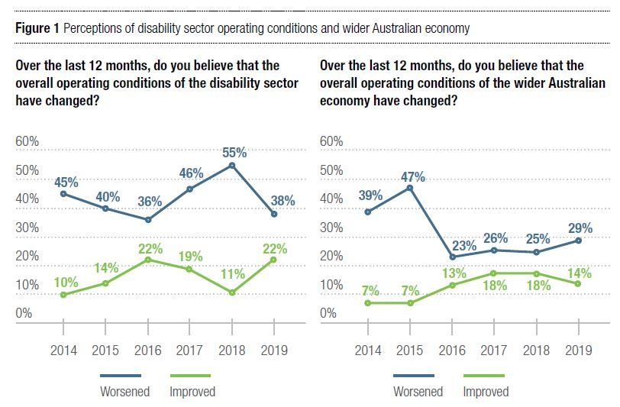

Flaws in Temporary Transformation Payment (TTP) implementation and pricing concerns
Half the respondents are worried that they won’t be able to provide NDIS services at current prices: 52 per cent answered this way in 2019, compared to 58 per cent in 2018.
Longer-established organisations were significantly more likely to indicate that they are concerned about the NDIS pricing structure: 58 per cent of them agree with the statement, compared to 37 per cent of organisations established after 2015.
Provider comments consistently reflect the interlinked administrative and service delivery costs that are not necessarily reflected in the NDIS pricing structure:
“The uncertainty about future pricing policies is causing us to reconsider whether we continue to provide core supports. Any increases need to be reflected in participant plans. There is significant unbillable time involved in providing core supports to participants and families with complex needs. The NDIS has fragmented service provision significantly making it difficult to provide [a] holistic approach to complex issues.”

Figure 2: NDIS operating environment
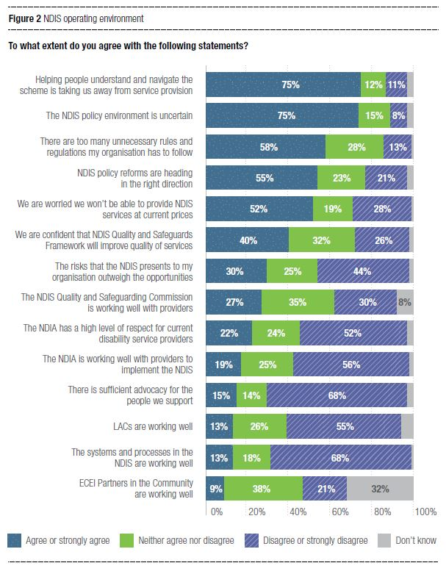
Provider views on their ability to offer NDIS services at ‘current’ prices have been impacted by uncertainty about the Temporary Transformation Payment (TTP).
The TTP is a conditional loading intended to allow providers of attendant care and community and centre-based activities to have access to a higher support price limit in order to assist providers with costs associated with transitioning to the NDIS.
After months of uncertainty, an early-October announcement clarifying how the TTP would be applied saw provider views on their ‘ability to provide services at current prices’ deteriorate significantly. In a follow-up survey—to which 381 organisations responded—76 per cent said they are worried they won’t be able to provide NDIS services at current prices, a considerably worse outlook than the 52 per cent that had agreed when responding to the same statement just one month earlier.

Figure 3: Follow-up TTP Survey
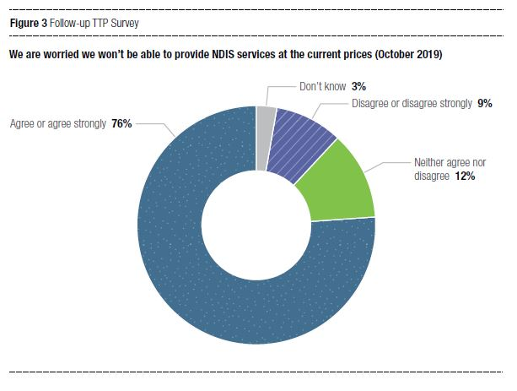

Pricing remains key in decisions about intentions to supply
In terms of future services, providers signalled their intention to supply more assistance with daily tasks or shared living, participation in community activities, and therapeutic supports over the next 12 months, compared to other service types (Figure 5).
In contrast, 19 per cent of plan management providers are planning to reduce or stop offering the service in the next 12 months. Other service types that providers are indicating they might stop or reduce include assistance with travel and transport arrangements (12 per cent), and life stage, transition and support assistance (10 per cent). Any restriction in transport is particularly concerning, given that this will make it harder for people with disability to access other supports.
Pricing appears to be a central concern for many providers when discussing whether they are considering cutting back on these services:
“NDIS pricing [is] not sustainable, providers are seriously considering exiting community based attendant care due to pricing not covering costs. This forces providers to run and operate [en] masse to attempt to cover its costs. This significantly increases risk to participants and support staff due to providers’ lack of resources for training and development, supervision, staff meetings etc.”

Figure 4: Intentions to change service volume
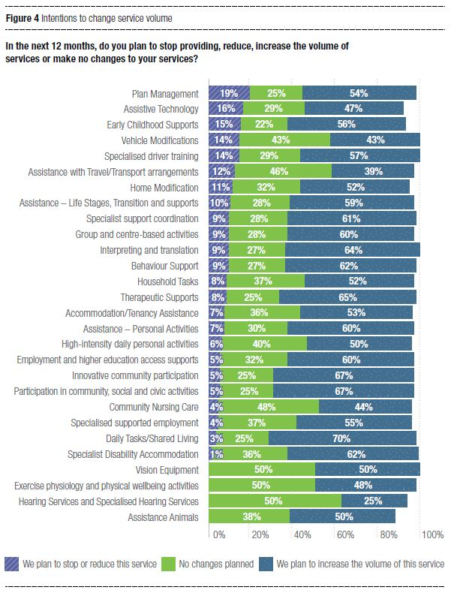
Organisational size is again a key characteristic influencing the intention to change service volume. For example, more very small and small organisations plan to increase plan management services, whereas more medium and large organisations plan to reduce, stop, or keep it the same (Figure 5). Demand for plan management from NDIS participants remains strong and is growing, providing opportunities for small accounting and financial brokerage organisations. Larger organisations, however, may be experiencing challenges in their attempts to accommodate the administrative burden of plan management, and are instead choosing to focus on delivering their other services.

Figure 5: Intentions to change service volume: Plan management
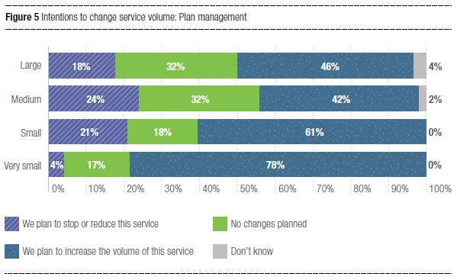

Organisational size classified by annual income
Very small* – Less than $1M
Small – Less than $5M
Medium – Less than $20M
Large – More than $20M
*These results could reflect a high proportion of sole traders.

Capacity constraints to consumer choice continue to emerge, but results should be interpreted cautiously. Only a few providers (nine per cent) say they plan to introduce any new NDIS-funded services in the next 12 months. Similarly, three quarters (76 per cent) of providers have received requests for services in the past 12 months that they were not able to provide, a significant increase compared to 2018 (69 per cent).
Providers may be receiving requests for services that they cannot provide either because they are at capacity or they do not provide the services required. In either case, the experience of NDIS participants is of constrained choice—that service providers they approach either do not offer or do not have capacity to provide services, or are turning away participants for other reasons (e.g., adverse selection of complex cases that carry high administrative costs, or servicing regional and remote areas). As one provider noted:
“The operating environment after five years of the NDIA remains immature. In rural areas the lack of options for people driven by the thin market is critical. Large metropolitan and regional city providers are not travelling to rural areas to provide services as they will not bear the travel costs.”

The sector’s relationship with government
A complex picture of sector-government relations is emerging, reflecting that providers must increasingly deal with multiple government agencies in relation to payments, the regulation of quality and safeguards, and funding streams.
Organisations operating in the NDIS and established after 2015 are more likely to agree that NDIS policy reforms are heading in the right direction (60 per cent), compared to organisations established prior to 2015 (55 per cent). Concerns about ‘unnecessary’ rules and regulations (which are not specific to any government agency) remain consistent: 58 per cent of all organisations agree there are too many, while 13 per cent disagree.
Administrative burdens of NDIS systems and processes still frustrate providers, with 75 per cent agreeing that helping clients understand and navigate the NDIS is taking them away from service provision (Figure 2). Significantly more organisations established prior to 2015 said this was the case (78 per cent), compared to 65 per cent of organisations established from 2015 onwards.
Overall, 22 per cent of organisations agree that the NDIA has a high level of respect for disability service providers, up from 15 per cent in 2018 (Figure 2). More established organisations—i.e. those with a longer experience of NDIS systems and processes—are less likely to agree that the NDIA has a high level of respect (21 per cent) compared to more recently established organisations (29 per cent).
Provider relationships with the Quality and Safeguards Commission differ by location, reflecting the state-by-state NDIS roll out. In general, responses suggest that the Commission has made a good start in establishing itself as a contemporary regulator.
Providers operating in New South Wales and South Australia (the first states to come within the Commission’s jurisdiction) are more positive than others: 36 per cent agree that the Commission is working well with providers, compared to 21 per cent of providers in the Australian Capital Territory, Northern Territory, Queensland, Tasmania and Victoria, which transitioned in mid-2019 (Figure 6). Given the Commission is not yet operating in WA, a significant proportion of providers in that state were less sure of the Commission’s impact.
44 per cent of providers operating in New South Wales and South Australia are confident that the NDIS Quality and Safeguards Framework will improve the quality of services and outcomes, compared to 38 per cent of providers in the Australian Capital Territory, Northern Territory, Queensland, Tasmania and Victoria (Figure 6).
“The Quality and Safeguards framework is a very promising process that will ensure quality service provision for people with disability however there is very little margin in NDIS services that allows for the development and implementation of organisational policy, practice and standards to meet the framework. Providers have to fund this themselves. Assistance with social and community participation both 1:1 and in a group environment continues to impact on our overall viability.”

Figure 6: Quality and Safeguards Commission
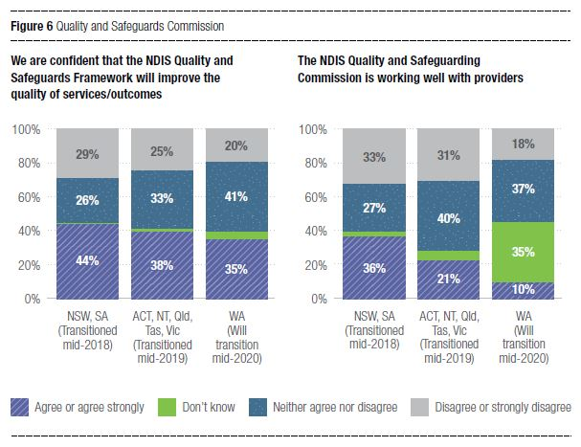
The 2019 survey introduced questions about provider interactions with Early Childhood Early Intervention (ECEI) partners and Local Area Coordinators (LACs). Providers were largely ambivalent or unaware of the impact of ECEI partners: 38 per cent said they neither agreed nor disagreed that ECEI partners in the community are working well, while 32 per cent said they didn’t know (Figure 2). This may be due to the fact that many providers have not interacted directly with ECEI partners.
Providers are critical, however, of Local Area Coordination. Only 13 per cent of survey respondents agree that the LACs are working well (Figure 2).
“It feels like NDIS staff as well as LACs send a message to clients to be wary of providers because we are all seeking to overcharge and rip off clients. I get this impression because clients will say things like “My LAC said to check all my bills really carefully”, and the attitude is evident with some support coordinators. It is highly disrespectful and demotivating, as we sometimes actually go unpaid for our services.”
Providers continue to invest substantial time and resources to support individuals to navigate the NDIS. Only 15 per cent of providers agree that there is sufficient advocacy available for their clients (Figure 2). 75 per cent of providers agree that helping people understand and navigate the Scheme was taking them away from service provision.
“A lot of participants are coming to us without advocacy and support coordination, meaning service providers are providing free services to ensure participants are supported fully in their transition.”
“The price changes, whilst heading in the right direction, went through a large change this year. This left participants relying heavily on providers to guide them through it. This soaked up time which would otherwise be spent on delivering services.”
In the employment space, only six per cent of organisations that provide supported employment services agree that the Government’s systems and processes impacting Australian Disability Enterprises (ADEs) are working well. Only 22 per cent of Disability Employment Services (DES) providers think the Government’s management of DES is working well.

NDIS systems and processes remain problematic
Most providers agree that the current NDIS policy environment remains uncertain, and only 13 per cent of providers agree that NDIS systems and processes are working well (Figure 2). This is a slight increase from the percentage of respondents that agreed with the statement in 2018.
However, in a significant change from 2018, the proportion of providers who feel that the risks in the operating environment outweigh the opportunities decreased to 30 per cent (from 38 per cent in 2018), while 44 per cent disagree or strongly disagree that the risks outweigh the opportunities (compared to 35 per cent in 2018). But a substantial 25 per cent still ‘neither agree nor disagree’, suggesting there is a consistent proportion of providers that remain unsure about the risks-to-opportunities balance. More established organisations (i.e. formed prior to 2015) are more likely to agree that the risks outweigh the opportunities than organisations formed since 2015. Recently established organisations are more likely to have designed their organisations with NDIS processes in mind, and are less likely to have experienced the many transition issues faced by more experienced organisations.

Organisation strategies focus on HR, workforce, and employee development
Depending on the size of organisations, there are significant differences in areas of focus depending on the size of organisations. Overall, many more organisations report actively focusing on improving their productivity, and having a clear three-year vision for their organisation (Table 1) than on other potential areas of focus in their organisational strategy.

Table 1: Overall organisational strategy
Organisation Strategy | 2018 | 2019
We are actively working on improving our productivity | 84% | 92%
We are considering getting out of the disability sector | 16% | 11%
We will stay in the disability sector but are not focused on growth | 26% | 25%
We are actively growing our organisation | 60% | 65%
We have a clear vision of where we will be three years from now | 54% | 61%
We are worried about our ability to adjust to changes resulting from changes in the policy environment | 58% | 53%

A smaller proportion of organisations report that they have considered leaving the sector in 2019 (11 per cent), compared to 2018 (16 per cent). Overall, this change was not significant, but in 2019, significantly more very small organisations said that they are considering leaving the sector (17 per cent). Similarly, there are differences depending on whether organisations are actively working on improving their productivity: 87 per cent of very small and 92 per cent of small organisations agree with this statement, compared to 98 per cent of medium and 99 per cent of large organisations.
Compared to very small organisations, small, medium and large organisations were more likely to report that they are actively growing their organisation. 17 per cent of respondents are sole providers, and as such are unlikely to be focused on growth. Finally, just over half (53 per cent) of organisations said they are worried about their ability to adjust to changes due to policy. Concerns about pricing and administrative burdens may be contributing to this uncertainty.

Workforce development and ICT need to improve
More organisations in 2019 report that they need to improve their HR strategy and workforce planning; Information, Communications and Technology (ICT); and employee learning and development. Quality and safeguards, risk management and compliance also feature as capability development priorities in the next 12 months (Table 2). Compared to the 2018 survey, fewer organisations say they need to improve their understanding and application of costing and pricing, as well as market research, strategies and planning.

Table 2: Business capability areas for improvement

In which of the following business capability areas does your organisation need to improve most in the next 12 months?
2016 | 1. Costing and pricing | 2. Information, communications and technology strategy | 3. Marketing practice
2017 | 1. Costing and pricing | 2. Marketing practice | 3. HR strategy and workforce planning
2018 | 1. Information, communications and technology strategy | 2. Costing and pricing | 3. HR strategy and workforce planning
2019 | 1. HR strategy and workforce planning | 2. Information, communications and technology strategy | 3. Employee learning and development

Larger organisations lead merger discussions, but picture of collaboration is mixed
Compared to 2018, fewer organisations are discussing mergers or organisation closure overall (Figure 7), but many more large organisations have either discussed or completed a merger with another service provider in the last 12 months (Figure 8). In contrast, smaller organisations were less likely to report having merger discussions. Instead, higher proportions of very small and small organisations report discussing winding up their organisations in the past 12 months.

Figure 7: Mergers and market exits
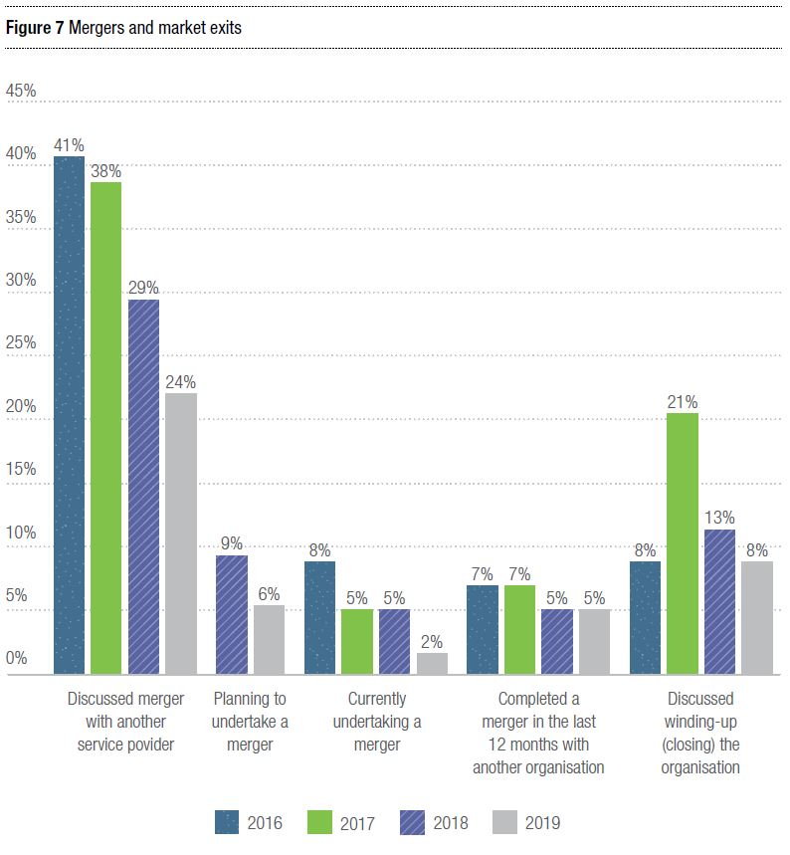

Figure 8: Mergers and organisation size
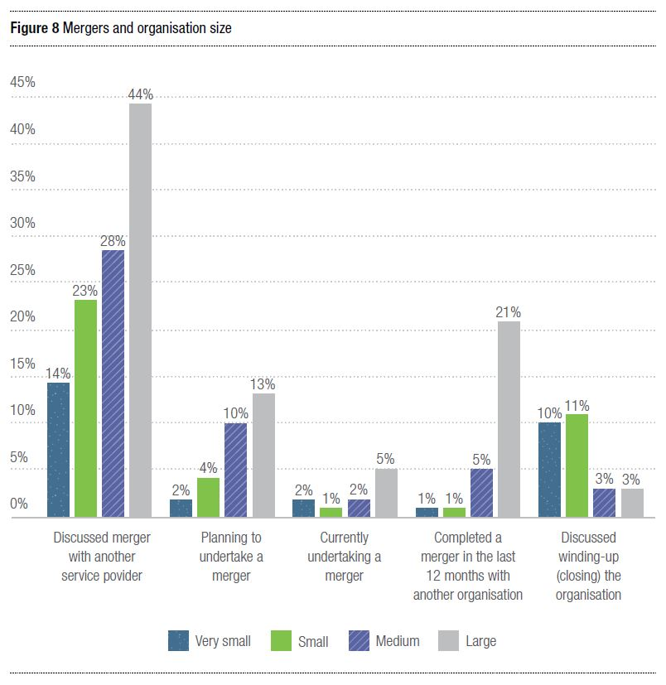
In a more competitive marketplace, monitoring collaborative activity offers insights into how the sector is working together. In 2019, fewer organisations were participating in agreements or MOUs with other organisations, and fewer were participating in group purchasing arrangements, resource-sharing, or outsourcing back office functions.
There were significant differences in collaboration across organisations depending on size. Collaboration appears to be less common in very small organisations: 17 per cent of very small organisations have agreements or MOUs with other organisations, compared to 69 per cent of large organisations. However, more very small organisations are outsourcing back office functions (27 per cent), compared to large organisations (14 per cent).

Figure 9: Partnerships
Does your organisation participate in partnership activities?
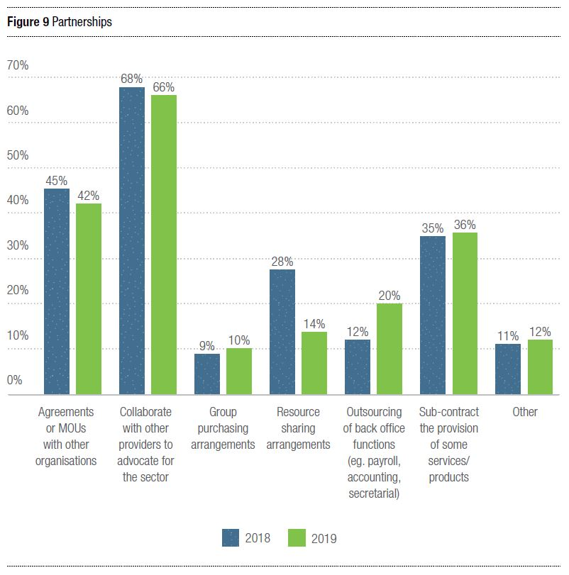
Some respondents indicate that collaboration appears to be increasing, particularly in the past 12 months.
“Organisations are more comfortable now to collaborate again than 12 months ago. Understanding the scheme better has given them the confidence to understand how you can collaborate in a commercially thinking sector.”
Others view collaboration largely as being restricted by the introduction of a competitive market for disability services.
“We realise that under the current system in the disability sector, it could be greatly beneficial for organisations like us to merge or collaborate with other small organisations to continue to be financially viable in this market. At the same time, we find that the collaboration and goodwill that existed in past, which benefited all participants, no longer exists due to the creation of a competitive marketplace.”

Financial sustainability remains fragile
Provider financial sustainability has remained consistent, though only 54 per cent of organisations report making a profit in the last financial year (Figure 10).

Figure 10: Financial sustainability
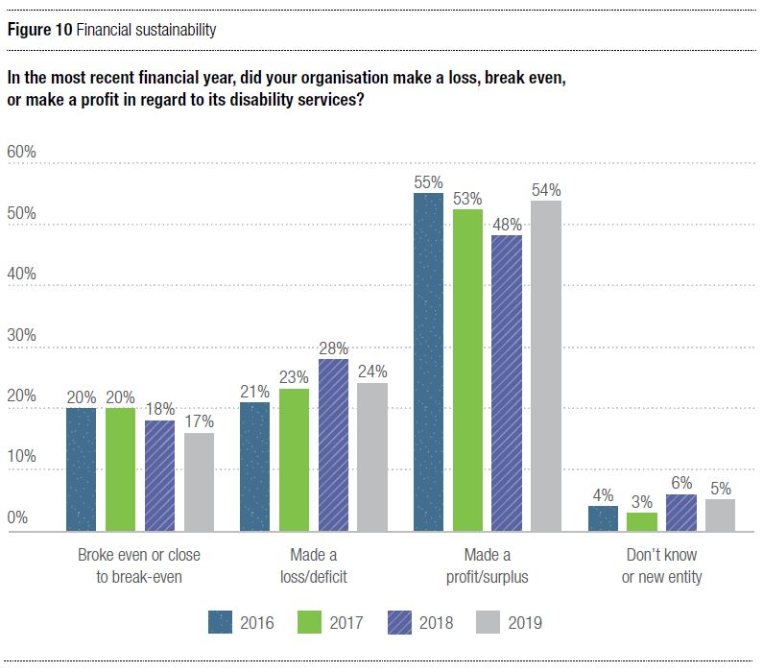

Just under half (49 per cent) of respondents reported profits exceeding a notional three per cent health CPI growth between 2018 and 2019 (ABS, 2019) (Figure 11).

Figure 11: Past year’s financial performance
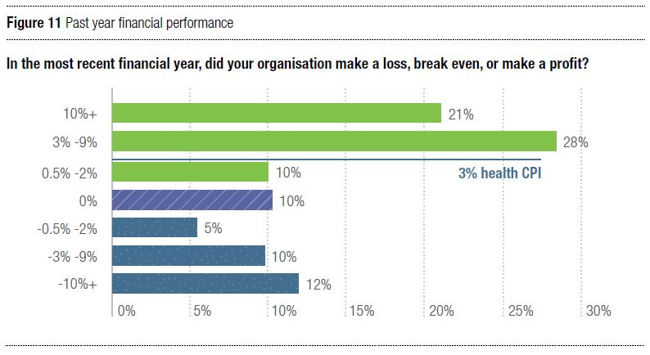
Looking forward, more than half of organisations (56 per cent) expected to make a profit in 2019/20, while only 13 per cent predicted a deficit, compared to 23 per cent in 2018 (Figure 12).

Figure 12: Expected performance in current financial year
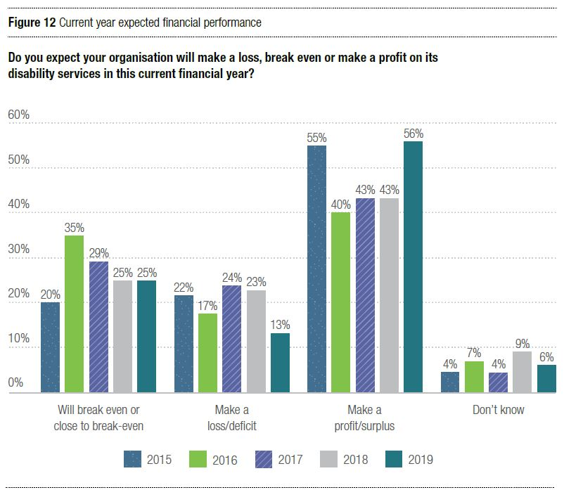

Research contact
For details about the survey data, please contact:
Associate Professor Gemma Carey
Centre for Social Impact, UNSW
gemma.carey@unsw.edu.au
Gordon Duff
General Manager – Sector Development and Research, NDS
gordon.duff@nds.org.au

The State of the NDIS
The expansion of the NDIS over the past year has placed intense pressure on disability service providers. As of the end of June 2019, about 300,000 participants were being supported by the NDIS, with almost a third of those receiving supports for the first time. This is generally good news for Australians with disability.

But we can do better. NDIS systems and processes need streamlining and redesigning to cope with the large volume of plans and payments the NDIS must process. The Minister for the NDIS, Stuart Robert, is focused on how to make this happen. The promised introduction of a Participant Service Guarantee will be a driver for this reform.

Improvements to pathways and the portal
Problems with the planning pathway have been the subject of discussion since the scheme began in 2013. Extensive work to improve the pathway has been progressively implemented over the past year, including the introduction of:

- Three pathways: the NDIS Participant Pathway, Complex Support Needs Pathway, and Early Childhood Early Intervention (ECEI) Pathway
- Two service streams: for psychosocial disability and hearing
- Service enhancements to meet the communication and engagement needs of people from different backgrounds, including people from Aboriginal and Torres Strait Islander communities and culturally and linguistically diverse (CALD) backgrounds, those living in remote and very remote communities, and LGBTIQA+ communities

While this important implementation work continues, the skills of planners continues to be a major factor in the quality of plans; the expertise of planners varies greatly. This highlights the need for strong induction, training and mentoring for all new planning recruits, rigorous quality assurance processes, and relatively stable workforces.

Improvements have been made to the portal, with more scheduled. It is anticipated that the recent changes to remove ‘plan gaps’ will reduce the number of payment problems experienced by providers.

Approvals of quotations for Supported Independent Living continue to be slow, resulting in unacceptable delays in payments for providers. A centralised team for approving these quotes has been established with the aim of speeding up approvals and achieving greater consistency between funding allocations. The effectiveness of this new team will need to be monitored over the coming year.

Pricing: Two steps forward, one step back
In July, disability service providers welcomed increases to the base prices for in-home support and community participation support, whether provided in a centre or in the community (one-to-one or in groups), as well as 4.5 per cent indexation.

On top of these increases, the NDIA introduced the Temporary Transformation Payment (TTP), set at 7.5 per cent this year, reducing by 1.5 per cent per year. It was stated that this payment was to provide additional funding to assist organisations to transform their business in order to operate in the more competitive NDIS market. Providers were encouraged to adopt these higher prices.

So participants were not disadvantaged, and plans already in existence were increased to accommodate the higher TTP-included prices, but this has not been done for new plans since 1 July. Providers can only charge the TTP-included prices if a participant agrees to forgo some hours of what has been determined as their ‘reasonable and necessary’ support needs.

NDS continues work to try to have this unfair decision by the NDIA overturned.

The annual pricing review did not increase the inadequate prices for participants with complex support needs. NDS is aware that some providers are not increasing the numbers of participants they support with complex support needs. We expect this will begin to become evident in unmet demand data.

In welcome developments, the loadings for remote and very remote supports were doubled, the cancellation policy was improved and therapy prices were increased.

The NDIA continues work to develop a pricing model for supported employment.

Market stewardship is lacking
Numerous entities—the NDIA, the NDIS Commission, the Department of Social Services (DSS), and state and territory governments—have interests and roles to play in market stewardship. Unfortunately, information on what these various interested parties are doing to monitor the market is scant (as well as information about what is being done to consolidate the information they do have).

Over the past year, DSS initiated a review into thin markets. This important work continues and will benefit providers when released. Providers need solid information to inform decisions on how they might grow and extend into new areas.

Unfortunately, there remains a paucity of information on the arrangements for the maintenance of critical supports across the country. These arrangements need to be finalised and information published.

Data on Specialist Disability Accommodation (SDA) is gradually improving and will be substantially boosted when participant demand is added. Existing information on SDA points to a worrying lack of interest in developing properties of a ‘robust build’, a problem highlighted by families and carers seeking housing for their children with challenging behaviours.

Over the coming year, a summary of market stewardship activities needs to be consolidated and published. Their effectiveness needs to be monitored.

Areas of weakness: Participant transport and provider travel
Unfortunately, there is little progress to report on how the NDIS responds to the needs of participants to move around their communities, or on reimbursements to providers for the cost of using vehicles to move between participants in order to provide them with supports.

Portal limitations continue to impede many participants wanting to use their core funding flexibly for transport, even if that is their wish. In addition, providers are struggling to justify maintaining vehicles to assist with participant transport as they often cannot recoup the costs of this support. If providers cease providing transport, many participants will struggle to participate in the community as they wish to.

With the exception of the NSW Government, state and territory governments are considering reducing (even removing) the access NDIS participants have to taxi subsidy schemes. NDS is resisting this trend, arguing that state and territory governments have an important role in providing transport for their citizens.

NDS is very disappointed that this year’s annual pricing review did not include a decision that would allow a provider to charge for the use of a vehicle to travel to provide support to a participant. This is a genuine and unavoidable cost of business which the NDIS needs to fund.

NDIS Commission is driving quality and safeguards
The NDIS Quality and Safeguards Commission now regulates providers and the quality of service provision in every jurisdiction except Western Australia (which comes under its coverage from July 2020).

In New South Wales and South Australia—which have been in the new system for over a year—significant numbers of providers have completed their certification audit. Their experience is giving some confidence to the sector that the process is generally a positive and productive one.

Services also report that their dealings with the NDIS Commission provider support functions are positive, and that the regulator is responsive—a point underlined by work the Commission is currently undertaking to review the Provider Registration Rules and reduce the regulatory burden on providers.

However, pressure points associated with the operation of the new system continue to emerge. NDS is actively engaged with the Commission to seek solutions to these challenges that include:
- the workload associated with reporting incidents and the use of restrictive practices resulting from poorly-designed data-gathering processes, compounded by limitations on the functionality of the Commission’s portal;
- uncertainty about the operation of new behaviour support arrangements; and
- continuing concern about the long-term costs associated with building and maintaining capabilities required by the NDIS Practice Standards.
All parties are committed to the value of a regulatory system that makes NDIS participants safer and strengthens the quality of the services they receive. NDS is working with the Commission on process improvements that ensure the Commission gets the information it needs while providers have reporting arrangements that are fit-for-purpose.

How NDS is taking action:
- Informing the NDIA about providers exiting parts of the market
- Participating in government committees and meetings and presenting arguments on the critical need for market stewardship
- Highlighting the growing problem of vacancies in Specialist Disability Accommodation and Supported Independent Living
- Providing a voice to providers on pricing and payment problems associated with social and community participation
- Highlighting planning problems to the Joint Standing Committee on the NDIS
- Advising the NDIA on how complexity should be defined and funded
- Urging state and territory governments to retain taxi subsidies for NDIS participants
- Providing priorities for portal enhancements to the NDIA
- Highlighting NDIS problems through the Federal Election campaign
- Assisting members to understand the requirements of the NDIS Commission by providing workshops, forums, webinars and other resources
- Raising concerns about inconsistencies and inadequate funding for worker travel and participant transport
- Operating the national NDS Helpdesk to respond to questions about the NDIS, quality and safeguards, and the Royal Commission
- Providing information to disability service providers through the national Essential Briefing series and other state-based activities

The State of the Broader Policy Environment

DSP recipients continue to exit workforce

The trend of declining numbers of Disability Support Pension (DSP) recipients continues. Over the 12-month period to 30 March 2019, the total number of DSP recipients decreased from 758,634 to 747,619.

Disappointingly, the number of DSP recipients reporting wage earnings also continues to decline. As of March, the number of DSP recipients reporting wage earnings was down by 1,100 (7.9 per cent) since June 2018.

NDS acknowledges that this ongoing decline could be arrested, in part, by the NDIA’s commitment to increasing the proportion of NDIS participants in employment to 30 per cent by 2023 (up from its current rate of 22 per cent). This initiative could be supplemented by extending the pensioner work bonus to DSP recipients. This would alleviate the effects of the DSP income test, which is a significant disincentive to DSP recipients working additional hours. It would also provide a significant boost to the income of those DSP recipients being paid a pro rata wage.

Review of disability strategies still underway

Slow progress on the review of the National Disability Strategy means there is little to report since this time last year. The current 10-year Strategy focuses on six areas: Inclusive and accessible communities; rights protection, justice and legislation; economic security; personal and community support (which includes the NDIS); learning and skills; and health and wellbeing.

Problems with the interface between the NDIS and the health system have been ameliorated by decisions of COAG’s Disability Reform Council (DRC). In June, the DRC agreed that a number of disability-related health supports are to be provided through the NDIS, and that governments will implement the Hospital Discharge Delay Action Plan to promote timely discharge of NDIS participants from public hospitals. The Minister for the NDIS has flagged his interest in resolving other problems associated with interfaces between the NDIS and mainstream services.

The review of the National Arts and Disability Strategy is also taking longer than expected. Consultations were held in the fourth quarter of 2018. Further consultation is scheduled for late 2019, with the new Strategy to be released in 2020.

National Disability Agreement in limbo

The review of the National Disability Agreement (NDA)—a high-level agreement that defines the roles and responsibilities of the Commonwealth and the states and territories in relation to disability services—was completed by the Productivity Commission in February.

Unsurprisingly, the Commission found the NDA no longer serves its purpose, has a weak influence on policy, and its performance targets show no progress in improving the wellbeing of people with disability. It recommended that a new agreement should promote cooperation, enhance accountability, and clarify responsibilities of governments.

NDS was pleased to see the recommendation that a new NDA set out a single, strengthened national performance reporting framework, with progress towards the outcomes of the new NDA publicly disseminated via a new National Disability Report, to be tabled in Parliament every two years. The Federal Government has not yet formally responded to the report.

How NDS is taking action:

Advising governments on interface issues between the NDIS and mainstream services, based on the experience of members

Providing policy submissions and evidence to national policy reviews

Extending our range of resources, such as Zero Tolerance, to help prevent violence, abuse, neglect and exploitation of people with disability

Advocating for governments to remain committed to continuity of support arrangements for people with disability who are ineligible for the NDIS

State of the Royal Commission

The Royal Commission into Violence, Abuse, Neglect and Exploitation of People with Disability is under way. With seven commissioners, a duration of at least three years, and over half a billion dollars in budget allocation, its significance cannot be overstated.

In opening the Commission at the first public sitting in September, Chair Ronald Sackville AO QC emphasised the magnitude of the Commission’s task and the breadth of inquiry. Since then, evidence has begun to be heard—and will continue to be heard in all states and territories. Providers have received letters expressing the Commission’s interest in information pertaining to complaints, reports and investigations of abuse in their organisations over the last seven years. The Commission is also interested to know what adjustments providers have made to improve their service provision as a result.

The Commission’s inquiries are expected to range from individual case studies to consideration of operations and governance. Disability service providers will be called upon to give evidence, and the Aged Care Royal Commission has provided some lessons already, for what may be expected. Speaking at NDS’s Essential Briefings across the country in 2019, legal and risk experts emphasised the significant powers royal commissions hold: they are inquisitorial in nature and commissioners have the ability to refer for prosecution. Providers were advised to have a plan, to attribute resources, to review past incidents, to review organisational culture, and to communicate early and well with staff and clients.

NDS supports the Royal Commission, and will continue our work to assist providers to improve their service provision, including through initiatives such as Zero Tolerance.

Through the Royal Commission, NDS will support our members to be informed and prepared. We have launched the Royal Commission Hub, where the suite of resources continues to grow. We continue to distribute regular Royal Commission newsletters and provide concise summaries of hearings as they unfold. We have held a number of webinars which have been well-attended. We have developed a panel of experts, from legal services to insurance and crisis management, whom members can engage at often discounted rates.

The next few years will not be easy for the sector. The Royal Commission will call on significant resources from providers, many of which are operating under difficult circumstances. However, there may be opportunity as well: to use the disruption to facilitate change; to reflect on service provision quality; and to invest in good systems, processes and governance which will support organisations into the future to deliver the best possible supports to people with disability.

How NDS is taking action:
- Assisting providers to remain abreast of information about the Royal Commission through the appointment of a senior policy officer
- Providing panels of organisations capable of assisting providers to engage with the Royal Commission (with legal advice, media management, insurance and risk management, and data management)
- Launching a Royal Commission Hub on the NDS website, regularly updated with the latest news and information

The State of Disability Employment

Employment rate remains static
The participation rate of people with disability in the workforce remains static—at 53 per cent. This is despite the commencement of the new Disability Employment Services (DES) contract, the continued transition of supported employment to the NDIS, and significant investment in the economic participation of people with disability through a number of Information Linkages and Capacity (ILC) grants.
As of 30 June 2019, 238,327 people with disability were on the DES caseload. Of this group, only 27.4 per cent were in post-placement support. While it is heartening to see the significant increase (approximately 30 per cent) of people now connected to DES, it is concerning that the number of individuals in sustainable employment has not increased accordingly.
Additionally, only 24 per cent of NDIS participants are in paid employment—a figure that has barely moved over the past few years. Consequently, the NDIA Board has set an aspirational employment target for participants of 30 per cent by 2022.

Continued efforts to increase employment participation under the NDIS
The NDIA launched its NDIS Participant Employment Taskforce in November 2018. The Taskforce is working to increase the focus on employment supports in plans to assist participants to find and retain employment, and to assist in creating employment-confident employers. An overarching strategy is anticipated to be announced in late 2019, looking to provide a continuum of employment support options that will enable greater individual choice.

Alongside this, the Agency is considering extension of School Leavers Employment Supports (SLES) beyond the current eligible cohort of school leavers, as well as recognition of the Customised Employment model as an employment support, especially the discovery process.

Wage-setting arrangements in supported employment remain unclear
The Fair Work Commission (FWC) Supported Employment Services (SES) Award Review is conducting further consultation with Award review parties following an approach to the Full Bench by DSS in September 2019.

DSS indicated in its correspondence to the FWC that the proposed NDIS pricing model for supported employment would likely result in increased funding for the support of people with disability accessing supported employment. DSS also noted that the proposed pricing may have implications for any SES Award review decision by the FWC that related to wage rates, classifications and wage assessment.

In response, the FWC requested that DSS lodge a submission concerning the funding changes and their possible consequences for the outcome of the Award Review proceedings. DSS lodged a submission on 22 October and the FWC held a report back hearing for the Award review parties the following day. The FWC requested that the Award review parties lodge a further round of submissions in response by 6 November.

NDS has consulted with its members through the National Committee on Supported Employment (NCSE) to anticipate the Full Bench’s possible decision in the SES Award review, including the mandating of the modified Supported Wage System as the sole wage assessment tool. At its meeting in March 2019, the NCSE articulated a formal position on the future of wage-setting in supported employment, designed to nullify controversy over wage rates.

NDS’s vision is that there be no pro rata wages paid in future and, consequently, no need for wage assessment tools. NDS will continue to advocate strongly that the Department of Social Services (DSS) fully fund the cost impact on supported employee wages.

In the 2018-19 Budget, the government announced it will provide $67 million over five years to support ADEs in transitioning to a new wage assessment model following the review of the SES Award by the FWC.

Pricing in supported employment still an issue, despite proposed funding model
After much anticipation, the NDIA released a proposed funding model for supported employment in October 2019, to be implemented in 2020. The pricing methodology will be tested and refined in consultation with NDS and the sector between now and March 2020.

Going forward, supported employment will be defined by intensive or frequent on-the-job support in a range of employment settings.

The proposed pricing’s design is intended to ensure employment is more easily incorporated into participant plans. Employment support will be moved into a participant's core budget, allowing more flexibility as to how it is used and reducing the need for participant plan reviews.

The price rates have been more closely aligned to those for community participation; they are based on hours worked by an NDIS participant and the employer's ratios of on-the-job support. The support ratios range from one-to-one support to one support worker for seven supported employees.

The prices will be subject to change through future NDIS annual price reviews. In the interim, participant functional capacity, relevant information collected during the planning process, hours of work sought and ratios of support will be taken into account when determining the participant price rate.

In the coming months, NDS will test the impact of any new funding model with its members to ensure that all aspects of the framework are workable; and that it can be practically applied without supported employee job losses, reduced hours, or jeopardising the ongoing financial viability of disability enterprises.

Year 1 of the new Disability Employment Services contract
With the commencement of the new Disability Employment Services contract on 1 July 2019, DSS offered business to 142 Disability Employment Service providers across Australia, with the number of sites increasing to 3,600.

The increase in competition has resulted in an overcrowded marketplace, with some Employment Service Areas having up to 20 providers competing for essentially the same number of vacancies. A number of services have been forced to novate their licenses either partially or in full. As a consequence, the number of providers has declined to 119.

There has been a significant increase in participants in the DES program. At the beginning of July 2018, there were 193,441 participants. By the end of June 2019, this number had jumped 23.2 per cent, to 238,327. The increase in outcomes has not kept pace with the increase in participants.

The Risk-Adjusted Funding Model has continued to impact on services, particularly those who specialise in developmental disability and autism cohorts. Funding is based on the likelihood of gaining employment, not on the significant upfront support required to prepare participants for employment or the need for ongoing support in the workplace.

Participants with an intellectual disability make up seven per cent of the total population, but only six per cent of 26-week outcomes. The Department of Social Services stated that it would recalibrate the funding mechanism from time to time, however NDS sees ample evidence that the model needs to be recalibrated now.

Additional compliance obligations have made it more difficult for providers to interact directly with participants. This, in part, explains the reduction of ongoing support claims. Since the start of the new contract, the number of people accessing ongoing support has dropped from 14,111 to 13,553. This is in spite of an increase in the total DES population. Providers are adamant that these compliance obligations misallocate their resources and the program’s funding, and reduce the amount of support that can be provided to ensure people with disability maintain their employment.

NDS is requesting that a review of the administrative burden and compliance obligations on service providers be undertaken at the same time as a recalibration of the Risk-Adjusted Funding Model.

How NDS is taking action:
- Assisting in development of the NDIA’s Employment Strategy through membership on the Independent Advisory Council to the NDIS
- Consulting regularly with the NDIS Employment Taskforce
- Developed a tool to assist organisations with their modelling of the impact of the supported employment pricing framework
- Assisting supported employers to prepare for the Royal Commission by meeting with supported employment providers to discuss the future of the sector, how it could best respond to the Royal Commission, and the development of a long-term sector strategy
- Provided an in-depth submission to DSS outlining the financial impact of Risk-Adjusted funding for certain cohorts
- Supporting young people with disability to access career development opportunities through our school-to-work program, Ticket to Work. An independent report commissioned by the program in 2019 found that Ticket to Work participants are much more likely to complete secondary school, be in further study post-school, and be more independent.

The State of the Workforce

The disability sector workforce has been growing more rapidly than at any time in its history, but still not quickly enough to meet the demands of an expanding sector.

Service providers report difficulties recruiting entry-level disability workers and sourcing and retaining allied health professionals. Some employers are describing an emerging ‘recruitment crisis’ and staff poaching is becoming an increasingly common practice.

The roll out of the NDIS has brought its own recruitment issues. Tight pricing has made it hard for employers to afford more qualified and experienced workers or factor in margins to allow for staff supervision and training.

The NDIS’s focus on choice and control for participants has been the great asset of the Scheme, and has allowed for people with disability to access supports more tailored to their individual needs. For support staff, this focus on more tailored supports has required more flexibility in work patterns and has increased casualisation of the workforce.

SCHADS Award Review presents challenges for workforce practices

After five years, matters in the Social, Community, Home Care and Disability Services (SCHADS) Award review in the FWC are coming to a head.

The FWC is considering a raft of contentious proposals for changes during the review of the Award, which covers the vast bulk of disability support workers. In consultation with its membership, NDS has advocated for sensible amendments to the Award that encourage best practice, align with NDIS pricing and slow the rate of casualisation of the workforce.

The Award review parties have had extensive discussions regarding various proposals to amend the Award. These include proposals that would affect arrangements for broken shifts, travel time, minimum engagements, remote response work, overtime for part-time employees, and phone allowances. There have been recent decisions on some similar issues in other modern awards which provide an indication of possible outcomes, but the FWC is considering submissions and evidence regarding the specific industry context.

Agreement on these matters for SCHADS has proven difficult to reach. Hearings by a Full Bench of the FWC resumed in mid-October 2019 with presentation of witness evidence with dates for closing submissions listed afterwards.

Broken shift and travel time changes will potentially have the greatest impact for NDS members, particularly those that provide individual supports in private residences. NDS agrees with the general principle that travel time should be payable where support workers are required to travel directly between clients, and acknowledges that broken shifts can be an onerous working arrangement for some employees. However, any safeguards for broken shifts need to be practical and allow flexible provision of services during the morning, midday and evening peak times when NDIS participants tend to seek support.

Following a round of hearings in April 2019, the Full Bench handed down a decision on some matters in September 2019. A particularly significant aspect of the decision is a new provision for the payment of casual loadings for casual employees working overtime on weekends and public holidays, in addition to the relevant penalty rates. This may present dilemmas for many employers. Following a decision on 18 October by the Full Bench, which took into account concerns expressed by employers regarding the initially-suggested two-stage implementation from 1 December 2019, the full 25 per cent loading will be introduced on 1 July 2020.

The NDIA may not adjust prices to reflect this additional salary cost, as the effect of the decision will be unevenly felt across the sector. The decision creates a clear price disincentive to using casual employees on weekends and public holidays, so providers with a more casualised workforce will likely incur higher wage costs.

We expect a number of further significant decisions on the SCHADS Award review in late 2019/early 2020.

Tracking workforce trends with Workforce Census
NDS tracks the changing structure and composition of the disability workforce using a number of risk indicators. Our Workforce Census reports remain the best and most accurate source of data concerning workforce risks emerging in the NDIS operating environment.
2019 data shows a continuing decline in the percentage of the workforce employed on a permanent basis, and a corresponding rise in the proportion of casual arrangements. At the same time, there is a widening gap between full-time permanent and part-time permanent work.
Taken together, the data shows that the rate of casualisation and replacement of full-time work with part-time work has been steadily increasing since data collection commenced in late 2015.
These trends remain problematic because we know from local and international experience that poorer outcomes result from discontinuity of care, and that a key driver of continuity is a stable, well-trained, properly remunerated and valued workforce. Turnover rates for casual staff remain consistently higher than other forms of engagement (Figure 15).
There are critical workforce shortages reported by employers in a number of occupational groups: psychologists, occupational therapists, speech therapists, and physiotherapists. These occupational groups are also significantly represented in the ‘hard to retain’ skillsets. (See Tables 2 and 3.)

Innovative Workforce Fund
The Innovative Workforce Fund was established by the Australian Government’s Department of Social Services to encourage the development and sharing of innovative workforce practices to support the roll out of the NDIS. In managing the Fund, NDS sought to showcase projects that engage, develop and utilise workforce in new ways to support people with disability under the NDIS. The IWF website is an evidence base containing case studies, tools, resources and contact details for the organisations leading workforce innovation. See https://workforce.nds.org.au/

How NDS is taking action:
- Contracted an external industrial relations expert to represent NDS and our members throughout the SCHADS Award review proceedings
- Collecting and analysing workforce data through the NDS Workforce Census survey
- Providing training programs and modules via NDS Learn and Develop
- Providing a one-stop-shop of disability workforce tools and resources on the NDS Workforce Hub
- Offering career advice and recruitment tools specifically for the disability sector via carecareers.com.au

Quotes from providers
- “Appropriately trained and experienced staff are not entering the sector due to pricing issues and increased casual employment.”
- “The challenge is not finding enough support workers, but rather that the quality of available workers is decreasing.”
- “The current pricing schedule does not allow for the time required for quality induction and ongoing supervision. This will continue to have an impact on retention.”
- “Being only able to offer casual hours employment and not consistent hours is difficult. Workers need to be reassured that they can rely on a certain number of hours work per week in order for them to make the commitment.”
- “With it now being a very casual employee environment, it is very difficult to recruit and retain staff. Not having the resources to offer even Permanent Part Time means the workforce is not secure. We cannot offer anything other than casual as there are no certainties with funding.”

Table 3:
In the last financial year (2018-19), how easy or difficult has it been to recruit competent staff in the following categories in relation to your disability services?
Occupation category | Percentage of respondents that answered "extremely or moderately difficult"
Psychologist | 84%
Occupational therapist | 83%
Speech therapist | 80%
Physiotherapist | 79%
Dietitian | 69%
Managers/supervisors of disability support worker | 64%
Disability support worker | 62%
LAC/Planner | 54%
Support Coordinator | 54%
Marketing/business development | 43%
HR/Workforce Development | 40%
Finance/Accounting | 32%
Information Technology | 32%

Table 4:
In the last financial year (2018-19), how easy or difficult has it been to retain competent staff in the following categories in relation to your disability services?
Occupation category | Percentage of respondents that answered "extremely or moderately difficult"
Speech therapist | 48%
Occupational therapist | 46%
Dietitian | 45%
Psychologist | 45%
Physiotherapist | 43%
LAC/Planner | 38%
Disability support worker | 34%
Support Coordinator | 30%
Manager/supervisor of disability support workers | 28%
Marketing/business development | 24%
HR/Workforce development | 22%
Information Technology | 18%
Finance/Accounting | 15%

Figure 13: Type of employment (%)
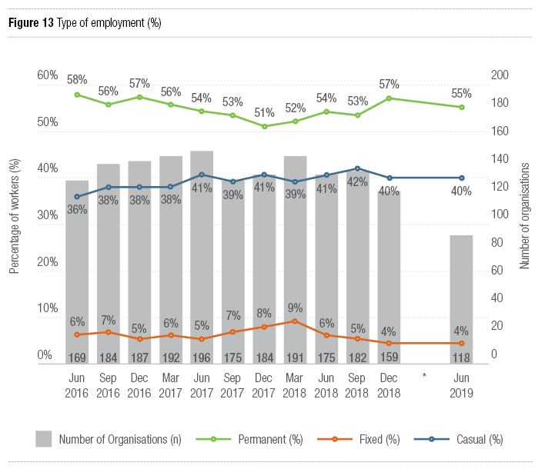
Commencing in June 2019, the NDS Workforce Census is now a bi-annual data collection. This may have impacted the number of organisations participating in the June 2019 collection.

Figure 14: Full-time permanent and part-time permanent work: Employment share
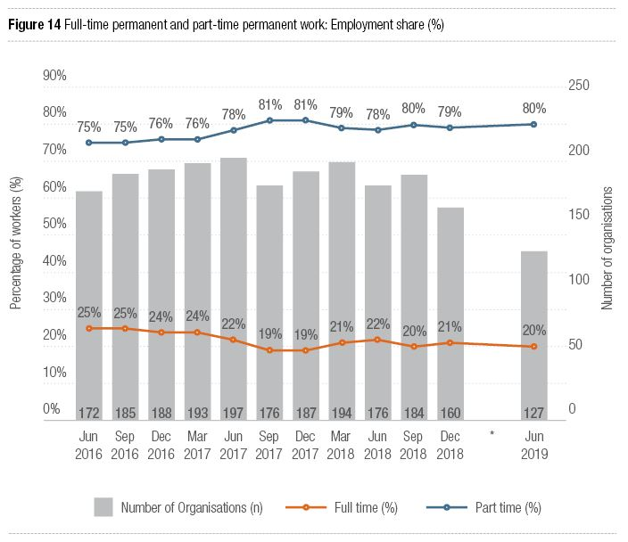

Figure 15: Quarterly turnover rates by forms of employment
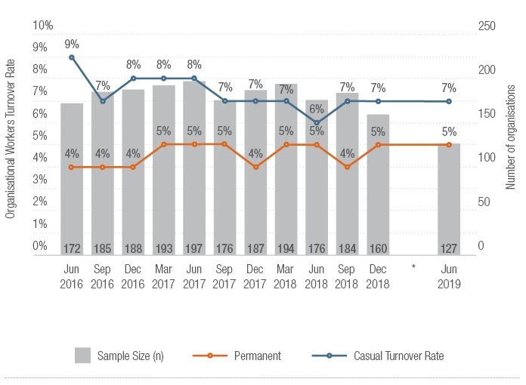

NDS Helpdesk continues to grow
A growing number of members are using the NDS Helpdesk to seek answers to questions associated with the NDIS and employment. Since it began, more than 1,000 questions have been posted and answered. The figure below shows Victorian members have been the most active on the site, followed by members in Queensland and New South Wales.
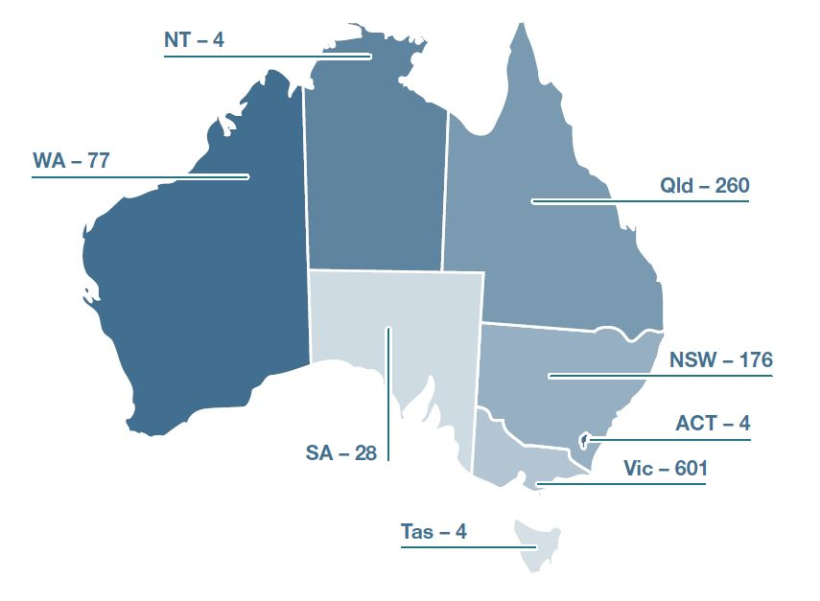
Over the two-month period from July to August 2019, 222 questions were posted and answered. Of these, 98 were in relation to the 2019–20 NDIS Price Guide, with providers seeking clarification on new pricing arrangements. The bulk of these pricing questions related to the Temporary Transformation Payment (TTP), changes to the cancellation policy, and provider travel.
Questions relating to quality and safeguards are growing in number over recent months, particularly questions about the NDIS Code of Conduct, Practice Standards and audit requirements.

State sections

Australian Capital Territory

- 7,786 NDIS plans approved
153% of bilateral estimate
- 4% NDIS participants are Indigenous
10% Culturally and linguistically diverse
- 1,643 registered disability service providers

Key Issues

NDIS interface management
Transitions at the interface between the NDIS and other service systems need to be better managed, including health, employment, housing and transport interfaces. In some areas, much-needed system changes are lagging behind. In others, planning has started too late, with required changes being rushed through at the last minute without proper consultation and consideration of the impact on disability service providers and the people they serve.

Inadequate investment in infrastructure
Investment in the capacity and availability of key sector infrastructure has lagged behind regulatory changes that assume such capacity exists in the small ACT sector. For example, the availability of specialists in positive behaviour support and quality auditors has not been ensured. Governments should publish statements on how transitions under proposed regulations will be managed, including investments to ensure required sector infrastructure is in place.

Adjusting to workforce changes
The ACT disability sector has experienced a noticeable increase in the size and diversity of its workforce, and ACT providers are adapting in order to make the most of this change. Additional resources to address remaining barriers for people from culturally and linguistically diverse backgrounds wishing to enter the disability workforce would assist the sector to grow and meet levels of participant demand under the NDIS.

ACT Case Study
Marija Gutesa
Sole Trader, New Leaf: Lifestyle Mapping

Tell us a bit about your organisation.
New Leaf: Lifestyle Mapping is a sole-trading support coordination business. I assist NDIS participants and their circles of support to work towards their NDIS goals. I recently moved into my second year of operation. I feel extremely humbled and proud to have gotten to this point. If you’d have asked me three years ago, I would have thought that was a wild dream!
What have the past 12 months been like for your business?
I am an eternal optimist. I have seen some really positive things in the past 12 months. I’ve noticed an element of growth on the part of NDIS representatives and Local Area Coordinators, which, although it is not as rapid as our folks need, provides me with hope. I’m seeing better NDIS plans being developed, growth in navigation of tricky subjects such as Specialist Disability Accommodation, and an increased understanding of terminology, processes and the ‘rules of the game’ from participants and their support circles.
I’ve also noticed that the most vulnerable of the vulnerable fall behind. As we go forward, we are leaving behind those without advocates, who share other marginalised identities.
But just as quickly as the NDIS matures, so do my business processes. I’m finding ways to make processes more efficient around the implementation of new plans and preparations for plan reviews. This excites me a lot! My clients blow my mind daily with their resilience and willingness to share their homes and speak about their lives for the purposes of talking the talk for the NDIS.
What has been your major challenge?
The chaotic, busy society we live in. Follow-ups are key, but I find myself getting frustrated sometimes about simple things, such as people not remembering to tell me they are not working on the day that I set a meeting for; and service providers not willing to admit failures or use a ‘lessons learned’ approach, or invest in their people. I sub-contract a number of my enabling services and invest deeply and sincerely in those relationships. This is non-billable time. However, the benefits of excellent engagement are invaluable. Our clients feel the effects of this too.
What has been the greatest lesson you’ve learned?
A high proportion of NDIS participants are living with an intellectual disability or autism, and my clients’ demographic is reflective of this. These amazing people have taught me the importance of slowing it down, planning for the future, and preparing for change. These valuable lessons present in my work life just as much as my personal life and have been invaluable to strengthening my relationships. I believe the percentage of people living with disability in Australia is around 30 per cent. It’s likely that everyone knows or is affected by this through living with, supporting or just knowing a person with disability. If we enhanced the lived experience of people with disability, it would benefit everyone. It bothers me that this is not recognised.
What has been your greatest achievement?
When I first started work in this area, I put together a strategic business plan. My vision was to raise the business’s profile as a best practice model in the support coordination industry. Although I’m not there yet, I have received numerous compliments and accolades from my clients, senior NDIS planners, advocacy representatives and peak bodies. This is backed up by the numerous referrals I receive through existing clients, providers and advocacy agencies. I do not put an inch of effort or resources into advertising… I’m very proud of that!
What is an outcome you have achieved for a service user that you have been proud of?
My work really is as a connector to other providers and services, so my achievements are based on the achievements of others. My clients have achieved amazing feats over the past two years: ceasing smoking and alcohol consumption; moving from squatting arrangements to having a home; obtaining much-needed equipment like wheelchairs; getting access to services for the first time like respite arrangements; and school holiday programs. Some of these achievements are fairly basic, but they are a reminder of how far we need to go. An area that I haven’t achieved in so far is employment. This disturbs me. It’s a wicked problem that is very detrimental to people’s quality of life and is a missed opportunity for society as a whole. We all need to do better here.
What are your goals for the next few years?
To get through the NDIS Commission process. I can’t afford to outsource it. Getting through that successfully will help me assess what’s going to happen after that. I don’t know how much longer I want to stay in this space. I really enjoy the work, but I’m tired. I’ve got too much on and I’ve been having to do a lot of hours. So I’m not taking on any new clients until the NDIS Commission process is done. There’s a huge level of uncertainty in this industry. I’ve heard about providers who are looking at deregistering because the process is too bureaucratic and expensive for them. I’m strategically waiting for other people to go through the NDIS Commission process so I can learn from them. Being a sole trader, I can’t rely on someone else: It’s all my responsibility! I’m trying to balance my clients’ needs with the NDIS Commission requirements.

New South Wales

- 104,854 NDIS plans approved
74% of bilateral estimate
- 6% NDIS participants are Indigenous
10% Culturally and linguistically diverse
- 9,106 registered disability service providers

Key Issues

Adapting to a new regulatory framework
In NSW, the new regulatory environment under the NDIS Commission and the new Ageing and Disability Commissioner have seen significant changes to how restrictive practices are managed and reported. Providers have been concerned that some participants that require positive behaviour support plans do not have sufficient funding to have these plans developed. The NSW Government has been consulting on what the restrictive practice authorisation process will look like post-2020.

Housing management issues
Providers report issues with managing vacancies in properties, which impact existing residents as well as sustainability for the provider. NSW Government leasing arrangements for properties they own have created additional issues. This has been compounded by delays in SDA being approved in participant plans and SIL quotes being assessed and confirmed. These vacancies are occurring in an environment where we know that there is inadequate housing for people with disability.

Role of NSW Government

The NSW Government needs to clarify its role in supporting NSW citizens with disability, whether they are eligible for the NDIS or not. This is particularly relevant given the withdrawal of the NSW Government from disability service provision and direct funding. The interface between the NDIS and mainstream services also continues to be problematic.

Case Study
Suzanne Becker
CEO, Lifestart

Can you tell us a bit about Lifestart?
Lifestart is a not-for-profit organisation supporting children and young people living with disability, their families and carers. The organisation was formed in 1996 by a small group of families whose children had been part of an early childhood intervention program at Macquarie University. Today we have a team of around 250, including 200 allied health professionals and educators.
What has the past year been like for Lifestart?
It has been wonderful to see so many people being assisted in our services and opportunities that the NDIS has offered them. We have supported around 2,100 clients in our general service delivery teams and 8,000 children and families in Early Childhood Early Intervention (ECEI). It is exciting to see the outcomes our teams are achieving working in Education NSW funded programs. These include programs connecting with families of children aged two to four years with developmental delay or disability who have not accessed pre-school or child care, and building the capacity of pre-school directors and educators to navigate the NDIS and ECEI.
Individual and community capacity building have featured strongly in our work. We have developed effective collaborations and relationships in community, and with government. This work helps break down barriers and increases access to opportunities for children and young people to be actively engaged in our broader community. We see this as important in moving away from a medical model of disability to a social model focusing on inclusion. This is essential to ensuring people with disability, who may not go on to receive a funded NDIS plan, will still receive inclusive mainstream services and supports.
We work hard, with passion and commitment, and aspire to deliver quality services. We have a strong and skilled board to provide oversight and guidance. This year, we completed our NDIS Quality and Safeguards quality audit with no non-conformances, which is a great achievement.
What has been your biggest challenge?
There have been a few challenges this year. We are experiencing a critical national shortage of allied health professionals, all the while competing in a sector with an increasing number of private practices. These practices do not necessarily go through the same valuable NDIS Quality and Safeguards audit process as we do.
Many students have experienced difficulty accessing disability supports during school hours, or an inclusive education of their families’ or carers’ choice. We have worked collaboratively with schools to improve learning opportunities for students, with some very positive outcomes. Although there are good examples where school communities are committed to including students with disability, this experience is not consistent. We are looking forward to seeing the implementation of the Education NSW Disability Strategy, which is committed to building a more inclusive education system.
We are seeing some great outcomes for participants in the NDIS, but there are aspects of the business model that do not work in specialist disability services. A fee-for-service and consumer-driven market are fine; however the current model is not taking into account the red tape and other requirements for running a not-for-profit organisation. There is sometimes an overwhelming amount of reporting on data, focusing on outputs rather than measurable outcomes. This is challenging for us when we are committed to strong evidence-based practice.
We continually look at innovative, effective ways to offer learning and development opportunities to our staff. Our Online Learning and Practice Hub, funded with a Department of Social Services Innovative Workforce grant, managed by NDS, has continued to be a great resource.
What is an outcome you have achieved with a client that you have been proud of?
The Belong INC program (funded by an Information, Linkages and Capacity Building grant) supports people aged 12 to 18 years to make choices, be connected and create opportunities related to their goals. After an on-air interview with the Belong INC team, Ivy Nehl, a producer with Radio Skid Row 88.9 FM, offered regular work experience and training for a young person with an interest in being on the radio. Adam, AKA ‘Adi G’, had experience as an MC and enjoys talking with others. Adam attended work experience sessions at the studio to learn the ropes about community radio, and went live to air in June, signing off with. “Thanks so much for tuning in everyone, it’s been a great experience.” After his debut, Ivy said, “We’re so proud of Adam for all the hard work he’s put in over the last few months. Adam’s show yesterday was amazing, and we loved his energy!” Adam now has a regular gig doing a sports report as part of the show.
What are your goals for the next few years?
We will keep working really hard to get things done. We want to see more co-operation between and across Commonwealth and state government jurisdictions so that people living with disability have easier, equitable access to the supports they need to participate meaningfully and inclusively in their community. We want to continue attracting committed and skilled people to work and stay in the sector, with pay representing the great work they do. We also want to ensure we can support recent graduates and students to provide them with the opportunity to develop a valued career pathway in the disability sector.

Northern Territory

- 2,453 NDIS plans approved
50% of bilateral estimate
- 52% NDIS participants are Indigenous
28% Culturally and linguistically diverse
- 848 registered disability service providers

Key Issues

Lack of housing
The NT sector has been struggling with a lack of accessible housing. There are a great number of people in continuing care wards with NDIS plans who can’t be supported due to housing shortages, and banks are not supporting disability organisations to acquire the capital to invest in purpose-built accommodation. Of 73 registered Supported Disability Accommodation (SDA) providers, only two are known as being active.

Remote service delivery challenges
Delivering the NDIS remotely is proving challenging for service providers, families and carers, and the NDIA in the NT. Plans are being underutilised in remote areas, and it is difficult to find service providers who can deliver supports in these locations. As well as this, there is a lack of connection to local Indigenous cultures from service providers. Thin markets is another challenging issue, and no provider of last resort has been allocated or implemented.

Ongoing NDIS transition issues

Major issues remain regarding the NDIS transition in NT. Since provider payments were centralised, providers are experiencing great financial burdens from being unable to withdraw funds. Support Coordinators need further training to fill gaps in knowledge and to address communication breakdowns with service providers. Concern also remains for people not receiving NDS plans due to lack of supports or funded programs.

Case Study
Stephanie Ransome
CEO, NT Friendship & Support (NTFS)
Can you tell us a bit about NT Friendship & Support?

NTFS is a not-for-profit organisation based in Katherine for 40 years and, more recently, Alice Springs. We offer services across the life span—from birth to older adults. Our programs include a culturally-responsive and ever-growing out-of-home care program and social supports for seniors. But we mostly provide services for people with disability. We have just opened an office in Alice Springs and in the past two years our staff numbers have grown from six to 23.

What has the past year been like for NTFS?

One of the reasons for our recent growth was opening EqualiTEA in Katherine. EqualiTEA is a social enterprise, using a cafe—providing training, employment, and activities. In the past year, we’ve also diversified and increased our services to meet the demand brought about by the NDIS. We use a ‘readiness’ framework for the people we work with at EqualiTEA. That means we work with a person to discuss and establish what their readiness for work is, and then find a program suitable for them. Unlike previous models, which try to fit a person with disability to a job, we’re passionate about fitting the job to the person. Our partnership with Katherine High School has also continued to grow as we’ve worked together to run a work experience and transition to employment program. The students who have taken part have blossomed, and it’s been amazing to see their confidence grow. The program has opened up their whole world!

What has been your major challenge?

Being able to plan in an ‘NDIS world’ and plan for the changes you don’t know are coming. As the NDIS moves forward, opening up choice and control for people with disability, the biggest challenge is to make sure we’re moving forward with it and understanding what’s involved. We’re lucky because we are a locally-based, organic organisation and we have been able to respond quickly to change. We’ve done this multiple times since the roll out—opening a purpose-built respite house to meet community needs, expanding our service provision catchment to include Alice Springs, listening to our community need for allied health services locally, and, more recently, with the opening of EqualiTEA.

What’s been the greatest lesson you’ve learned?

As an organisation, we’ve learned something each time there’s been a challenge, and we’ve been able to adapt accordingly. Our ability to be agile in this environment has also allowed us to grow. Organisations and providers are taking on more risk with the NDIS roll out, so we’ve learned to embrace this and take a leap of faith from time to time.

What has been your greatest achievement?

EqualiTEA, and being able to provide appropriate employment choices for people with disability in Katherine. Before EqualiTEA, there were no real employment choices in Katherine for people with disability. We’ve only been operating in Katherine for 10 months, and the support from the community and travellers has been amazing. We employee nine people with disability, a cafe supervisor, three casual workers, and we have some school trainees about to start. It’s a lovely atmosphere. We encourage all our patrons to give feedback so we can continually improve and have training opportunities for both our supported and open employees.
Given the broad demographics our programs cover, it’s no surprise that the same is true for EqualiTEA. As well as being a space for people with disability, we’ve found it is now a space for First Nations people and disengaged younger people to seek meaningful employment. We bake everything fresh each day, and everyone contributes and works to their strengths. Our first supported employee has transitioned to working three days a week, and makes the most amazing scones!

What is an outcome you have achieved with a client that you have been proud of?

One outcome in particular comes to mind, which came about because we support our clients to explore their employment opportunities. If a job they take on doesn’t suit their skills, interests or personality, we make efforts to match their skills to other opportunities more suited to them. One person in particular accepted the challenge of a different role and has gone from strength to strength. It’s fantastic to see the change in this person and how their confidence has continued to grow. We’ve been especially proud that they have immersed themselves in the office culture, improved their communication skills, and are now so cheeky and playful.

What are your goals for the next few years?

We’re going to open a new EqualiTEA in Alice Springs. This one will be different—not a cafe—but we will still be providing fully inclusive employment opportunities for people with disability and still have a focus on high-quality services. We’re looking at ways we can expand EqualiTEA and continue to respond to community needs. We’re looking at ways we can expand EqualiTEA and continue to respond to community needs.

Queensland

- 52,249 NDIS plans approved
57% of bilateral estimate
- 8% NDIS participants are Indigenous
5% Culturally and linguistically diverse
- 5,964 registered disability service providers

Key Issues

Large proportion of participants yet to register
The NDIS June 2019 Quarterly Report noted that over 52,000 Queenslanders have been supported by the NDIS in Queensland—only 57 per cent of those anticipated. Early roll out regions have demonstrated that the anticipated numbers can be achieved.

Regional and remote delivery remains challenging
Queensland’s geographic scale, dispersed population and cultural demographic means regional, remote and very remote service delivery remains challenging. Recent price increases and the correction of anomalies in location classifications are anticipated to encourage improved service delivery options. Thin markets, which can be caused by geographic location, cultural background and support service type, will continue to be of concern for the foreseeable future.

Difficulty recruiting for a rapidly growing sector

The disability service support sector is expanding rapidly. With the number of people receiving disability services in Queensland now exceeding those supported under the previous state services, providers are experiencing difficulty in recruiting staff across all service types and operational roles. The influx of additional people anticipated to join the Scheme (approximately 40,000) will only see this difficulty continue.

Case Study
Jess Lane
Innovations Manager, Community Lifestyles Agency
Can you tell us a bit about your organisation?

Community Lifestyles Agency (CLA) is a not-for-profit, non-government organisation started by families, for families. We’ve been servicing the Fraser Coast community for nearly 30 years. Being a small organisation, we’re aware of our limitations and like to focus on core, family-based values. Our staff come from diverse backgrounds and this mix of experiences supports our innovation. Some staff have had careers in mining, hospitality, defence and law. The roll out of the NDIS has led to a period of growth and we knew we needed to get innovative with our recruitment! We came up with ‘pop-up’ interviews; which were group interviews that took place in a park or in a cafe or hall. These were really successful.

What have the past 12 months or so been like for Community Lifestyles Agency?
The past year has been a whirlwind! Generally speaking, the NDIS has made a dramatic difference for the people we are blessed to support, with fantastic outcomes in their quality of life. Participants who actively engaged in pre-planning have had incredible, significant outcomes.
To get ready for the NDIS, we started business planning and education early. Even with this preparation, we didn’t fully anticipate the workload and now the implementation of the NDIS Quality and Safeguards Commission has got us on our toes again! The upside is, the NDIS Commission has an important function to respond to and keep vulnerable people safe, so we are grateful it is in the forefront of everyone’s minds.

What has been your major challenge?
Working with the community to prepare them for the NDIS roll out. We’ve done a fair bit of work with the Chamber of Commerce, small business and the Fraser Coast Regional Council. We worked with a dance school to expand the classes and widen their offering. We’ve spoken with small businesses about their opportunities and how they can work alongside the NDIS. Can they provide a mobile service? Can they provide a sensory, autism-friendly service? Last year, we went to our local theatre and spoke with them about being able to communicate using sign. We taught all of their volunteers some basic Auslan in case of an emergency. It’s fantastic to see the community embracing change!
One of the best community stories is our local Mighty LionHearts Lions Club, an initiative started by CLA which is the first of its kind. The Club is governed entirely by people with disability. We use this model to engage the community in conversations about business opportunities.

What’s been the greatest lesson you’ve learned?
No one can afford to stop researching and being curious. What was described as best practice 10 years ago isn’t the same today.
We have also learned to keep persevering. We know an amazing woman with cerebral palsy who really wanted to go skydiving. We approached a company, who initially said no, however we kept asking and eventually ‘no’ turned into ‘how?’ We worked with them to find a way and succeeded! They have picked up a further 10 clients since then. How’s that for return on investment?

What has been your greatest achievement?

I’m proud we were able to switch from a traditional NGO into a strong business model but still be tied to values. Our mission and purpose reflect our energy and intent—’Imagine Amazing Together’! We had some robust conversations about values as an organisation, especially about how we could operate in the new world without compromising. We consulted with the community as well, asking, ‘What do you want from us?’ That’s the reason we opened up services in Hervey Bay—the community told us we were needed there.

What is something you’ve done this year that you’ve been proud of?

A huge highlight for me was being able to take a crew on the Rally for a Cause—Dunga Derby! The Dunga Derby is a four-day car rally which is great fun, going from coast to country each year. Funds raised go to the Rally for a Cause Charity which supports families and individuals affected by life-limiting medical conditions or who have had their lives disrupted by circumstances beyond their control. Dunga Derby and Rally for a Cause were super inclusive and considerate. All our car rally peers and partners were great fun to hang out with and, more than anything, we went places that we have never been before and made new friends we may not have ever met otherwise. The Car Rally pushed us all way out of our comfort zone and had us doing things we would never have imagined doing.

What are your goals for the next few years?
The first goal would be to not slow up on the innovation. We’re speaking with other sectors and businesses about partnerships and collaborations and how we can best serve our community. Our second goal would be to do a regional push on governance opportunities for people with disability using the Lions Club model. This Lions Club group have been doing some great things. Working with a soup kitchen, they realised that the organisation was having to spend money on bread, so they decided to take on making the bread so the funds could be freed up for ingredients to make more nutritious soup!
In achieving our goals, it’s important to us to not lose touch of our values. We wouldn’t be who we are without them.

South Australia
- 29,034 NDIS plans approved
90% of bilateral estimate
- 5% NDIS participants are Indigenous
7% Culturally and linguistically diverse
- 6,115 registered disability service providers

Key Issues

Underutilisation of funding in NDIS plans
On average, South Australians are only spending 60 cents or less for every dollar they are allocated in their plans. In some areas, it is much less. There is some concern that people may not be using all of their funding because they are having trouble locating or connecting to supports, or the supports simply don’t exist in their region.

In-kind supports affecting the marketplace
NDIS supports provided as in-kind continue to impact on the wider disability marketplace, with Government-funded services not only crowding out other providers, but causing funding portability issues for participants who want to exercise greater choice and control in how they live their lives. While the South Australian government has indicated that it intends to exit from direct disability service delivery, there is no firm plan in place and it is still one of the largest providers in the state.

Attracting the right workforce
Attracting the right workforce continues to be an issue for many organisations and is contributing to thin markets across South Australia. The NDIS has seen an increased demand for support workers, and not everyone is suitable for this work. This is emerging as a major impediment to the NDIS reaching its full potential in the state, with many organisations scrambling to fill shifts when there is an unexpected absence or request for support.

Case Study
Jenny Karavolos
CEO, Autism SA

Tell us a bit about your organisation.

Autism SA is both a peak body and service provider for individuals on the autism spectrum and their families. We provide expertise, understanding, services and training to individuals, parents, professionals and agencies.

What have the past 12 months been like?
The past year has brought many opportunities, challenges and constant change. We have worked hard to continue our transformation program to thrive in a sector that is adapting to operate in the NDIS landscape. People with autism are the largest cohort in the Scheme. We have been successful with a number of ILC [Information, Linkages and Capacity Building] grants, which enables us to build inclusion and participation for our community.
On the flip side, with the NDIS still evolving, the rules are constantly changing for providers and participants. It’s not a mature market, and that creates challenges for us. One of the biggest challenges is timeliness—in terms of participants getting their plans on time, getting the right plan, and going through reviews on time. This has a cascading effect. It’s difficult to be effective when things are stopping and starting. It’s also hard to plan your investment when rules are changing, prices are changing, and plans aren’t coming through in a timely way.

What has been your major challenge?
The NDIA is very transactional. As a result, it’s administratively heavy. There is also a lot to be done to support the effective operation of the Scheme with gaps, reviews, and educating participants to navigate the Scheme. And while we support change, there have been a lot of changes driven externally at the same time: Quality and safeguards; ILC grant releases; state government block grants to support non-individualised supports being removed... and, at the same time, we are focusing on providing the best supports for our clients and community.
I come from a commercial sector, and I am finding we need to be more proactive and agile in this sector very quickly. As a result, you are constantly reacting to things. It is all about our participants at the end of the day, but we have a commitment to our community to ensure we are sustainable, so we can continue to best support them.
South Australia has also had differences to the other states, such as being the last to have the ECEI gateway rolled out; and also being the first to go through Quality and Safeguards audits… This has been challenging.

What’s been the greatest lesson you’ve learned?
We need to run our own race, with a focus on remembering why we exist. The passion behind the organisation is powerful, and it has enabled us to slay the challenges before us and make the most of opportunities to support the people who need it most: our community.
The other big lesson is to set your foundations by getting your processes, culture and systems right. Be prepared for constant change, because this is the one thing that is certain. You can plan for growth, but you are not completely in control of your own growth as it is not a free market. You have to be agile enough to react to the changes while the sector matures and evolves. If you think it’s a mature market and it’s not going to change, I’d say it will take about five years for things to settle.

What has been your greatest achievement?
Continuing to be sustainable and thrive, while improving what we are delivering for the community that we are here for. And at the same time, making the most of the opportunities. We have had a dual focus: service provision and meeting more of what participants want; but also inclusion and capacity building for our community and advocating as a strong voice, despite the challenges around us.
We are still giving back to the community despite the new environment that we’re working in. We have managed to reinvest in the business, our staff and the community. The feedback is that people love the inclusion that we’ve been creating in the sector through initiatives such as the Autism Friendly charter, so that people can live the life that they want to lead.
What are your goals for the next few years?
Our goals are to continue to thrive and expand our footprint so we can provide more of what people actually want: The types of services; the range across the lifespan; the quality of services; the accessibility. Our goals are not just meeting the needs of the community, but exceeding them.
In the next year, we have a plan to improve our Northern Hub and build our Southern Hub site; and we’re rolling out two further projects for the community under ILC grants that facilitates greater inclusion and capacity building. We’ve been actively developing and designing more groups, more individualised services, more of what our cohort is telling us that they want. We will also continue advocating and working at a systemic level to improve the sector as a whole, and we’re part of the Australian Autism Alliance and the Australian Advisory Board on Autism.
I really believe that the NDIS has the potential to be life-changing. It would be great if we could do more co-design with the NDIA, and learn the lessons together. We’d have greater capacity together, and get the outcomes from all stakeholders.

Tasmania
- 6,831 NDIS plans approved
65% of bilateral estimate
- 7% NDIS participants are Indigenous
3% Culturally and linguistically diverse
- 1,525 registered disability service providers

Key Issues

Travel challenges across the state
The transport and travel of people with disability remains a critical issue for Tasmania. There are limited options for public transport throughout the state; shortages of allied health professionals, which magnifies the inadequate NDIS travel allowances and funding for transport; capping of state taxi subsidies and no certainty of the extension of this vital program post-2021; and a lack of State Government support for fleet services operated by service providers.

Funding of community information and service organisations
The Tasmanian Government has greatly reduced funding arrangements for a number of specialised disability information organisations. All organisations are now being encouraged instead to apply for ILC funding through the NDIA. NDS believes that the State Government retains the responsibility to ensure these organisations are funded.

Housing crisis continues and centralised payment issues
The State Government has brought its commitment of $20 million forward in estimates, but this is still inadequate considering the needs of the sector. Another $15 million minimum over three years should be invested in disability housing. Reports of NDIS payment delays and errors continue to rise and the centralised payment centre is not meeting the needs of the sector. This must be addressed to ensure ongoing financial viability and security of the industry.

Case Study
Lynne Harwood
CEO, Mosaic

Can you tell us a bit about your organisation?
At Mosaic Support Services we live our Mission of enriching and improving the lives of people with a disability and their families by providing a suite of quality tailored programs. Until recently, we were only providing services in the south of Tasmania, but we have now recalibrated our strategy to become a whole-of-Tasmania provider. We will soon be opening a range of programs in the north of Tasmania.
Mosaic is in a great position for future growth, having weathered the storm after the NDIS roll out. We have redefined and transformed our thinking and have created a clear strategic intent. We have clarity as to what a sustainable and viable future looks like. Our focus is on our clients and providing excellent-quality services, and to provide career pathways and opportunities for our employees.
What have the past 12 months or so been like for the organisation?
I think the past year has been amazing. I’ve just completed my first year, both as the CEO of Mosaic and as a new Tasmanian. Prior to Mosaic, I was a successful Chief Executive Officer of four community organisations, across two states, over an 18-year period, and my professional passion is finding the ideal balance between the organisation’s ‘client purpose’ and effective ‘business acumen’ to ensure true sustainability and great client outcomes. It’s been wonderful to be welcomed in Tasmania and to take on the challenges of an organisation that needed a complete overhaul.
Mosaic’s transformation has been really positive and we are now set up very well for the future. I realised we needed a much greater understanding of the NDIS and how to work with it. To do that, we needed to stop thinking about how things used to be and embrace the change. We needed to take responsibility for what needed to happen to make the NDIS work in our organisation, we needed to stop playing victim and as one of my favourite sayings goes, “Be the change we wish to see.” We are definitely heading in the right direction now.
What has been your major challenge?
The transformation has felt like we were changing the wheels on a moving vehicle. Our main challenge was that change needed to happen quickly. The inverse of that was that we needed to prioritise the change and pace the change appropriately. Once we had clarity in our thinking and clarity of our vision and strategy, we were able to move forward in leaps and bounds.
What has been your greatest achievement?
I am a career CEO. I have had the privilege to be the CEO of five community organisations now. Each of these organisations has been quite different, yet each one has had so many of the same variables. I have applied strategic leadership to drive transformational change through each of them and I am really proud of the results.
I am very proud of transforming Mosaic from a struggling organisation to one which now has a solid foundation for future sustainability, scalability and quality—an organisation that places the client at the centre of everything we do and strives to be the best we can be. This has only been possible due to lots of hard work and dedication by many people. I am very proud of the team we have built here and their individual and collective contributions to the organisation’s achievements.
What are your goals for the next few years?
I’m committed to realising our vision to become an absolutely first-rate, reputable, whole-of-Tasmanian service provider. I want to ensure that we have a truly authentic quality model of service for clients; one that is recognised not just in Tasmania but the whole of Australia. In order to do this, I want to keep building on our excellent team of people who are leaders in their own right and who can bring the best versions of themselves to Mosaic every day.
Is there anything else you would like to add?
When I first came to Mosaic, I set about removing the blaming, finger-pointing culture that had become inherent with the organisation. There was a culture of resisting change and to blame the NDIS for everything. Once you remove this way of thinking and instil a culture of potential and possibilities, it changes everything. Once we took ownership and carriage of our destiny, change become much easier and great client outcomes are now what we focus on.

Victoria

79,089 NDIS plans approved

75% of bilateral estimate

2% NDIS participants are Indigenous

10% Culturally and linguistically diverse

7,202 registered disability service providers

Key Issues
Emerging gaps in disability information and community development
Victoria has long invested in information and community development. Much of the state funding for these activities now forms part of our contribution to the Information, Linkages and Capacity Building (ILC) funding in the NDIS. The ILC grants are for one to three years and are based on continual competitive grant processes. The grant periods do not adequately reflect the ongoing need for these services.

New demands for workforce
As the demand for services grows, there is an increased need for support workers; specific difficulties getting staff out of business hours; and a shortage of allied health professionals and psychologists. These issues are felt even more keenly in regional areas. The Victorian Government has supported NDS to run the Disability Workforce Innovation Project, whose staff operate across regional Victoria to collect data on areas of need, support innovation, assist providers to take advantage of grant opportunities and provide training.

Dual regulation issues

As the main funding of disability services moves from the State Government to Federal Government, there remain many levels of shared regulation. NDS is working with government and service providers to understand requirements, advocate to reduce duplication, and develop effective quality and safeguarding approaches.

Case Study
Kerry Nelson, CEO, and Louise Jellie, NDIS Manager
Mpower

Can you tell us a bit about Mpower?

Mpower is based in Warrnambool and provides services to the south-west region of Victoria. 70 per cent of our services are NDIS, and we also have some ongoing bulk-funded carer respite and integrated family services. We provide Early Childhood Early Intervention (ECEI) support for community participation and daily activities, and plan management functions as well as short term accommodation, some 1:1 services, group programs, and after-school programs for young people.

What have the past 12 months been like for the organisation?
We are now in our second year since transitioning to NDIS. The last six months have been better and our organisation is in recovery mode. Prior to that, it felt like never-ending change. We thought we were prepared for the NDIS: the three-year strategic plan leading up to roll out was dedicated to the transition. We hadn’t planned on the sheer numbers and continuous change, which meant it was quite daunting.
We are in a much better place now and we can start to look back, review and change things for the future. More importantly, the staff are feeling better because the change has slowed down. We are more used to the systems now and it’s getting easier to understand the rules so we can greatly improve our ability to pre-empt what the clients are looking for. Financially, we are in a good position too, which means we can breathe a little easier.

What has been your major challenge?
Our greatest challenge is getting through the workload generated by NDIS roll out. There have been new systems to learn and our service provisions are working to capacity at all times.
Staff in the Agency who were used to block funding, were learning a lot about how to equate value on your time. Billing was new and curious and changed often. Therapists in Early Childhood Early Intervention found it hard to bill beyond face-to-face. There were a lot of challenges with a change in the intent of what they do. Therapists in ECEI have spent their whole careers up to this point without billing, and it felt like the processes had changed the nature of their relationships with clients to transactional.

What’s been the greatest lesson you’ve learned?

To be prepared and flexible in an environment of change. We now look at challenges as opportunities and just try things. The NDIS was all new and no one knew how to get it moving, so we would give things a go, evaluate them and adapt if needed. Our staff were brilliant. We asked a lot of them, and during this process, they have built great resilience. We’re lucky to have an incredible team who pulled together at the hardest time and helped each other through.

What has been your greatest achievement?

Surviving! We got through the transition and I’m confident we are going to have a strong future. There have been some fantastic stories for clients who achieved great outcomes from the NDIS transition. These stories make the challenge feel like it’s all been worthwhile. We share the outcomes with our staff and board. Because of these stories, you know what’s possible, so when you hear the not-so-good stories you can go in to bat for participants that are still not getting what they need.

What is an outcome you have achieved for a client that you have been proud of?

There have been many great outcomes, and to stick to one person is difficult. Seeing a young person go from having no support services to attending programs and recreational activities in the community; a family having the first holiday away in many years; seeing parents move from feeling isolated to feeling included and supported; seeing skills develop with access to therapies that had not been possible in the past… We are proud that we have been able to be a part of their stories.

What are your goals for the next few years?
Definitely staff recruitment and retention, especially in the therapy programs. Disability support services are pulling on the same workforce as other programs, so our aim is to be seen as an employer of choice and be able to provide the services we’re proud of. We would like to attract more group therapists and add a new therapy tier, which means we’ll need to recruit specialists in the 7+ age range.
We see it as our responsibility to be a steward for our service system and put back into our community; to have strong services. Our regional and rural areas are working well in the community and we’ve been able to maintain good relationships with the other service providers.

Western Australia

- 16,520 NDIS plans approved
63% of bilateral estimate

- 6% NDIS participants are Indigenous
6% Culturally and linguistically diverse

- 1,141 registered disability service providers

Key Issues

Local decision-making and an adaptable hybrid pricing framework
The transition to the NDIS in WA is at a critical juncture. Operational scheme implementation decisions must be informed by local knowledge to suit local operating conditions, which vary immensely. NDS continues to advocate for the implementation of hybrid pricing that reflects the cost of supports for regional and remote areas. This approach would provide greater confidence in the NDIS pricing framework and build long-term sustainable supports for NDIS participants.

Implementation of WA Market Review recommendations
The NDIA has expressed an interest in continuing work with the WA Market Review Advisory Group to ensure its recommendations are implemented effectively, which is good news. This includes providing information about the volatility of the WA labour market and the impact of the resources sector on the cost and supply of labour in boom periods.

Emergency decision-making and market viability

Signs are emerging of serious market failure risks with the implementation of the NDIS in WA. These risks will increase over the next two years unless there is a stronger market stewardship approach to ensure the supply of services into the future. There is also an urgent need to establish a suitable structure to address emergency and crisis need.

Case Study
Kathy Hough
CEO, Far North Community Services

Tell us a bit about your organisation.

Far North is based in the Kimberley. We deliver a range of services from within the core support: capacity building, therapy, plan management and support coordination. The reason we’re here is because there’s a need for a locally-governed organisation, with staff that live and work in the region—not a drive-in drive-out service. In some of the areas we’re working, 100 per cent of the people we support are Aboriginal and Torres Strait Islander. It takes time to build trust and relationships in those communities, and it’s important that the people who are accessing services have a service provider that they trust and who they’ve built a relationship with over time.

What have the past 12 months been like for the organisation?

It’s been a really challenging year in that we rolled in to the WA NDIS and now we’ve almost finished transitioning into the nationally-administered Scheme. In the past year, we’ve not only had to manage that change, but we’ve experienced significant growth. We’ve moved into new areas: for example, establishing services in Halls Creek with an accessible house, office, and short-term accommodation. We’ve also started to offer new service types with plan management and support coordination. When we transferred into the nationally-administered NDIS, we were facing up to a 20 per cent price drop to continue delivering the same services, and this posed a serious financial risk for the organisation and the potential for market failure... It’s been one of the most challenging years I’ve ever experienced in over 30 years in the sector.

What has been your major challenge?

Initially, it was the decrease in price... A significant challenge has been the constant change and learning new systems for a group of participants and families and staff who were already change-weary, and the loss of relationships where people had had the same LC for many years in the state system. Another challenge has been managing growth and trying to build a workforce to maintain the growth whilst focusing on continuous improvement and quality. There were so many new people entering the Scheme in remote and very remote areas that, as an organisation, we made significant time and financial investments in establishing services in remote communities and in new areas. It was a lot of additional unpaid work and cost borne by Far North, and I think this is an area that needs consideration going forward.

What’s been the greatest lesson you’ve learned?

When the price dropped initially, we had a lot of anxiety about how we could continue to deliver the same services at a reduced price. We were cautious about bringing on additional roles to get us through the transition. However, the workload didn’t change, so that workload and pressure has just flowed to the people that are already here. We didn’t predict that we would get the level of growth that we did. In hindsight, I would have acted much earlier to bring more people on to the team to support us. We also thought we knew what the changes would be, in terms of how we operate, and the workload in various parts of the organisation, and changes to the roles. Going from funding in advance to payment in arrears, filling the gap of additional support for families as we don’t have LAC in remote and very remote areas, and changes to the majority of our systems was a far higher admin burden than we ever anticipated. I think if we’d better understood that, we would have made some different decisions.

What has been your greatest achievement?

We’re really proud of the work we did in ILC [Information, Linkages and Capacity Building] and to get people registered in the Scheme. We’re proud of our partnerships with Aboriginal communities and with the councils, to get services into remote communities. And I’m really proud of our team, who are dynamic people who have risen to the challenge and kept adapting. They’ve been resilient and have managed to stay together and work as a team. And also the people we’re supporting, who have had three years of change, and they’ve stuck by us. We’re proud of that as a team.

How has the NDIS changed things for Far North?

I think the principles of the NDIS are fantastic. The fact that more people are getting services is brilliant. But the processes of the NDIS have left lots of families distressed and dissatisfied… The other challenge has been that people have gone from having one LAC to having a planner, support coordinator, provider, a multitude of people involved in their lives. That’s been particularly challenging for people in remote areas. A huge challenge has been that small changes to plans require a plan review. It just creates stress for people and it’s an unnecessary admin burden.

What are your goals for the next few years?

For us, it’s to consolidate what we’re doing; to maintain a focus on quality and training; and to continue to grow and develop our therapy services. We want to make sure we continue to deliver the services here, and with a real focus on quality and putting the participants first. We want everyone in our organisation to understand that we work for the participants, and be across how our service responds to the challenges and opportunities of the NDIS, while being agile and flexible so we can continue to meet the needs of the participants. We want to grow the local workforce and provide the training. We’re really looking forward to working in one system going forward, and being able to do that well.

Back cover page

Publisher
National Disability Services

David Moody
Acting CEO
03 8341 4343
david.moody@nds.org.au
All rights reserved. No part of this publication may be reproduced, distributed or transmitted in any form without the prior written permission of the publisher. Except in the case of brief quotations embodied in critical reviews and certain other non-commercial uses permitted by copyright law.

About National Disability Services
National Disability Services is Australia’s peak body for non-government disability service organisations, representing 1000 service providers. Collectively, NDS members operate several thousand services for Australians with all types of disability.

Acknowledgements
The 2019 Annual Market Survey was carried out by the Centre for Social Impact at the University of New South Wales.
Associate Professor Gemma Carey
Research Director
Centre for Social Impact, UNSW
gemma.carey@unsw.edu.au
Dr Megan Weier
Research Fellow
Centre for Social Impact, UNSW
www.csi.edu.au
Thank you to our members who participated in our case studies.
Thank you to the many people who have agreed to allow photographs of themselves to be used in NDS publications.
This report was printed by a Disability Enterprise.

