State of the Disability Sector Report 2022
It’s been another stormy year for the disability sector.
Too few workers. Too much red tape.
Reform fatigue and fears about the economy.
But with optimism about the early direction of federal government reforms, there may just be some blue sky ahead.
Cover art
Kate Knight
Untitled
2021
Copic marker on paper
About the artist:
Untitled is part of Kate Knight’s most recent body of work whereby bright, multi-colour swatches of irregular shapes fill the plane. The interlocking imagery morphs continuously from organic leaf-like grid lines through to more geometric and obscure shapes, creating a myriad of powerful directional shifts within each piece. The changing pattern of shapes and colours and the intersecting angles and linework results in a mesmerising undulating optical effect.
Kate Knight has worked at the Arts Project Australia studio since 2008. She has been involved in numerous group exhibitions including at Spring 1883; Melbourne Art Fair; Gallery 101, Ontario; and C3 Gallery, Abbotsford. Her work is held in national and international private and corporate collections.

Contents
Contents 2
The state of play 9
The way forward 11
1. Listen to providers 11
2. Talk to providers 11
3. Don’t just talk 11
4. Keep reviewing the cost model 11
5. Focus on strategies that address the recruitment of workers across all roles in the sector 11
6. Help keep workers engaged 11
7. Focus on the things that matter to create safer services 12
8. Cut red tape 12
9. Put time and energy into trialling and testing different approaches to disability employment 12
10. Keep it simple 12
Northern Territory 13
Case study 13
Tell us about HPA 13
What’s been your proudest achievement? 13
Has the past year been more or less challenging than most? 13
What are the major challenges? 13
What are the major opportunities? 13
Why did you get into the sector? 14
What’s surprised you most? 14
What’s impressed you most? 14
NT sector stats 15
Top three issues 15
Workforce 15
Quality and safeguarding compliance 15
Quality support for First Nations people with disabilities 15
Australian Capital Territory 16
Case study 16
Tell us about Koomarri 16
What has been your proudest achievement? 16
What does an average day generally look like for you? 16
Has the past year been more or less challenging than most? 16
What are some of the major opportunities? 17
What are some of the major challenges? 17
Why did you get into the disability sector? 17
What’s surprised you most (about the sector)? 17
ACT sector stats 18
Top three issues 18
Pricing 18
Quality and safeguarding systems 18
Pressures on support coordination 18
The state of the operating environment 19
Continuing impact of COVID-19 19
NDIS operating environment 20
Confidence in the regulatory environment 25
Relationships with providers 29
Innovation, data and research 30
Organisations and growth 34
Operations and collaboration 36
Financial outlook is pessimistic 36
South Australia 39
Case study 39
Tell us about Kudos 39
What’s been your proudest achievement? 39
Has the past year been more or less challenging than most? 39
What are the major opportunities? 39
What are the major challenges? 40
Why did you get into the sector? 40
What’s surprised you most? 40
What’s impressed you most? 40
SA sector stats 41
Top three issues 41
Workforce 41
Transition 41
Provision of affordable quality housing 41
Queensland 42
Case study 42
Tell us about selectability 42
What’s been your proudest achievement? 42
Has the past year been more or less challenging than most? 42
What are the major opportunities? 42
What are the major challenges? 42
Why did you get into the sector? 43
What’s surprised you most? 43
What’s impressed you most? 43
Qld sector stats 44
Top three issues 44
Workforce 44
Worker screening 44
NDIA pricing 44
The state of the NDIS 45
State of NDIS policy 45
State of NDIS prices 45
State of NDIS regulation 46
The state of the Royal Commission 48
The state of the workforce 49
NDS Workforce Census 56
Employment types 57
Tasmania 62
Case study 62
Tell us about Enriched Care 62
What’s been your proudest achievement? 62
What does an average day look like? 62
Has the past year been more or less challenging than most? 62
What do you think are the major opportunities? 62
What do you think are the major challenges? 62
Why did you get into the sector? 63
What’s surprised you most? 63
What’s impressed you most? 63
Tas sector stats 64
Top three issues 64
Workforce 64
Housing 64
Reform fatigue 64
Western Australia 65
Case study 65
Tell us about PeopleKind Group 65
What has been your proudest achievement? 65
What does an average day look like for you? 65
Has the past year been more or less challenging than most? 65
What are some of the major opportunities? 65
What are some of the major challenges? 66
What’s impressed you most? 66
What’s surprised you most (about the sector)? 66
WA sector stats 67
Top three issues 67
Investing in the disability workforce 67
Housing 67
Administrative burden of the NDIS 67
The state of disability employment 68
Attitudes towards DES reforms 71
Supported employment operating environment 74
Employment sector update 75
The state of the broader policy environment 77
Number of DSP recipients increases following 2021 COVID restrictions 77
New workforce plan for the sector 77
National Disability Strategy sets ambitious agenda 77
New South Wales 79
Case study 79
Tell us about McCall Gardens 79
What’s been your proudest achievement? 79
What does an average day look like? 79
Has the past year been more or less challenging than most? 79
What are the major opportunities? 79
What are the major challenges? 80
Why did you get into the sector? 80
What’s surprised you most? 80
What’s impressed you most? 80
NSW sector stats 81
Top three issues 81
Workforce 81
Administrative burden 81
Financial viability 81
Victoria 82
Case study 82
Tell us about Melba 82
What has been your proudest achievement? 82
What does an average day look like? 82
Has the past year been more or less challenging than most? 82
What are some of the major opportunities? 83
What surprises you about the sector? 83
What’s impressed you most? 83
Why did you get into the disability sector? 83
Vic sector stats 84
Top three issues 84
Economic viability 84
Mental health and wellbeing 84
Onerous reporting 84

The state of play
An expert, they say, is someone who will know tomorrow why the prediction they made yesterday didn’t work out today.
This is a little unfair. But the world is not exactly short on confident pronouncements from columnists, economists, academics and think tanks that turn out to be quite off the mark.
We don’t think you’ll find many here. As NDS’s Annual Market Survey enters its ninth year, it’s pointing out just how remarkably prescient the people we talk to have, again and again, proved to be.
In last year’s survey, for example, precisely 45 per cent of disability providers predicted they would make a profit in 2021-22. This year, 46 per cent of providers have told that, yes, that’s just what they did.
Similarly, last year, 23 per cent of respondents expected to end 2021-22 with a loss – and, 12 months later, that’s exactly what happened.
The real experts, results like this suggest, are often the people on the ground, rather than the strategists watching from afar. Providers know this industry because they are this industry. When they talk, policy makers need to listen. This is a survey to take very seriously.
So, what have providers been saying this year? The 2021-22 survey contains six major takeaways – the first being a real and growing optimism about the new federal government’s NDIS reforms. Some 43 per cent of respondents believe that policy changes are heading in the right direction, compared to just 25 per cent last year.
That positivity is tempered, however, with a profound pessimism about the Australian economy. Sixty-seven per cent of respondents believe that conditions have worsened, and 36 per cent expect to make a loss in the coming year. Alarmingly few organisations plan to deliver new types of services in the year to come, even though many were unable to meet the demand for services over the course of the last 12 months, often due to a shortage of workers.
Takeaway number three is that workforce troubles continue: recruiting and retaining suitably qualified staff remains a major challenge. A skills shortage has become a full-blown labour shortage. Many report it’s now more difficult to find good support workers and finding allied health clinicians feels almost impossible. Corporate roles in IT and HR are also a challenge to fill.
On the regulatory front, more than 40 per cent of providers expressed concern about the Quality and Safeguarding Framework they’re expected to follow. Operating within current regulations clearly creates more administrative work. But is it actually helping to create safer outcomes?
The fifth takeaway involved Disability Employment Services: many are concerned about where they are headed. Some 48 per cent of DES providers do not believe that DES policy reforms are going in the right direction, while only four per cent take a positive view of the digital services model for job seekers that was rolled out in July.
Last but not least, this survey makes clear that, while the disability sector wants and needs more reform, it is also suffering from change fatigue. Far too many leaders have spent far too much time dealing with never-ending NDIS changes. And far too many disability workers feel exhausted by the challenge of constantly learning new systems and the complex administrative sagas that each tend to involve.
Here at NDS, we are cautiously optimistic that the year ahead will see great progress. The new federal government seems to be heading in the right direction.
But it will need to move in step with providers.
It will need to listen to the views of the experts.
And it will find them right here.

The way forward

Listen to providers
We encourage government to engage with providers and draw on their expertise to develop NDIS reforms and a new workforce strategy, focusing on where quick wins can be achieved.

Talk to providers
As reforms and improvements are identified, the sector will need support to implement them. This will require clear communication to participants and providers, appropriate timeframes and resourcing, and mitigation of any unintended consequences.

Don’t just talk
While providers welcome the potential of the NDIS Review to improve the Scheme and address interface issues, their support will ultimately rely on seeing these plans turn into action.

Keep reviewing the cost model
While the price increases announced in June 2022 were welcome, it was a catch-up payment. Economic conditions remain challenging. The cost model needs to be continually reviewed to reflect wage pressures and changes, including changes to the SES and SCHADS award, adequate training, and support and supervision needs.

Focus on strategies that address the recruitment of workers across all roles in the sector
Providers have given useful feedback about what improves their worker recruitment effort and where the greatest challenges lie.

Help keep workers engaged
More funding is needed for fit-for-purpose training, support and supervision, visible career pathways and leadership opportunities.

Focus on the things that matter to create safer services
Focus on quality and safeguarding measures that improve outcomes and share data that support providers to innovate and identify good practice.

Cut red tape
Reduce duplication of reporting between regulators, cut unnecessary red tape that reduces the effectiveness of services without improving standards, and take steps to address the uneven playing field between registered and unregistered providers.

Put time and energy into trialling and testing different approaches to disability employment
It’s still unclear which approaches are most effective and provide employment outcomes for people with disability. The sector needs investment in a transition process for supported employment that provides certainty around what is required of providers and a sustainable future for supported employees.

Keep it simple
The sector wants reform but is fatigued by change. Policy makers should ensure that solutions simplify the processes for providers, who have limited resources to engage with the review and contribute their practical expertise. Reforms will need to be progressively implemented to maintain momentum.

Northern Territory

Case study
Kerry Bosch
Helping People Achieve

Tell us about HPA
We provide employment opportunities to people with disabilities, as well as accommodation and community access services. And as part of our employment services, we run a couple of workshops which make metal and timber products.

What’s been your proudest achievement?
It’s really, really hard to pick one thing that you’re proud when every day you can come into work and see smiles on someone’s face. Just the number of people that we touch on a daily basis. That’s what makes me proud.

Has the past year been more or less challenging than most?
Obviously, the COVID situation has presented us with a few challenges. There was one instance there before Easter, where we kept having symptomatic people turn up at our day program who later turned out to be positive. We eventually had to close down a particular program for a week, just for the sake of a circuit-breaker.
It was a decision that we didn’t take lightly, as we definitely appreciate the importance of routines and the impact that it would have on other support mechanisms.

What are the major challenges?
The workforce is the main challenge for everyone at the moment, and I’m not just talking about the disability sector. It’s across the board.
The ever-evolving NDIS landscape is also presenting challenges. We’ve now been working within this new funding model for long enough that we’re starting to see the impact of the reforms and changes being implemented by the NDIS to their original model.

What are the major opportunities?
I see the change of government as an opportunity. Without wanting to make any sort of political statement, the NDIS was originally a Labor Party policy, and the new minister seems to be saying the right things. So, I’m feeling quite optimistic.

Why did you get into the sector?
Well, I worked in media and marketing roles for 20-odd years and my entire existence was basically getting up every day and making a shareholder rich. I had a bit of an epiphany a few years ago and decided that I wanted to get up out of bed every day and make a difference to someone’s life.

What’s surprised you most?
Just the passion and the work ethic of the people in the sector. There’s some very, very smart people out there who could probably go make more money elsewhere, but they continue to work in this sector because they see the smiles on people’s faces.
When you have a consumer-driven market, there are always going to be some slightly shady providers. But I’ve got to say that 99 per cent of the providers that I deal with are 100 per cent in it for the right reasons and simply want to give participants an opportunity to lead a fulfilling life.

What’s impressed you most?
The sense of unity is pretty remarkable. While we are nominally in a competitive market, we all work well together. When I took on this CEO’s role, I immediately started receiving phone calls from other CEOs within the sector, offering to catch up for coffee and just generally help me make the transition.

NT sector stats
5,079 Active participants including ECA
116 Active ECA participants
50.4 per cent NDIS participants are Indigenous
6.5 per cent Culturally and linguistically diverse

Top three issues

Workforce
Along with general shortage of people to fill roles across the industry, there is a shortage of people with the appropriate skill or experiences to hold specific roles to a high standard (e.g., behaviour support practitioners, management roles, support work for complex participants).

Quality and safeguarding compliance
Providers understand their registration is not protection against poor practice. However, they feel the level of compliance and oversight attributed to their work is not equally applied to an unregistered provider. This concern is amplified when unregistered providers offer higher risk supports, such as SIL and personal care). There is genuine concern about people being able to provide direct support to vulnerable people without a NDIS Worker Screening (or any other) check. As it stands, people with criminal histories can, and have, commenced direct support in an unregistered marketplace.

Quality support for First Nations people with disabilities
Registered providers are conscious of their responsibility to support people’s access to family, culture and country, and the need for well-trained staff to offer culturally sound support. But current NDIS planning and pricing does not consistently allow this.

Australian Capital Territory

Case study
Nadine Stephen
Koomarri

Tell us about Koomarri
Koomarri provides support to people with intellectual disability in the ACT and surrounding regions.
It was created in 1952 by two women in a backyard garage who fought for the rights of their sons with disability to receive an education and the opportunity to work. This year marks our 70th anniversary!

What has been your proudest achievement?
With the impending introduction of the NDIS in 2014, we embarked on a journey to transition Koomarri to a more contemporary and personalised service delivery model.
After significant research, investment and implementation, we have a successful customised employment model that is seeing long-term, personally meaningful and socially valued work for our service users.
I’m so proud that, after 70 years, Koomarri continues to adapt to market changes and trends while still successfully finding community-based jobs for people with disability.

What does an average day generally look like for you?
There is no such thing as an average day! Koomarri delivers supports to hundreds of people across multiple service lines and offerings. Therefore, my days are incredibly diverse, as I bounce between service users, family, staff, strategic, financial, regulatory, legislative, quality and compliance matters.

Has the past year been more or less challenging than most?
Quite honestly, the past few years have all been a bit of a blur. We have continued to operate within a flawed funding model, and during floods, fires, storms and a once-in-a-lifetime pandemic.
My focus over the past year has been on the mental health and wellbeing of the Koomarri family. Our service users, families and staff have all endured lengthy periods of uncertainty, isolation and change, so we have been making a concerted effort to take care of one another whilst taking care of day-to-day business.

What are some of the major opportunities?
I think there is a level of optimism and new energy with the change in government. There is a great opportunity for the sector to come together and provide practical solutions to the policy and process issues that have plagued the Agency.

What are some of the major challenges?
The combination of ongoing inadequate pricing, ever-changing NDIA policies, industrial requirements and increased (unfunded) regulatory work is placing significant pressure on organisations to remain viable.
The change in government is very welcome. However, many organisations do not have the luxury of time to ensure their long-term sustainability. We need some significant changes soon to prevent market failure.

Why did you get into the disability sector?
Disability has always been in, and a big part of, my life. When growing up, there was no such word as ‘can’t’ in my home and this translated into a strong desire to enable and empower people to be the best they could be in whatever they desired.

What’s surprised you most (about the sector)?
The resilience of our sector is extraordinary. I challenge you to find and name another industry or sector that could operate as well as we do under the adverse conditions that we have experienced. Name one!

ACT sector stats
9,518 Active participants including ECA
169 Active ECA participants
4.5 per cent NDIS participants are Indigenous
10.4 per cent Culturally and linguistically diverse

Top three issues

Pricing
Inadequate pricing remains a major concern. While the recent increase to the pricing of some support categories was very welcome, the underlying hourly rate still does not adequately reflect the large amount of administration required to operate under the Scheme. Inadequate NDIS prices pose a risk not only to individual disability service providers, but to the Scheme as a whole.

Quality and safeguarding systems
ACT providers are reporting significant increases in unfunded compliance costs. Providers are required to report separately to the NDIS Commission and the ACT Government, which results in a doubling of administrative costs. This problem is compounded by the lack of available behaviour support practitioners.

Pressures on support coordination
Several organisations in the ACT have ceased support coordination services in recent times, and many more are considering it. Support coordination is a critical component of the Scheme, especially for people with high and complex needs, but many support coordinators simply do not have the capacity to complete the work that is expected of them, and express concerns around mental health and wellbeing.

The state of the operating environment
The 2022 NDS Annual Market Survey was conducted by the Centre for Disability Research and Policy at the University of Sydney. As NDS’s Annual Market Survey enters its ninth year, the results identity both growing optimism and residual uncertainty in the market, in part related to the COVID-19 pandemic.
We received 364 responses from across Australia, 96 per cent of whom were registered NDIS service providers. Three-quarters were from not-for-profit organisations. Twenty-four per cent of the organisations were established in 2014 or later (i.e., in the NDIS era). Of the respondents:
- 4 per cent were sole traders
- 33 per cent had less than 50 people in their organisation
- 35 per cent had 50-199 people in their organisation
- 23 per cent had 200-999 people in their organisation
- 5 per cent had over 1,000 people in their organisation.
Incomes ranged, with:
- 17 per cent of organisations having an income of less than $1m (very small)
- 24 per cent having an income between $1m and $5m (small)
- 35 per cent having an income between $5m and $20m (medium)
- 24 per cent having an income over $20m (large).
Ninety-eight per cent of respondents were providing NDIS services, nine per cent were providing employment services (DES/Job Active/NESM/Transition to Work), and 20 per cent were providing supports in employment services under the NDIS (including ADEs and social enterprises).

Continuing impact of COVID-19
Ninety-three per cent of respondents reported that the COVID-19 pandemic was having ongoing financial and operational impacts on the sector. Many cited staffing issues related to recruitment, sickness, costs of PPE and vaccination refusal.
‘The 2021-22 [finances] present a false illusion of a surplus, [due to] the COVID support payments.’
NSW medium not-for-profit
‘Ongoing health impacts for workers – absenteeism (e.g., particularly for key roles like direct support workers) impacts participants.’
Qld medium for-profit
Respondents noted a lack of coordinated support by governments. For example:
‘The pandemic is still here and yet the government is taking an ad hoc approach. Both participants and staff are still getting sick and require isolation, which is stretching the organisation’s ability to respond to changes, as the workforce is already stretched with extreme staff shortages which has still not been addressed by governments.’
Qld small for-profit

NDIS operating environment
High levels of pessimism in 2021 have turned into greater optimism that NDIS policy reforms are heading in the right direction in 2022. Up from 25 per cent last year (the lowest level ever recorded), 43 per cent of respondents agreed or strongly agreed that NDIS policy reforms were heading in the right direction. However, seen over a longer period, the 2022 results are returning to pre-pandemic levels, which have not been higher than 55 per cent between 2016 and 2021.
Given the timing of the poll (September 2022), the results may reflect early messaging and action from the new Federal Labor Government. A series of announcements during and since the federal election in May 2022 included planned changes to the NDIA Board, the initiation of a review into the backlog of AAT decisions, a review into acute hospital beds blocked by NDIS participants awaiting suitable accommodation, the Jobs and Skills Summit, the NDIS Review and a disability employment national roundtable. This was reflected by a number of respondents:
‘We are looking forward to a change in direction from Minister Shorten – however, it is still early days.’
Tas large not-for-profit
‘I am hopeful things will improve under the new government – early indications are positive, but I fear operationalising good intent will take time.’
Vic large not-for-profit
However, a general optimism about the future direction of NDIS policy was not reflected in the overall assessment of the operating conditions for the disability sector. Business confidence has also softened. There was continued pessimism about the wider Australian economy, with 67 per cent of respondents considering that conditions had worsened. While pessimism about the wider economy appears to be linked to the pandemic (correlating with the pandemic years of 2020-22), the pessimism about the disability sector appears to show a longer trend.
Apart from 2019, which could be considered an anomaly, pessimism about the operating conditions facing the non-government disability sector has been increasing for a number of years. In 2016, just 36 per cent of respondents considered that operating conditions had worsened. This number has risen year on year, with 67 per cent of respondents in the 2022 survey considering that operating conditions had worsened, and just 8 per cent considering that they had improved.

Figure 1: Operating conditions in the non-Government disability sectors
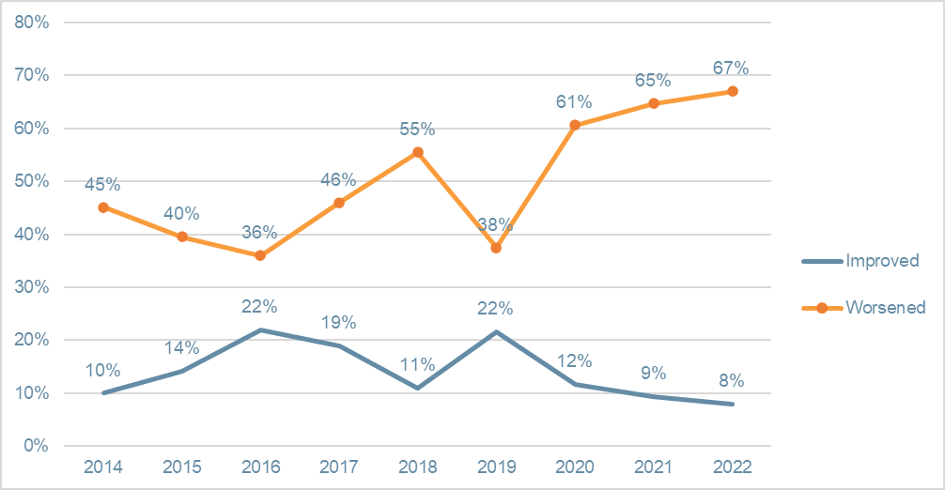
 | 2014 | 2015 | 2016 | 2017 | 2018 | 2019 | 2020 | 2021 | 2022
Improved | 10 per cent | 14 per cent | 22 per cent | 19 per cent | 11 per cent | 22 per cent | 12 per cent | 9 per cent | 8 per cent
Worsened | 45 per cent | 40 per cent | 36 per cent | 46 per cent | 55 per cent | 38 per cent | 61 per cent | 65 per cent | 67 per cent

Figure 2: Operating conditions in the wider Australian economy
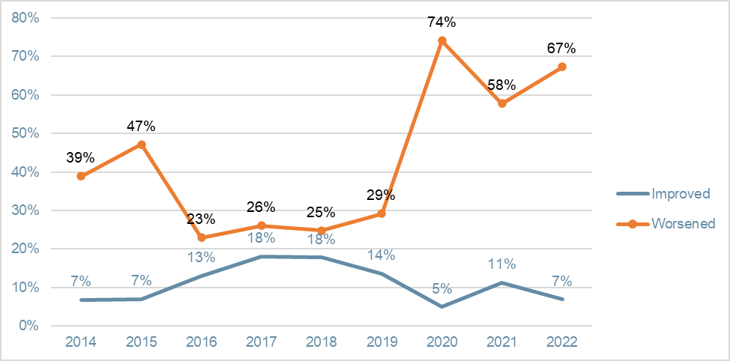
 | 2014 | 2015 | 2016 | 2017 | 2018 | 2019 | 2020 | 2021 | 2022
Improved | 7 per cent | 7 per cent | 13 per cent | 18 per cent | 18 per cent | 14 per cent | 5 per cent | 11 per cent | 7 per cent
Worsened | 39 per cent | 47 per cent | 23 per cent | 26 per cent | 25 per cent | 29 per cent | 74 per cent | 58 per cent | 67 per cent
The reasons for this have been well-rehearsed in previous surveys. Respondents continued to tell a story of frustration with administrative burdens, NDIS systems and processes, and staffing. Concern also continued that NDIS prices would not cover costs and support quality service provision, and that unfunded activity, such as helping people understand and navigate the scheme, was distracting from direct service provision (together with a related concern that there was insufficient advocacy for NDIS participants).
‘… tight labour market; participants have not fully returned; also impacted [by] external operating environments supply chain shortages, limited skilled managers available in the market; continuing costs of PPE to provide safe environment for my people; exodus of volunteers from three years of COVID.’
Vic large not-for-profit
‘The operating environment has been very challenging due to COVID-19, [especially] the NDIA’s ongoing reductions to participants plans without any information or notice of why the reductions have been made.’
NT small not-for-profit
Seventy-nine per cent thought that the NDIS policy environment was uncertain. The number of respondents who agreed or strongly agreed that ‘the risks that the NDIS presents to my organisation outweigh the opportunities’ sat at 30 per cent (roughly the same as the previous three years) and was matched by respondents who were undecided about the risk-to-benefit equation (31 per cent), while only 39 per cent were more positive that the opportunities outweighed the risks.
Figure 3: Perception of NDIS environment
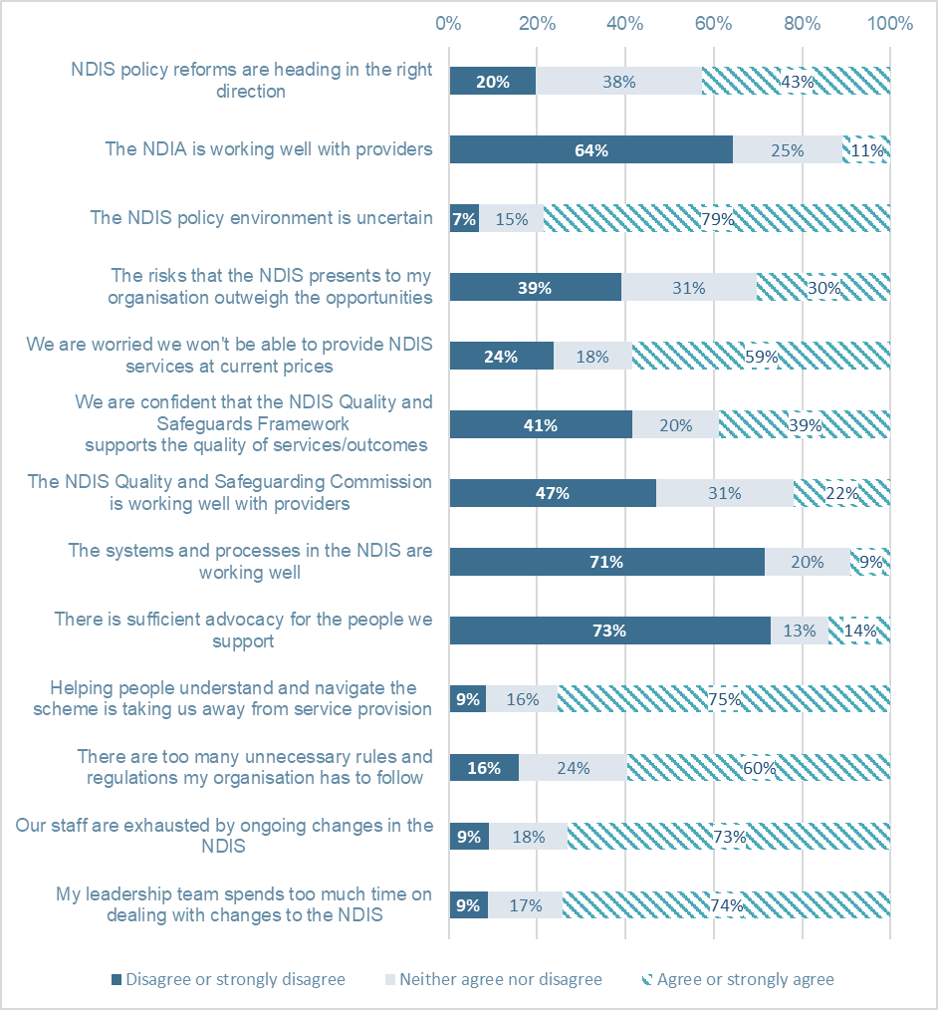
 | Disagree or strongly disagree | Neither agree nor disagree | Agree or strongly agree
NDIS policy reforms are heading in the right direction | 20 per cent | 38 per cent | 43 per cent
The NDIA is working well with providers | 64 per cent | 25 per cent | 11 per cent
The NDIS policy environment is uncertain | 7 per cent | 15 per cent | 79 per cent
The risks that the NDIS presents to my organisation outweigh the opportunities | 39 per cent | 31 per cent | 30 per cent
We are worried we won't be able to provide NDIS services at current prices | 24 per cent | 18 per cent | 59 per cent
We are confident that the NDIS Quality and Safeguards Framework supports the quality of services/outcomes | 41 per cent | 20 per cent | 39 per cent
The NDIS Quality and Safeguarding Commission is working well with providers | 47 per cent | 31 per cent | 22 per cent
The systems and processes in the NDIS are working well | 71 per cent | 20 per cent | 9 per cent
There is sufficient advocacy for the people we support | 73 per cent | 13 per cent | 14 per cent
Helping people understand and navigate the scheme is taking us away from service provision | 9 per cent | 16 per cent | 75 per cent
There are too many unnecessary rules and regulations my organisation has to follow | 16 per cent | 24 per cent | 60 per cent
Our staff are exhausted by ongoing changes in the NDIS | 9 per cent | 18 per cent | 73 per cent
My leadership team spends too much time on dealing with changes to the NDIS | 9 per cent | 17 per cent | 74 per cent
Two new questions were introduced this year, both relating to the perceived impact of ongoing change and uncertainty. Most leadership teams were absorbed with dealing with NDIS changes, and respondents reported their staff were exhausted by ongoing changes in the NDIS, a condition likely to adversely affect already challenging workforce issues.
Perhaps one of the more significant consequences of these factors was that boards and leadership teams were finding it difficult to develop strategies and a set direction in the current policy and operating environment. Nearly half of respondents (48 per cent) agreed or strongly agreed that this was the case. This uncertainty was felt across different states, organisation types (not-for-profit or for-profit) and organisation sizes.
Concerns about a confusing NDIS operating environment were expressed by respondents:
‘The Scheme is still being written, placing unnecessary burden on providers. Providers are largely kept out of discussions with the NDIA because the Scheme is funding participants, not providers. Unfortunately, providers usually know a lot more about what they can provide at what price and be sustainable; we know more about our clients than the NDIA does about its participants, yet they continually make arbitrary and unilateral decisions that do not support the Scheme, their participants, our clients or the providers.’
NSW large not-for-profit
‘Changes in the NDIS have not been backed up by clear written policy and associated detail, including guidance. Changes to policy and practice by the NDIA have lacked transparency and appropriate engagement with, and support to, both providers, participants and families.’
Tas large not-for-profit
‘The lack of consistency from the NDIA when we call about issues for clarification is poor. The rules change and the lack of information or reasoning is not clear for many of the participants we support. It is felt that NDIA has made changes and informed providers and expected us to communicate the changes to participants and families, leaving us open to the backlash when the changes are not our decision.’
Vic small not-for-profit
The overall proportion of respondents who agree with the statement, ‘We are worried we won’t be able to provide NDIS services at current prices‘, has remained remarkably stable over the last five years. Some 59 per cent of respondents agreed in 2022.
NDIS pricing appears to affect different organisations in different ways. Very small organisations and organisations that were established after the introduction of NDIS in 2014 were less likely to agree with this statement, suggesting that these organisations were more confident that they could provide services at current prices.
Post-2014 organisations were set up within the NDIS environment, so may be expected to be designed with NDIS operational confines in mind and, therefore, more comfortable with the pricing model. Despite that, almost half of the post-2014 organisations were still worried that they wouldn’t be able to provide NDIS services at current prices.

Confidence in the regulatory environment
This year’s survey continued to explore provider support for all the regulatory instruments that make up the NDIS Quality and Safeguarding Framework (the Framework). As with last year, large variations in confidence in the Framework’s components persisted, but overall, there was declining support. The NDIS Code of Conduct received the most support (at 77 per cent), while the ‘Registered NDIS provider notice of changes and events’ (which only impacted larger providers) received the least support (36 per cent).
Figure 4: We are worried we won’t be able to provide NDIS services at current pricing
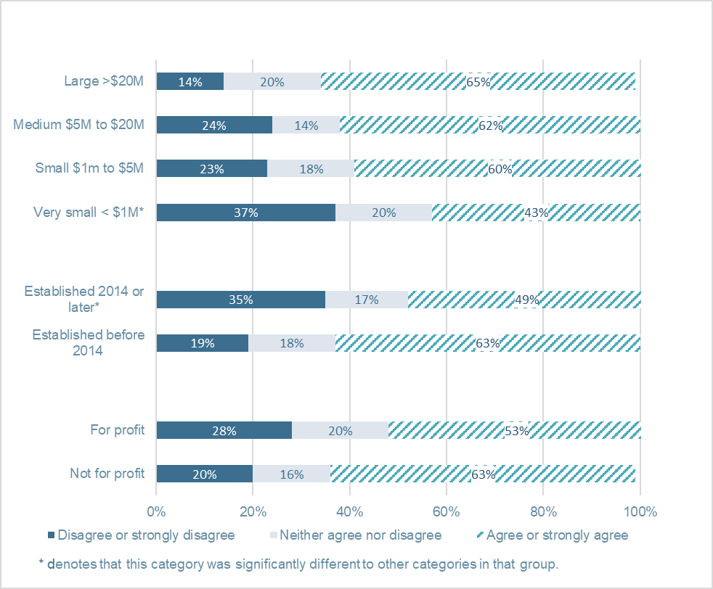
 | Disagree or strongly disagree | Neither agree nor disagree | Agree or strongly agree
Not for profit | 20 per cent | 16 per cent | 63 per cent
For profit | 28 per cent | 20 per cent | 53 per cent
Established before 2014 | 19 per cent | 18 per cent | 63 per cent
Established 2014 or later* | 35 per cent | 17 per cent | 49 per cent
Very small < $1M* | 37 per cent | 20 per cent | 43 per cent
Small $1m to $5M | 23 per cent | 18 per cent | 60 per cent
Medium $5M to $20M | 24 per cent | 14 per cent | 62 per cent
Large >$20M | 14 per cent | 20 per cent | 65 per cent
Overall, only 39 per cent of providers were confident that the Framework supported the quality of services and outcomes (significantly lower than the 45 per cent of respondents who agreed in 2021). Forty-one per cent disagreed or strongly disagreed, worse than previous years. Support or lack thereof for the Framework and its components was consistent across key organisational features, including state, size (by income) and whether organisations were for-profit or not-for-profit.
These results reflect general concerns about the regulatory environment across the entire service ecosystem. This is shown by 60 per cent of all respondents (about the same as last year) agreeing or strongly agreeing that ‘there are too many unnecessary rules and regulations (that) my organisation has to follow’. A major theme in respondents’ comments was calls for greater accountability for unregistered providers and greater consistency and fairness in the application of regulatory instruments between registered and unregistered providers.
‘The responsiveness of the Commission to reports of poor care and coercion of clients is very poor. The auditing framework is irrelevant when there are no positive outcomes for the provider from high compliance. There is no impact on providers of poor quality or unregistered providers.’
Vic very large not-for-profit

Figure 5: Quality and Safeguarding Framework is leading to good outcomes to participants
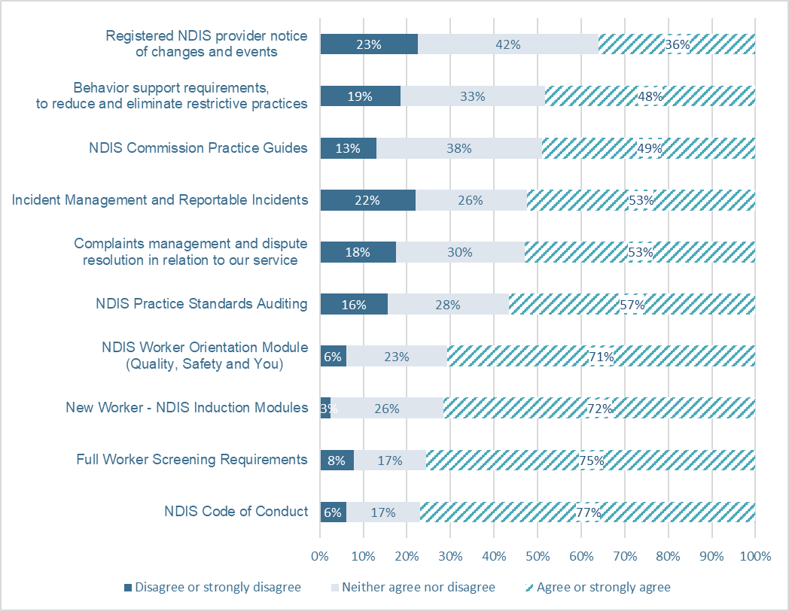
 | Disagree or strongly disagree | Neither agree nor disagree | Agree or strongly agree
NDIS Worker Orientation Module (Quality, Safety and You) | 6 per cent | 23 per cent | 71 per cent
NDIS Code of Conduct | 6 per cent | 17 per cent | 77 per cent
New Worker - NDIS Induction Modules | 3 per cent | 26 per cent | 72 per cent
Full Worker Screening Requirements | 8 per cent | 17 per cent | 75 per cent
NDIS Practice Standards Auditing | 16 per cent | 28 per cent | 57 per cent
Complaints management and dispute resolution in relation to our service | 18 per cent | 30 per cent | 53 per cent
Incident Management and Reportable Incidents | 22 per cent | 26 per cent | 53 per cent
Behaviour support requirements, to reduce and eliminate restrictive practices | 19 per cent | 33 per cent | 48 per cent
Registered NDIS provider notice of changes and events | 23 per cent | 42 per cent | 36 per cent
NDIS Commission Practice Guides | 13 per cent | 38 per cent | 49 per cent

Relationships with providers
The NDIS Commission’s relationship with service providers appears to have deteriorated. Nearly half of respondents (47 per cent) disagreed or strongly disagreed that the Commission is working well with providers (significantly higher than the 36 per cent of respondents who disagreed or strongly disagreed in 2021), while only 22 per cent responded that it is working well.
Comparatively, two thirds (64 per cent) disagreed or strongly disagreed that the NDIA is working well with providers (only 11 per cent believe that they are working well).
On 18 October 2022, Bill Shorten, Minister for the NDIS, announced an independent review into the NDIS ‘to improve the wellbeing of Australians with disability and ensure the scheme’s sustainability’. Minister Shorten stated that the NDIS Review will work with participants, their families and carers, as well as providers.
Providers are clear that a review is well overdue:
‘Our staff are feeling the ongoing pressure we place on them for compliance and quality safeguards. [Org name] as a business is concerned that registered providers have enormous compliance and pressure to ensure our staff are providing quality services, whereas workers can provide services unregistered or regulated. This makes people with disability very vulnerable to exploitation, etc. I do not understand why it seems that the push is for unregistered or private provision of services where historically the Dept knows this is where the highest area of fraud and abuse occurs. At times we wonder why we have gone through all the processes and pressure to be a registered provider. Being a small self-employed business would be more profitable and easier to manage. If you want quality standards, it needs to [pay] for management and infrastructure of these businesses.’
WA small for-profit

Innovation, data and research
The 2021 survey identified a sobering assessment of the system’s failure to provide the conditions for innovation to flourish. The issue remains a major source of concern, with only 11 per cent of respondents agreeing or strongly agreeing that, ‘taken together, NDIS Pricing and Regulation are conducive to providing innovative services that respond to Participant needs’. (A close match to the 12 per cent who did so in 2021, when the question was first asked).
Providers also continued to report a paucity of the kind of necessary, timely and easily accessible data that they need to plan their services. Only 17 per cent agreed or strongly agreed that the necessary data was available. Similarly, 53 per cent, disagreed or strongly disagreed that enough implementation-ready research is available to support evidence-informed services.
Two recent developments have real potential to improve the conditions for innovative, data-informed policy and practice occurring in the service ecosystem. Firstly, the Australian Government has committed to developing a National Disability Data Asset, following successful pilots across five test cases. Work is progressing to design an enduring data asset that aims to enhance sharing, linking and accessing information pertinent to service provision. Secondly, the National Disability Research Partnership (NDRP) will transition out of a two-year establishment phase and emerge as a stand-alone entity by early-to-mid-2023.
But these positive developments will take time to make a difference. Service providers are clear what factors are impeding innovation now:
‘Present NDIS pricing does NOT fund quality.’
Vic medium not-for-profit
‘The true cost of compliance and on-costs needs to be absorbed across our part-time service offerings and we cannot afford to scale to a full-time large service. We also firmly believe we are commercially disadvantaged in competing against non-regulated NDIS service providers.’
NSW very small not-for-profit
‘NDIA implement policies without thinking of implications (e.g., the emergency plans for participants can take 20 hours to do but [there’s no] no line item or funding).’
NSW very small for-profit

Figure 6: Services provided
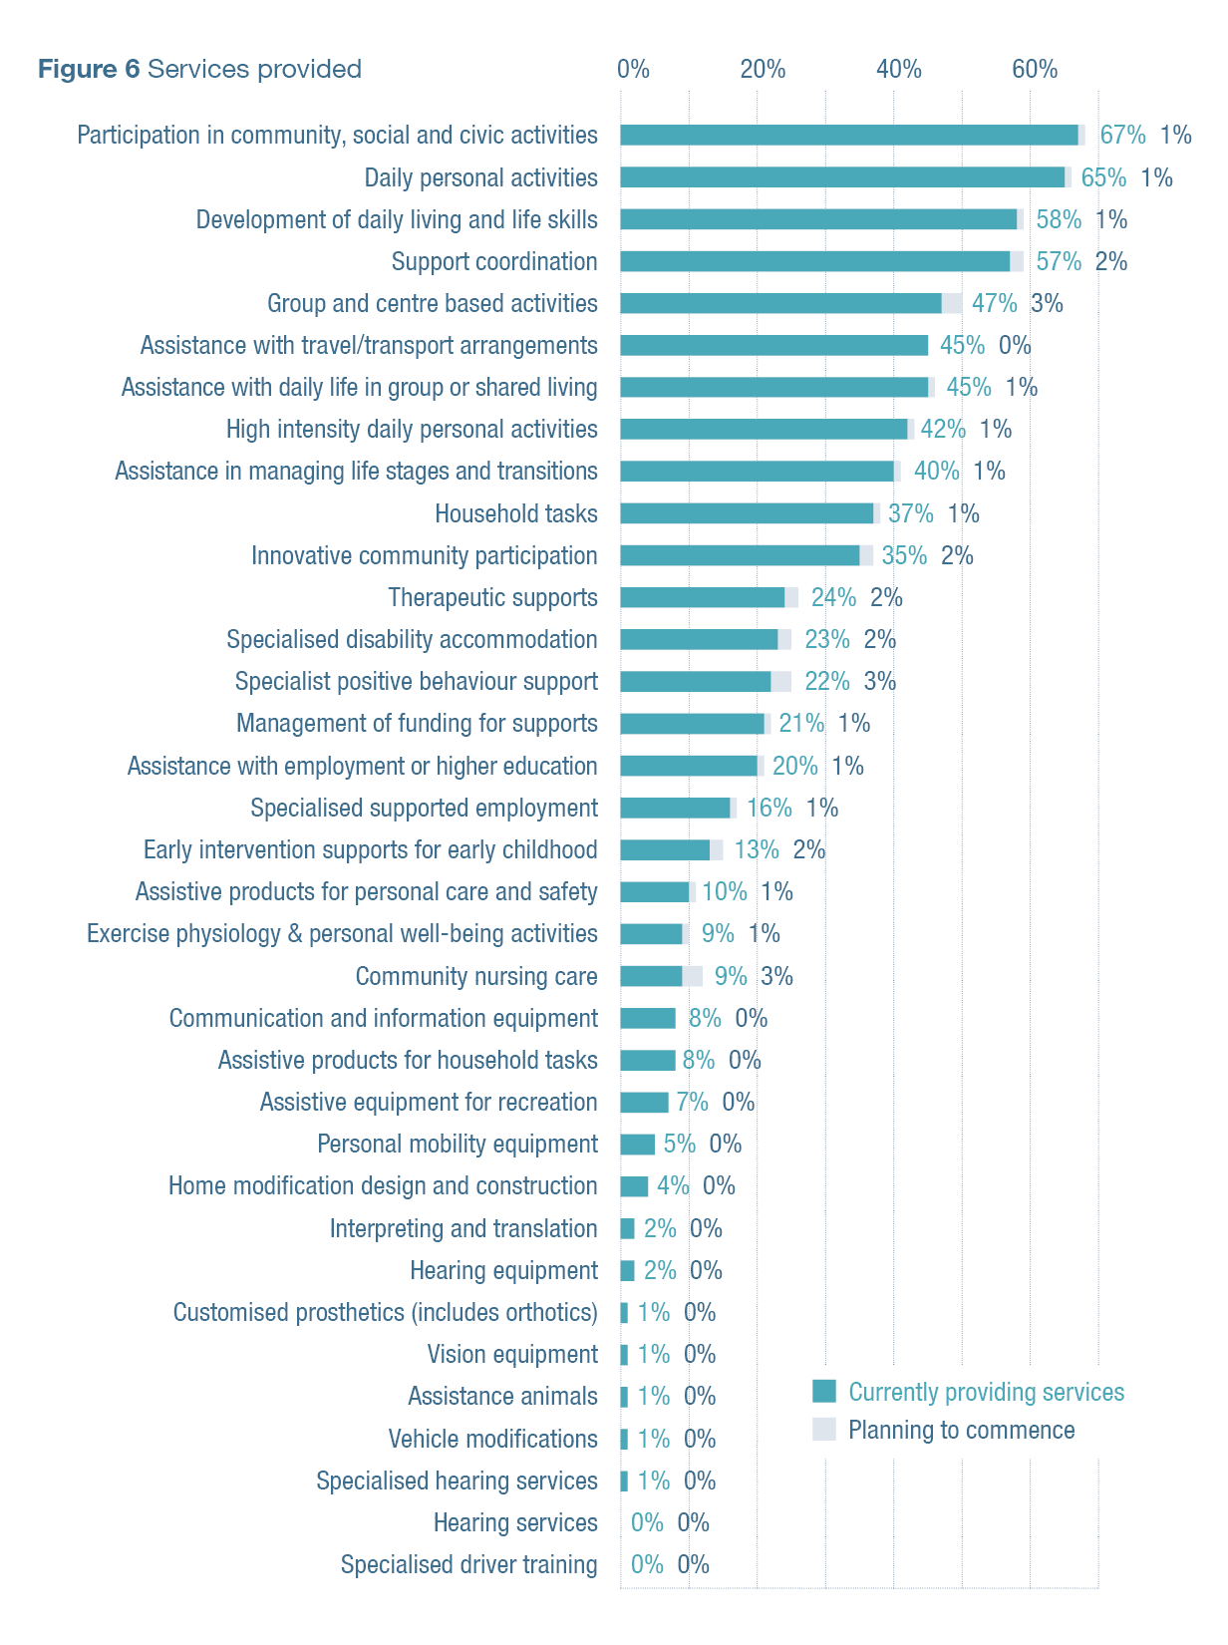
 | Currently providing services | Planning to commence
Participation In Community, Social And Civic Activities | 67 per cent | 1 per cent
Daily Personal Activities | 65 per cent | 1 per cent
Development Of Daily Living And Life Skills | 58 per cent | 1 per cent
Support Coordination | 57 per cent | 2 per cent
Group And Centre Based Activities | 47 per cent | 3 per cent
Assistance With Travel/Transport Arrangements | 45 per cent | 0 per cent
Assistance With Daily Life Tasks In A Group Or Shared Living Arrangement | 45 per cent | 1 per cent
High Intensity Daily Personal Activities | 42 per cent | 1 per cent
Assistance In Coordinating Or Managing Life Stages, Transitions And Supports | 40 per cent | 1 per cent
Household Tasks | 37 per cent | 1 per cent
Innovative Community Participation | 35 per cent | 2 per cent
Therapeutic Supports | 24 per cent | 2 per cent
Specialised Disability Accommodation | 23 per cent | 2 per cent
Specialist Positive Behaviour Support | 22 per cent | 3 per cent
Management of Funding for Supports | 21 per cent | 1 per cent
Assistance to Access and Maintain Employment or higher education | 20 per cent | 1 per cent
Specialised Supported Employment | 16 per cent | 1 per cent
Early Intervention Supports For Early Childhood | 13 per cent | 2 per cent
Assistive Products For Personal Care And Safety | 10 per cent | 1 per cent
Exercise Physiology and Personal Well-being Activities | 9 per cent | 1 per cent
Community Nursing Care | 9 per cent | 3 per cent
Communication And Information Equipment | 8 per cent | 0 per cent
Assistive Products For Household Tasks | 8 per cent | 0 per cent
Assistive Equipment For Recreation | 7 per cent | 0 per cent
Personal Mobility Equipment | 5 per cent | 0 per cent
Home Modification Design And Construction | 4 per cent | 0 per cent
Interpreting And Translation | 2 per cent | 0 per cent
Hearing Equipment | 2 per cent | 0 per cent
Customised Prosthetics (includes Orthotics) | 1 per cent | 0 per cent
Vision Equipment | 1 per cent | 0 per cent
Assistance Animals | 1 per cent | 0 per cent
Vehicle Modifications | 1 per cent | 0 per cent
Specialised Hearing Services | 1 per cent | 0 per cent
Hearing Services | 0 per cent | 0 per cent
Specialised Driver Training | 0 per cent | 0 per cent

Organisations and growth
Alongside 2022’s increasingly pessimistic outlook, this year’s results revealed a significant decrease in the number of organisations who were growing. Respondents told us about NDIS services they currently provide – with over half responding that they provided services related to participation in community, social and civic activities, daily personal activities, development of daily living and life skills, and support coordination. Respondents were also asked if they planned to offer new services in the coming year. Very few organisations planned to begin delivering new types of services; however, three per cent of organisations planned to begin providing services in the areas of group-and-centre-based activities, specialist positive behaviour support or community nursing care.
Over 2021-22, growth was seen in the provision of:
  - management of funding for supports (58 per cent of respondents reported an increase)
  - support coordination (56 per cent of respondents reported an increase)
  - specialist positive behaviour support (50 per cent of respondents reported an increase).
There were fewer decreases in service provision across the board, though nearly one-third of organisations providing services for participation in community, social and civic activities and group and centre-based activities reported decreases.
When asked about future planning, many respondents told us that they planned to increase their provision of:
  - support coordination (66 per cent)
  - participation in community, social and civic activities (64 per cent)
  - assistance with daily life tasks in a group or shared living arrangement (63 per cent)
  - group and centre-based activities (63 per cent)
  - daily personal activities (60 per cent)
  - innovative community participation (59 per cent)
  - daily living and life skills development (58 per cent); and
  - household tasks services (52 per cent).
Very few service decreases were planned.
Similar to preceding years, many organisations were unable to provide some of the services requested by participants. Eighty per cent of respondents reported that they had received requests for disability services they had been unable to provide. This was largely due to not having enough staff or not having staff who were qualified to assist the clients with the services. In some cases, clients were turned away because their plan would not cover the requested service.
Sixty-three per cent of respondents indicated that they were actively growing their organisation. The most common approaches to growth involved:
  - increasing their client base
  - increasing their workforce
  - increasing the ranges of services they offer; and
  - operating more service locations.
Less common approaches to growth included:
  - broadening operations to include sectors beyond disability
  - taking management ownership of another organisation; and
  - merging with another organisation.
This was similar to approaches to growth in 2021.
Figure 7: We are actively growing our organisation
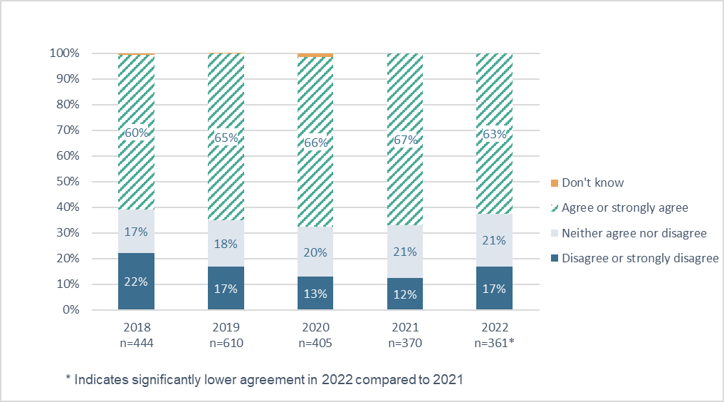
 | 2018  n=444 | 2019  n=610 | 2020  n=405 | 2021  n=370 | 2022  n=361*
Disagree or strongly disagree | 22 per cent | 17 per cent | 13 per cent | 12 per cent | 17 per cent
Neither agree nor disagree | 17 per cent | 18 per cent | 20 per cent | 21 per cent | 21 per cent
Agree or strongly agree | 60 per cent | 65 per cent | 66 per cent | 67 per cent | 63 per cent
Don't know | 1 per cent | 0 per cent | 1 per cent
Organisations were also asked about areas they needed to improve. The most frequent responses included HR strategy and workforce planning, costing and pricing, employee learning and development, information, communications and technology, qualified workforce, data reporting and use, and financial processes and control.
Though it was not one of the most commonly reported area of improvement, when compared to 2021, fewer organisations reported needing to improve market research, strategies and planning.

Operations and collaboration
Outsourcing of back-office functions and group purchasing remained consistent in 2022. There was a slight increase in resource-sharing arrangements (14 per cent in 2022 versus nine per cent in 2021); however, this likely reflects a return to a pre-COVID operating environment (12 per cent in 2020) rather than significant change.
The sector continued to show high levels of organisation and collaboration when it came to advocating for change, with 80 per cent of organisations reporting they collaborate with others to advocate for the sector in 2022. Similar to 2021, 79 per cent of organisations continued to collaborate with other providers to solve service access problems for individual clients.

Financial outlook is pessimistic
Despite the uncertainty around COVID-19, predictions in the 2021 Annual Market Survey regarding financial outlook were quite accurate. In 2021, 45 per cent of respondents predicted they would make a profit or surplus in the 2021/22 financial year – and in this year’s survey 46 per cent of respondents reported that they made a profit or surplus for that financial year. Similarly, last year, 23 per cent predicted a loss or deficit and 23 per cent did have a loss or deficit. This shows that the sector has a realistic understanding of the impact of the operating environment on financial operating conditions.
In 2021, many organisations reported concerns about the impact that ending JobKeeper would have on overall operating profit or surplus. This was also borne out. The decrease from 2020/21 to 2021/22 in the number of organisations making a profit was highly statistically significant (68 per cent versus 46 per cent). For-profit organisations were more likely than not-for-profit organisations to report a profit or surplus in 2021/22 (56 per cent versus 42 per cent).
There was more pessimism about operating conditions, with 36 per cent of organisations indicating that they expect to make a loss or deficit in 2022/23, up from 23 per cent in 2021/22. As noted, historically, organisations have demonstrated high levels of accuracy in financial prediction, a record which suggests that the sector is likely to experience poor operating conditions into the immediate future. When compared with not-for-profit organisations, for-profit organisations were more likely to predict making a profit in 2022/23 (64 per cent versus 39 per cent).
Figure 8: In its most recent full financial year (year ending 30 June 2022) did this organisation make a loss, break-even or make a profit (surplus) in regard to its disability services
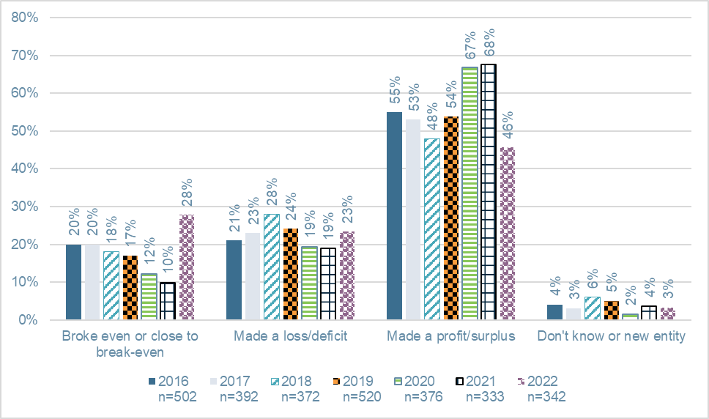
 | 2016  n=502 | 2017  n=392 | 2018  n=372 | 2019  n=520 | 2020  n=376 | 2021  n=333 | 2022  n=342
Broke even or close to break-even | 20 per cent | 20 per cent | 18 per cent | 17 per cent | 12 per cent | 10 per cent | 28 per cent
Made a loss/deficit | 21 per cent | 23 per cent | 28 per cent | 24 per cent | 19 per cent | 19 per cent | 23 per cent
Made a profit/surplus | 55 per cent | 53 per cent | 48 per cent | 54 per cent | 67 per cent | 68 per cent | 46 per cent
Don't know or new entity | 4 per cent | 3 per cent | 6 per cent | 5 per cent | 2 per cent | 4 per cent | 3 per cent
Figure 9: Do you expect your organisation will make a loss (deficit), break-even or a profit (surplus) on its disability services in this current financial year (year ending 30 June 2023)?
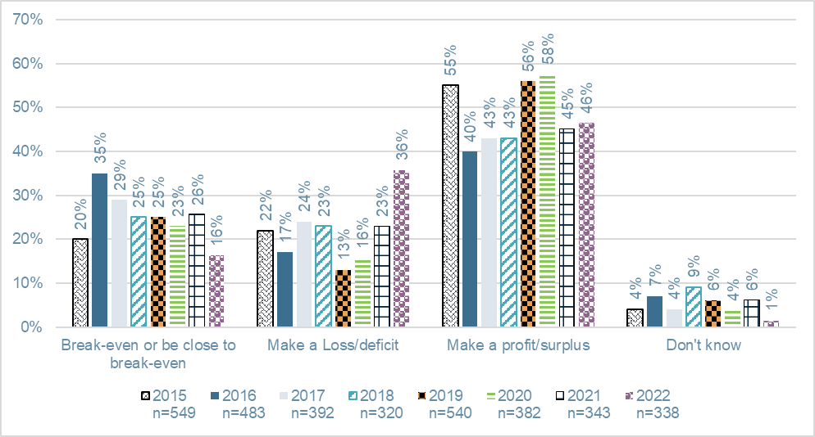
 | 2015  n=549 | 2016  n=483 | 2017  n=392 | 2018  n=320 | 2019  n=540 | 2020  n=382 | 2021  n=343 | 2022  n=338
Break-even or be close to break-even | 20 per cent | 35 per cent | 29 per cent | 25 per cent | 25 per cent | 23 per cent | 26 per cent | 16 per cent
Make a Loss/deficit | 22 per cent | 17 per cent | 24 per cent | 23 per cent | 13 per cent | 16 per cent | 23 per cent | 36 per cent
Make a profit/surplus | 55 per cent | 40 per cent | 43 per cent | 43 per cent | 56 per cent | 58 per cent | 45 per cent | 46 per cent
Don't know | 4 per cent | 7 per cent | 4 per cent | 9 per cent | 6 per cent | 4 per cent | 6 per cent | 1 per cent

South Australia

Case study
Darrin Johnson
Kudos Services

Tell us about Kudos
Kudos is Australia’s first not-for-profit, employee-owned mutual spun out of public service. We began in 2018 with around 90 staff from the Department of Human Services, so we have this strange blend of being a start-up but with a long heritage in working in complex needs disability services.
We formed with two key objectives: to be the Early Childhood Partner in Community for the NDIA in South Australia and to provide a therapy-based business for people over seven who are living with a disability.,

What’s been your proudest achievement?
The organisation had to do a lot in its early years – we needed a lot of back-of-house processes and systems to be developed very quickly. We also had to quickly establish a commercial model without the benefit of a fundraising arm, or without any of the investment income that many of the large established not-for-profit providers have.
I think the proudest achievement was when we could look at our results for a particular month and comfortably feel we had a viable business model.

Has the past year been more or less challenging than most?
I think we have had multiple challenging years, because we have needed to rapidly expand and grow our business, while still trying to bed down its basic systems and processes.
COVID has impacted everyone, of course, but we had a particularly hard couple of months earlier on this year. We deliver a large amount of our services through schools and many of them just couldn’t let us back on site for term one.

What are the major opportunities?
Meeting the unmet demand for services. Despite nearly doubling over the last two years, we are set to expand probably even faster over the next 12 months. So we are really excited about our business at this point.

What are the major challenges?
Workforce, workforce and then workforce. We’ve developed a viable business model but being able to recruit more allied health-based practitioners is still a major challenge.
I also think there is a level of change fatigue in the sector. With the change in federal government, we are expecting further reforms to the NDIS system. While we would expect these changes to be improvements, after several years of COVID interruptions, I think most agencies just want to be able to get on with their jobs for a bit.

Why did you get into the sector?
My background is marketing and business development, but along the journey I’ve had a son who is legally blind, and who has been involved in the NDIS basically since its inception. I think for many working in the sector, disability is a calling not a career. Many of our team have lived experience, either personally or in their immediate family.

What’s surprised you most?
Just how much people working in the sector care. They care about their clients and their families, they care about their profession, and they care about each other. You just don’t see people going through the motions in the disability sector.

What’s impressed you most?
We are in a sector where there is never enough money and never enough time. But the team members are incredibly skilled at getting the most they can out of the funding and time available for their clients and their families. They do it professionally. They do it with a smile. And then they come back the next day and do it all again.

SA sector stats
47,425 Active participants including ECA
845 Active ECA participants
6 per cent NDIS participants are Indigenous
7.2 per cent Culturally and linguistically diverse

Top three issues

Workforce
The lack of available workforce across all disciplines is a key issue for the sector across Australia. However, in South Australia this shortage of workers is compounded by the inequity in the operating conditions for non-government and government providers. Support
co-ordination is particularly at risk currently, due to insufficient pricing resulting in withdrawal of service providers.

Transition
The transition of people with disability out of government institutions (including aged care, hospitals, prisons and mental health facilities) and into vacancies needs to include greater engagement with non-government providers, who are interested and equipped in supporting this process, resulting in filling existing vacancies.

Provision of affordable quality housing
With only six per cent of participants eligible for specialist disability accommodation, there is an alarming shortage of suitable and affordable housing enabling participants to have real choice about their living arrangements. The nebulous policy environment that exists for housing requires urgent attention to encourage further investment.

Queensland

Case study
Debra Burden
Selectability

Tell us about selectability
We’re a not-for-profit charity that works across regional Queensland to prevent suicide and improve mental health. We support about 3000 people, of which about a third would be in the NDIS.

What’s been your proudest achievement?
Probably the fact that we are so financially sound. When I joined selectability five years ago, we were going through the transition to NDIS and really feeling the pain.
But these days, we are doing well. And the basis of that financial success has been the NDIS.

Has the past year been more or less challenging than most?
Well, it’s certainly been busier. We’ve officially opened six new buildings and taken on about 350 new employees.
When COVID first hit, we just knew that there was going to be a huge increase in demand for mental health services – and most likely, a lot less funding. So, we decided to get on the front foot. We’d had a really good surplus the year before, and our board, who are very savvy, just said ‘put it all back into the business. Invest whatever you need to position us well for the future’.
We’re aiming to have 1000 employees by the end of this financial year and around 2000 the year after that.

What are the major opportunities?
I don’t know about the rest of the sector, but personally I am excited about some of the changes that the federal government is putting through.

What are the major challenges?
Like everyone, our big challenge is having a workforce that’s large enough to meet the demand that’s out there.

Why did you get into the sector?
The first 30 years of my working life were spent in the credit union movement, then I had a stint with an ASX-listed company. I learned a lot there, but it certainly wasn’t for me.
At selectability, I get a great deal of satisfaction from the fact that we really can and really do make a difference in the lives of people with severe mental illness. I’ve had a lot of good gigs in my career, but this one is the best.

What’s surprised you most?
When I first joined the sector, we used to have regular meetings with a group of other CEOs, which I approached with a commercial lens. We were going through a merger at the time, so I’d be talking about how ‘we’re having a restructure’, how ‘we’re looking at pricing’, how ‘we’re working through our margins’ – only to be told ‘You know, Debra, you need to understand that that’s not how we do things in this sector’.
And I thought to myself, ‘Wow, I thought financial viability was what every organisation did’.
I’m sad to share with you that, of the ten CEOs who were sitting around that table, I’m the only one who’s still here today.
At selectability, we don’t back away from the fact that we need to be financially viable, even though we’re not-for-profit. There’s 3000 odd people out there who are relying on us to support them and 650 employees who rely on us too.

What’s impressed you most?
The people. The compassion and the commitment. People with severe and permanent mental illness can, at times, be very challenging, and to see the work that our people do just blows me away me every day.

Qld sector stats
115,651 Active participants including ECA
3,814 Active ECA participants
9.8 per cent NDIS participants are Indigenous
5.4 per cent Culturally and linguistically diverse

Top three issues

Workforce
Providers have been struggling to attract new workers, and retain current ones, with increased numbers of staff on leave due to COVID-19 and influenza. Regional and remote areas of Queensland have been under particular strain, with ever longer queues of clients seeking appointments.

Worker screening
Despite a worker not being able to commence a risk-assessed role without a NDIS Working screening clearance, many providers still faced lengthy waits to have some of these clearances processed.

NDIA pricing
Following the release of June’s price guide for 2022-2023, many providers have expressed their concerns around the sustainability of their services due to inadequate NDIA pricing systems. Current concerns in these areas have focused on lack of indexation for support coordination and plan management and therapy prices.
Another issue has been the removal of Level 3 high-intensity supports, which has left providers questioning how they can provide adequate services.

The state of the NDIS

State of NDIS policy
With a new government, new minister, and a new NDIA Chair and CEO only recently appointed, the policy environment remains uncertain.
In line with Labor’s election commitments, Minister Shorten has announced a significant review of the NDIS. As such, the terms of reference are broad and will examine the fundamental elements of the Scheme.
Conducted over a 12-month period by an independent panel, and reporting to the disability reform ministers, the review will consist of two parts. Part one will focus on the design, operation and sustainability of the NDIS, while part two will examine ways to build a more responsive, supportive and sustainable market and workforce.
With such a broad remit, the 12-month timeframe announced for the review is ambitious. So it will be important to look for quick wins that can be implemented easily and result in tangible improvements.
As part of his reform agenda, Minister Shorten is also tackling fraud. Continued review of provider claiming practices is likely to follow.
Legislative changes to the NDIS Act (The National Disability Insurance Scheme Amendment (Participant Service Guarantee and Other Measures) Act 2022) passed by Parliament in early 2022 are likely to continue to drive policy changes.
Primarily focussed on implementing the NDIS Participant Guarantee, the reforms include changes to how participant plans can be varied as well as some new terminology. This will distinguish between scheduled and unscheduled plan reviews and reviewable decisions. Welcomed by the sector, risk assessments aligned to those who are self-managing will be implemented where participants wish to use plan managers.
A further amendment opens the door for the Agency to pay service providers directly on behalf of participants (including self-managing participants) through a new payment platform. As a first step, a new ICT business system called PACE will be introduced and is scheduled to be tested in Tasmania late in 2022. Improvements to the current Provider Portal are necessary. However, rigorous testing will be required to avoid the 2016 provider payment debacle, caused by the introduction of a new portal.

State of NDIS prices
The results of the Annual Price Review were a case of the best of times and the worst of times. A much-needed uplift in prices of supports based on the Disability Cost Model was a great result, and we saw an average increase of nine per cent. This included:
  - 1.7 per cent increase to base prices
  - 2 per cent temporary loading, reviewed annually
  - 4.6 per cent increase in award minimum wages
  - 0.5 per cent increase to superannuation guarantee charge.
NDS also welcomed a one-off payment to registered providers of daily living and community access supports. The payment recognised the significant costs that providers incurred keeping participants safe during COVID and complying with increased regulation.
However, the decision to not index price limits for plan management, level 2 and 3 support coordination and therapy and psychology supports hit providers hard. Plan managers, support coordinators and therapy providers continue to be challenged by cost increases in a wide range of areas, including wages (the competition from other sectors is intense), the superannuation guarantee, professional development (in specialised areas such as mealtime management and the prescription of assistive technology), supervision, and general CPI and compliance costs for registered providers.
These price settings also fail to recognise the specialisations required for NDIS therapists and could drive a more medicalised, clinic-based approach to delivery.
The decision to streamline the pricing of high-intensity supports is one that the sector supported. However, we were dismayed to see removal of the previous level 3 high-intensity price limits. This is likely to leave some participants with very complex support needs without the level of support that they need.
These concerns support our call for an independent pricing authority – as does the need to ensure that prices keep up with the market, enable participant choice and control, and generate further improvements in service quality and participant outcomes. Current arrangements that have prices set by the NDIA involve a conflict of interest. The NDIA should be trying to ensure there is a vibrant market for high-quality supports, but it also has a strong agenda on constraining costs – as evidenced by the public debate on the sustainability of the NDIS.

State of NDIS regulation
The appointment of a new NDIS Quality and Safeguarding Commissioner early in the year saw some developments in the NDIS regulatory environment. Amid growing concerns about the two-tier system of registered and unregistered providers that currently exists, the NDIS Commissioner commenced exploring this issue with a Roundtable being held in March 2022 and has promised more discussion to come. NDS will continue to engage with the NDIS Commission and the government on this issue.
In August 2021, the NDIS Commission launched its first own motion inquiry into aspects of supported accommodation in the NDIS. Examining reportable incidents and complaints across six large SIL and SDA providers, the report, we hope, will also focus on models of best practice when it is released later this year.
The use of restrictive practices and unauthorised restrictive practices continues to be prominent on the agenda of the NDIS Commission. Providers continue to report difficulties in accessing behaviour support practitioners, variation in the quality of behaviour support plans, and duplicative and cumbersome systems of authorisation and reporting across the different states and territories.
During the year, work began to better align regulation and reduce duplication across the care and support sectors. The first reforms saw changes to aged care legislation to recognise NDIS worker screening clearances. Other proposals on the table include the development of common core and sector specific supplementary service standards and single point monitoring (report once, use often). Such proposals have merit in a sector that has been required to adjust to ongoing changes in policies, procedures and processes. Alignment activities need to be minimal and fast-tracked, follow a co-design model, and take every opportunity to streamline compliance requirements (without compromising quality or safety).
The NDIS review also includes a focus on the Quality and Safeguarding Framework and the role of regulation. This will provide a critical opportunity for the sector to give feedback on how quality and safeguarding mechanisms can continue to be improved.

The state of the Royal Commission
The Royal Commission into Violence, Abuse, Neglect and Exploitation of People with Disability continued to hold public hearings and receive submissions across 2021-22 into the adequacy, quality and safety of services and supports.
With two hearings on the experiences of people with disabilities who receive supports from Disability Employment Services or work in Australian Disability Enterprises, the Royal Commission also looked at the work, wages and support structures for people with disabilities who are either transitioning from supported employment or accessing and maintaining open employment.
A further hearing examined the experiences of people with disability who access disability day-based services. Findings and recommendations of previous hearings on abuse in disability services also began to be released.
The lessons for providers contained in these reports reinforce the importance of examining organisational systems and governance arrangements and the extent to which these facilitate the involvement of people with disabilities in organisational decision making. Other key takeaways include the adequacy and nature of their responses to abuse or allegations of neglect, and the extent to which these take a proactive or reactive approach to addressing issues and improving organisational culture.
In addition to public and private hearings, the Royal Commission continued its focus on the experiences of people with disabilities through COVID-19, issuing a statement of ongoing concern and an issues paper in response to the Omicron wave. Issues relating to access to PPE, adequate supports and vaccinations continued to be examined.
Two policy roundtables were convened on a national supported decision-making framework and best practice models of guardianship. A public hearing on guardianship, substitute and supported decision making will be held in late November.
A further service provider hearing will be held in February 2023. At this stage, the areas that it will examine have not been released.
As 2022 draws to a close and we await both the reports from various hearings and the Royal Commission’s final report, there is an opportunity for the sector to act now. It behoves providers to undertake a close examination of their organisation against the themes, findings and recommendations emerging from the hearings and reports and to consider the implications for their operations, systems and processes.

The state of the workforce
In terms of workforce, 2022 is probably most accurately described as ‘going from bad to worse’. Recruitment and retention challenges remained across the board and many staffing categories became substantially worse. As one respondent put it:
‘We are no longer in the midst of a skills shortage. It’s now a labour shortage, which means that across most sectors even unskilled or low-skilled jobs are more difficult to fill.’
Tas large not-for-profit
Recruiting a suitably qualified workforce continued to be a significant challenge, with more organisations reporting moderate or extreme difficulty recruiting allied health clinicians, including speech pathologists (98 per cent) occupational therapists (97 per cent), psychologists (94 per cent) and physiotherapists (86 per cent). Organisations reported that they received limited applications for positions and identified the bureaucratic burden as a barrier associated with employing international candidates.
‘Occupational therapists – no response to advertising for jobs. New graduates who have applied have asked for higher wages than we can reasonably offer. Currently still recruiting. Speech pathologists – limited responses to advertisements for jobs. We have recruited an international speech pathologist. Long and arduous process held up by bureaucracy. Psychologist – limited or no applicants in response to advertisements.’
WA small not-for-profit
Some organisations reported increased salary expectations among allied health practitioners, which could not be met, and noted the loss of candidates to more lucrative sole trader positions.
‘Speech pathologists, occupational therapists – they don’t want to be mobile, and they want a much higher salary. There aren’t enough out there. We can’t afford to take students. Staff don’t have the time.’
NSW small not-for-profit
‘Finding staff that are qualified and open to the level of pay relevant to the position is tricky. It is also disappointing to employ staff (and) train them up (only) for them to then leave and start up as a sole trader. This has occurred a number of times and is difficult to navigate.’
Vic small not-for-profit

Figure 10: Occupational Groups proving difficult to recruit competent staff
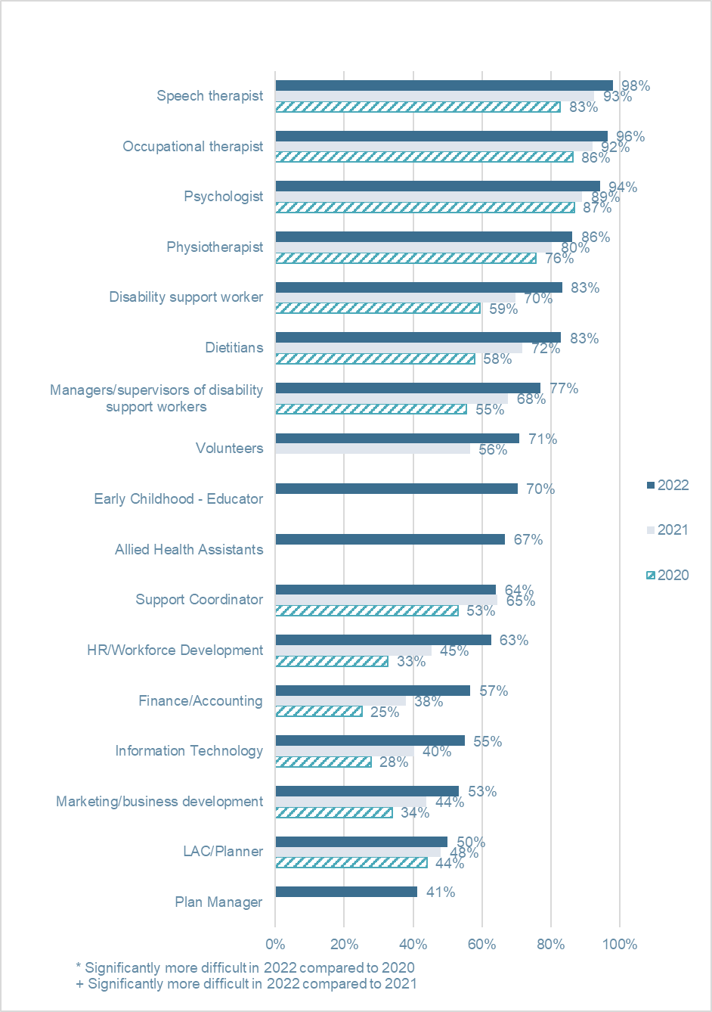
 | 2020 | 2021 | 2022
Occupational therapist | 86 per cent | 92 per cent | 96 per cent
Physiotherapist | 76 per cent | 80 per cent | 86 per cent
Speech therapist | 83 per cent | 93 per cent | 98 per cent
Psychologist | 87 per cent | 89 per cent | 94 per cent
Dietitians | 58 per cent | 72 per cent | 83 per cent
Disability support worker | 59 per cent | 70 per cent | 83 per cent
Allied Health Assistants | - | - | 67 per cent
Support Coordinator | 53 per cent | 65 per cent | 64 per cent
LAC/Planner | 44 per cent | 48 per cent | 50 per cent
Plan Manager | - | - | 41 per cent
Early Childhood - Educator | - | - | 70 per cent
Managers/supervisors of disability support workers | 55 per cent | 68 per cent | 77 per cent
Marketing/business development | 34 per cent | 44 per cent | 53 per cent
Finance/Accounting | 25 per cent | 38 per cent | 57 per cent
Information Technology | 28 per cent | 40 per cent | 55 per cent
HR/Workforce Development | 33 per cent | 45 per cent | 63 per cent
Volunteers | - | 56 per cent | 71 per cent
Organisations reported having difficulty identifying and recruiting suitably qualified disability support workers and noted that current award pay rates do not reflect the complexity of the role.
‘Award pay rates do not acknowledge the level of skill required by DSWs. As a NFP organisation, we cannot pay above-award rates and therefore constantly struggle to attract qualified, experienced staff and struggle to retain them due to for-profit competitor salary rates.’
Tas large not-for-profit
Compared to 2021, in 2022 it was significantly more difficult to recruit disability support workers, managers or supervisors of disability support workers, volunteers, and people working in HR or workforce development and information technology.
Open-ended responses indicate that recruitment of non-clinical staff has also been impacted by increased salary expectations and changing attitudes towards working from home.
‘The pool of quality staff has been poor. People are constantly unwell or not willing to work. We offer a hybrid workplace and some people don’t even want to come in one to two days a week for collaboration. We struggle with poor attitude and high expectations regarding salary when we pay all staff under the SCHCADS award. We cannot compete with intermediaries who do not pay the same award.’
NSW small not-for-profit
Key barriers and facilitators to recruiting competent staff reported by respondents were:
Barriers to recruitment
  - Tight labour market
  - Lack of qualified or suitable staff
  - Allied Health staff hard to find or competition from other sectors
  - Pay expectations; rates cannot compete with other sectors or other employers within disability sector
  - Lack of job security due to unpredictable funding
  - Scarcity of accommodation, especially in regional and rural areas
  - Low prestige of the disability sector
  - Do not want shift work or do not want to work out of usual business hours
  - Delays caused by employment checks
  - Short shifts, split shifts or part-time work.
Facilitators of recruitment
  - Word of mouth or recommendations from current staff
  - Reputation of organisation
  - Relationships with schools, TAFEs or universities
  - Offering student placements
  - Traineeships
  - Relationships with local communities or community organisations
  - Recruit for values, train for skills
  - Attraction of ‘tree change’ locations
  - Established Allied Health team and supervision available.

Figure 11: Occupational Groups proving difficult to retain competent staff
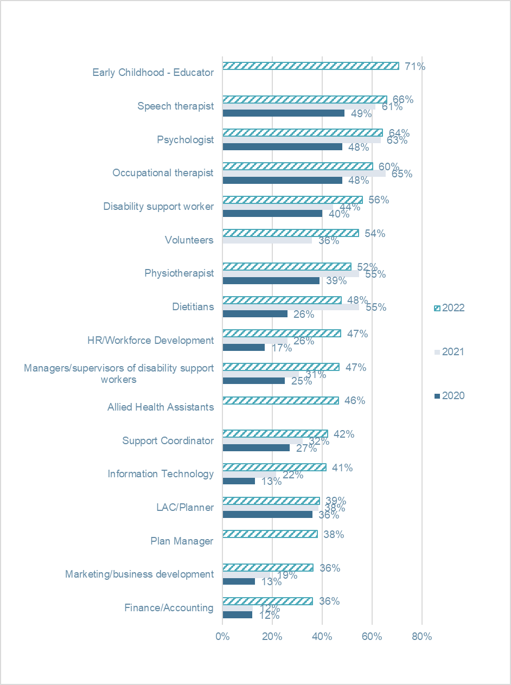

 | 2020 | 2021 | 2022
Occupational therapist | 48 per cent | 65 per cent | 60 per cent
Physiotherapist | 39 per cent | 55 per cent | 52 per cent
Speech therapist | 49 per cent | 61 per cent | 66 per cent
Psychologist | 48 per cent | 63 per cent | 64 per cent
Dietitians | 26 per cent | 55 per cent | 48 per cent
Disability support worker | 40 per cent | 44 per cent | 56 per cent
Allied Health Assistants | - | - | 46 per cent
Support Coordinator | 27 per cent | 32 per cent | 42 per cent
LAC/Planner | 36 per cent | 38 per cent | 39 per cent
Plan Manager | - | - | 38 per cent
Early Childhood - Educator | - | - | 71 per cent
Managers/supervisors of disability support workers | 25 per cent | 31 per cent | 47 per cent
Marketing/business development | 13 per cent | 19 per cent | 36 per cent
Finance/Accounting | 12 per cent | 12 per cent | 36 per cent
Information Technology | 13 per cent | 22 per cent | 41 per cent
HR/Workforce Development | 17 per cent | 26 per cent | 47 per cent
Volunteers | - | 36 per cent | 54 per cent
This year was also a particularly challenging one in terms of retention. While Allied Health staff remained challenging to retain, the biggest jumps occurred in the ‘non-clinical’, support worker and managerial staff. The most substantial increases in retention issues were seen in the following staff groups: HR or workforce development; managers or supervisors of disability support workers; information technology; marketing or business development; finance or accounting; volunteers; and disability support workers and support coordinators.
Key barriers and facilitators to retaining competent staff reported by respondents were:
Barriers to retention
  - Competition and poaching
  - Low pay rates
  - Burnout and COVID fatigue
  - Attraction of solo practice or unregistered ABN work
  - Lack of career pathway
  - Working for multiple agencies or casualised nature of the industry
  - Complexity of the work or it not being what staff expected
  - Leaving for ‘easier’ work in different sectors
  - Vaccination mandate
  - Transient workforce, students move on
  - Casualised workforce
  - Workload
  - Headhunting by other companies.
Facilitators of retention
  - Culture of organisation
  - Flexible working arrangements
  - Competitive pay
  - Training and development
  - Supervision
  - Manageable workload
  - Rewards and recognition program
  - Support and staff wellbeing programs
  - Match between staff values and the work we do
  - Highlighting the impact staff make to the lives of participants.

NDS Workforce Census
The NDS Workforce Census response rate was substantially reduced this period. However, some trends were still apparent.
Firstly, the trend towards a shift from permanent staff to casual staff appears to be continuing. This is consistent with the qualitative feedback from the Annual Market Survey. Many respondents reported casualisation of the workforce was making retention more challenging. This was often related to unpredictable income and reticence to appoint staff to permanent positions. One respondent to the Annual Market Survey exemplified this by saying:
‘[The] casualised nature of the industry makes it difficult for staff to make ends meet and therefore [they] leave for permanent roles in other industries.’
NSW small not-for-Profit

Employment types
A dramatic feature of the disability services workforce (similar to other highly feminised workforces such as aged care and childcare) is the sustained, very high level of part-time workers. Despite the slight drop in percentages in the most recent survey, the rate of part-time workers remains very high at between 75 per cent and 80 per cent.
In the greater job market, ABS data suggest that about 70 per cent of workers work full-time hours and, at last collection point (data collection ceased from 2018), about 60 per cent were employed in a full-time position. (Australian Bureau of Statistics, Australia, Understanding full-time and part-time work (18 February 2021), ABS Website, accessed 18 October 2022.) In the disability sector, this number has ranged between 20 per cent and 24 per cent over the last five years, indicating dramatically lower rates of full-time employment.
This issue is worthy of closer investigation, as it may have complex implications for the sector. Firstly, this situation is likely related to the continued casualisation of the sector mentioned above and may have implications for retention. Many respondents described issues related to employees who worked for multiple organisations and had limited availability to cover shifts, as well as the dissatisfaction caused by short shifts, split shifts and unpaid travel time between shifts. Secondly, staff costs are likely to be much higher when there is a high proportion of staff who are not full-time. Given these factors, it will be prudent to further explore the drivers and implications of this issue for the disability sector.

Figure 12: Type of employment (per cent)
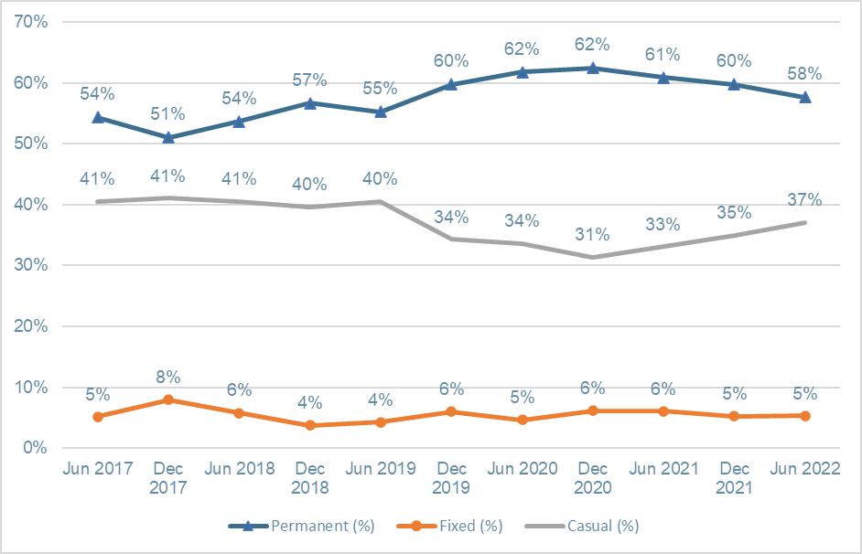
Month | Permanent ( per cent) | Fixed ( per cent) | Casual ( per cent)
Jun 2017 | 54 per cent | 5 per cent | 41 per cent
Dec 2017 | 51 per cent | 8 per cent | 41 per cent
Jun 2018 | 54 per cent | 6 per cent | 41 per cent
Dec 2018 | 57 per cent | 4 per cent | 40 per cent
Jun 2019 | 55 per cent | 4 per cent | 40 per cent
Dec 2019 | 60 per cent | 6 per cent | 34 per cent
Jun 2020 | 62 per cent | 5 per cent | 34 per cent
Dec 2020 | 62 per cent | 6 per cent | 31 per cent
Jun 2021 | 61 per cent | 6 per cent | 33 per cent
Dec 2021 | 60 per cent | 5 per cent | 35 per cent
Jun 2022 | 58 per cent | 5 per cent | 37 per cent

Figure 13: Full-time permanent and part-time permanent: employment share (per cent)
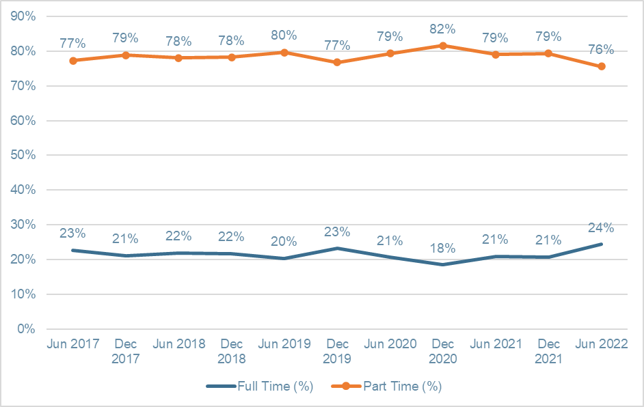
Month | Full Time ( per cent) | Part Time ( per cent)
Jun 2017 | 23 per cent | 77 per cent
Dec 2017 | 21 per cent | 79 per cent
Jun 2018 | 22 per cent | 78 per cent
Dec 2018 | 22 per cent | 78 per cent
Jun 2019 | 20 per cent | 80 per cent
Dec 2019 | 23 per cent | 77 per cent
Jun 2020 | 21 per cent | 79 per cent
Dec 2020 | 18 per cent | 82 per cent
Jun 2021 | 21 per cent | 79 per cent
Dec 2021 | 21 per cent | 79 per cent
Jun 2022 | 24 per cent | 76 per cent

Tasmania

Case study
Lisa McConnon
Enriched Care

Tell us about Enriched Care
We were started in 2013 by two foster parents who were caring for three young men with disabilities. We provide SIL, community access, respite care and in-home care and will be looking to extend into providing a day support centre in the future. Our point of difference is our ability to match participants to staff and ensure that our participants feel like part of a larger family.

What’s been your proudest achievement?
My proudest achievement is the way that the staff have adapted to change. The support staff and office staff have been fantastic at embracing new ideas and new ways of doing things and moving away from the ‘that’s what we do in this industry’ attitude.

What does an average day look like?
I don’t think I have average days. Each one is different, which I love.

Has the past year been more or less challenging than most?
It’d be hard to comment, as I have only been in the sector 13 months, but I’ve been really grateful for the support and guidance from other, more experienced CEOs. They have really welcomed me into the sector.

What do you think are the major opportunities?
I definitely think that providers could work more cohesively. We are all facing the same rules and guidelines from the NDIS and there is plenty of business available. We should be working together to be able to provide services to those that require it, no matter which provider this comes from. We are all looking towards the same result.

What do you think are the major challenges?
Major challenges are around workforce. As someone with a background in HR, I have never seen such a challenging sector. We struggle to attract people to the sector and the ones we do are working multiple jobs to make ends meet.
The other challenge is around the ever-changing playing field of the NDIS and the red tape surrounding what providers can and can’t do. My biggest frustration is around the differences in what registered and unregistered providers do. It leads to frustration with providers, participants and families, and it is all too easy now for people to just become an unregistered provider without proper balances and checks in place.
It would be good to be spending more time providing actual service than to be continually creating documents and doing paperwork.

Why did you get into the sector?
After spending the past 11 years at a utilities company, I wanted to be working in a sector where it felt like I was making a difference. I am a people person and love seeing people thrive. If I can help facilitate that then I am happy!

What’s surprised you most?
I was surprised to find that staff care more about participants than themselves at times. This is something I am actively working on changing in our business. We are all important and we all need to look after ourselves and each other, no matter what our role.

What’s impressed you most?
The commitment from staff to make sure that we are all doing the right things. The ability to be able to adapt, especially when the goalposts move. And most of all, how incredibly able our participants can be when given the right environment and support to thrive.

Tas sector stats
12,295 Active participants including ECA
191 Active ECA participants
9.3 per cent NDIS participants are Indigenous
3.1 per cent Culturally and linguistically diverse

Top three issues

Workforce
Like employers all over Australia, Tasmania’s disability service providers have been finding it difficult to attract and retain staff.

Housing
Tasmanians with disability continue to find it harder than they should to access affordable, accessible and well-maintained housing stock.

Reform fatigue
The impacts of COVID continue to be felt all over the state, most noticeably in the mental health space. The after-effect of isolation impacts the workforce at all levels.

Western Australia

Case study
Gordon Trewern
PeopleKind Group

Tell us about PeopleKind Group
We’re a parent company which enables six organisations to provide services to West Australians with complex needs. In disability, we offer supported accommodation, nursing, occupational theory, physiotherapy and speech pathology.

What has been your proudest achievement?
I have been CEO for 28 years. My proudest moment was when we closed the big hostel, essentially a typical congregate setting for people with severe and profound disability. We supported people to move and integrate into the community.
The consensus at the time for people with profound and severe disability was; ‘You can’t move these people out in the community. They won’t survive. It won’t work for them.’
Needless to say, it did!

What does an average day look like for you?
My day typically starts at 5am. I get on the computer straightaway, check email and review the day ahead, then I go off to the gym. From that point on though, it varies, because anything can pop up at any time when you’re dealing with human services.

Has the past year been more or less challenging than most?
It’s a very timely question. We’ve been an advocate for the NDIS, but I’ve been bitterly disappointed by the way it’s been rolled out. It’s been a classic example of poor execution of public policy. The architecture of the scheme was wrong from the start.
Our disability service has been tracking deficits every year and we came very close to shutting it all down. That’s how bad it got. Long story short: we’re now at breakeven, but that’s not a sustainable model.

What are some of the major opportunities?
This is not a political statement, but my optimism today comes from the fact that we’ve got a minister who understands what the problems are, and I think he’s genuinely trying to resolve them.
There’s a lot of work to be done, but there’s also a lot of confidence that we might actually get it right this time.

What are some of the major challenges?
I think the main challenge is that so many organisations have burned their cash. I think we will lose some organisations in the future, which is a concern and challenge.
Second, disability workers aren’t valued enough, and I think that’s a terrible thing. They should be a valued workforce, just the same as essential services like nurses and doctors and they should be paid a better wage for what they do.
Finally, the big challenge for the sector is undertaking the sheer amount of compliance work. We must have safeguards and compliance, there’s no question about that. We need external oversight and advice. But do we have to make it as intensive as we’re experiencing?

What’s impressed you most?
I think people in our sector have a great capacity to come together when we need to. You come across great people all the time – and their resilience is just extraordinary.

What’s surprised you most (about the sector)?
The way that we’ve allowed ourselves to become a market. Personally, I don’t go to work every day to put money in a shareholder’s pocket. It’s about delivering a social dividend rather than a shareholder dividend, and many of my colleagues would say the same thing.

WA sector stats
47,302 Active participants including ECA
827 Active ECA participants
7.8per cent NDIS participants are Indigenous
8.1per cent Culturally and linguistically diverse

Top three issues

Investing in the disability workforce
The WA community deserves a well-functioning, well-resourced and highly skilled workforce. A primary focus should be on providing career pathways and training opportunities for frontline and support workers at the forefront of this critical work. Without good attraction, recruitment and retention practices, which includes remuneration for these essential workers, service providers will be unable to meet the individual needs of people within the WA community. A siloed sector approach is unlikely to meet the demand for care and support services which is expected to increase significantly in the coming years.

Housing
In the period since 2020, the specialised disability accommodation environment has undergone significant change, with private developers and disability service providers entering the market as property developers to capitalise on SDA funding, and many existing properties become increasingly unfit for purpose.

Administrative burden of the NDIS
The system is groaning under red tape and this impacts on the financial viability of service providers who want to provide quality services. Much of the burden for providers relates to the content and structure of pricing arrangements.

The state of disability employment
Australia’s relative performance supporting people with disability to achieve meaningful employment continues to rate lower than other OECD countries (see key statistics in box below). The Australian Government’s recent reforms (including DES and Workforce Australia) were designed to redress persistent inequities. The disability employment sector’s view is that they are likely to fail.
Australian Disability Employment Outcomes (Australian Bureau of Statistics, Australia, Disability, Ageing and Carers, Australia: Summary of Findings (24 October 2019), ABS Website, accessed 26 October 2022.)
Working-aged people with disability have a lower employment rate (48 per cent) than working-aged people without disability (80 per cent)
Opinions of employment policy reforms remain pessimistic. Just under half of DES providers (48 per cent) disagreed or strongly disagreed that DES policy reforms were heading in the right direction, down almost 10 per cent from last year. Respondents commented:
‘If DSS proceed to build a new DES without taking on board the problems that exist in the current program from a provider perspective, there is high risk that these problems will be perpetuated in the new model.’
WA very small not-for-profit
‘The complete lack of clarity around the new model for DES certainly keeps me awake at night.’
SA medium not-for-profit
‘The Royal Commission calls out not meeting individual needs and person-centred, individualised support – the [DES policy] model does not support this approach.’
NSW medium not-for-profit
Similarly, very few respondents believed that Workforce Australia policy reforms were heading in the right direction.

Figure 14: Employment services
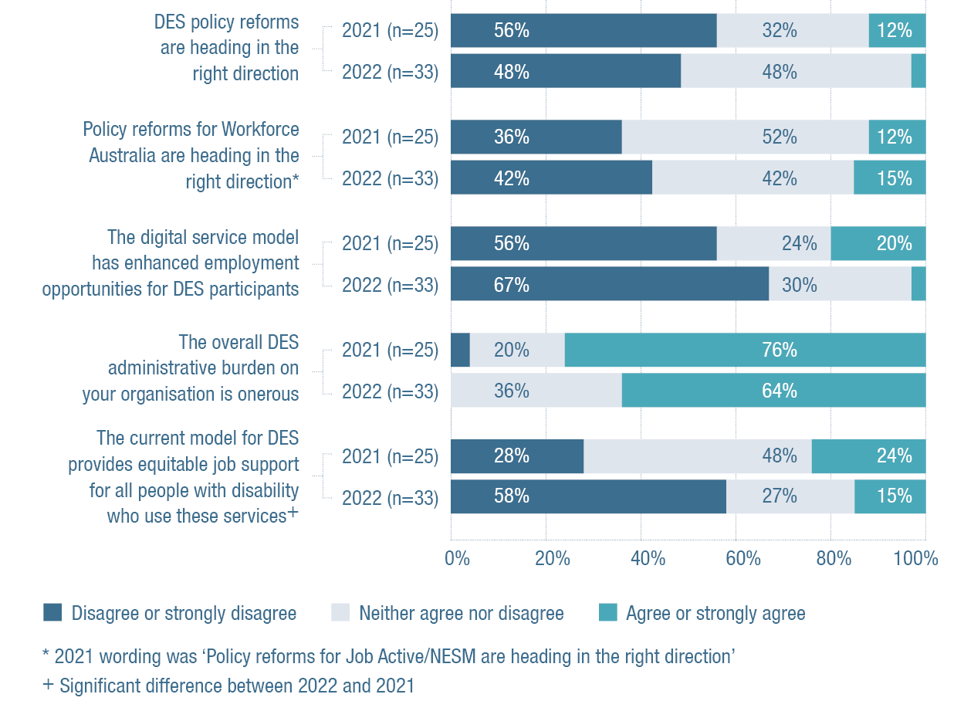
DES policy reforms are heading in the right direction | 2021  n=25 | 2022  n=33
Disagree or strongly disagree | 56 per cent | 48 per cent
Neither agree nor disagree | 32 per cent | 48 per cent
Agree or strongly agree | 12 per cent | 3 per cent

Policy reforms for Workforce Australia are heading in the right direction + | 2021 n=25 | 2022 n=33
Disagree or strongly disagree | 36 per cent | 42 per cent
Neither agree nor disagree | 52 per cent | 42 per cent
Agree or strongly agree | 12 per cent | 15 per cent

The digital service model has enhanced employment opportunities for DES participants | 2021 n=25 | 2022 n=33
Disagree or strongly disagree | 56 per cent | 67 per cent
Neither agree nor disagree | 24 per cent | 30 per cent
Agree or strongly agree | 20 per cent | 3 per cent

The overall DES administrative burden on your organisation is onerous | 2021 n=25 | 2022 n=33
Disagree or strongly disagree | 4 per cent | 0 per cent
Neither agree nor disagree | 20 per cent | 36 per cent
Agree or strongly agree | 76 per cent | 64 per cent

The current model for DES provides equitable job support for all people with disability who use these services * | 2021 n=25 | 2022 n=33
Disagree or strongly disagree | 28 per cent | 58 per cent
Neither agree nor disagree | 48 per cent | 27 per cent
Agree or strongly agree | 24 per cent | 15 per cent

Attitudes towards DES reforms
Almost half of respondents (48 per cent) disagreed or strongly disagreed that current DES data provides comprehensive information which can be used to support business decisions. Two-thirds (67 per cent) disagreed or strongly disagreed that the digital service model had enhanced employment opportunities for DES participants, while only four per cent agreed or strongly agreed with this statement, a notable drop from 20 per cent in 2021. Comments included:
‘Shift to digital does not factor in capacity, access, connectivity for a large cohort of people with disability.’
NSW medium not-for-profit
‘The Commonwealth view that digital platforms have a significant role in employment services I think is misguided.’
SA medium not-for-profit
Administrative burden continues to be an issue for DES providers. Sixty-four per cent of respondents agreed or strongly agreed that the overall DES administrative burden on organisations is onerous. Tellingly, not a single respondent disagreed with this statement. Respondents commented that administrative burdens and time constraints were impacting their practice.
‘The compliance elements are onerous and counter-intuitive.’
Vic large not-for-profit
‘The incentives are money and avoiding punitive departmental action for what are often mistakes, or simply being one day late. Financial is ok as it relates to sustained employment for participants. We, DES, spend enormous resources trying to ‘get it right’ then responding to audits, then responding to the audit finding, which in many cases have been reversed after our further action.’
Vic large not-for-profit
Figure 15: What time of administrative burden is the most onerous
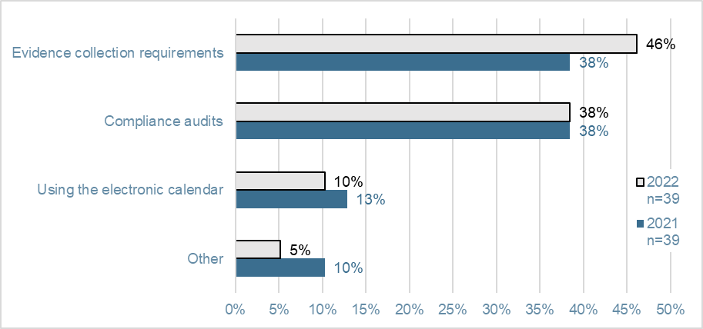
 | 2021  n=39 | 2022  n=39
Compliance audits | 38 per cent | 38 per cent
Evidence collection requirements | 38 per cent | 46 per cent
Using the electronic calendar | 13 per cent | 10 per cent
Other | 10 per cent | 5 per cent
In 2022, almost half (46 per cent) of respondents cited the requirements around evidence collection as being the most onerous type of administrative burden. This represents an increase of almost ten per cent on the previous year’s reporting.
Only 15 per cent agreed or strongly agreed that the current DES model can provide equitable job support. This represents a drop of almost ten per cent from the previous year’s results.
‘DES doesn’t work. Supported employment does, but [it] is the embarrassing cousin no one wants to acknowledge.’
NSW large not-for-profit
‘DES is clueless as to what happens in providing value services to participants.’
Qld medium not-for-profit

Figure 16: Employment services funding and incentives
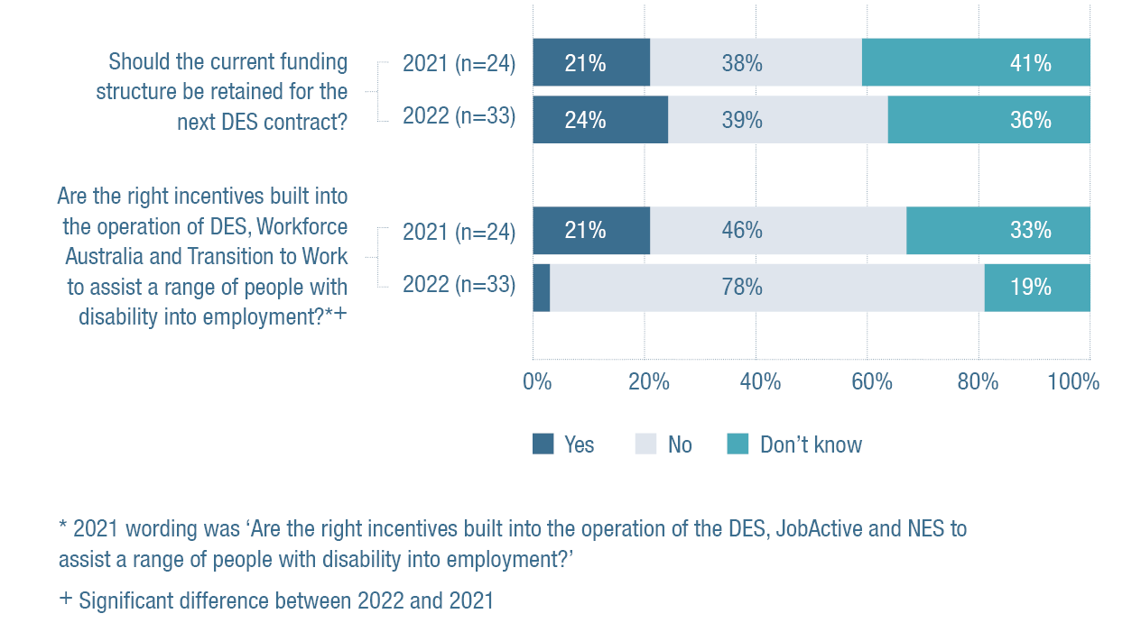
Should the current funding structure be retained for the next DES contract? | 2021  n=24 | 2022  n=33
Yes | 21 per cent | 24 per cent
No | 38 per cent | 39 per cent
Don't know | 41 per cent | 36 per cent

Are the right incentives built into the operation of DES, Workforce Australia and Transition to Work to assist a range of people with disability into employment?*+ | 2021  n=24 | 2022  n=32
Yes | 21 per cent | 3 per cent
Don't know | 33 per cent | 19 per cent
No | 46 per cent | 78 per cent
Over one-third (39 per cent) of respondents did not believe that the current funding structure should be retained for the next DES contract, while around 24 per cent did and 36 per cent were unsure. Respondents cautioned:
‘The long-term viability of DES is in question; the funding model needs to shift to 1:1 support only to produce real outcomes.’
NSW medium not-for-profit
‘Providers are gaming the system to get the funding they need rather than providing person-centred services that help participants achieve long-term, sustainable employment outcomes.’
Vic large not-for-profit
‘All wage subsidies should be removed from the contract – to stop providers paying for jobs and buying outcomes.’
ACT medium not-for-profit
‘Funding is not competitive relative to other employment contracts with government (e.g., wage subsidy differences between contracts).’
NSW medium not-for-profit
The majority of respondents (78 per cent) did not believe that the right incentives to assist a range of people with disability into employment are built into the operation of DES, Workforce Australia and Transition to Work. This is a notable and statistically significant increase on last year, where only 46 per cent held this view.

Supported employment operating environment
This year, only 18 per cent of supported employment providers agreed or strongly agreed that the current operating environment for supports in employment providers is more certain than it was 12 months ago. Over half (56 per cent) did not agree with this statement. Respondents commented:
‘The new framework is overly complex from an administrative basis (and) thus margins have decreased further. Supported employment is clearly not favoured and under escalating pressure. Nothing is being done to encourage improved transition to open employment or to recognise that a lot of people with disability simply do not want to be in open employment.’
WA large not-for-profit
‘We have lost 50 per cent of our workforce since the commencement of the NDIS as work is no longer a priority and for-profit providers and LACs are actively discouraging people from working so they can attend their non work options. Instead, they go as far as telling people to stop allowing us to rip them off.’
NSW medium not-for-profit
Similarly, barely one-third (36 per cent) of respondents agreed or strongly agreed that the transition to the NDIS has enhanced their capacity to provide employment opportunities. Forty-two per cent of respondents disagreed or strongly disagreed with this statement.
Finally, almost half (45 per cent) of respondents agreed or strongly agreed that their organisation can provide the support required for individuals under the NDIS pricing arrangements. Over one third (34 per cent) of respondents disagreed or strongly disagreed with this statement. One commented:
‘The pricing arrangements are the lowest in the sector for the delivery of disability supports and could definitely be increased to ensure greater capacity for service delivery.’
NSW medium social enterprise

Employment sector update
NDS sought feedback this year from supported employment providers on their headline issues. These included the outcome of the SES Award review and wage setting arrangements for supported employees, business sustainability, difficulty recruiting supported employees, and NDIS compliance and red tape.
During a three-day hearing in April 2022, the Disability Royal Commission (DRC) also examined the experiences of supported employees in disability enterprises. NDS provided evidence to the DRC during this hearing.
A large provider of supported employment in Western Australia announced a significant number of supported employee redundancies, prompting the new federal government to announce a relief package designed to support those losing their jobs into alternative employment and day support options. NDS has been working closely with both supported employment providers and other disability services through its membership of the taskforce set up to manage the transition.
NDS members continue to focus on ways to broaden their provision of employment supports and services, while being guided by the principles identified in our industry vision for the sector. A new vision reference group was established that better reflected a broad range of expertise and views on the future of the supported employment model.
Other key issues for the sector are the difficulty some providers are experiencing in recruiting supported employees. NDS remains extremely concerned that the size of the supported employment workforce has contracted significantly, last being reported by the NDIA as being below 16,000. This represents a contraction of around 20 per cent over the last few years. This contraction is also reflected in a stagnant NDIS participant employment rate of 22 per cent, well below the target rate for June 2023 of 30 per cent.
The outlook for DES providers has improved following the re-opening of the economy, but the inflexibility of the DES program continues to hinder their delivery of employment supports. NDS has heard from DES providers that their headline issues include the DES reform agenda and the timing of the new contract, the general level of compliance, excessive claim compliance and the Right Fit for Risk IT security requirements.
A formal performance assessment for DES providers conducted by DSS in 2022 (Department of Social Services, Australia, DES Monthly Report – 30 June 2022
(10 July 2022), accessed 8 November 2022.) saw 52 providers lose some business, while about 15,000 participants will need to move to a new provider. It is important to note that the FPA was always scheduled to be conducted during the current contract and was not connected to the DRC’s examination of the DES program.
DSS, industry peak bodies (including NDS) and providers contributed to some important work illustrating good practice in open employment service provision. NDS has been active in guiding the development of the new DES contract which will now commence mid-2025. Particularly through our role on the DES Reference Group, which is charged with leading the DES reform process.
DES participant numbers continue to fluctuate, with clear evidence that younger participant numbers are down, while older participant numbers continue to increase. The most numerous age cohort now in DES is the 55-64, with almost 29 per cent of the caseload.
The removal of two previously eligible DES cohorts has seen total program numbers decrease by 22,720 in 2021-22. NDS has concerns that these participants may not be adequately serviced by Digital Services or Workforce Australia. NDS will continue to advocate that jobseekers and employees with disability are able to access the DES program, if it is the service model that best meets their needs.
Both open and supported employment providers are cautiously optimistic that a new federal government will be more willing to heed their feedback and to investigate practical disability employment policy reform.

The state of the broader policy environment

Number of DSP recipients increases following 2021 COVID restrictions
According to DSS data, (Department of Social Services, Australia, DSS Demographics – June 2022 (26 August 2022), accessed 8 November 2022.) the number of DSP recipients rose by 11,958 over the 2021-22 financial year, the largest increase in over a decade. The increase follows significant economic and labour market disruption caused by severe COVID restrictions imposed in NSW and Victoria from mid-2021. Encouragingly, the number of DSP recipients reporting earned income recovered across the course of the year, starting at 6.9 per cent in July 2021 and dipping to 6 per cent in the September 2021 quarter (the lowest rate in decades) before finishing at 6.8 per cent as of 30 June 2022.
Unfortunately, the rate of earned income by DSP recipients has been stagnating at around seven per cent since mid-2020, down from previous average rates of around 8.1 per cent since mid-2014. These figures highlight yet again the importance of government policy initiatives and strategies that encourage increased workforce participation by people with disability. DSP recipients can be encouraged to gain work by providing better information on how earned income affects their welfare benefits and easing disincentives by giving them access to the pensioner work bonus.

New workforce plan for the sector
The new government will develop a new workforce plan for the disability sector (and pleasingly, workforce is a key area of focus in the NDIS review). At a time when unemployment rates have hit an all-time low and demand for workers across the care and support sectors is predicted to continue its upward trajectory, we need a coordinated and integrated response to lessen competition for workers.
The October 2022 Federal Budget included a commitment to establishing Jobs and Skills Australia and there are significant opportunities for this new body to drive through whole-of-government strategies that address barriers to workers entering and remaining in the sector. This response will depend on improved workforce data.
Workforce and training solutions must be developed in partnership and led by the sector to be effective. Training that does not respond to the needs of employers or the end users of supports will not result in the outcomes that the community expects from the sector or from government.

National Disability Strategy sets ambitious agenda
Rebadged ‘Australia’s Disability Strategy’ and with a much-needed outcomes and reporting framework, the strategy sets an ambitious agenda for a more inclusive and accessible Australian community.
Targeted action plans have been developed to support work over the next 12 months in the areas of employment, early childhood, safety and emergency management and community attitudes. However, with no outcomes reports available and funding for the strategy unclear, how well we are progressing is yet to be determined.
Modern Award reviews demonstrate inconsistent outcomes
Reviews by the Fair Work Commission (FWC) of two modern awards covering the disability sector – the SCHADS Award (covering community services workers) and the SES Award (covering employees of supported employment services) – each experienced significantly different outcomes during 2021-22.
After many years of complex negotiations and proposed wide-reaching changes to pay and conditions, the SCHADS Award review concluded. The outcomes of the review saw new or changed provisions covering minimum shifts, guaranteed hour reviews for part-time employees, a soiled clothing allowance, remote response work, broken shifts, client cancellation, overtime for part-time and casual staff and the payment of employee travel time between shifts or client appointments.
Following submissions by the employer parties (including NDS), the Fair Work Commission postponed the most extensive changes affecting employer costs until October 2022. NDS also worked closely with members to ensure that the effects of the changes were fully understood by providers.
The review of the SES Award is finally nearing completion with the FWC releasing a Decision in November 2022 confirming the inclusion of its originally proposed wage structure through a draft variation of the Award. The most important matter covered during the review – the payment of wages to employees with disability will be determined by a new classification structure containing two grades for employees with disability, seven mainstream grades and the inclusion of SWS assessments for those employees whose productivity is reduced by their disability. The FWC will allow one final round of written and oral submissions, closing in December 2022 and is then expected to deliver a final determination on the future of wage setting in supported employment shortly afterwards.

New South Wales

Case study
Belinda Colombrita
McCall Gardens

Tell us about McCall Gardens
Based in north-west Sydney, McCall Gardens provides supported independent living, specialist disability accommodation, support coordination, community activities, inclusive play options and school holiday programs, as well as before-and-after school supports for children with disability.
We operate ten purpose-built group homes, a community centre at Box Hill and an inclusive play centre for people of all ages and abilities.

What’s been your proudest achievement?
We are very excited that our team has been able to commit $40 million to redevelop our community centre. We will soon be providing allied health, community participation, swimming school, hydrotherapy, sensory gardens, a café and a vast outdoor landscaped area to enjoy the rural setting with family and friends.

What does an average day look like?
No two days are the same. With the redevelopment, McCall has a dual focus at the moment and I’m needing to devote a great deal of time to work on the sale of a large portion of our land at Box Hill, and the redevelopment of roughly four hectares.

Has the past year been more or less challenging than most?
Probably less. Although after year one of COVID, I think that our baseline for what is considered challenging has shifted!

What are the major opportunities?
The NDIS has already provided so many opportunities for people with disability. It’s definitely made providers change the way they do business and provide more dynamic services. It’s forced the entire sector to think differently and become more professional and commercially focused.
With that shift, the sector now offers the workforce a broader range of opportunities.

What are the major challenges?
Attracting, training, developing and retaining a skilled workforce is the major challenge our sector, and, indeed, many others will continue to face over the next two or three years. This challenge can be addressed by creating great opportunities and career paths in this sector, so that we are not simply competing with health and aged care workers.
Secondly, while we wholeheartedly support compliance and regulation, we are operating in a market where unregistered providers can provide just the same service, but with very little oversight and additional costs.

Why did you get into the sector?
A general manager of disability services provider sought my assistance for a particular task. It was a rewarding and fulfilling short term contract that awakened my desire to work in the sector. Twenty years later, I still believe that it is the best job in the world!

What’s surprised you most?
When I entered the disability sector back in 2002, funding was very limited, and services providers like McCall had to operate on the smell of an oily rag.
Despite that, there were so many individuals, staff and families ready and willing to give up their time to fundraise, paint houses and provide additional supports (and so much more) to people in need of care and assistance.

What’s impressed you most?
People are always willing to share and support each other. During the past two COVID years, providers have really rallied together. Although it was the most challenging time I have experienced in my career, I always knew that I had a network to call on.

NSW sector stats
165,811 Active participants including ECA
4,756 Active ECA participants
8 per cent NDIS participants are Indigenous
10.9 per cent Culturally and linguistically diverse

Top three issues

Workforce
In speaking with service providers about issues, time and time again the response is ‘workforce, workforce, workforce.’ The issue relates to both attraction and retention of workers. The problem extends to Allied Health services, where there is much discussion across the sector around waiting times to get appointments for necessary supports.

Administrative burden
Excessive administration burden remains a challenge. The requirement of dual reporting to both the NSW Government and NDIS Quality and Safeguards Commission, the need to renegotiate service agreements resulting from sudden changes in participant’s plans, quality audit activities and recruitment activities all add to the drain on already stretched resources and result in increased cost of delivery.

Financial viability
Financial sustainability was a major issue for a great many services during the state’s 2020-21 COVID lockdowns – and 2021-22 has not been much better in the absence of a JobKeeper-style scheme.

Victoria

Case study
Haley Dean
Melba Support

Tell us about Melba
Melba is a not-for-profit Victorian-based provider from the outer east of Melbourne. We are celebrating our 50th birthday this year. We’re well known for our outcomes-based human rights approach and for supporting people with complex needs.

What has been your proudest achievement?
We became a registered NDIS provider in 2015 and during the next two years more than quadrupled in size. And then COVID hit. So, we’ve had lots of big and unprecedented changes. I’m immensely proud of our fabulous staff and their ongoing resilience, commitment and dedication.
If I had to pick out one moment that filled me with pride, it was when I was finally able to go and visit a woman we support who had moved into her own home. Melba and a community housing provider built the townhouses and apartments through COVID. This person finally had a home of her own, where she had the freedom to do what she wanted, when she wanted, and was now directing her own supports. When she invited me in to see her home recently, that was a great moment.

What does an average day look like?
There is no average day! I start my day with exercise at 6am, emails at 7am and then review priorities and what the day holds. That might be presenting the human rights and zero tolerance section of our induction program, or meeting a group of people supported by Melba and their families, or reviewing different models of service.

Has the past year been more or less challenging than most?
My first reaction is more – but it’s a different challenge. The peak of COVID was a very reactive, adrenaline-fuelled environment where everyone just had to pull together and get through it. It went on for longer than we had hoped, but we did incredibly well. Now we are experiencing some fallout, including a very tired workforce. Thankfully, we are seeing some welcome changes to what has been a volatile NDIS.

What are some of the major opportunities?
Some people only know the NDIS and are looking for innovation, responsive flexibility, creative solutions and options. So, I think that we live in exciting times. ‘Challenging’ doesn’t have to be a negative word. Every challenge presents an opportunity.

What surprises you about the sector?
What surprises me most is that we don’t see more disruption. I’d particularly like to see more innovation driven by people with disability.
For all its operational challenges, the NDIS is philosophically fantastic. The power is in the hands of the person who can vote with their feet. As providers, it often feels we are just tinkering around the edges of systems and programs that have been around forever and weren’t created by people with a disability.
I’m surprised that there’s not more responsive innovation. You don’t want to be a Blockbuster. You want to be a Netflix.

What’s impressed you most?
We’re a sector that pulls together when required and always does what’s needed.
I think COVID was a fabulous example of incredible individuals from different parts of the sector being willing to help each other. It’s not about competing; it’s about enabling better lives for people with a disability.

Why did you get into the disability sector?
Serendipity! I was 15, and a job experience placement accidentally sent me to the wrong place. It turns out it was the right one!

Vic sector stats
145,462 Active participants including ECA
3,222 Active ECA participants
3.2 per cent NDIS participants are Indigenous
11.8 per cent Culturally and linguistically diverse

Top three issues

Economic viability
Regular NDS polling indicates that economic viability is a major concern, with many members facing challenging budget situations. Day services are experiencing particular challenges with the shift to the new pricing model, and reports of some participants who have chosen not to return to services after the pandemic lockdowns. Short term measures such as JobKeeper payments and one-off NDIS funding have been welcome, but do not address the underlying multiple pressures impacting the market.

Mental health and wellbeing
The extent of pandemic restrictions in Victoria has resulted in an exhausted workforce. Participant routines were disrupted during lockdowns, and providers report continuing mental health effects.

Onerous reporting
The Victorian government’s laudable commitment to quality and safeguarding has increased reporting requirements and resulted in a complex tangle of administrative requirements. The overlay of state and federal bodies interested in reporting, and limited information protocols between such bodies, continues to pose a challenge to NDS members.

State and territory sector statistics: NDIS Quarterly Report to disability ministers (30 June 2022) © National Disability Insurance Agency. ndis.gov.au, accessed 6 September 2022
Publisher
National Disability Services
Laurie Leigh
CEO
03 8341 4343
laurie.leigh@nds.org.au
All rights reserved. No part of this publication may be reproduced, distributed or transmitted in any form without the prior written permission of the publisher. Except in the case of brief quotations embodied in critical reviews and certain other non-commercial uses permitted by copyright law.
About National Disability Services
National Disability Services is Australia’s peak body for non-government disability service organisations, representing over 1000 service providers. Collectively, NDS members operate several thousand services for Australians with all types of disability.
Acknowledgements
The 2022 Annual Market Survey was carried out by Professor Jennifer Smith-Merry, PhD, and her team at the Centre for Disability Research and Policy at the University of Sydney
Thank you to members who participated in our case studies.
National Disability Services acknowledges the Traditional Owners and Custodians across the lands in which we live and work and we pay our respect for Elders past, present and emerging.

