State of the Disability Sector Report 2021
[Cover page]
Frustration. Pessimism. Confusion. Distress. Disability service providers have had a difficult year, and most don’t expect 2022 will be all that much better.

Cover art
Artist name: Philip Truett
Title: Untitled

About the Artist:
Philip Truett (b 1960, Melbourne) is a painter whose work presents a nuanced understanding of paint mediums and colour combinations. Often harnessing the delicacy of ink wash and nib in his compositions, he builds layers of repetitious lines and colour to produce artworks that are rich and ephemeral. Truett has worked at Arts Project since 2005 and had his work exhibited in group shows in Melbourne. His work is held in private collections throughout Australia.

Contents
Cover art 2
Contents 3
The state of play 3
The way forward 6
Case study: Tasmania 9
Case study: South Australia 12
The state of the operating environment 16
Case study: Australian Capital Territory 48
Case study: Victoria 51
The state of the NDIS 54
The state of disability employment 57
The state of the workforce 62
Case study: Queensland 71
Case study: Northern Territory 74
The state of the Royal Commission 76
The state of the broader policy environment 78
Case study: New South Wales 80
Case study: Western Australia 83

The state of play
This time last year, many Australian businesses must have felt like they were staggering to the finish line after a year spent dealing with the challenges of COVID.
Little did they realise that the race was just getting started – and that 2021 would feel more like a marathon.
While every industry has had its struggles this year, and been forced to operate in new and often difficult ways, the disability sector has been disproportionately affected. The three big themes of this year’s Annual Market Survey Report are pessimism, frustration, and distress. Disability service providers are seriously concerned about the future, and their frustration has at least four causes.
Source number one of concern is the NDIA itself. One of the starkest findings of this year’s report is just how few providers think that the Agency interacts well with them or regard its processes with anything close to approval. Just 12 per cent told us that they think the NDIA works well with providers, less than half of the number last year. Meanwhile, a full 59 per cent feel that it imposes ‘too many unnecessary rules and regulations’, and even more object to its ‘systems and processes’.
As for the policy reforms that are underway, only 25 per cent feel that they’re heading in the right direction.
Money worries were the second source of concern. While all over Australia, trading conditions and business sentiment are rebounding, according to the last survey from the Australian Bureau of Statistics, a deep sense of financial pessimism for the disability sector pervades our Report.
Sixty-five per cent of providers say that operating conditions are getting worse, up from 61 per cent in 2020 and 38 per cent in 2019.
Only around a half (57 per cent) of those that recorded a profit in 2021 expected to make a profit in 2022.
Some providers note that JobKeeper led to ‘artificial profits’ this year, or at least helped them to break even instead of making loss. Many fear the coming year, when such government supports will be a thing of the past
Providers’ third big concern centres around labour shortages. Recruiting and retaining workers has been an issue for all industries this year, thanks to the closing of international borders. In the latest ABS survey, some 27 per cent of all Australian businesses reported difficulty finding staff to fill jobs.
But here again, the disability sector seems to be doing it tough. In our survey, an extraordinary 70 per cent of providers reported problems recruiting support workers, up even further from the still significant 59 per cent in 2020.
In 2021, it became even harder for organisations to recruit occupational therapists and disability support workers and recruitment of speech therapists, psychologists and physiotherapists remained challenging.
Our survey’s fourth major source of concern relates to innovation – and the current system’s failure to provide the conditions to enable it to flourish. It’s hard to escape the conclusion that the pricing arrangements we have now, together with a general sense of policy uncertainty, have been making it extremely difficult for providers to think far ahead – let alone plan for, and invest in, the future. To put it simply, it is hard to move forward when you spend all your time and effort on simply staying afloat.
This is a problem because the bar is rising all the time. Participants and their families expect services to improve every year – and, indeed, this is what they deserve.
This survey has much to say to the politicians and Agency setting the policies and conditions for the disability sector. We very much hope it is heard

The way forward
- Draw on the knowledge and experiences of providers
It is pleasing to see a greater emphasis on co-designing scheme improvements with participants. This needs to be extended to providers, who play an essential role in delivering the scheme stakeholders want and in scheme success.NDIS price models that reflect true costs
Pricing and price models that are based on realistic assumptions, following service sector input and consultation.
- Develop transparent and accurate cost models for all NDIS supports
Accurate, transparent and fit-for-purpose cost models need to be developed for all NDIS supports. The over-reliance on the Disability Support Worker Cost Model generates price limits not suited to some supports. How price limits are set for other supports are opaque.
- Increase the level of supports being purchased by NDIS participants in remote areas
One of the biggest disappointments of the NDIS has been that the delivery of supports in remote and very remote areas lags well behind the rest of Australia. NDS urges the NDIA to work with providers in remote and very remote areas to find solutions to improve supply.
- Work with adjacent sectors to respond to acute allied health shortages
The disability, health, aged care and veteran affairs sectors are all experiencing difficulties in attracting and retaining essential allied health workers. A collaborative plan to address shortages is urgently required.
- Invest in the NDIS National Workforce Plan: 2021-25
The release of the National Workforce Plan was welcomed by the sector, which is reporting acute workforce shortages. It now needs solid investment in co-ordinated initiatives to address the multiple workforce challenges.
- Facilitate the delivery of quality and safe supports
Provide information and training to the sector to drive quality and safeguarding improvements. Require all workers who directly support participants to have an NDIS Worker Screening Check. Learn from the hearings of the Disability Royal Commission and implement actions that will safeguard people with disability and improve the quality of the supports they receive from specialist disability and mainstream services.
- Create a stable NDIS operating environment
After eight years, it is disappointing that so many NDIS processes and systems are still being reviewed and reformed. This work needs to be fast-tracked, in consultation with all stakeholders, and a more stable NDIS be in place.
- Better connect NDIS pricing and funding with NDIS Commission requirements
NDIS pricing does not adequately cover the cost of NDIS Commission requirements, which will become more pronounced when the practice standard on emergency management is introduced; this must be addressed. In addition, rapid plan adjustments to make funding available for a positive behaviour support plan or swallowing assessment must be implemented.
- Hold all governments to account for outcomes under the Australian Disability Strategy
It is exciting to see Australian Governments commit to a performance framework to measure the impact of the Australian Disability Strategy. Activities and initiatives to drive better outcomes for all people with disability need to begin in earnest.
- Encourage and support employment ambitions among young people with disability
It is essential that there is an early connection to the world of work for young people with disability while at school, including the supports required to participate in the workforce. An emphasis on skills acquisition and work aspiration will help achieve sustainable sustainable and rewarding employment outcomes.
- Close the gap between the employment rates of people with disability and that of the rest of the population
Ensure the design of the new DES program allows for a flexible approach to the provision of relevant support. Funding should reflect the real cost of service provision, including providers’ efforts to train, place and support people with disability. The Federal Government should provide additional incentives for employers to employ people with disability. Australian governments should set quotas for employment of people with disability in their public services. Governments at all levels should also mandate procurement targets from social enterprises that employ people with disability.

Case study: Tasmania

John Gilpin, CEO, St Michaels

Tell us about St Michaels
We started up as a special school for people with dyslexia in 1966 and became a community disability support provider back in 2000 for people with intellectual disabilities, psychiatric disabilities, learning difficulties and difficult behaviours.
From there, we’ve grown quite substantively and now offer multiple accommodation options all over Northern Tasmania, as well as personal support programs, day programs, community access programs and employment linking programs.
‘Developing independence’ is our tagline. We concentrate on the things that people can do rather than the things they can’t.

What has been your proudest achievement?
A good support worker, actively engaged with the participant, is just such a wonderful thing to see. We’ve gone from 30 odd staff to nearly 200 in the last ten years, so I’m also really proud of how we’ve been able to grow and support and train all our people.

What does an average day look like?
We’re have been expanding into Tasmania’s north-west coast, and that’s been a big recent focus. Eighteen months ago, we had no property (there), no staff and no participants. Now we have 50-odd participants and 25 staff there, offering day services, in-home support and various community access program, plus we’re building 16 independent living units.
My day consists of working with families, participants, behaviours, incidents, vacancies (staff and participants), building codes, training all while keeping an eye over the strategic helm of the Association.

What do you think are some of the major opportunities awaiting the sector?
There’s opportunity to have more pathways for people regarding accommodation. Housing shortage is still a big issue, in my opinion.

What do you think are some of the major challenges facing the sector?
The NDIS and the Agency have a funding and processing and service model problem. The NDIS Safeguards Commission are pushing the idea that every time there is something wrong, you’ve got to put a complaint to them. They’re becoming a regulator seeking their own empire. They’re becoming a punitive body, rather than one that’s supportive.
The paperwork for a support worker is immense now and makes it hard to keep staff engaged. All they (Support Staff) want to do is work closely with participants, to see them smile and get enjoyment out of life, instead of having to spend all their time sitting down and filling out forms.

Why did you get into the disability sector?
I started out in Vocational Education and Training and various Registered Training Organisations. A job came up in disability employment and I ended up finding it very, very fulfilling.
It was just really rewarding to help people who had been marginalised and excluded from the community and be able to help them and promote them and get them in there and amongst it.

What’s impressed you most?
I think it’s the frontline people and their ability to do what they do, day in and day out. Their range of skills, their patience, their loyalty, their empathy, their resilience. It’s inspiring.
They are the ones with the heavy commitment. All that we in management need to do is just keep the road clear for them by removing the roadblocks!

Key issues
- Housing
The lack of diverse housing options for people with disability in Tasmania is currently compounded by delays in NDIS participant plan processing. These delays mean that the needs of people with disability, particularly those with complex needs, are not being met.
- Mainstream interface
Tasmanian mainstream services are not attuned to the diverse needs of people with disability. There continues to be issues with interface between the NDIS and mainstream services, particularly health. There is a lack of depth of support for transitions in and out of mainstream services.
- Workforce
A skilled, sufficiently large and diverse disability workforce is critical to the delivery of high-quality services and the success of the NDIS and other disability services in Tasmania. With high forecasted demand for the future, a larger workforce is needed to meet this demand. With adequate investment, the disability sector can help drive employment and economic growth in Tasmania.

Tasmanian Sector Stats
Active participants including ECA: 11,358
Active ECA: 278
NDIS participants are Indigenous: 8.8 per cent
Culturally and linguistically diverse: 3.1 per cent

Case study: South Australia

Michelle Holian, Lighthouse Disability

Tell us about Lighthouse
Lighthouse Disability’s origins are in the northern suburbs of Adelaide, South Australia. In 1989, a group of parents whose sons and daughters lived in a state-run nursing home, saw that a different kind of accommodation and new standards of care could help people with disability fully realise their potential and improve their quality of life. We have now grown to 27 houses, with capacity to support over 90 adults with complex and diverse disabilities. Our other services have also grown too and now include support coordination and plan management.
We have now grown to 27 houses, with capacity to support over 90 adults with complex and diverse disabilities. Our other services have also grown too and now include support coordination and plan management.

What has been your proudest achievement?
Over the past 12 months we have welcomed a number of new Support Workers to our team, resulting in reduced reliance on external agency workers. As a result, we have improved the continuity and consistency of supports for our clients.

What does an average day look like for you?
My days are varied and busy, but also very rewarding. It is full of engaging with clients, families, and staff to ensure our key focus – supporting people with disability to live their life, the way they want to, is being achieved.
I also work closely with our board to support their effective governance of the organisation. This includes continuously improving on our data analysis and reporting and updating them on progress we have achieved.

What do you think are some of the major opportunities awaiting the sector?
The introduction of the NDIS has been, without doubt, the biggest social reform since Medicare and has brought with it many advances to the wellbeing of people living with disability. Many people have been provided with access to supports they may not have had under the previous block funding model. Yet working within the framework can be daunting and the process of receiving plan reviews for changing support needs can take a long time for clients, families and providers. Clients and families would benefit from the process for accessing NDIS funding to be more transparent to navigate and faster than they currently experience.

What do you think are some of the major challenges facing the sector?
Supported Independent Living (SIL) funding is integral to people with disability living their life as independently as possible. However, changes to funding experienced by SIL providers this this year create a risk to financial viability, especially for providers that have SIL as their main service stream.

Why did you get into the disability sector?
Growing up, both of my parents lived with polio, so I have been close to their experience of living with disability. My whole career has been in organisations with a community service and social justice focus, so working in the disability sector aligns well with both my personal values and professional experience.

What’s surprised you most?
People might think that smaller organisations, supporting fewer clients, would be easier to manage. In my experience, that is not the case. Smaller organisations face the same service delivery challenges as larger organisations, but with fewer resources.

What’s impressed you most?
There are so many incredible people who work in the disability sector. I continue to be impressed by people who are 100 per cent person-centred in the way they provide services and have seen first-hand the rich and positive relationships our staff members have with their clients.

Key issues

Reductions in SIL funding
SA providers are consistently reporting, reductions in SIL packages for individual participants. Oftentimes, these reductions occur without any consultation, and leave providers organizations with unviable support packages. NDS will continue to advocate for consultation with the sector and a change to the decision making process for SIL packages.

Financial sustainability and business planning
In the current NDIA climate it is very difficult to plan for the future or to even set budgets given today’s policy and process may not be the same or interpreted in the same way tomorrow. These things have a compounding effect and lead to financial instability and challenging business planning for organisations trying to operate across the sector.

Quality and safeguarding systems
SA service providers are experiencing an increasingly burdensome Quality and Safeguarding Framework. The NDIS Commission has markedly ramped up compliance requirements to the point where the demands for responses to reportable incidents cost significantly more than current pricing would accommodate.
Additional responses to incidents are being sought by the Commission up to 12 months after an incident has been reported and often involve doubling up of information already provided. There is even evidence of non-compliance notices being served for incidents that had previously been closed.

SA Sector Stats
Active participants including ECA: 43,166
Active ECA: 700
NDIS participants are Indigenous: 6 per cent
Culturally and linguistically diverse: 7.2 per cent

The state of the operating environment

About the Annual Market Survey
This section analyses the results of NDS’s 2021 Annual Market Survey of disability service providers across Australia. The Centre for Disability Research and Policy at the University of Sydney conducted the ninth wave of NDS’s Annual Market Survey in partnership with NDS.
A total of 396 valid responses were received from all over the country, 78 per cent of them from not-for-profit providers.
Of these respondents:
• 21 per cent had incomes of over $20m
• 33 per cent had incomes between $5m and $20m
• 29 per cent had incomes between $1m and $5m; and
• 17 per cent had incomes of less than $1m.
It is also worth noting that:
• 97 per cent provided NDIS-funded services
• 78 per cent had pre-NDIS experience of providing disability services and supports
• 22 per cent were formed after 2014 (ie in the NDIS era)
• 19 per cent provided supported employment through an Australian Disability Enterprise (ADE); and
• 9 per cent provided disability employment services through jobactive, a New Employment Services Model program and/ or a Disability Employment Services (DES) program.
Most respondents either provided services as a company (49 per cent) or as an incorporated association (41 per cent), while the remainder operated as sole traders (4 per cent), trusts (4 per cent) or in partnerships (1 per cent).

Attitudes towards the NDIS
The results of this survey show high levels of pessimism amongst respondents about both the current operation and future of the NDIS. This pessimism relates to decision making by both the NDIA and government.
When asked if NDIS policy reforms were heading in the right direction, only 25 per cent of respondents agreed with this statement in 2021, compared to 51 per cent in 2020. This is a significant decline in trust and confidence in government policy-making in support of the NDIS. Not-for-profit providers established prior to 2014 (when the NDIS was established) were more likely to disagree with this statement, but there was no difference for organisational size or state/territory of operation.

Figure 1: NDIS policy reforms are heading in the right direction
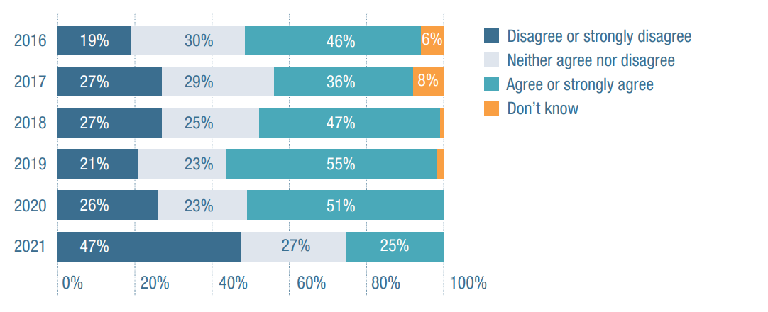
2016
Disagree or strongly disagree: 19 per cent
Neither agree nor disagree: 30 per cent
Agree or strongly agree: 46 per cent
Don’t know: 6 per cent
2017
Disagree or strongly disagree: 27 per cent
Neither agree nor disagree: 29 per cent
Agree or strongly agree: 36 per cent
Don’t know: 8 per cent
2018
Disagree or strongly disagree: 27 per cent
Neither agree nor disagree: 25 per cent
Agree or strongly agree: 47 per cent
Don’t know: 1 per cent
2019
Disagree or strongly disagree: 21 per cent
Neither agree nor disagree: 23 per cent
Agree or strongly agree: 55 per cent
Don’t know: 1 per cent
2020
Disagree or strongly disagree: 26 per cent
Neither agree nor disagree: 23 per cent
Agree or strongly agree: 51 per cent
Don’t know: 0 per cent
2021
Disagree or strongly disagree: 47 per cent
Neither agree nor disagree: 27 per cent
Agree or strongly agree: 25 per cent
Don’t know: 1 per cent
The NDIS policy environment is still in its establishment phase. While full scheme maturity has been formally achieved, in reality there are frequent changes to the policy and operating environments. These changes are evidenced by ongoing changes to operating guidelines and refining of programs, including supported independent living (SIL) and supported employment. This means that providers are still engaged in establishment activities when they should be consolidating their NDIS service strategy.
In the survey, an overwhelming 81 per cent of respondents agreed or strongly agreed that the NDIS policy environment is uncertain, compared to 69 per cent in 2020. This sentiment was uniform across different sized organisations and not-for-profit and for-profit providers. Typical comments included:
“the environment is too uncertain to determine strategic direction” and “the operating [environment] is very uncertain and we need further long-term clarity’”
“additional requirements and increased employee wages/super are not being matched by increasing NDIS prices”; and “constant changes to the price guide creates additional finance/admin work which is not paid for within the prices”

Figure 2 The NDIS policy environment is uncertain
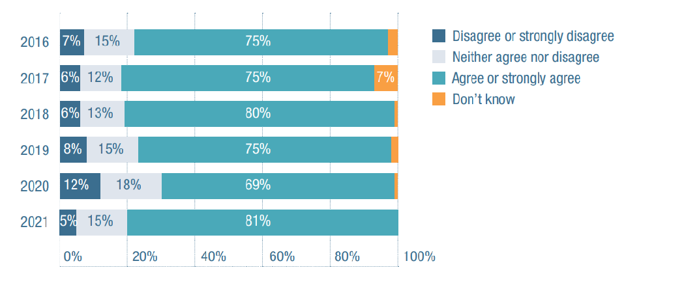
2016
Disagree or strongly disagree: 7 per cent
Neither agree nor disagree: 15 per cent
Agree or strongly agree: 75 per cent
Don’t know: 3 per cent
2017
Disagree or strongly disagree: 6 per cent
Neither agree nor disagree: 12 per cent
Agree or strongly agree: 75 per cent
Don’t know: 7 per cent
2018
Disagree or strongly disagree: 6 per cent
Neither agree nor disagree: 13 per cent
Agree or strongly agree: 80 per cent
Don’t know: 1 per cent
2019
Disagree or strongly disagree: 8 per cent
Neither agree nor disagree: 15 per cent
Agree or strongly agree: 75 per cent
Don’t know: 2 per cent
2020
Disagree or strongly disagree: 12 per cent
Neither agree nor disagree: 18 per cent
Agree or strongly agree: 69 per cent
Don’t know: 1 per cent
2021
Disagree or strongly disagree: 5 per cent
Neither agree nor disagree: 15 per cent
Agree or strongly agree: 81 per cent
Don’t know: 0 per cent
Despite this uncertainty, only 26 per cent believed that the risks the NDIS poses to their organisation outweigh the opportunities. Not-for-profit organisations were more likely to agree with this statement. Uncertainty was not the only common sentiment among respondents. Stress and frustration were also a theme, along with a general sense that NDIS’s original values have been in some way betrayed. Much of this frustration centred around the NDIA’s trial and eventual abandonment of independent assessments (or at least independent assessments of the type then proposed), as evidenced by comments like:
“the level of distress caused by the focus on independent assessments over the last 12 months has had a negative impact on participants, families and carers we support and that has also flowed through the organisation.”
The sentiment expressed about the independent assessments process likely flowed into the overall assessment of the NDIA-provider relationship by respondents in this round of the survey. The independent assessments debate sat alongside a political discussion about scheme affordability. This ‘affordability’ question remains central to some of the decision making around the scheme, including the pricing of the SIL and ADE programs.
Respondents report increased demand and hours provided in most areas, which equates to money flows from the scheme to providers. Scheme affordability is therefore a shared interest of the government, the NDIA and providers – the ongoing viability of each is dependent on getting the pricing right. Fifty-eight per cent of providers, however, either agree or strongly agree that pricing is not right and are worried they won’t be able to provide NDIS services at current prices. Not-for-profit providers (compared to for-profit providers) and small, medium and large organisations (compared with very small organisations) were more likely to agree with this statement. Only 21 per cent are not concerned about their ability to provide services at current prices.
There also remains a trust deficit between the sector and the NDIA. Just 12 per cent of respondents believed that the NDIA was working well with providers, with 61 per cent disagreeing. This was a decline from last year, suggesting a deteriorating relationship between the NDIA and providers. For-profit providers were more likely to believe that the NDIA was working well with them.
Sixty-five percent of respondents disagreed with the statement that the systems and processes in the NDIS were working well and 59 per cent believe that there are too many unnecessary rules and regulations that organisations need to follow. These are ongoing concerns similarly expressed over the last three years.
Typical comments included: “the NDIA continues to demonstrate a lack of transparency about its modelling on scheme costs and projections ... we do not have a clear understanding of what the cost pressures are ... this creates a lack of trust within the sector”; and “I think everyone is so stressed and under the pump that there is an increasing level of distrust or perhaps just a lack of trust - I think this is symptomatic of a bit of divide and conquer attitude of the NDIA”.
Almost all respondents (96 per cent) were currently registered and providing NDIS services. Just three organisations indicated that they had previously offered NDIS services and were no longer doing so; two organisations were not interested in moving into the provision of NDIS organisations. This shows that the operation of the disability sector remains inextricably tied to the NDIS.

Figure 3 We are worried we won’t be able to provide NDIS services at current pricing
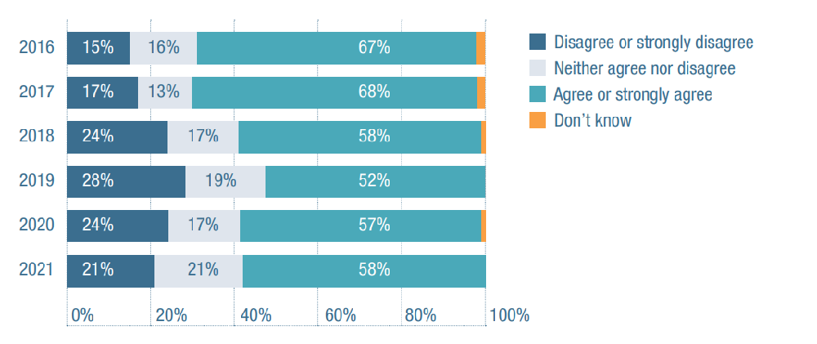
2016
Disagree or strongly disagree: 15 per cent
Neither agree nor disagree: 16 per cent
Agree or strongly agree: 67 per cent
Don’t know: 2 per cent
2017
Disagree or strongly disagree: 17 per cent
Neither agree nor disagree: 13 per cent
Agree or strongly agree: 68 per cent
Don’t know: 2 per cent
2018
Disagree or strongly disagree: 24 per cent
Neither agree nor disagree: 17 per cent
Agree or strongly agree: 58 per cent
Don’t know: 1 per cent
2019
Disagree or strongly disagree: 28 per cent
Neither agree nor disagree: 19 per cent
Agree or strongly agree: 52 per cent
Don’t know: 1 per cent
2020
Disagree or strongly disagree: 24 per cent
Neither agree nor disagree: 17 per cent
Agree or strongly agree: 57 per cent
Don’t know: 2 per cent
2021
Disagree or strongly disagree: 21 per cent
Neither agree nor disagree: 21 per cent
Agree or strongly agree: 58 per cent
Don’t know: 0 per cent

Figure 4 We are worried we won’t be able to provide NDIS services at current pricing
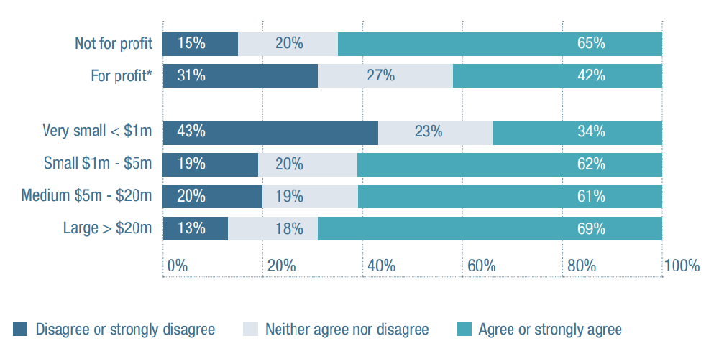
Not for profit
Disagree or strongly disagree 15 per cent
Neither agree nor disagree 20 per cent
Agree or strongly agree 65 per cent
For profit
Disagree or strongly disagree 31 per cent
Neither agree nor disagree 27 per cent
Agree or strongly agree 42 per cent
Very small <$1m
Disagree or strongly disagree 43 per cent
Neither agree nor disagree 23 per cent
Agree or strongly agree 34 per cent
Small $1m - $5m
Disagree or strongly disagree 19 per cent
Neither agree nor disagree 20 per cent
Agree or strongly agree 62 per cent
Medium $5m - $20m
Disagree or strongly disagree 20 per cent
Neither agree nor disagree 19 per cent
Agree or strongly agree 61 per cent
Large >$20m
Disagree or strongly disagree 13 per cent
Neither agree nor disagree 18 per cent
Agree or strongly agree 69 per cent

Figure 5 The NDIA is working well with providers
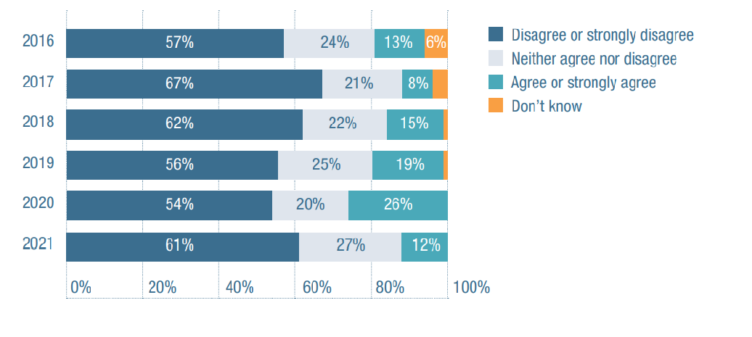2016
Disagree or strongly disagree: 57 per cent
Neither agree nor disagree: 24 per cent
Agree or strongly agree: 13 per cent
Don’t know: 6 per cent
2017
Disagree or strongly disagree: 67 per cent
Neither agree nor disagree: 21 per cent
Agree or strongly agree: 8 per cent
Don’t know: 4 per cent
2018
Disagree or strongly disagree: 62 per cent
Neither agree nor disagree: 22 per cent
Agree or strongly agree: 15 per cent
Don’t know: 1 per cent
2019
Disagree or strongly disagree: 56 per cent
Neither agree nor disagree: 22 per cent
Agree or strongly agree: 19 per cent
Don’t know: 3 per cent
2020
Disagree or strongly disagree: 54 per cent
Neither agree nor disagree: 20 per cent
Agree or strongly agree: 26 per cent
Don’t know: 0 per cent
2021
Disagree or strongly disagree: 61 per cent
Neither agree nor disagree: 27 per cent
Agree or strongly agree: 12 per cent
Don’t know: 0 per cent

Sector confidence and business viability
Business confidence continued to decline across the sector. Over half (65 per cent) of respondents believing that conditions had worsened, up from 61 per cent in 2020 and 38 per cent in 2019. Pessimism about the operating conditions of the wider Australian economy continues but shows a more moderate appraisal than 2020, where 74 per cent of respondents thought that conditions had worsened. In 2021, this number had fallen to 58 per cent.
The proportion of organisations reporting a profit or surplus in remained stable at 68 per cent in 2021, when compared with 2020 (67 per cent).
Of these organisations, 32 per cent reported a profit of more than 10 per cent (including 7 per cent reporting a profit of more than 20 per cent). When compared with 2019 and earlier, there was a significant increase in the proportion of respondents reporting a profit or surplus. The proportion of organisations reporting a surplus of more than 10 per cent has steadily increased over the past 5 years, from 12 per cent in 2017, to 16 per cent in 2018, 21 per cent in 2019 and 26 per cent in 2020.
The impact of JobKeeper is almost certainly tempering these seemingly positive results, however. For those who received it, JobKeeper helped 45 per cent to retain workers, 16 per cent to make a profit and 40 per cent with ongoing financial viability.
Although not specifically asked, comments indicated that at least 33 per cent of responding organisations did not apply for, or were not eligible for, JobKeeper.

Figure 6 Operating conditions in the non-Government disability sector
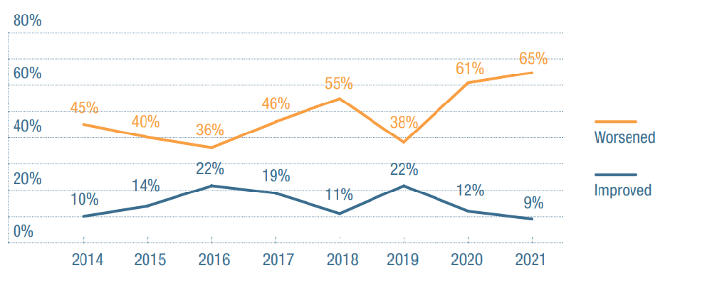
2014
Worsened: 45 per cent
Improved: 10 per cent
2015
Worsened: 40 per cent
Improved: 14 per cent
2016
Worsened: 36 per cent
Improved: 22 per cent
2017
Worsened: 46 per cent
Improved: 19 per cent
2018
Worsened: 55 per cent
Improved: 11 per cent
2019
Worsened: 38 per cent
Improved: 22 per cent
2020
Worsened: 61 per cent
Improved: 12 per cent
2021
Worsened: 65 per cent
Improved: 9 per cent

Table 1 Impact of JobKeeper
 | Number1 | per cent
Ability to make a profit | 58 | 16 per cent
Ability to retain workers | 163 | 45 per cent
Ensure financial viability for the organisation | 145 | 40 per cent
1 The total number of organisations responding to this question was 360.
Services based in Victoria and New South Wales were more likely to report that JobKeeper helped to ‘ensure ongoing financial viability’, which is likely linked to the greater frequency of lockdowns experienced in these states. Comments indicated that JobKeeper also helped respondents enhance their technological capacity and preserve their organisational cultures:
“Should the organisation not have received JobKeeper, there would have been a 3.5 per cent profit margin loss”; and “with the introduction of JobKeeper, we are able to maintain our organisational culture, assist staff to advance their learning and supported employees, maybe for the first time, were financially engaged as equals”.
The perceived impact of JobKeeper was significantly lower for very small organisations and those in the for-profit sector, probably because more organisations in these categories were not eligible for subsidy or did not apply for it (43 per cent and 45 per cent, compared with the overall average of 33 per cent).
One in five respondents continued to make a loss, indicating a high level of financial stress in the sector. Some 9 per cent of respondents reported a loss of more than 10 per cent (including 2 per cent reporting a loss of over 20 per cent). Not-for-profit services were three times more likely to report a deficit (21 per cent of services) than for-profit services (7 per cent). There were no statistically significant differences in services’ financial profitability according to size or state/territory of operation.

Figure 7 Financial outcome 2020-2021 by organisation type
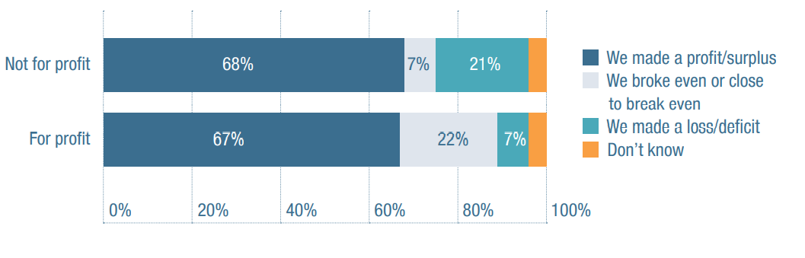
Not for profit
We made a profit/surplus: 68 per cent
We broke even or close to broke even: 7 per cent
We made a loss/deficit: 21 per cent
Don’t know: 4 per cent
For profit
We made a profit/surplus: 67 per cent
We broke even or close to broke even: 22 per cent
We made a loss/deficit: 7 per cent
Don’t know: 4 per cent

Figure 8 Profit and loss - Last financial year and expected result for current financial year
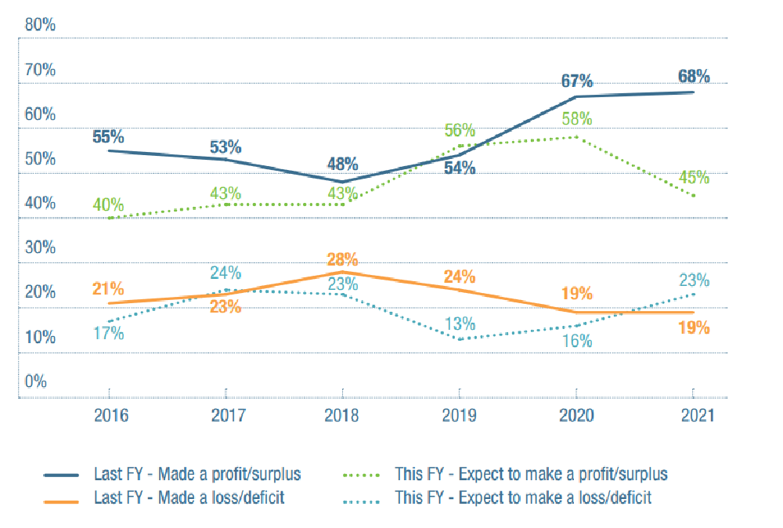
2016
Last financial year - Made a profit/surplus: 55 per cent
This financial year – Expect to make a profit/surplus: 40 per cent
Last financial year – Made a loss/deficit: 21 per cent
This financial year – Expect to make a loss/deficit:17 per cent
2017
Last financial year - Made a profit/surplus last financial year: 53 per cent
This financial year – Expect to make a profit/surplus:43 per cent
Last financial year – Made a loss/deficit: 24 per cent
This financial year – Expect to make a loss/deficit: 23 per cent
2018
Last financial year - Made a profit/surplus last financial year: 48 per cent
This financial year – Expect to make a profit/surplus: 43 per cent
Last financial year – Made a loss/deficit: 28 per cent
This financial year – Expect to make a loss/deficit: 23 per cent
2019
Last financial year - Made a profit/surplus last financial year: 56 per cent
This financial year – Expect to make a profit/surplus: 54 per cent
Last financial year – Made a loss/deficit: 24 per cent
This financial year – Expect to make a loss/deficit: 13 per cent
2020
Last financial year - Made a profit/surplus last financial year: 67 per cent
This financial year – Expect to make a profit/surplus: 58 per cent
Last financial year – Made a loss/deficit:19 per cent
This financial year – Expect to make a loss/deficit: 16 per cent
2021
Last financial year - Made a profit/surplus last financial year:68 per cent
This financial year – Expect to make a profit/surplus: 45 per cent
Last financial year – Made a loss/deficit: 23 per cent
This financial year – Expect to make a loss/deficit:19 per cent
When it comes to the future, only 57 per cent of organisations that recorded a profit in 2021 expected to make a profit again in the coming year. It will therefore be important to track profit and loss in future years to determine whether government support has been artificially enhancing the financial health of the sector. This was a risk identified by respondents: “we will post an artificial profit from 2020-21 due to JobKeeper”; “the end of JobKeeper will make operating our services much more difficult and we expect our first deficit ever this financial year”. The tone of the comments also reflected some discord, disharmony and resentment within the sector.
Respondents identified a number of inequities based on organisational size, and uneven playing fields between for-profit and not-for-profit organisations. Representative comments included: “it is too easy for ‘for profit’ operators to do very well by cherry picking what is most profitable at the expense of more whole-of-life commitments from ‘not-for-profits’”; “these are shameful results of the underfunding of the system to registered not-for-profit orgs”.
Despite these sentiments, most respondents said that they actively collaborate when it comes to a number of key sector-building activities, including advocacy (78 per cent) and building knowledge of best practice (65 per cent).
For-profit providers and providers established after 2014 were less likely to collaborate with other providers to advocate for the sector and establish agreements and MOUs with other organisations.
This fact is important to note because it provides evidence that organisations designed to fit the market-based NDIS model are less inclined to work collaboratively.

Learning to live with COVID-19
Despite the ongoing challenges of the pandemic, and other operational issues, the sector continues to show resilience and an ability to adapt quickly to changing circumstances.
Eight-five per cent of respondents either agreed or strongly agreed that their organisations were able to respond well to the pandemic. Older organisations established prior to 2014 were more likely to agree with this statement

Figure 9 Pandemic response
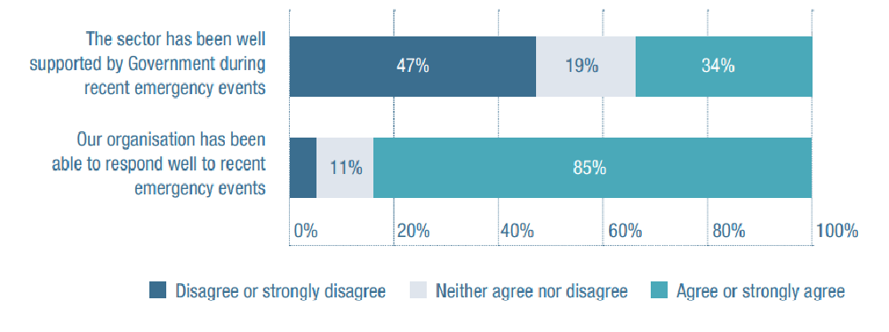
The sector has been well supported by Government during recent emergency events:
Disagree or strongly disagree: 47 per cent
Neither agree nor disagree: 19 per cent
Agree or strongly agree: 34 per cent
Our organisation has been able to respond well to recent emergency events:
Disagree or strongly disagree: 4 per cent
Neither agree nor disagree: 11 per cent
Agree or strongly agree: 85 per cent
However, attitudes toward government support during the pandemic were somewhat less positive. While 34 per cent of respondents agreed that the sector had been well-supported, 47 per cent disagreed with the statement. For one respondent, in fact: “it is only pure luck that we have not had the virus rip through the disability sector and take many lives”.
Vaccination of staff was another key issue: “[the] lack of mandating vaccinations in the sector was woeful”; “the Commonwealth Government’s response has been appalling and it starts with the botched vaccination roll out”.
No significant differences in perceived Government support were detected based on organisational size or type. Respondents from Victoria and New South Wales reported significantly lower satisfaction with government support during the pandemic than those from Queensland and Western Australia.

Service change, innovation and growth Innovation
The NDIS aims ‘to facilitate access to high quality innovative supports’ (NDIS Act). However, in a clearly sobering but perhaps standout finding of this year’s survey, only 12 per cent of service providers agreed with the statement that ‘taken together, NDIS Pricing and Regulation are conducive to providing innovative services that respond to participant needs’.
Typical comments included: “The transaction-heavy nature of NDIS removes any discretionary time to do things like innovate. The ongoing uncertainty about policy and pricing does not facilitate innovation”
“NDIS pricing and regulation are stifling innovation. So much of the innovation in the sector driven by people with disability is being codified in regulation to the extent of it no longer being innovative: “Pricing actively works against innovation. It discourages research, training and development”
These and other comments highlight how current pricing arrangements and policy uncertainty limit organisational growth and innovation. In addition, an uncertain and unstable policy environment causes mistrust and makes it difficult for providers to think far ahead.
It is worth noting that organisations that were established after 2014 (and thus developed their business model in the context of the NDIS) were more likely to agree that NDIS pricing and regulation are conducive to innovation. These organisations would not have been burdened with transition costs associated with de-layering their organisations from management structures designed around ‘block funded’ programs. They were also able to start operating with more agile business models (eg bespoke IT systems built for the NDIS, as opposed to legacy systems for a block funding environment). Some older organisations were also locked into awards and workforce classification systems that were not compatible with NDIS pricing structures. Providers established before 2014 were also more likely to agree with the statement ‘we are worried we won’t be able to provide NDIS services at current prices’.
Organisations that did not provide SIL services were also more likely to agree that NDIS pricing and regulation are conducive to innovation. This likely reflects the pricing-related concerns of this sector of the market.
An important way that organisations can improve practice and innovate is by using data and research. However, only 19 per cent of respondents agreed that data they were able to draw on when planning futures services was ‘sufficient, timely and easily accessible’.
“There is no useable data provided from any source to enable planning for services”; “Data is too high level to be able to use for service planning”; “Ha, ha, ha, ha, ha – are we even allowed to have the data?”
Disability research was also lacking. Only 16 per cent of respondents believed that disability research evidence was ‘sufficient, easily accessible and implementation ready to inform service development’. Others noted that more independent research would be particularly welcome, given the lack of service data available to a sector which is “often driven/interpreted by NDIS”.
“[we] need funding for independent research”.

Service changes
The survey suggests that service provision continued to expand throughout 2021, with respondents indicating high levels of growth in:
• behaviour support
• daily tasks/shared living (eg SIL and shortterm accommodation)
• assistance with life stages transition and supports (eg support connection and support coordination)
• therapeutic supports; and
• personal activities assistance.
As regards the future, 9 per cent of the organisations that provide group and centre-based activities planned to reduce this service, and 9 per cent of the organisations that provide plan management services indicated an intention to stop.

Figure 10 Plans to stop, reduce or increase the volume of services
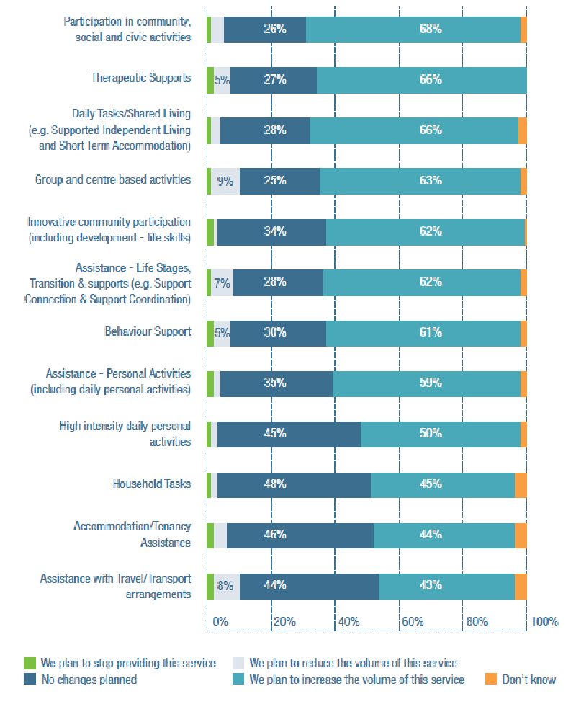
Participation of social, civic or community activities
We plan to stop providing this service: 1per cent
We plan to reduce the volume of this service: 4per cent
No changes planned: 26per cent
We plan to increase the volume of this service:68per cent
Don’t know: 2per cent
Therapeutic supports
We plan to stop providing this service: 2per cent
We plan to reduce the volume of this service: 5per cent
No changes planned: 27per cent
We plan to increase the volume of this service: 66per cent
Don’t know: 0per cent
Daily tasks/Shared living (e.g. Supported Independent Living and Short Term Accommodation)
We plan to stop providing this service: 1per cent
We plan to reduce the volume of this service: 3per cent
No changes planned: 28per cent
We plan to increase the volume of this service: 66per cent
Don’t know: 3per cent
Group and centre-based activities
We plan to stop providing this service: 1per cent
We plan to reduce the volume of this service: 9per cent
No changes planned: 25per cent
We plan to increase the volume of this service: 63per cent
Don’t know: 2per cent
Innovative community participation (including development – life skills)
We plan to stop providing this service: 2per cent
We plan to reduce the volume of this service: 1per cent
No changes planned: 34per cent
We plan to increase the volume of this service: 62per cent
Don’t know: 2per cent
Assistance – Life stages, transition and supports (e.g. support connection and support coordination)
We plan to stop providing this service: 1per cent
We plan to reduce the volume of this service: 7per cent
No changes planned: 28per cent
We plan to increase the volume of this service: 62per cent
Don’t know: 2per cent
Behaviour support
We plan to stop providing this service: 2per cent
We plan to reduce the volume of this service: 5per cent
No changes planned: 30per cent
We plan to increase the volume of this service: 61per cent
Don’t know: 2per cent
Assistance - Personal activities (including daily personal activities)
We plan to stop providing this service: 2per cent
We plan to reduce the volume of this service: 2per cent
No changes planned: 35per cent
We plan to increase the volume of this service: 59per cent
Don’t know: 2per cent
High intensity daily personal activities
We plan to stop providing this service: 1per cent
We plan to reduce the volume of this service: 2per cent
No changes planned: 45per cent
We plan to increase the volume of this service: 50per cent
Don’t know: 2per cent
Household tasks
We plan to stop providing this service: 1per cent
We plan to reduce the volume of this service: 2per cent
No changes planned: 48per cent
We plan to increase the volume of this service: 45per cent
Don’t know: 2per cent
Accommodation / Tenancy assistance
We plan to stop providing this service: 2per cent
We plan to reduce the volume of this service: 8per cent
No changes planned: 46per cent
We plan to increase the volume of this service: 44per cent
Don’t know: 4per cent
Assistance with travel / transport arrangements
We plan to stop providing this service: 2 per cent
We plan to reduce the volume of this service: 8per cent
No changes planned: 44per cent
We plan to increase the volume of this service: 43per cent
Don’t know: 4per cent
Despite pessimism over the direction of the NDIS, 26 per cent of respondents indicated that their organisation was planning to provide new NDIS-funded services. Potential areas for expansion included:
• specialist disability accommodation (10 per cent)
• group and centre-based activities (8 per cent); and
• assistance with accessing or maintaining employment or higher education (8 per cent).
Compared to 2020, fewer providers were considering moving into:
• therapeutic supports (4 per cent)
• community nursing care (2 per cent)
• household tasks (0 per cent); and
• assistance with travel (0 per cent).
Comments explaining the reasons for these shifts included: “diversification, as at any time the NDIA can refuse to put support coordination funding into a clients plan – instantaneously leaving us without income”; “there is a large gap in the market for specialised social learning groups for school leavers with complex intellectual disabilities and communication challenges”; and “SDA is needed in the community to reduce housing issues for people with disabilities”.

Accommodation and SIL
SIL and short-term accommodation services have grown in the past 12 months and are expected to grow still further. The NDIA have been concerned about the growing costs of providing this support and in 2020 identified a range of issues relating to administrative complexity and SIL including errors in costing and provider payment delays. They launched a consultation process in response, with providers noting increased costs for client establishment, costs not covered in the funding model, provision of services in rural and remote locations and costs associated with compliance with the NDIS Quality and Safeguardings Framework. In August 2021, an update to pricing arrangements was released, but SIL pricing was not changed. Multiple respondents were highly critical: “the decrease in SIL funding will result in either poorer service delivery as DSOs provide only exactly what is funded or services choosing not to provide SIL”; and “NDIS continually reduce the SIL funds to such an extent that we are losing thousands of dollars on each resident, making it impossible for us to provide services that are required”.
SIL providers were also less likely to agree that NDIS policy reforms were heading in the right direction, or that the NDIA was working well with providers.
It will be important to monitor the ongoing capacity of the sector to provide this support given the increasing level of operation and the concerns raised by providers with respect to costing.

Growth and diversification
One-third of respondents were actively growing their organisation, most by increasing their client base (27 per cent) or their workforce (23 per cent). A quarter reported that, while they planned to stay in the disability sector, they were not focussed on growth and 6 per cent were considering getting out of the sector entirely. These findings are similar to growth plans reported in 2020

Figure 11 In what ways are you planning on actively growing your organisation?
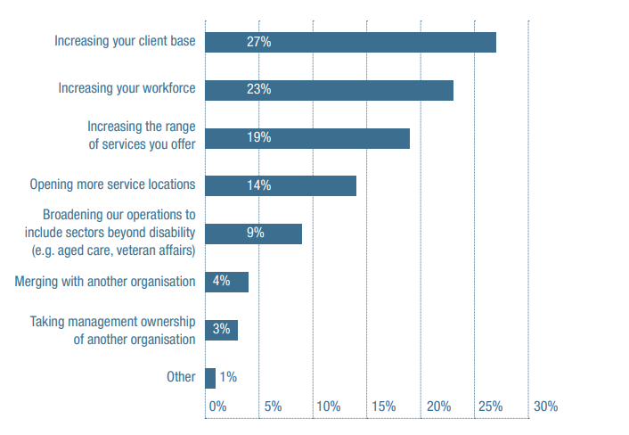
Increasing your client base: 27per cent
Increasing your workforce: 23per cent
Increasing the range of services you offer: 19per cent
Open more service location: 14per cent
Broadening our operations to include sectors beyond disability (e.g. aged care, veteran’s affairs): 9per cent
Merging with another organisation: 4per cent
Taking management ownership of another organisation: 3per cent
Other: 1per cent
Two-thirds of organisations were not intentionally growing. For some respondents, such a path was reported as financially unviable: “our cashflow is continually reducing, which has the effect of reducing our ability to grow”.
Other respondents were reluctant to over-reach: “small is good, enhances client results”; ”we have doubled in size in the last five years and there is a need to consolidate”. Internal and external structural and labour market constraints were also said to limit growth. “there is demand for services, and a limited supply of quality and effective labour ... it means we will not meet our growth plan and unfunded overheads will lead to financial losses and high stress for leadership staff”
Organisational areas identified as in need of improvement included:
• HR strategy and workforce planning
• data reporting and use
• employee learning and development; and
• costing and pricing.
Service requests denied
The sector’s shortage of skilled, capable or sufficiently qualified workers is vividly illustrated by the fact that 77 per cent of respondents received requests for disability services that they were unable to provide, a slight decrease from 2020 but broadly consistent with results from previous years.
Twenty-nine percent of respondents reported lack of capacity as their main reason for turning clients away. Workforce remained a pain point specific to service provision; nearly half (47 per cent) of the respondents reported they lacked the workforce capacity or reported that their workforce was not qualified to assist the clients seeking services (25 per cent), and 20 per cent reported that their organisation did not otherwise have the capacity.
Other reasons clients were turned away included that the client’s plan would not cover the requested service (23 per cent), the service wasn’t offered (22 per cent), the client was unable to access the service due to distance or transportation issues (9 per cent) or the client lived too far away to provide home-based services (9 per cent).
The text-based responses on this topic were wide-ranging and included references to unrealistic pricing expectations, types and hours of support needed being incompatible with provider services, provider time and resource constraints, as well as risk.
For example: “a person’s support requirements were higher than we could manage”; “not enough staff”; “COVID concerns about being able to serve existing clients if it hit hard, made us reluctant to onboard many new clients”; “in our supported employment, a person was referred via the justice system and we decided that considering the type of work we were offering and the environment, the person would be a high risk”; “there are insufficient services in our area: demand is high and capacity low”.

Market stewardship
Nearly three-quarters (74 per cent) of respondents feel that that helping people understand and navigate the scheme was taking them away from service provision. Medium-sized organisations were more likely to agree with this statement, as were providers that were established before 2014, an outcome perhaps reflective of the more holistic roles that they had with clients prior to NDIS.
“the monthly rate does not cover the amount of work and time the majority of participants require to understand, navigate and implement their services”
Meanwhile, 78 per cent of respondents reported that they sometimes collaborate to resolve service access problems for individual clients. It is also noteworthy that only 18 per cent of respondents believed that there is sufficient advocacy for the people they support. This result has not changed much in three years.
“persons with complex needs including those with severe intellectual disability have no “real voice” ... advocacy is non-existent”; “lack of solid advocacy (which NDS is now working on)” “those that are in need of support and advocacy are left without their needs being met”, “advocacy is dwindling away to nothing”.

Quality and Safeguards Framework
Overall, 45 per cent of providers were confident that the NDIS Quality and Safeguards Framework will improve services and outcomes in coming years. Thirty percent disagreed, a slightly larger number than in previous years.
Regarding the NDIS Quality and Safeguarding Commission, 32 per cent agreed that it is ‘working well with providers’ but 36 per cent did not (up slightly on previous years). Queensland and New South Wales providers were more likely to agree with this statement.
Comparatively, as discussed above, only 12 per cent of service providers agree or strongly agree that the NDIA is working well with providers). This survey was the first to explore (what turned out to be very varied) levels of confidence in each of the nine regulatory instruments that make up the Framework. As shown in the table below, the area of greatest ambivalence relates to the Framework’s requirement that providers report ‘significant changes and events’.
Introduced in January 2020, this requirement was designed to require providers to alert the Commission about their ability to comply with any conditions of registration, and provide early warning signs vis-a-vis financial sustainability, market exits, emerging ‘thin’ markets and board/CEO changes.
But exactly how the Commission is using this intelligence to achieve that result remains largely unclear.

Figure 12 Quality and Safeguarding Framework is leading to good outcomes for participants
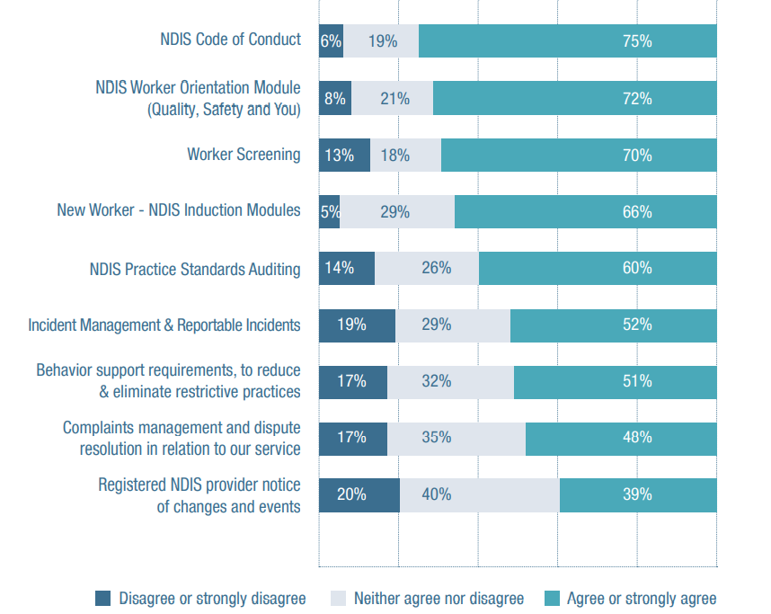
NDIS Code of conduct
Disagree or strongly disagree: 6per cent
Neither agree nor disagree: 19per cent
Agree or strongly agree: 75per cent
NDIS worker orientation module (Quality, Safety and You)
Disagree or strongly disagree: 8per cent
Neither agree nor disagree: 21per cent
Agree or strongly agree: 75per cent
Worker screening
Disagree or strongly disagree: 13per cent
Neither agree nor disagree: 18per cent
Agree or strongly agree: 70per cent
New worker – NDIS Induction modules
Disagree or strongly disagree: 5per cent
Neither agree nor disagree: 29per cent
Agree or strongly agree: 52per cent
NDIS Practice Standards Auditing
Disagree or strongly disagree: 14per cent
Neither agree nor disagree: 26per cent
Agree or strongly agree: 60per cent
Incident management and reportable incidents
Disagree or strongly disagree: 19per cent
Neither agree nor disagree: 29per cent
Agree or strongly agree: 52per cent
Behaviour support requirements, to reduce and eliminate restrictive practices
Disagree or strongly disagree: 17per cent
Neither agree nor disagree: 32per cent
Agree or strongly agree: 51per cent
Complaints management and dispute resolution in relation to our service
Disagree or strongly disagree: 17per cent
Neither agree nor disagree: 35per cent
Agree or strongly agree: 48per cent
Registered NDIS provide notice of changes and events
Disagree or strongly disagree: 20per cent
Neither agree nor disagree: 40per cent
Agree or strongly agree: 39per cent
Calls were made for accountability to the Framework to be more consistent between registered and unregistered providers:
“NDIS Quality and Safeguards Commission holds registered providers accountable but what about the unregistered providers? ... too much inconsistency and when you call to report to be told there is nothing they can do”;
“quality regulations will improve service delivery, however only for those who are registered and abide by the regulations” “reportable incidents – again, only registered providers need to comply!”
Concerns about worker screening requirements featured strongly among respondents’ comments on the NDIS Quality and Safeguarding Framework:
“worker screening is a nightmare ... takes too long”; “worker screening is good conceptually but it needs to be withdrawn until it works properly”
“delays in worker screening are severely hampering service delivery”; “the length of time it takes to get the outcome of the NDIS worker screening is causing huge issues with recruitment”
“long-term staff have been stood down until clearances are received, (which is) having a huge impact not only on staff but being able to provide care to participants’”; “the length of time it takes to get the outcome of the NDIS worker screening is causing huge issues with recruitment”
Finally, several respondents expressed concern that unprofessional providers might be undermining the quality of services:
“we watch ex-staff terminated due to serious policy breaches (even assault) become independent providers who then are able to exercise flexibility with the NDIS by breaking the law, claiming hours of support to fund holiday accommodation and travel, to sponsor siblings of participants etc”; “cowboy providers with no rules and quality are a threat to clients and the industry.”
Taken together, all of these sentiments underline the major theme of this year’s survey: that there is an undercurrent of discord within the sector and dissatisfaction with the disability policy actions of the Federal Government and the NDIA.

Case study: Australian Capital Territory

Hugh Packard, CEO, Valmar
Tell us about Valmar
Valmar was one of the many organisations that started in the 1960s when parents with young kids with disabilities got together. Over the years, as their kids grew up and their needs changed, it evolved from a playgroup to a special school, to a young person’s program to an employment program to a residential program and a day program. Nowadays we even run an aged care program!
We have about 550 staff across a large chunk of south-east NSW and the ACT. So it’s an interesting, diverse organization that touches the lives of many thousands of people.
What has been your proudest achievement?
This is my 31st year as CEO, so I did get to know a lot of those founding families. I guess I’m most proud of the fact that we’ve been able to honour that commitment that they wanted to make to their children; that we helped their kids to live their best life possible in their community, rather than being shipped off to some institutional alternative.

What does an average day look like?
That’s a hard question because Valmar’s an incredibly diverse organisation. On any given day I could be doing anything, negotiating the purchase of a front-end loader, getting hospital supplies, talking about food standard registrations, buying a house to be a new group house, to working out how to get access accreditation for the new bus that we’ve bought and pre Covid, calling in on one or two services unannounced.

What do you think are some of the major challenges facing the sector?
There is serious disconnect between the compliance and regulatory agenda of the Quality and Safeguards Commission and individual rights/individual space between the two, where they’re each asking us to do almost mutually exclusive things.
The NDIS is saying ‘these people should not be in regulated group houses; they should individually be choosing where they go and who they associate with.’ Which is great but then you have the Commission saying that ‘you have to be 100 per cent accountable for everything that happens in their lives and if anything adverse happens, it’s your fault.’
It’s just two diametrically opposed agendas, which I find really distasteful, actually. All our operational life, we’ve been working to be non-institutional and non-medical and non-restrictive and now we’re being forced into effectively controlling people’s lives. program/self-determination agenda of the NDIS. Providers are stuck in this incredibly uncomfortable.
What are some of the major opportunities?
If it stripped away the regulation, if the government let it do what it can do, then I think that the NDIS could be a wonderful agent for letting people live their own lives. I do see great examples of this from time to time. The Scheme’s still only in its teenage years, if that, so I’m still optimistic that it will mature.

Why did you get into the disability sector?
After doing a couple of degrees, I’d gone into sheep farming before coming down with a serious illness. While recuperating, I needed a job which was less physically demanding, and ended up with a job in the disability sector. And right from that time, it fitted like a glove.

What’s impressed you most?
I’m continually in awe of the hands-on staff who actually do the hard yards and just how good human nature can be. There’s always the bad press about the things that have gone wrong, but the vast majority of the sector is just people making other people’s lives better.

Key issues
- COVID
COVID-19 has had a significant impact in the ACT, with the government taking a very proactive approach. Funding was provided to NDS to research the sector’s a capacity to manage a future outbreaks and ensure that sufficient workers would be available to enable continuity of service.
- Supported Independent Living
SIL has been a hot topic in the ACT this year, with many SIL providers concerned about reduction in funding in participants plans (without consultation), complex processes and procedures. NDS has and will continue to advocate strongly on this issue until it is resolved.
- Housing
Access to affordable, accessible and well maintain housing was also front of mind. Many ACT members have raised concerns on the length of time it takes to access priority accommodation, the current state of public housing stock, and an apparent disconnect between the ACT Housing Strategy 2018 and the requirements of people with disability. The recent budget announcement of $80 million over four years to address some of these issues was most welcome.

Australian Capital Territory Sector Stats
Active participants including ECA: 8,954
Active ECA participants: 126
NDIS participants are Indigenous: 4.4 per cent
Culturally and linguistically diverse: 10.7 per cent

Case study: Victoria

Kate MacRae, CEO, Able Australia

Tell us about Able Australia
We began in 1967 as a small charity supporting parents whose babies had been born deaf or blind as a result of the Rubella epidemic. Since then, we’ve grown and expanded to offer support to adults with complex disabilities across Victoria, Tasmania, ACT and Southeast Queensland.

What has been your proudest achievement there?
Helping to drive the sector’s COVID response by facilitating a Collaboration of CEOs and executives. This has enabled so many professional alliances to flourish and that has benefited those whom we support and the disability sector more broadly.

What does an average day look like for you?
It is difficult to think of a time before COVID given how all-consuming it has become! All days involve working closely with my Executive team, to ensure the smooth running of our day-to-day operations. Before COVID I was able to visit staff, clients, and families.

What do you think are some of the major opportunities awaiting the sector?
NDIS providers have many opportunities to find and forge partnerships that provide mutual benefit. If you want to go fast you can stride out on your own, however, if you want to go far and in a sustainable way, you will do this more effectively in partnership with other like-minded people and organisations.

What do you think are some of the major challenges facing the sector?
I find the impermanence of the NDIA pricing structure and the inconsistency in NDIS processes and application of principles challenging. Responding to these changes requires significant administrative and operational input, and this detracts from the vital work we should be concentrating on – providing the very best support for our clients.
The chronic shortage of workforce is a real challenge. The growth of the unregistered workforce is very troubling. The lack of regulatory oversight of those who are providing support to vulnerable people with disabilities should concern everyone in the community.

Why did you get into the disability sector?
I grew up in very small communities in the Highlands and Islands of Scotland, where people with disability were not segregated in any way. My family was deeply involved in these communities, and I have taken that value of collectiveness and collaboration into my career. Moving from a career in public health into the role of CEO of Able was a natural progression for me.

What’s surprised you most?
The breadth and depth of the provider market surprised me greatly. As has the diversity within the sector, and its ability to come together to collaborate in times of need with a common purpose. Few other sectors can come together in this way.

What’s impressed you most?
The strength and resilience of the workforce and the clients we support. The frontline teams have worked so tirelessly throughout the pandemic, without complaint, and without media recognition or reward. These individual attributes have been mirrored in the collegiate nature of the sector and the absence of politics.
When I started the CEO Collaborative in March 2020, I never anticipated that it would grow to a group of over 115 CEOs and executives who volunteer their time, energy, and intellect to work through some of the wicked problems we are facing in the sector. It is a collaboration which is genuinely working towards the common good of the people we support.

Key issues

COVID
COVID-19 has continued to dominate life in Victoria this year, particularly in Melbourne with its six lockdowns. This has placed unrelenting pressure on disability services, and driven new ways of operating. NDS has supported the sector with multiple updates on the changing government guidance, communities of practice and webinars, and development of an array of practical resources, including videos and podcasts, all on our COVID-19 hub.

Mental health
Two years of outbreaks and lockdowns have taken a toll on mental health and wellbeing across disability services, at all levels. The initial fear and fatigue from 2020 has evolved to overwhelming exhaustion and flatness for many people. NDS has responded by developing a Mental Health and Wellbeing Toolkit, running interactive workshops for providers, and encouraging leaders to focus on their own mental health.

Collaboration
The generosity and collaboration of the disability sector has been the shining light from Victoria’s extended COVID-19 experience. Sector leaders stepped up to share learnings, resources and even staff to support each other through this difficult time. The transition to online engagement enabled NDS to initiate multiple communities of practice and interactive webinars to bring providers together from far and wide, and ensure their voice was heard at decision-making levels in government.

Victoria Sector Statistics
Active participants including ECA: 132,609
Active ECA participants: 3,525
NDIS participants are Indigenous: 3 per cent
Culturally and linguistically diverse: 11.7 per cent

The state of the NDIS
The Greek philosopher Heraclitus once said that ‘change is the only constant’. He could have been talking about the NDIS. Despite the fact that the scheme has been ‘fully implemented’, many of its elements are still being amended or reviewed.
This makes for a difficult and confusing operating environment for providers, as well as for participants, their families and carers.

State of NDIS policy
Over the past year, the NDIA has been developing a series of policies designed to get the NDIS to ‘full scheme operation’. Broadly speaking, this means ensuring that the scheme is ‘financially sustainable’ and trying to identify and set out ‘the scheme work of the future’.
One policy that was intended to achieve both of these ends involved the introduction of independent assessments. The NDIA wanted to use assessments to determine whether people are eligible to access the scheme; and to confirm that they’re still eligible every five years, and/or after changes to their circumstances.
After extensive lobbying by key stakeholders the Minister for the NDIS, Linda Reynolds, announced that independent assessments would not go ahead in that form. A cooperative effort to ‘re-think’ these assessments is now underway, with disability The state of the NDIS representative organisations and the Independent Advisory Council both involved. It is not expected to be finalised quickly.
Had independent assessments been introduced as planned, there would have been a number of ‘flow on’ policy implications for the roles of planners, local area coordinators and support coordinators. The changes that were envisaged for support coordination, plan flexibility and plan processes, as well as aspects of the early childhood reform, have therefore stalled. Many decisions about the ‘scheme work of the future’ are now not expected until some time next year.
Disagreements about the scheme’s financial sustainability have been playing out in the media over the past year and remain unresolved. Disability ministers from around Australia have agreed to engage an independent actuary to provide an assessment of sustainability issues. A report on this work will be given to the ministers before the end of this calendar year.

State of NDIS prices
As the NDIA did not conduct an Annual Pricing Review to inform price caps for July 2021, it was no surprise that prices only increased by the minimum amount. The Agency incorporated national minimum wage rates where it was required to, together with the increased superannuation guarantee levy and CPI.
This disappointing decision condemned the sector to struggle with inadequate prices for yet another year.
Changes to SIL prices and processes also hit providers hard. Due to the cessation of SIL quotes, SIL funding for some participants was immediately reduced by up to 10 per cent. On top of this, an alarming number of participants were re-categorised from high-intensity to standard support without any consultation, which left providers to deal with increased risks. In homes where at least one participant needs an active overnight shift, there are examples where the funding provided is inadequate.
Urgent action is required to address the inadequate SIL price caps, as well as this unilateral decision making by planners to reduce rosters of care and support intensity. NDS has put these concerns to ministers and is negotiating to resolve them as quickly as possible.
In better news on the pricing front, 2021 saw providers of group community and centre-based supports be given another year to transition to the new pricing model. NDS is very pleased the NDIA listened to our argument that the challenges of COVID warranted a delay.

State of NDIS regulation
The NDIS Commission is now the regulator for disability service providers right across Australia. WA providers were the last to come into the regulator’s purview and have experienced a very busy and challenging year adjusting to multiple new requirements.
They are not alone, however, in facing challenges. The introduction of the national NDIS Worker Screening Check has also been difficult for providers all over the country, due to incessant bureaucratic delay. The sector urgently needs these checks to be completed far more expeditiously, so workers can either be cleared to work or excluded on the grounds of risk.
Another issue with the screening check is 35 that it only applies to certain (‘risk assessed’) roles. NDS continues to make the case that all workers directly supporting NDIS participants should undergo a Worker Screening Check. This should be required by unregistered as well as registered providers, and by individuals operating with an ABN. Given the safety risks associated with disability support, not requiring a check should quite simply not be a choice.
On a more positive note, 2021 saw the establishment of the NDIS Worker Screening Database, a register of workers who have applied for, or gone through, a check. Registered NDIS providers can now view the clearance status of workers in order to safeguard participants and assist with recruiting.
The horrific death of Ann Marie Smith, an NDIS participant from Adelaide, in 2020 prompted a number of significant changes to NDIS regulations. Where a participant is supported by only one worker, the Commission now requires providers to have additional safeguards in place. Other safeguarding amendments to the National Disability Insurance Scheme Act 2013 have just been passed by Parliament.
In other news, the report on a review on the NDIS Quality and Safeguards Commission being undertaken by the Joint Standing Committee on the NDIS has not been released. It is possible that the Australian National Audit Office will shortly launch an audit into the effectiveness or otherwise of its regulatory functions.

The state of disability employment
Employment is an important mechanism for advancing social inclusion and should be available to all people with disability. However, the employment rate of people with disability in Australia continues to be lower than other OECD countries.

Figure 13 DES policy reforms are heading in the right direction
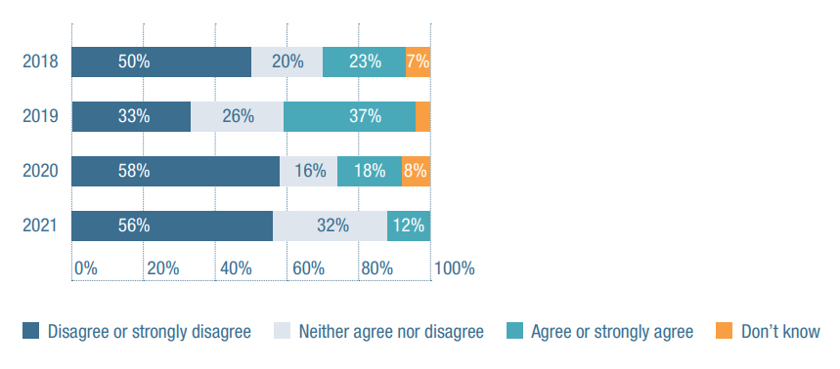
2018
Disagree or strongly disagree: 50per cent
Neither agree nor disagree: 20per cent
Agree or strongly agree: 23per cent
Don’t know: 7per cent
2019
Disagree or strongly disagree: 33per cent
Neither agree nor disagree: 26per cent
Agree or strongly agree: 37per cent
Don’t know: 4per cent
2020
Disagree or strongly disagree: 58per cent
Neither agree nor disagree: 16per cent
Agree or strongly agree: 18per cent
Don’t know: 8per cent
2021
Disagree or strongly disagree: 56per cent
Neither agree nor disagree: 32per cent
Agree or strongly agree: 12per cent
Don’t know: 0per cent

Survey attitudes towards DES
People with disability often need support to find and retain jobs and DES is here to provide this support. In recent years, there have been several major changes to the DES program, including more competition through market share caps, increased mechanisms designed to allow participants to choose providers, a restructured fee model, and the introduction of a panel of approved DES providers.
But these reforms have not resulted in increased performance with the 2018 reforms instead leading to increased caseloads and the development of perverse incentives which impacted negatively on both providers and people with disability.
Just over half of DES providers (56 per cent) who participated in this year’s Annual Market Survey disagreed or strongly disagreed that DES policy reforms were heading in the right direction.
As in previous surveys, administrative burdens continue to weigh heavily on DES providers. Seventy-six per cent of respondents agreed or strongly agreed that the overall DES administrative burden on organisations is onerous. Only one respondent disagreed.
Only 24 per cent agreed or strongly agreed that the current model for DES can provide equitable job support for all people with disability who use these services. “incentives are not tailored to the participant/candidate’s support requirements”; “as a specialist DES/Employment Support Service provider that supports people with an Intellectual disability, our service has been significantly impacted by risk adjusted funding and people in these cohorts have been discriminated against.”
A new digital service model will be introduced from 2022. Under this model, job seekers will be able choose whether to have digital employment services instead of DES, with the option of being referred to a DES provider if they would like to, or if they do not obtain a job within 12 months. Over half of respondents (56 per cent) disagreed or strongly disagreed that this move will enhance employment opportunities for DES participants, and only 20 per cent agreed or strongly agreed with the statement.

Figure 14 ADE operating environment
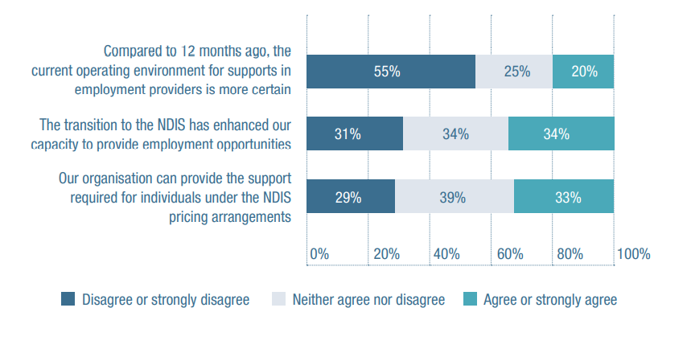
Compared to 12 months ago, the current operating environment for supports in employment providers is more certain
Disagree or strongly disagree: 55per cent
Neither agree nor disagree: 25per cent
Agree or strongly agree: 20per cent
The transition to the NDIS has enhanced our capacity to provide employment opportunities
Disagree or strongly disagree: 31per cent
Neither agree nor disagree: 34per cent
Agree or strongly agree: 34per cent
Our organisation can provide the support required for individuals under the NDIS pricing arrangements
Disagree or strongly disagree: 29per cent
Neither agree nor disagree: 39per cent
Agree or strongly agree: 33per cent
DES changes and challenges
The DES program has been subject to strong government scrutiny in recent years, as participants numbers and program expenditure continued to grow at the same time as employment suffered. In a period of unprecedented labour market volatility, the number of DES participants grew from 193,441 in mid-2018 to 315,926 on 30 June 2021, according to the Australian Government’s DES monthly data reports.
Consequently, the government decided to remove certain participants from DES, including those with a work capacity of 30 or more hours. Between 10-13 per cent of the total DES population became ineligible in July, according to those same reports. COVID restrictions also affected DES, not least with the suspension of the Star Ratings in September 2020. A revised methodology will be used for formal DES performance assessments from early 2022. As this year’s survey makes clear, both
COVID restrictions and ongoing reforms have created an uncertain and complicated environment for DES providers. Many also remain unhappy about a number of specific compliance obligations, such as the need for audits and contract evidence collection.
When the new DES model arrives in mid-2023, it is vital that it come with fewer compliance obligations, so that providers have the time they need to get on with core business.

Survey attitudes towards ADEs
In this year’s Annual Market Survey, just 20 per cent of ADE providers agreed or strongly agreed that the current operating environment for supports in employment providers is more certain than it was 12 months ago. Fifty-five per cent disagreed or strongly disagreed with this statement.
The NDIS introduced changed pricing arrangements from mid-2020 for supports in employment and ADEs have until the end of 2021 to make the transition. While the old pricing model provided an ongoing weekly price, the new model is based around hours and ratios of support. One review found that transitioning would involve a great deal of work and a number of ‘change management’ issues. This prediction was borne out in the survey comments: “many of our areas of business in our ADE will transition (under the new pricing) from being profitable to causing a financial loss”; “NDIA do not know the client and their actions are purely a cost-cutting measure”.
Twenty-nine percent of respondents disagreed or strongly disagreed that their organisation could provide the support required for individuals under NDIS pricing arrangements and 33 per cent agreed or strongly agreed.
While the NDIS Participant Employment Strategy aims to have 30 per cent of work-aged NDIS participants employed by 2023, only 34 per cent of respondents agreed or strongly agreed that ADEs’ transition to the NDIS has helped them to provide employment opportunities.
Despite this sentiment, 65 per cent of respondents planned to increase their specialised employment support services over the next 12 months.
With the 31 December deadline fast approaching, 2021 saw providers continue to transition to NDIS supports in employment pricing. As of August, the NDIA estimated that around two-thirds of supported employees had their plans determined under this new pricing.
A similar proportion of providers also reported having employees under the new pricing arrangements. They now face the challenge of maintaining or improving the quality of their services while these employees exercise greater choice and control. Provider sentiment seems more uncertain than in 2020, with a significantly higher proportion of survey respondents unsure that these NDIS pricing arrangements will allow them to provide quality services.

The state of the workforce
Over the past year, the combined impact of COVID-19, the closing of international borders and the growth in the number of NDIS participants have made it difficult to source the workers required to provide people with disability with the supports they seek to purchase. The recent release, therefore, of the NDIS National Workforce Plan: 2021-25 has been welcomed by the sector.

COVID complications
Again this year COVID-19 brought significant disruption to the sector and its workforce. Outbreaks of the Delta strain across the country, but significantly in NSW, ACT and Victoria, created a difficult operating environment. The virulent nature of Delta saw significant numbers of positive cases in disability services requiring a well-trained and supported workforce. Large numbers of cases in the community also saw significant numbers of workers needing to quarantine or isolate as close and casual contacts. Sourcing surge workforce became an even greater challenge and COVID-19 Preparedness Plans were put to the test.
The discussion around mandatory vaccines for workers was and remains a hot issue. The decision by National Cabinet in June not to mandate vaccinations for disability support workers, after announcing that all aged care workers needed to have at least one dose of COVID-19 vaccine by mid-September, puzzled many in the sector. Continued advocacy by NDS saw individual states and territories commence implementing their own approaches. While this has been welcomed, settings for each state and territory are different creating implementation issues for providers and for workers who work across jurisdictions.

Recruitment challenges
In this year’s Annual Market Survey, many providers said that they had been finding it increasingly difficult to recruit frontline disability support workers – a problem likely exacerbated by COVID concerns and competition from other community care sectors.
As these respondents put it: “(it is) extremely hard in a small town with lots of big companies paying bigger wages”; “recruiting into remote settings is almost impossible”; “(there is) extreme need in the region with no qualified staff to provide therapies”.
When it came to specific roles, 93 per cent found it difficult to fill speech therapist roles, 92 per cent occupational therapists, 89 per cent psychologists, and 80 per cent physiotherapists. In a worrying development, 70 per cent of providers also had problems recruiting disability support workers, up from 59 per cent in 2020. The roles that were least difficult to recruit were finance (38 per cent), IT (40 per cent), marketing (44 per cent) and HR (45 per cent). Fifty-six per cent of providers also indicated they had difficulty recruiting volunteers.

Retention challenges
It also became more difficult to retain staff in 2021. As one respondent put it: “recruiting and retaining a skilled and competent workforce is our #1 focus and challenge”.
Key reasons for this appeared to include the lack of permanent positions, availability of better working conditions elsewhere and staff burnout.
Comments included: “the fact that they are casual makes it very difficult to retain them”; “many good OTs and speech pathologists are choosing to exit the NDIS workforce and seek employment in Aged care, Health Education or private practice where they do not have to deal with the onerous ‘Big Brother’ approach of the NDIS”
“for Support Coordination (SC), it is an extremely difficult support provision to maintain due to the high stress associated with the role and resultant burn out of staff”
In terms of specific roles, providers had difficulty holding on to occupational therapists (65 per cent, up from 48 per cent), physiotherapists (55 per cent, up from 39 per cent), speech therapists (61 per cent, up from 49 per cent), psychologists (63 per cent, up from 48 per cent) and dietitians (55 per cent, up from 26 per cent).
Forty-four per cent also had difficulty retaining disability support workers, up from 40 per cent in 2020.

Figure 15 Occupational Groups proving difficult to recruit and retain
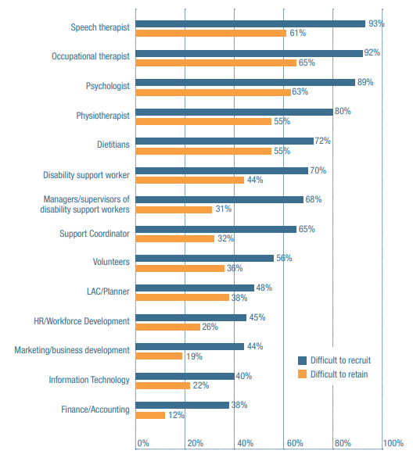
Speech therapist
Hard to recruit: 93per cent
Hard to retain: 61per cent
Occupational therapist
Hard to recruit: 89per cent
Hard to retain: 63per cent
Psychologist
Hard to recruit: 80per cent
Hard to retain: 55per cent
Physiotherapist
Hard to recruit: 72per cent
Hard to retain: 55per cent
Dietitians
Hard to recruit: 70per cent
Hard to retain: 44per cent
Disability support worker
Hard to recruit: 68per cent
Hard to retain: 31per cent
Managers/supervisors of disability support workers
Hard to recruit: 65per cent
Hard to retain: 32per cent
Support Coordinator
Hard to recruit: 56per cent
Hard to retain: 36per cent
Volunteers
Hard to recruit: 48per cent
Hard to retain: 38per cent
LAC/Planner
Hard to recruit: 45per cent
Hard to retain: 26per cent
HR/Workforce Development
Hard to recruit: 44per cent
Hard to retain: 19per cent
Marketing/business development
Hard to recruit: 40per cent
Hard to retain: 22per cent
Information Technology
Hard to recruit: 93per cent
Hard to retain: 61per cent
Finance/Accounting
Hard to recruit: 38per cent
Hard to retain: 12per cent

Employment types
NDS’s Workforce Census survey attracted a record number of responses this year. A decrease in permanent employment was reported, down from 62 per cent in December 2020 to 61 per cent in June 2021.
Permanent part-time employment and the combined average hours worked per week also decreased, while the turnover rate for casual positions rose by 4 per cent. Given the number of Victorian and NSW COVID restrictions in play during the second half of 2021, these figures are unlikely to improve before the next data collection due in December.
The Federal Government’s NDIS National Workforce Plan: 2021–25 will be vital in the coming years, as the sector seeks to rebuild a skilled and capable workforce.
The Plan’s third priority – centered, as it is, on reducing red tape and encouraging new service models, innovation and opportunities – will be a major part of achieving that goal.
Figure 16 Type of employment (per cent)
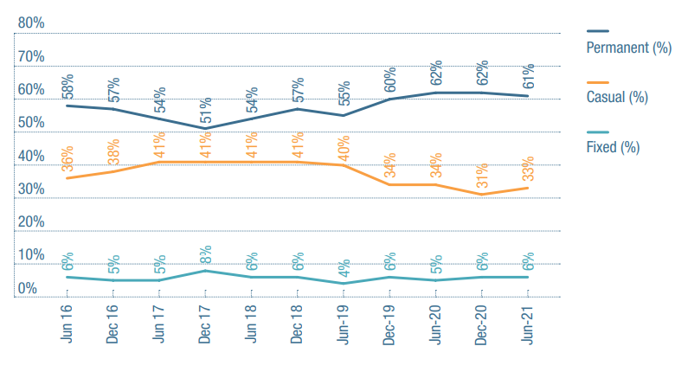
June 2016
Permanent: 58per cent
Casual: 36per cent
Fixed: 6per cent
December 2016
Permanent: 57per cent
Casual: 38per cent
Fixed: 5per cent
June 2017
Permanent: 54per cent
Casual: 41per cent
Fixed: 5per cent
December 2017
Permanent: 51per cent
Casual: 41per cent
Fixed: 8per cent
June 2018
Permanent: 54per cent
Casual: 41per cent
Fixed: 6per cent
December 2018
Permanent: 57per cent
Casual: 41per cent
Fixed: 6per cent
June 2019
Permanent: 55per cent
Casual: 40per cent
Fixed: 4per cent
December 2019
Permanent: 60per cent
Casual: 34per cent
Fixed: 6per cent
June 2020
Permanent: 58per cent
Casual: 36per cent
Fixed: 6per cent
December 2020
Permanent: 62per cent
Casual: 31per cent
Fixed: 6per cent
June 2021
Permanent: 61per cent
Casual: 33per cent
Fixed: 6per cent

Figure 17: Full time and Part time work – employment share
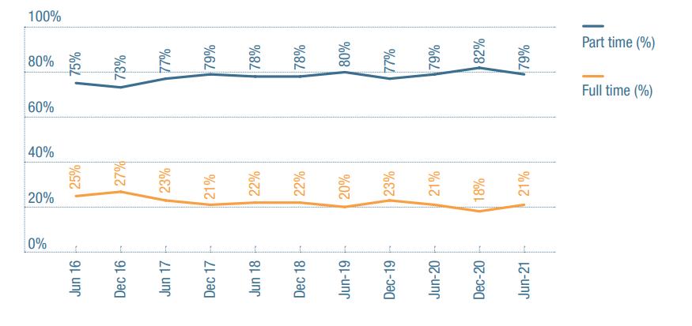
June 2016
Full time: 75per cent
Part time: 25per cent
December 2016
Full time: 73per cent
Part time: 27per cent
June 2017
Full time: 77per cent
Part time: 23per cent
December 2017
Full time: 79per cent
Part time: 21per cent
June 2018
Full time: 77per cent
Part time: 22per cent
December 2018
Full time: 78per cent
Part time: 22per cent
June 2019
Full time: 80per cent
Part time: 20per cent
December 2019
Full time: 77per cent
Part time: 23per cent
June 2020
Full time: 79per cent
Part time: 21per cent
December 2020
Full time: 82per cent
Part time: 18per cent
June 2021
Full time: 79per cent
Part time: 21per cent

Case study: Queensland

Wesley Beakley, CEO ROPE

Tell us about ROPE
ROPE stands for Redcliffe Opportunities for People’s Enhancement. It was created over 22 years ago by a group of parents who decided they wanted a bit more for their children than was on offer.
Today ROPE focuses on the development of life skills, independence, communication, community access and more, but in a way that’s giving our participants the opportunity to become their own person. We strive to provide a unique style of service, the type that isn’t normally on offer.
What has been your proudest achievement?
Just seeing our participants achieving their goals is what makes us proud; watching people grow, develop, become independent and if desired gain employment. They come here to learn what they want to learn, achieve what they want to achieve, and then move on to the next phase of their life, and that’s how it should be, moving on to the next chapter of their life. Our other major achievement is ROPE TV. This was ground breaking for ROPE.

What does an average day look like? Was this year very different, due to COVID etc?
Obviously, there’s always the boring stuff, like insurance and the accounts and so on, but COVID certainly helped liven up the sector that’s for sure. Basically, it’s about getting in there and growing the organisation, to develop and offer as many opportunities to as many people as we can. COVID or no COVID this never changes we adapt and move forward.

What do you think are some of the major opportunities awaiting the sector?
There are many opportunities out there, it’s whether service providers are game enough to challenge themselves to push beyond their comfort zone. It takes courage to change and take a different direction, but when you do there is nothing more satisfying.

What do you think are some of the major challenges facing the sector?
The big challenges for me are employment and disability – they’re the areas that I think are sadly lacking now. It’s about getting the public to understand that if they can take a chance and employ someone with disability, they’re going to get themselves a fantastic employee. They’ve just got to get in there and give it a shot. I feel this is something that needs to be pushed a lot more within the sector.

Why did you get into the disability sector?
My background is training and marketing, so this will sound terrible but, when I first started, I had no idea what to expect. I wanted a change, a new challenge. If you talk to anyone, they’ll tell you that the thing about disability is that it gets under your skin. So, this was just what I was looking for, and it’s true you do fall in love with the job, and it becomes all about helping the participants achieve their goals and desires.

What’s surprised you most?
I came in quite lucky because I had absolutely no preconceptions. But I do think that this industry needs to be shaken up and challenged more. There is still the line of thought that ‘disability services are done this way and this way only and you don’t change it.’ This is an old-fashioned way of thinking, disability needs a fresher a more youthful approach to service delivery, expect more and you will achieve more. We’re constantly trying to reinvent ROPE. You can’t stay the same year after year after year; that’s not a smart business model. So, we’re always looking for new adventures and new opportunities and new challenges that we can take on, that’s what makes ROPE unique.

Key issues

A struggling market-based model
NDS in Queensland provided support to the Queensland Productivity Commission (QPC) during their inquiry into the operation of the NDIS in the state. After extensive consultation, the Commission concluded what disability service providers already knew, that the NDIS is large and overly complex, insufficiently flexible, and creates a large and sometimes disproportionate regulatory burden, which deters new entrants, limits investment and innovation and generally hinders the effective functioning of the market. NDS looks forward to seeing the Queensland government’s response to the QPC’s report.

Workforce
Queensland providers continue to experience significant shortages in high-skills roles, including leadership, Allied Health and support coordination. NDS continues to see the impact of staff shortages in providers being unable to take up growth opportunities and the low utilization of participant’s plans.

COVID
Queensland organisations have done a wonderful job in keeping NDIS participants and staff safe during the pandemic. Providers have responded well to health directions and the need to swiftly change operational models. Many providers have responded to the COVID-19 situation with new services, new policies and practices. COVID has however reconfirmed the difficulty in mainstream interfaces for people with a disability. Vaccination rates for people with a disability are well below the general population and are of great concern to NDS as Australia prepares to open up.

Queensland Sector Statistics
Active participants including ECA: 101,187
Active ECA participants: 3,712
NDIS participants are Indigenous: 9.5 per cent
Culturally and linguistically diverse: 5.4 per cent

Case study: Northern Territory

Kim McRae, Ngaanyatjarra Pitjantjatjara Yankunytjatjara Women’s Council

Tell us about NPY Women’s Council.
We provide a range of human services and advocacy for Aboriginal people living in the remote, cross-border region of Northern Territory, South Australia and Western Australia. NPYWC was formed in 1980 so we are 41 years old.
What has been your proudest achievement there?
My proudest achievement has been staying in my role at NPYWC for almost 17 years and being able to retain many of my current staff for ten years or longer, despite the changes to funding in the sector. I am also proud that we have been able to build up the numbers of our NDIS Participants to the point that we are financially viable.
What does an average day generally look like?
My average day consists of checking in with staff and receiving updates on what is happening, responding to emails, participating in a range of meetings via Teams or Zoom, speaking up about the needs of people in our remote region, speaking to participants and their families, supporting staff to access relevant training, maintaining culturally safe and appropriate supports for our clients and their families through continuous improvement, responding to feedback and complaints, and liaising with our funding bodies.
What do you think are some of the major opportunities awaiting the sector?
There are definitely opportunities inherent in the NDIS and I am genuinely hopeful that eventually people living in our region will be able to access the care and support they need to live happy and healthy lives in country. There has been a significant increase in the funding that is available to support people with disability through their NDIS Plan.
There is great potential to build the local care workforce by recruiting and supporting local Aboriginal people to take up careers in disability and aged care support. There will need to be a commitment to long-term (three-to-five years) funding to recruit, support, mentor, train and retain potential disability workers.

What do you think are some of the major challenges facing the sector?
The challenges we are facing in remote Central Australia continue to be lack of services, endemic poverty, and balancing the expectations of our participants and their families with the expectations of the NDIS.

Why did you get into the disability sector?
I was working in a catering business as a casual support worker in residential care for people with profound disability. I was keen to find a job that aligned with my values, and I really enjoyed doing this work and found it very fulfilling.

What’s surprised you most?
I have been surprised and pleased by the flexibility of the sector in the COVID environment. People with disability have continued to receive quality supports during the pandemic and the sector has proven its capacity to pivot and be creative in the way that services are delivered.

What’s impressed you most?
I have been incredibly impressed by the resilience and commitment of the sector. So many organisations supporting people with disability have managed the transition from block funding to the NDIS and are now successfully operating in this new environment.

Northern Territory statistics
Active participants including ECA: 4,485
Active ECA participants: 126
NDIS participants are Indigenous: 49.6 per cent
Culturally and linguistically diverse: 6.5 per cent

The state of the Royal Commission
Royal Commissions are rarely linear or predictable, and 2021 certainly was no exception. Anyone expecting a clear start, middle and end – with hearings running sequentially and findings and recommendations quick to follow – was set to be disappointed.
We saw a change to the end date – with an extension to September 2023 making the enquiry’s duration of four-and-a-half years among the longest in recent history.
Seven Commissioners became six once more.
We also saw that the Commission won’t wait until its final report to start making findings and recommendations. The Commission found systemic discrimination of people with cognitive disability in healthcare; it made 22 recommendations regarding the Federal Government’s Covid-19 response; it found psychotropic medication is overprescribed to people with cognitive disability. Findings were proposed about disability services.
We saw change in legislation to protect information given confidentially to the Royal Commission – a positive for anyone concerned a submission made in confidence would have been made public at the end of the enquiry.
And we saw an ambitious hearing schedule form and re-form many times, as COVID The state of the Royal Commission continued to deliver challenges. The schedule involved a series of hearings focusing on preventing and responding to abuse in disability services, which made for particularly difficult viewing for the sector. Nonetheless, part of the challenge lies in resisting the urge to be defensive – and being prepared to learn lessons where they emerge.
Disability services hearings presented questions for all providers to consider. Do organisations make decisions based on their own interests, or those of service users? What cultures proliferate in organisations and how do these shape attitudes to feedback and complaints? Are organisations open and transparent, especially around investigations? How do senior staff assure themselves of adequate flow of information? Do organisations take responsibility and apologise when things have gone wrong?
NDS continued to assist providers to stay across all that was going on, by watching and condensing hundreds of hours of hearings into concise news updates. We continued to respond to issues papers – with a total of 11 responses to date, some of which were highlighted in the Commission’s overviews. We are approaching our thirtieth edition of the RC Newsletter, a one-stop-shop of all relevant RC-related information that some provider CEOs use as the basis for briefing their boards.
With hearings listed for the start of 2022, we have some idea of the direction the Royal Commission will take. It appears disability services will be a focus.
The enquiry will be with us until late 2023. And the work required after then should not be underestimated. In the meantime, hearings and reports will continue to provide lessons, findings and recommendations. We know providers will be challenged in how they respond. Will they take the attitude, ‘that couldn’t happen in my organisation’? Or will they instead ask, ‘what can I change to assure myself that never happens in my organisation?’ NDS will continue to work to support organisations to adopt the latter approach.

The state of the broader policy environment
It would be reasonable to assume that high levels of negotiation and protest about the proposed independent assessments for the NDIS, together with intense work to minimise the impact of COVID-19 on NDIS participants, have slowed work on other areas of disability policy. This work is expected to increase in the coming year.

National Disability Strategy launched
This year saw the slow development of a new national disability strategy finally conclude with the launch of the ‘Australian Disability Strategy’. Despite widespread frustration with its slow evolution, the new strategy certainly contains improvements on its predecessor, not least in its ambition to hold governments more accountable for their actions. NDS hopes this drives a greater commitment by all governments to improve mainstream services for people with disability.

NDIS Workforce Plan release
In 2021 the long anticipated NDIS Workforce Plan and NDIS Capability Frameworks were released.
NDS has long called for a coordinated approach that outlines practical strategies to meet increasing demands for a skilled, competent, and engaged NDIS workforce. The National Workforce Plan aims to bring all key stakeholders: government, employers, training and employment service providers, workers, and people with disability together to design and implement strategies that will address what are well known shortages. However, we are concerned that the Plan was released without new funding attached or initiatives proposed.

ILC funding under review
The year also saw responsibility for the Information, Linkages and Capacity Building (ILC) component of the NDIS framework shift from the NDIA to the Department of Social Services. NDS understands that a review of how ILC funding has been allocated and used is currently underway, with a view to better aligning its use to the Australian Disability Strategy. ILC funding is an important adjunct to the individualised funding provided by the NDIS. We want its role to be strengthened.

DSP recipient numbers decline
The number of DSP recipients declined through 2021, with 1,172 fewer people claiming the pension on 30 June 2021 than 12 months before. Just 6.9 per cent of DSP recipients reported wage earnings, the lowest ever June figure and down from 8.5 per cent in June 2011. This figure is likely to continue to fall in the second half of the year, due to ongoing COVID restrictions in NSW and Victoria.
With the number of DSP recipients likely to increase at the same time, it is imperative that the NDIA reaffirms its commitment to NDIS Participant Employment Strategy targets. This commitment must include identifying a realistic mid-2022 target that reflects the impact of the 2021 restrictions. It is instructive to note that the Strategy’s December 2021 employment target for participants is 27.5 per cent, while the rate of employment for participants in June 2021 was 22 per cent.
NDS remains adamant that the Government must address disincentives to employment for DSP recipients and consider any recommendations which arise from the current Australian Senate Committee enquiry into the DSP.

Modern Award review
Throughout 2021, NDS continued to participate in the Fair Work Commission’s review of the SCHADS Award. In late August the full bench of the Fair Work Commission issued a decision finalising a range of substantive SCHADS Award matters. Importantly, NDS and others successfully argued that these changes should come into effect on 1 July 2022 as opposed to the original operative date of 1 October 2021. NDS has raised the impact of the Award changes on the operating costs of providers with the NDIA and will provide further detail in our submission as part of the NDIS Annual Price review.
Some of the more contentious matters include minimum engagement, broken-shift and traveltime arrangements, rostering and overtime for part-time employees.

Case study: New South Wales

Carol Smail, CEO of ACL Disability Services, Gig Buddies

Tell us about ACL
ACL Disability Services is a not-for-profit organisation founded in the 1960s. We provide support for people with mild to moderate learning disabilities. We have group homes and provide drop-in support to independent clients in the community.

What has been your proudest achievement there?
Starting up our volunteer befriending scheme, Gig Buddies. It’s a good example of how NDIS gives participants the choice of who they want support from and the freedom to do the things they want to do.
We match a person with disability with a volunteer who has similar interests – e.g., the same taste in music. It started off with going to gigs but now it’s a wide range of activities. We have participants who go to museums, rock climbing or bushwalking. It works for the volunteers because it fits into their lifestyles.
It works for the clients because, regardless of how good a support worker might be, there’s always going to be a certain power imbalance with a person paid to be in their life. People have made lifelong friendships. It’s a really nice thing to see.
What do you think are some of the major opportunities awaiting the sector?
Innovation in general. NDIS gives us the opportunity to do things a bit differently. Gig Buddies started out as this tiny little project we did on Friday afternoons, when we’d done all our other work, and now it’s one of our main revenue streams.
What do you think are some of the major challenges facing the sector?
For some of us, I’d say surviving.
I remember when I was in Melbourne at an NDS CEO Conference (just prior to NDIS) a CEO presented and said ‘in three years’ time about a third of you will be gone, and mostly it will be the small organisations. I always reflect on that because I thought that all these for-profit organisations were going to come in and swallow us and overwhelm us, and that certainly hasn’t been our experience.

Why did you get into the disability sector?
I was studying law and social science and had a field placement with a psychologist which involved visiting the families of women who were in prison. And a great deal of their children – I would say 50 per cent – had learning difficulties due to fetal alcohol and other conditions. It was a big awakening that prompted me to become a support worker.

What’s surprised you most?
Looking at the sector in the UK, many people with disability are quite aware of their rights, nothing’s ever been given to them. They’ve always had to fight really hard. In Australia, we were a bit cossetted when we had block funding: money used to magically drop in your bank account every quarter, there was no real accountability. Nothing like that ever happened in the UK so a lot of people there have become quite good at self-advocating.

Key issues

Financial impact
In the absence of a JobKeeper type scheme, sustainability for some services became a real issue during NSW’s lengthy and rolling COVID lockdowns. NDS helped ensure that measures such as JobSaver were able to be utilised by the sector by joining a push for the threshold to be reduced from 30 per cent decline in income to 15 per cent for not-for-profits.

Vaccinations
The decision to mandate vaccinations for those disability workers providing supports in persons was welcomed by the sector but the 10-day timeframe originally proposed could have been problematic. With the support of other peak bodies and the unions, NDS successfully advocated for an extension to this time frame to ensure that all workers were able to comply with the requirements. The next step is to see vaccinations become mandatory for all workers delivering direct disability supports. This needs to be supported by adequate supplies, an engaging information campaign and a realistic timeframe to comply. This advocacy has seen vaccines become mandatory for our sector.

Workforce
COVID highlighted and exacerbated a number of workforce healthy and safety issues, and required NSW providers to develop and implement a range of sophisticated and creative strategies. NDS is working with members, the NDIA and government to understand and manage the longer-term impacts (both positive and negative) that COVID-19 may have when it comes to attracting and retaining disability workers.

New South Wales Sector Statistics
Active participants including ECA: 154,227
Active ECA: 4,525
NDIS participants are Indigenous: 7.8 per cent
Culturally and linguistically diverse: 10.8 per cent

Case study: Western Australia

Jacquie Thomson, Ability WA

Tell us about Ability WA
Ability WA is a large disability service provider that’s currently celebrating our 70th anniversary. We very much stands on the shoulders of giants – those giants being the founding family members who had a vision of inclusion and opportunity for their children’s future and for every person who comes after them.

What has been your proudest achievement there?
I have been the CEO of Ability WA for three years. So much has happened in three years. It’s been an unbelievable time. One thing that stands out is the way we’ve really put the customer at the centre of the organisation – and I mean in a real way, not just through lip service. That’s involved appointing a Chief Customer Officer at the Executive level, establishing a Customer Advisory Council, publishing a Customer Commitment, and putting a Customer Experience Committee together at board level.

What does an average day look like?
There’s no such thing! I might wake up thinking my day is completely planned, but then life takes over. The phone will ring, or people pop by my office – it can all change. But I’m ok with it as we’re all about people and the richness and messiness of what makes us human. I have a very talented and committed Executive team, so I try my best not to get in their way.

What do you think are some of the major opportunities awaiting the sector?
I think it’s about new ways of working: about being both collaborative and customer-focused; about constructively engaging with government as we see the next stage of the NDIA develop; and about providing services to those not NDIS eligible. The disability sector has never shied away from its community stewardship responsibilities. The current context provides us with an opportunity. With the heightened awareness of the obligation and benefits of inclusion, our sector can strategically influence governments, corporates and the community to be inclusive too.

Why did you get into the disability sector?
Previously, I worked for a state government department with heavy involvement in the not-for-profit sector. It’s such an interesting sector, and I’ve come into it at its most interesting time. There’s an increased awareness of the sector, huge opportunities for growth, new ways of working, and contemporary modalities to be developed.

What’s surprised you most?
The complexity of our policy and operating environment. For example, the NDIA sets around 95 per cent of provider’s revenue through pricing, with operating costs being influenced by the free market, and geographically and industrially volatile settings. It’s not like the private health sector, where at least rates and indexation can be negotiated with health funds in reflection of those expenditure pressures. There’s also been a real failure to bring people with disability along the NDIA journey. For some of our customers, the system is still so overwhelming and difficult to navigate. People with disability have more choices and opportunities than ever before – we need to empower them better to make the best of those opportunities.

What’s impressed you most?
There’s inspiration all around us, working in this sector. Every day, we work with people with significant challenges to support them in living life their way. And these people smash their dreams and aspirations out of the park!

Key issues

Higher costs of delivering services in WA
The current pricing model does not reflect the economic market conditions in Western Australia. This could be addressed through mechanisms like an appropriately adjusted pricing regime that includes SIL and the costs of regional and remote service delivery.

Operational challenges
There’s a need for improvement to the sustainability of the sector by reducing bureaucracy and increasing the efficiency of the NDIA agency, reducing sector costs.

Workforce shortages and underinvestment
Greater investment is needed in disability workers. There is growing competition for workers as the sector competes with the WA resources sector and the aged care and health sectors. There is a critical requirement for funding for a range of disability workforce initiatives to help address the shortage of disability workers.

Western Australia Sector Statistics
Active participants including ECA: 42,256
Active ECA: 600
NDIS participants are Indigenous: 7.5 per cent
Culturally and linguistically diverse: 8.1 per cent
[back page]

References
- State and territory sector statistics: National Disability Insurance Scheme (2021, September), Quarterly Reports 2021-22 Q1, retrieved from ndis.gov.au
- ABS (2021, June), Business conditions and sentiments, retrieved from abs.gov.au
- Australian Government (2021, June), Disability employment services monthly dataset, retrieved from lmip.gov.au
Publisher
National Disability Services
Laurie Leigh, Interim CEO, 03 8341 4343, laurie.leigh@nds.org.au
All rights reserved. No part of this publication may be reproduced, distributed or transmitted in any form without the prior written permission of the publisher. Except in the case of brief quotations embodied in critical reviews and certain other non-commercial uses permitted by copyright law.
About National Disability Services
National Disability Services is Australia’s peak body for non-government disability service organisations, representing over 1000 service providers. Collectively, NDS members operate several thousand services for Australians with all types of disability.
Acknowledgements
The 2021 Annual Market Survey was carried out by Associate Professor Jennifer Smith-Merry, PhD, and her team at the Centre for Disability Research and Policy at the University of Sydney. Thank you to members who participated in our case studies.
National Disability Services acknowledges the Traditional Owners and Custodians across the lands in which we live and work and we pay our respect for Elders past, present and emerging.

