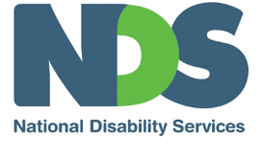
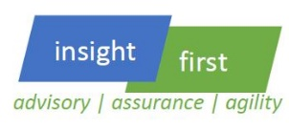

Smart Product Design: Things to remember

What is smart support design?
A support is smart if it can be:
- Available to consumers when and where they need it
- Easily understood by clients and replicated by staff
- Delivered accurately and precisely
- Delivered efficiently
- Uniquely matched clearly to participant needs, goals and satisfaction
- Mapped to genuine life-trajectory change
- Mapped to evidence based good practice.
Decorative images omitted.

Why is this important?
To make us the preferred provider? To deliver on our promises to clients? To deliver on excellence for our organization? Because it’s the right thing to do.

Things to focus on:

What makes us unique? How do we stand out to attract and retain clients?
- Price: we are the cheapest!
- Quality: we will provide the BEST support
  - Relationship: we know you! We understand your goals
  - Distribution: we will be the most easily accessible
- Unique: our product is different (and hard to copy)

Are we actually listening to what are clients want?
- Wants: price, convenience, value
- Needs: quality control, best practice framework
- Goals: best practice, clearly measured

Are we best practice? How would we know?
- Do we have evidence based methodologies that demonstrate our practices actually work?
- Do we consistently apply these frameworks?
- Can we leverage off our models?
- Is the product mix actually appropriate and profitable

Are the supports we are offering actually going to change the life trajectory of clients?
- Quality of life
- Increased Independence
- Reduction in supports or costs over lifetime.

What do I need to remember?
- Smart design framework!
- Think differently, what changes can make a difference?
- Despite the profit, think about outcomes and life trajectory change

What are our next steps?
- Do your homework! (also last week’s homework)
- Make informed decisions
- Think, plan and act wisely
- Lead with clear thinking and discipline
You and your teams are in this sector to really make a difference. Despite the profit, remember that your clients are relying on you to create a program that generates genuine life trajectory change for them. Make sure you play your part!
End of document.

