NDIS Commission Providers and the Audit process

Slide 1

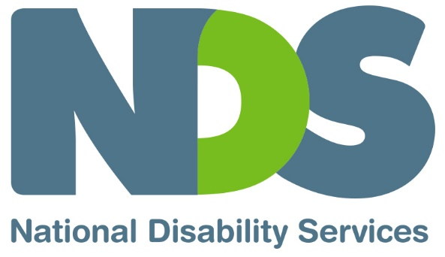

NDIS Commission Providers and the Audit process

Slide 2

What we will cover
- How audit assessments relate to Provider Registration
- Terminology used
- What to expect from auditors
- Requirements of auditors and the audit process
- Requirements of providers in relation to the audit process
- How the auditors determine a quote
- What impact the auditor guidelines have on providers

Slide 3

First some terminology

NDIS Approved Quality Auditor Scheme:
- A framework for auditing of approved NDIS auditing bodies on how to audit NDIS providers

NDIS Practice Standards:
- The applicable standards providers will be assessed against for registration purposes

Methods used to determine Quality Assurance:
- Verification (For low risk service types) designed particularly for the owner operator segment
  - Desk top audit of documents in relation to the Verification Standards
- Certification (For medium - high risk service types)
  - Comprehensive process; Desk top audit of documents, onsite review, interviews of staff and participants against the NDIS Practice Standards

Approved Quality Auditor (AQA):
- A Body or person approved by the Commission to conduct audits using the Practice Standards. Only Approved Quality Auditors can conduct audits for NDIS Commission purposes.

Slide 4

Audits and the NDIS provider registration process
Step and who is responsible:
- Transitioning to the NDIS Commission-Commission will inform providers when to start re-registration process, NDIS Commission is responsible
- Complete online application form on the NDIS Commission website, Provider is responsible
- Select an approved quality auditor, Provider is responsible
- Undergo audit, Provider is responsible
- Commission assesses your re registration application and makes a decision, NDIS Commission is responsible
- Receive application outcome, Provider is responsible
- Mid-term surveillance audit, Approved quality auditor is responsible
- Re-Registration application re commences, NDIS Commission is responsible

Slide 5

Auditor Guidelines/What to expect from auditors
- requirements for Approved Quality Auditor’s in their conduct of audits using the NDIS Practice Standards
- management of Auditor competence
- Auditor Code of Conduct
NDIS Approved Quality Auditors Scheme Guidelines 2018

Slide 6

Guideline Terminology

Scope of Audit
- Describes the range of services and supports that are to be assessed by the approved Quality auditor.

Consent
- A participant provides written consent for an auditor to involve them in the audit process.

Proportionality
- The size of the organisation and operational scale of the service delivered will determine the expectations auditors will place on providers in the detail of systems and evidence they will be required to demonstrate.

Slide 7

Certification Audit process
- Stage one audits
- Stage two audits
- Mid term surveillance audits

Slide 8

What to expect from auditors
- Discuss and provide an audit program prior to arrival
- Check there is no conflict of interest with audit team members
- Be respectful of participants and their families and minimise disruption to the service
- Deliver a summary of audit findings at a closing meeting
- Provide a written report to the provider that:
  - includes attainment ratings against each of the outcome and indicator
  - Ensure finding statements and corrective action requests are completed and appropriate to the level of attainment and risk determined,
  - Identifies opportunities for improvement
  - Is given to the provider for comment prior to submitting the Commission

Slide 9

Quotes from Approved Quality Auditors
- Quotes are based on ‘scope of audit’ document
- Quotes are provided on a ‘no obligation’ basis, free of charge
- The Auditor Guidelines require all auditing bodies to have a documented process for how they calculate a quote
- Seek a range of quotes
- Questions to ask when requesting a quote
- Any change in the scope of audit (e.g. to registration category) a provider makes will impact on cost.

Slide 10

Implications for providers
Audit requirement and Implication for provider
Participant sampling:‘Opt out’ rather than ‘opt in’. Implication: Require strategy to obtain prior informed consent in writing from each participant selected to be part of the audit.
Auditors select participant sample from all participants (unless they have opted out). Implication: Providers have no control over which clients/staff are selected for audit purposes.
Provide list of audit team member names prior to commencing the audit. Implication: Can object to any team member with reason.
Remote location costs. Implication: Commission may agree to off-site audit.
Evidence of a documented support plan and evidence of delivery of supports to execute the plan. Implication: Determine the adequacy of current documentation and respond to this requirement. Service agreement details of delivery arrangements may be inadequate.
Internal audits program. No implications indicated.
Both surveillance and stage two audits will review governance and operational management. Implication: Providers will need to be prepared for this focus.

Slide 11

Potential Future developments
Feedback from participants is the most important indicator of quality
- Mutual recognition
- Addition of new registration classes
- Use of unannounced or short notice audits

Slide 12

Questions to ask auditors when seeking a quote
- What does the quote cover?
- Experience of proposed assessment team members in disability?
- Technical expertise for relevant supplementary modules?
- References?
- Ability to communicate with participants with communication difficulties?
- Mutual/simultaneous accreditation possibility?
- Availability to meet your needs e.g. dates?

Slide 13

Resources (links)
NDS Quality Hub
NDIS Commission Provider Requirements
NDIS Commission Provider Registration
NDIS (Approved Quality Auditors Scheme) Guidelines 2018

Slide 14
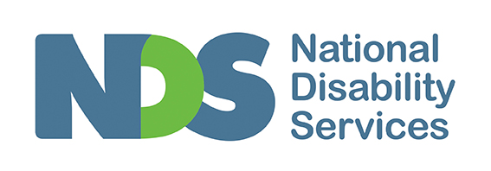
End of document.

