Document in English language

Slide 1

Practice Leadership Workshops for Behaviour Support Practitioners
Facilitator: Dave Relf
National Practice Lead – Zero Tolerance Initiative

Slide 2

Outcomes of today’s discussions
- To share and discuss why practice leadership is critical to Positive Behaviour Support
- To understand the importance of being attuned to the culture of a staff team
- Understand the role of the behaviour support practitioner in staff training and ongoing practice development
- To consider how you might apply practice-based coaching methods to PBS implementation
- Provision of resources and further reading

Slide 3

What is Practice Leadership?
- “An individual who develops, encourages and supports their staff team to put into practice the vision of the organisation.” (Beadle-Brown, Bigby & Bould, 2015)
- Consider the difference between “management” and “leadership”
- Who else might contribute to practice development?

Slide 4

5 Components of Practice Leadership
- Focus on the quality of life of the person and how well staff support this
- Allocating and organising staff to deliver support when and how service users need and want it
- Coaching staff to deliver better support by spending time with them providing feedback and modelling good practice
- Reviewing the quality of support provided by individual staff in regular supervision and finding ways to help staff improve it
- Reviewing how well the staff team is enabling people to engage in meaningful activity and relationships in regular team meetings
(Mansell, Beadle-Brown, Ashman & Ockenden, 2004)

Slide 5

Practice Leadership and Positive Behaviour Support
Have you ever written a high quality behavior support plan that wasn’t fully implemented?

Slide 6

Employee engagement in Australia
If these percentages were representative of a staff team you are supporting – how would you go about engaging the team?
Who would you focus on?

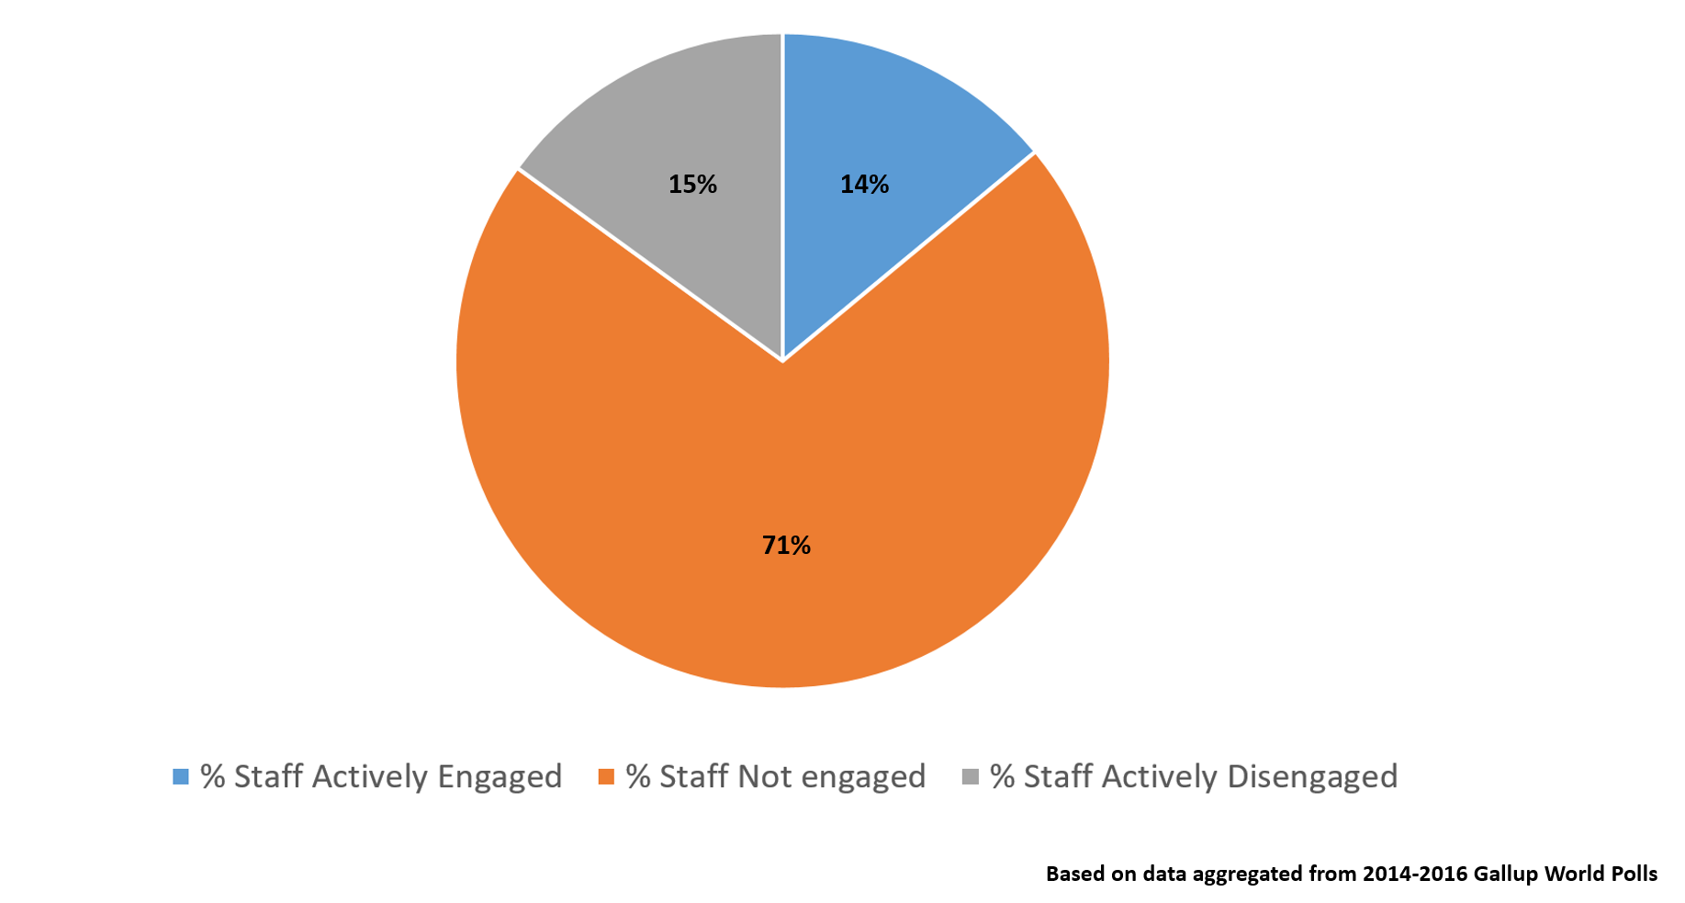

Slide 7

Becoming attuned to service culture
“The way we do things around here”

Dimensions of Culture:
- Alignment of power-holders’ values
- Regard of participants
- Perceived purpose
- Working practices
- Orientation to change and ideas
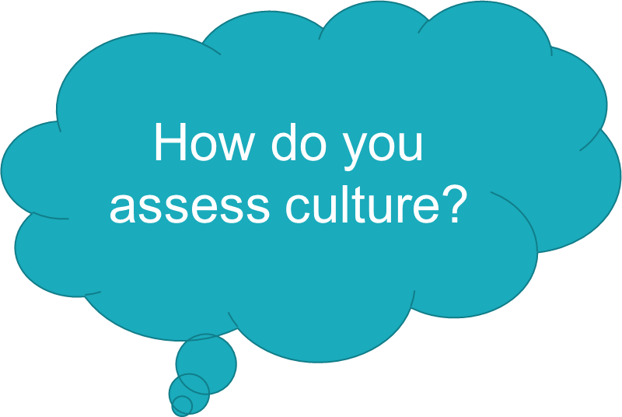
Bigby & Beadle-Brown (2016)

Slide 8

Quick Stretch
Image of a fluffy bird with its claws wrapped around two baby bamboo stems (stretching)

Slide 9

What is the role of the Behaviour Support Practitioner in practice leadership?
- Focus on human rights
- Making recommendations regarding ecology to enable positive behaviour support
- Promote least restrictive alternatives
- Consider the capacity of the person and their support network
- Collaborate with other service providers – support implementation across multiple contexts
- Provide implementers with information about possible risks if the plan is not implemented consistently
- Identify the roles of the person receiving support, staff and others
- Assess service culture
- Facilitate team building opportunities
- Choosing when to teach staff
- Choosing how to teach staff
- Implementation is a process – not an event

Slide 10

Training methods and approaches
Educative vs Interactive Approach

Training methods
- Multi modal (generally most effective)
- Experiential
- Video/Multi media
- Verbal (least effective)
- Written language

Slide 11

Practice-based coaching
Picture of an arrow pointing to the next image that says It all starts here
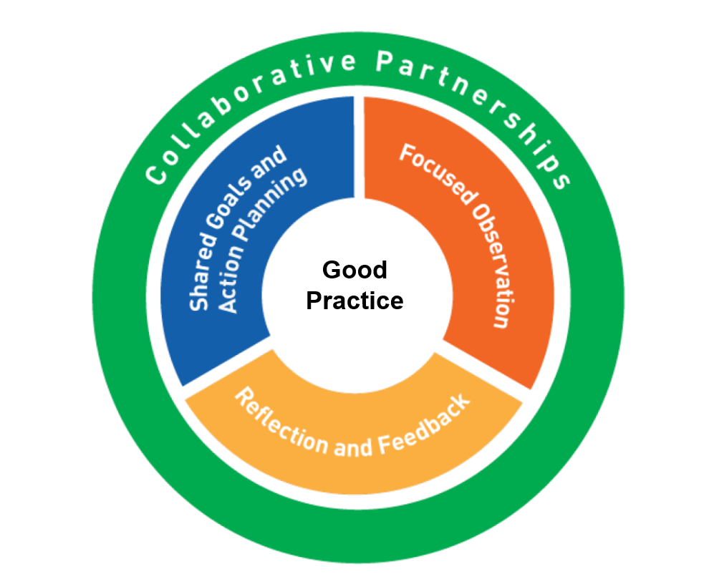
Created by and available from the National Centre for Pyramid Model Innovations (NCPMI) at Challenging Behaviour

Slide 12

Developing collaborative partnerships
- Focus on constructive communication between the coach and the coachee
- Establish a written agreement
- Empower and inspire
- Motivation in the moment – the power of praise

Slide 13

Shared Goals and Action Planning
Goals and Action plans should always be developed collaboratively between the coach and the support worker

Goal Considerations
- Does the goal contain one or more specific actions the coachee will do?
- Can the actions be counted and measured?
- Are there times of day, activities, routines or transitions included to make it clear when the coachee should be implementing the practice?
- Is the goal achievable over the next few coaching sessions?

Slide 14

SMART Goals
Specific – what exactly do you want to accomplish?
Measurable – How will you track progress?
Achievable – Do you have what you need to achieve this goal? What other support do you need?
Relevant – Is the goal worthwhile? Is it the right time to accomplish it?
Timely – When will you achieve this goal? When will you work on it?
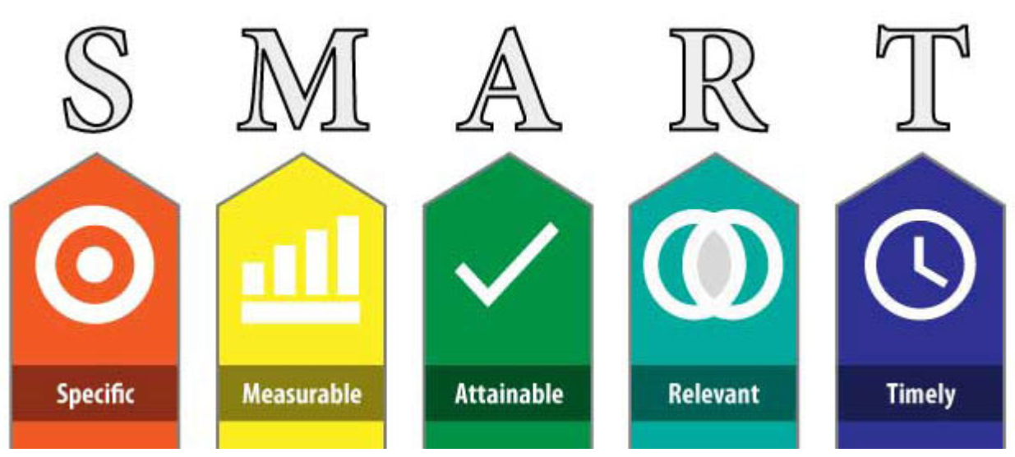

Slide 15

Shared Goal and Action Planning
An Action Plan is a working document that describes:
- The goal(s) that the support worker wants to achieve
- Planned actions or steps to be taken towards achieving goals
- An explicit statement about when the goal will be achieved

Slide 16

Focused observation
- A Practice Leader should be comfortable with observing staff supporting people
- It’s important that the person receiving services , other service users and the staff member feel comfortable being observed also
- Make the time to observe staff practice on a regular basis
- Record any significant observations
- Provide positive and constructive feedback regularly
More information and resources on Practice Based Coaching:
Implementation

Slide 17

Supporting the Practice Leader
- Collaboration between the Behaviour Support Practitioner and the Practice Leader is critical
- Identify the barriers and enablers to implementation
- Enquire about the Practice leader’s confidence and capacity to implement practice-based coaching
- Provide opportunities for reflection and offer feedback regularly
- Determine how feedback will be provided to others in the person’s support network
Feedback should be:
- Planned
- Focused
- Supportive
- Constructive

Slide 18

Helpful Resources
- NDS Empowerment Cycle
- Behaviour Cycle – visual tool to support implementation
- SMART goals template
- Collaborative Action Plan
- NDS Recognising Restrictive Practice films
What tools are others using to support PBS training and implementation?

Slide 19

The PBS Capability Framework

Knowledge: Implementation

Core Behaviour Support Practitioner
- Understand the importance of individualised implementation of a behaviour support plan
- Understand how implementation approaches can vary for a person across different stages of life
- Consider the people to include in implementation
- Understand that functioning and resilient teams are likely to increase the consistency of implementation

Skills: Implementation

Core Behaviour Support Practitioner
- Provide individually tailored education and training to those who are implementing a behaviour support plan
- Consider the capacity of the person at the centre of a behaviour support plan and their role in implementation
- Support implementers to incorporate strategies into daily support plans and other relevant support documents
- Support implementation across different environments and contexts
- Provide feedback to implementers on implementation and model alternatives
- Support those implementing a behaviour support plan to use the recommended data collection systems
- Promote least restrictive practices

Slide 20

Knowledge: Implementation

Proficient or Above Behaviour Support Practitioner
- Understand the critical people to include in implementation across diverse cultural contexts
- Know different methods of giving feedback
- Be aware of complex team dynamics and know strategies to manage these effectively
- Understand the importance of incident debriefing practice

Skills: Implementation
- Provide education and training to an interdisciplinary team
- Address barriers to implementation
- Identify the resilience, capacity and sustainability of implementers and make appropriate adjustments to a behaviour support plan to take these into consideration
- Provide implementers with information on risks and consequences of non-compliance with implementation
- Provide implementers with information on ethical reactive strategies
- Train implementers in escalation mechanism and emergency response plans
- Identify appropriate methods of feedback for those implementing a behaviour support plan
- Facilitate team building to enable successful implementation of a behaviour support plan
- Adjust a behaviour support plan as required
- Identify incident debriefing supports available to implementers
- Provide training on facilitating critical incident debriefing to appropriate members of the implementing team if required

Service Provider and Implementing Provider Considerations across all Practitioner Levels
- Ensure staff supporting the person have good links with community
- Provide clear expectations of staff that a key component of their role is to identify and develop meaningful activities for each person throughout the day
- Lead and monitor the implementation of a behaviour support plan
- Provide resources to support implementation
- Provide staff with ongoing training, supervision and support in the implementation of a behaviour support plan
- Use performance management systems to ensure staff are using strategies outlined in a behaviour support plan
- Provide critical incident debriefing for all involved parties when necessary

Slide 21

Future Workshops

Practice Leadership Workshops for Behaviour Support Practitioners
- Reflective Practice
- Collecting meaningful data and measuring outcomes
- Supporting the person (and their support network) to be incolved in the development of their own plan
Recognising Restrictive Practices workshops

Slide 22

Evaluation
Decorate image omitted

Slide 23

References
- Aarons, G. A., Hurlburt, M., & Horwitz, S. M. (2011). Advancing a conceptual model of evidence-based practice implementation in public service sectors. Administration and Policy in Mental Health and Mental Health Services Research, 38(1), 4-23.
- Ager, A., & O’May, F. (2001). Issues in the definition and implementation of “best practice” for staff delivery of interventions for challenging behaviour. Journal of Intellectual and Developmental Disability, 26(3), 243-256.
- Beadle‐Brown, J., Mansell, J., Ashman, B., Ockenden, J., Iles, R., & Whelton, B. (2014). Practice leadership and active support in residential services for people with intellectual disabilities: an exploratory study. Journal of Intellectual Disability Research, 58(9), 838-850.
- Beadle‐Brown, J., Bigby, C., & Bould, E. (2015). Observing practice leadership in intellectual and developmental disability services. Journal of Intellectual Disability Research, 59(12), 1081-1093.
- Dench, C. (2005). A model for training staff in positive behaviour support. Tizard Learning Disability Review, 10(2), 24-30.
- Deveau, R., & McGill, P. (2016). Practice leadership at the front line in supporting people with intellectual disabilities and challenging behaviour: A qualitative study of registered managers of community‐based, staffed group homes. Journal of Applied Research in Intellectual Disabilities, 29(3), 266-277.
- Gordon, S. P. (2004). Professional development for school improvement: Empowering learning communities. Allyn & Bacon.
- Mansell, J., Beadle-Brown, J., Ashman, B., & Ockenden, J. (2004). Person-centred active support: A multi-media training resource for staff to enable participation, inclusion and choice for people with learning disabilities. Brighton, UK: Pavilion.
- MacDonald, A., & McGill, P. (2013). Outcomes of staff training in positive behaviour support: a systematic review. Journal of Developmental and Physical Disabilities, 25(1), 17-33.
- Snyder, P. A., Hemmeter, M. L., & Fox, L. (2015). Supporting implementation of evidence-based practices through practice-based coaching. Topics in Early Childhood Special Education, 35(3), 133-143.
End of document

