Document in English language

Slide 1

Supporting the person (and their support network) to be involved in all aspects of positive behaviour support
Facilitator: Dave Relf
National Practice Lead, Zero Tolerance Initiative

Slide 2

Acknowledgement of Country
We acknowledge the traditional custodians of country and pay our respects to their Elders past, present, and emerging.

Slide 3

Housekeeping
- Overview of Zoom functions
- This workshop is intended to be interactive, please join in the discussion
- The usual conduct around confidentiality of individuals’ personal information applies
- The content of this workshop is designed to be applicable to a wide range of PBS practitioners and professionals. This is an opportunity for us to all share our expertise and learn from each other
- A copy of the registration confirmation for this course can be kept as evidence for the PBS Capability Framework.

Slide 4

Overview of Previous Workshops

Practice Leadership Workshops for Behaviour Support Practitioners
- Implementing positive behaviour support
- Reflective Practice
- Collecting meaningful data and measuring outcomes
- Supporting the person (and their support network) to be involved in all aspects of positive behaviour support.

Slide 5

Outcomes of today’s discussions
- Reflect on the values of positive behaviour support
- Review relevant research
- Consider the various aspects of positive behaviour support and reflect on how we can do better
- Measuring contextual fit
- Hear from a practitioner and a person they support
- Discuss how the person’s support network can be actively involved
- Consider the restrictive practice authorisation process
- Provision of useful templates and other resources
- The Positive Behaviour Support Capability Framework.

Slide 6

Polling questions
- “Reflecting on what you’ve observed in your work experience, do you think the provision of positive behaviour support and associated processes (e.g. Restrictive Practice authorisation, staff training etc.) in the disability sector could be more person centred?”
- “When considering how well you involve people in all aspects of positive behaviour support, do you think this is an area where you could improve your practice?”

Slide 7

Positive Behaviour Support
Positive behavioural support is a multicomponent framework (Dunlap and Carr, 2007; LaVigna and Willis, 1992; MacDonald, Hume and McGill, 2010) for:
- developing an understanding of the [behaviours of concern] displayed by an individual, based on an assessment of the social and physical environment and broader context within which it occurs;
- with the inclusion of stakeholder perspectives and involvement;
- using this understanding to develop, implement and evaluate the effectiveness of a personalised and enduring system of support; and
- that enhances quality of life outcomes for the focal person and other stakeholders (Gore et al., 2013).

Slide 8

Positive Behaviour Support
“Consistent with person centred values, positive behaviour support requires active engagement and collaboration with the person.” (Carr et al., 2002)
“The [people receiving support] (and their advocates) are the key decision makers in defining the goals and the parameters of positive behaviour support.” (Dunlap et al., 2008)

Slide 9
Stakeholder Participation
Stakeholder participation is one of nine critical features of positive behaviour support (Carr et. al., 2002).
Stakeholders have evolved from a passive role in which they are instructed by an expert, to an active role in which they:
- provide valuable qualitative perspectives for the purpose of assessment;
- determine whether proposed strategies are relevant;
- evaluate whether the approach taken is practical and is in line with the values, needs, and organisational structures related to the individual with disabilities and his or her support network; and
- define what outcomes are likely to improve the general quality of life and enhance the person’s personal satisfaction.

Slide 10

The Values of Positive Behaviour Support
- Dignity
- Social Interaction
- Respect
- Communication
- Inclusion
- Unconditional Positive Regard
- Personalisation
- Person Centred Practice
- Consistency
(Gore et al., 2013).

Slide 11

Benefits of involving the person in PBS
- Upholds the values of positive behaviour support
- Increases the validity and credibility of plans
- Recognises people with disability as experts in their own lives
- Promotes choice and control
- Empowers the people we support
- Promotes ownership of strategies aimed at improving quality of life
- Improves insight
- Outcomes can be shared and are more rewarding for everyone involved (especially the person receiving support).

Slide 12

Review of relevant literature
An exploratory study of Behavioural Specialist experiences of involving service users in the development of their positive behavioural support plans (Kruger & Northway, 2017)

Major themes:
- The communication process
- Complicating factors
- Focus on the individual

Minor themes:
- Understanding individual ability
- Using alternative approaches
- Avoiding distress
- Complexity of need
- Time/resources
- Cognitive ability
- Observations and assessments
- Multi-disciplinary team working
- Collaborating with carers
- One-to-one interaction.

Slide 13

Review of relevant literature
- ‘Just look at my face’: co-production of a positive behaviour support plan (Ham & Davies, 2018)
  - Describes how a service user (Sebastian) became fully involved in the development of his positive behaviour support plan and participated in training his support team.
“Sebastian appeared to gain confidence in vocalising his concerns, wishes, needs and frustrations which, in turn, gave staff greater confidence in supporting him knowing that was what he wanted.”

Slide 14

Sebastian’s assault cycle:
Baseline: interact and chat with me about my day, and what I would like to do
Slow Trigger: Use diffusion/distraction techniques as described in my positive behaviour support plan
Fast Trigger: Ask me if I would like ‘time out’ in a place of my choice
Crisis: use bespoke technique as per my positive behaviour support plan that staff have been trained to do
Post-crisis: Asses my mood to find out how close I am to baseline, remember you may be upset too
Baseline: ask me if I would like to discuss the events that have happened – please do not pressure me if I would not like to
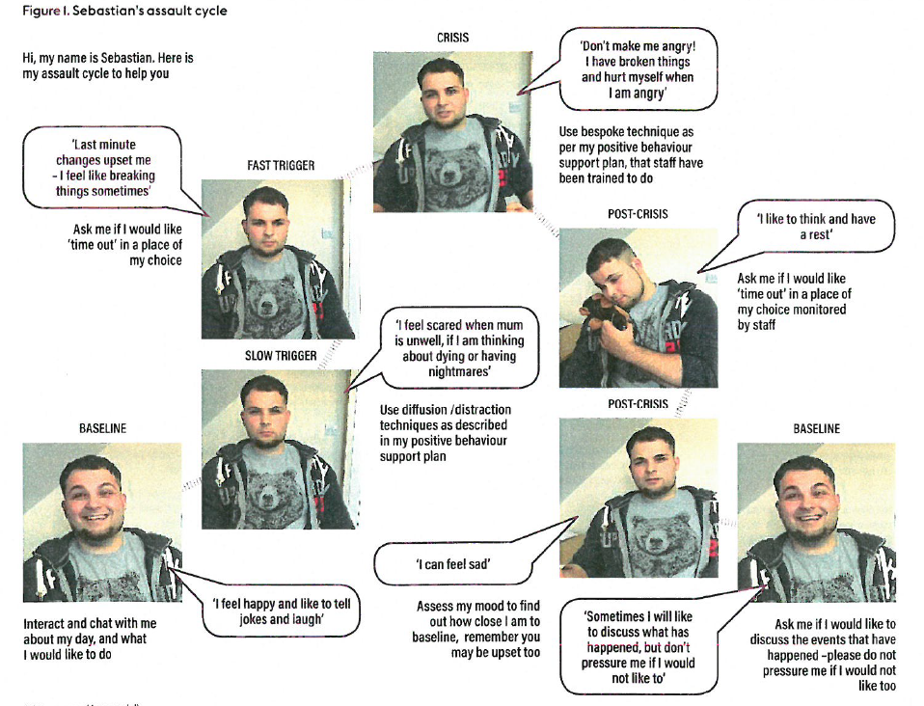

Slide 15
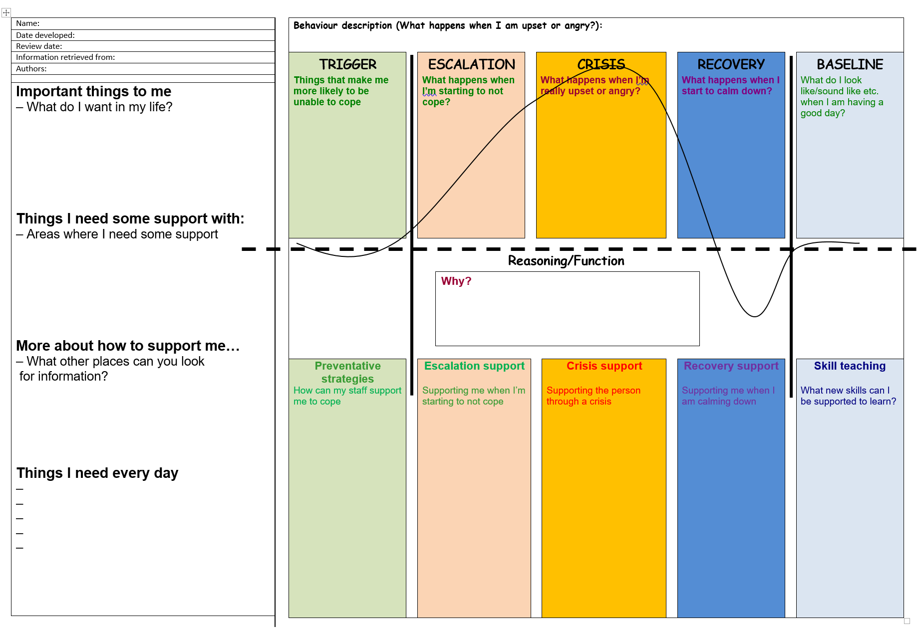

Slide 16

Making a plan
- When are you most likely to get really upset or angry?
- What happens when you get upset or angry?
- What do other people do? How does this make you feel?
- What would help you not get this upset?
- What are some options you have instead of doing this?
- What would be good rewards for you, to help you know you’re doing a good job?

Slide 17

Review of relevant literature
“I feel like just a normal person now”: An exploration of the perceptions of people with intellectual disabilities about what is important in the provision of positive behavioural support (McKenzie et al., 2018).

Good support included:
- being treated as a human being;
- being included, listened to and respected;
- having a good and full life and being helped with behaviours and skills.

Slide 18

Barriers and Enablers of Involving the person in all aspects of PBS
Take two minutes to consider two barriers and two enablers of involving the person in all aspects of PBS. Type into chat box.
Consider:
- Likes/dislikes
- Functional Behaviour Assessment
- Response strategies
- Training staff
- Data collection
- Research
- Presentations.

Slide 19

Practice example
Meet Georgia and Evelyn.10 minute discussion between a Behaviour Support Practitioner and the person she supports.

Slide 20

How do we make involving the person the new norm?
- Embed a person centred approach into everything we do
- Take the time
- Advocate for the people we support
- Be creative/innovative
- Share successes and learn from each other
- Other ideas?

Slide 21

Involving the person’s support network
- Circles of Support
- Increased wellbeing
- Establishment and maintenance of relationships, friends
- Reduced isolation
- Support to achieve goals and improve quality of life
- Advocacy
- Safeguarding.

Slide 22

Quick Stretch
Decorative image omitted.

Slide 23

Considering whether a circle of support might be useful
- Are there any unpaid people in this persons life?
- Do you believe there are others who will care and contribute to this persons life?
- Is there room for others to be involved in this person’s life?
- Is the persons safety and wellbeing compromised and is this causing anxiety?
- Is the person (and/or their family) prepared to ask others to help?
Etmanski & Etmanski (2000).

Slide 24

Supported Decision Making
Being able to participate in making decisions is a basic human right.
- Support for Decision Making Framework, Latrobe University.
- A video explaining the important link between supported decision making and legal capacity, Michael Bach.
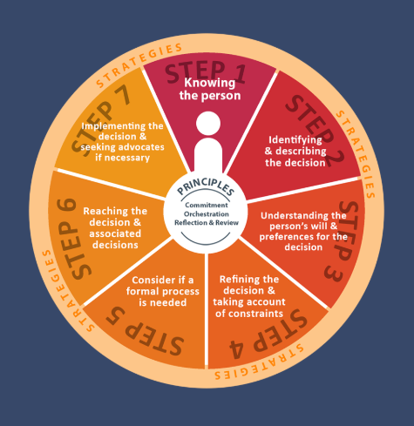

Slide 25

Explaining what PBS is and seeking consent
- Ensure the person has an understanding of the process of positive behaviour support and provides consent (where possible) What is Positive Behaviour Support?
- Use visual tools and resources to support the person’s understanding
- Explain how the person can be involved in the process
- Ask the person how much they would like to be involved.
Decorative image omitted.

Slide 26

About the Person
- All positive behaviour support plans should start by introducing the person
- Discuss their strengths and interests
- Outline where the person may need additional support
- There are lots of ways to involve the person in this part of the process.

Slide 27
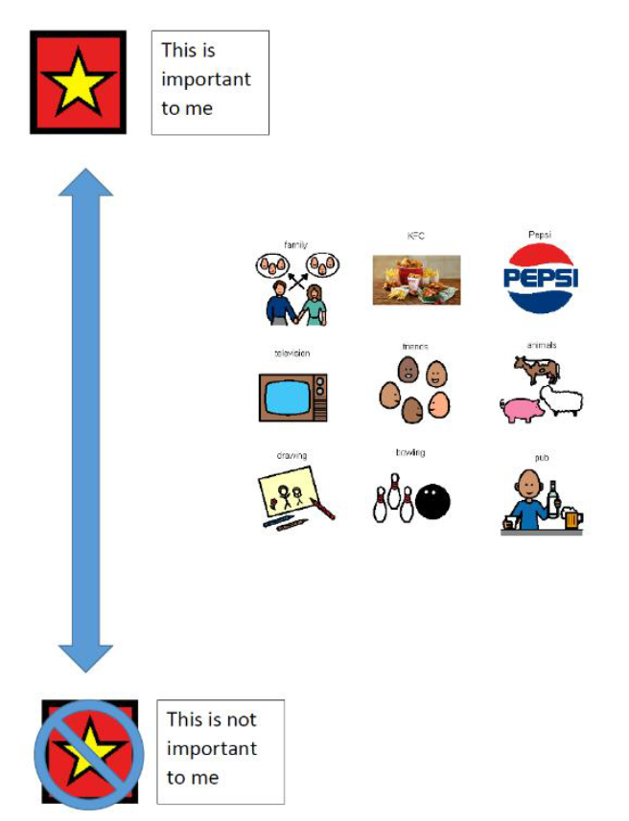

Slide 28

Person Centred Thinking Tools

(Helen Sanderson Associates)
- Perfect week
- 4 plus 1 questions
- Good day/bad day
- Sorting important to/for
- What's working/not working
- The doughnut
- Relationship circle
- Presence to contribution
- Matching support
- Learning log
- Decision making profile
- Decision making agreement
- Communication chart

Slide 29
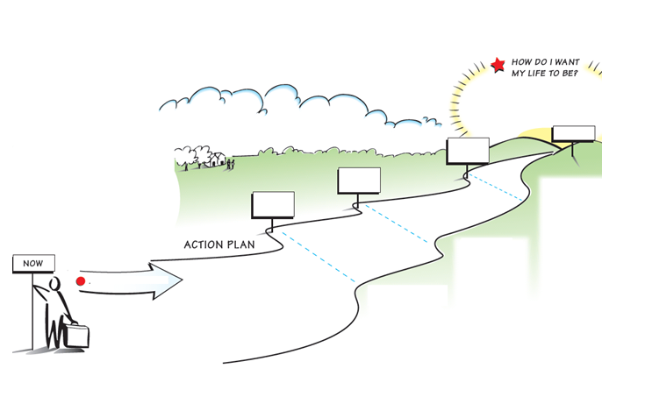

Slide 30

Functional Behaviour Assessment
- Setting events and triggers: use visual supports to discuss these with the person
- Once the function has been determined: ask the person how they might be able to get their needs met in a different way
- Brainstorm possible solutions with the person and their support network.

Slide 31
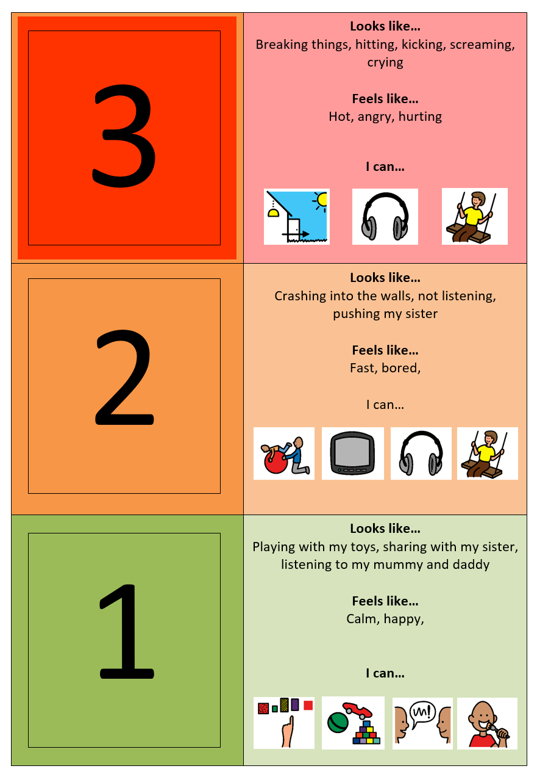

Slide 32

Collaborating on Response Strategies
- Use visual supports to ask the person what their preferred response is when they are upset, angry or overwhelmed
- Helps people feel safe
- Provides choice and control
- Engage in post incident reviews.

Slide 33

Social Autopsy
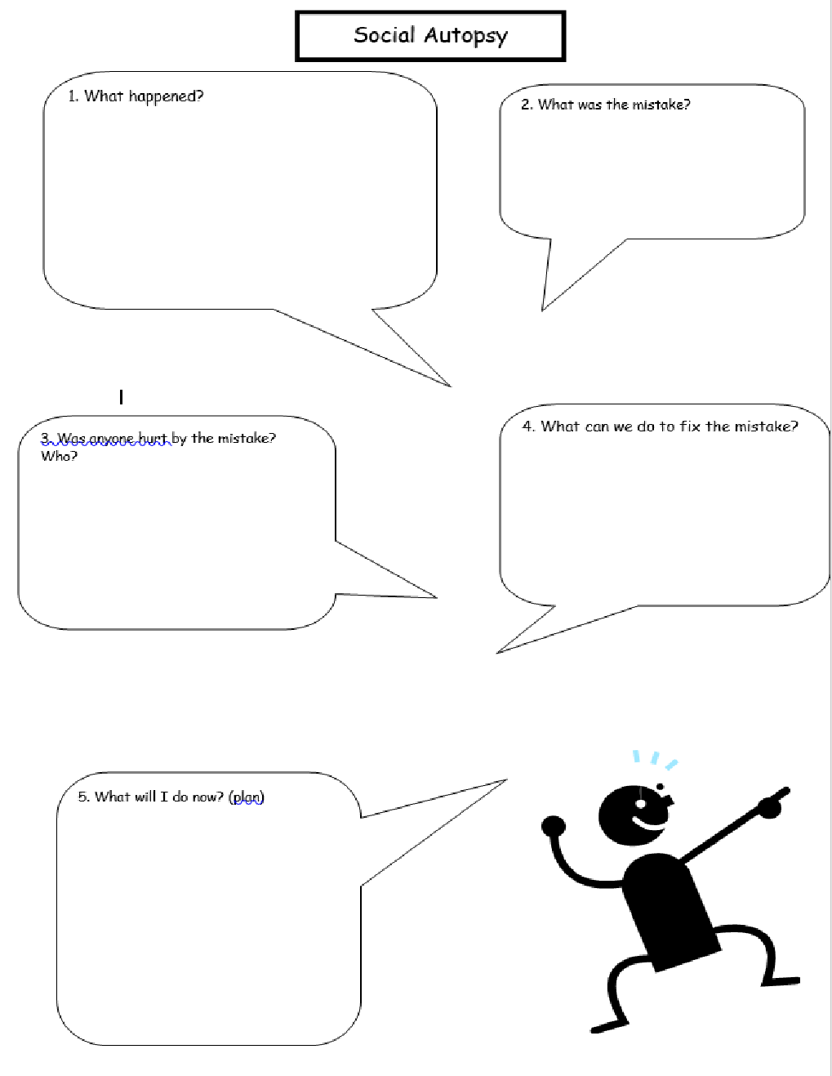

Slide 34

Measuring Contextual Fit
- “Contextual fit is the match between the strategies, procedures, or elements of a positive behaviour support plan and the values, needs, skills, and resources of those who implement and experience the intervention.”
Measurements of contextual fit have been developed for the school settings and in services/family home. (Albin et al., 1996; Horner et al., 2003)
What about a measure of contextual fit developed for the person?

Slide 35
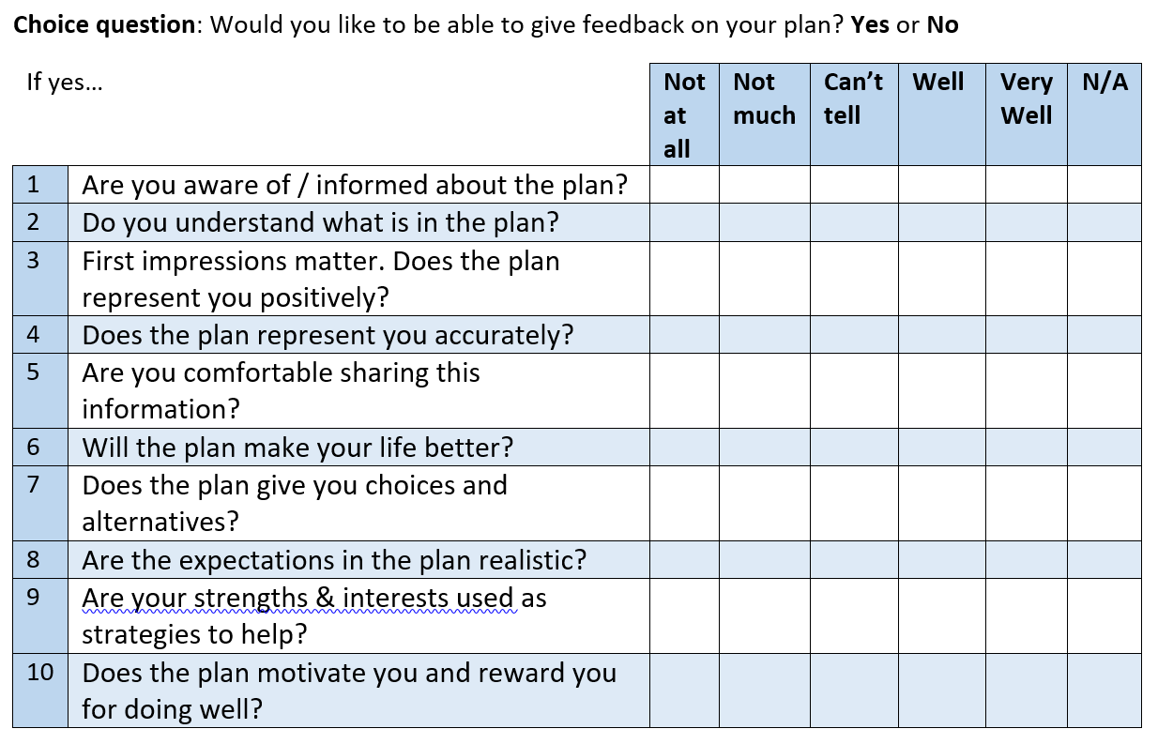

Slide 36

Implementation
- Develop an implementation checklist that can be reviewed and agreed to by the person you’re supporting.
- Ask the person how they would like to be involved in the implementation process.
  - Staff training
  - Regular check ins and reviews
  - The person may like to tick off each action as it is implemented.

Slide 37

State/Territory based Restrictive Practice Authorisation Process
Discussion:
- How person centred is your state/territory-based restrictive practice authorisation process?
- How could this be improved?
- What can you do in your role to support a more person centred approach?

Slide 38

Supporting the person to train their support team
- Summer Foundation’s participant led videos
- Co-facilitated presentations
- Photos and Posters
- Podcasts
- Other ideas?

Slide 39

Communication Support
- Talking Mats
- Easy read resources (will be provided in follow up email)
Speak Up and Be Safe from Abuse Communication Board

Slide 40

The PBS Capability Framework
Knowledge: Interim Response  Core Behaviour Support Practitioner | Skills: Interim Response  Core Behaviour Support Practitioner | Service Provider and Implementing Provider considerations across all practitioner levels
- Understand behaviours may occur that cause immediate risk of harm to the person or others  - Know high-risk behaviours need to be managed safely and effectively using the least restrictive options  - Know high-risk situations and environments can be identified (including antecedents, triggers)  - Know how and why interim responses will be unique to the person  - Be aware that interim risk management may include restrictive practices  - Understand the consequences of unauthorised use of restrictive practices  - Understand legal and ethical expectations | - Gather and document appropriate authorisation and consents where required by state or territory laws and policies  - Evaluate the risk posed by the behaviour to the person and others  - Consult with the person, their family, carers, guardian or other relevant person  - Communicate clearly and effectively with relevant parties to gather information and provide direction  - Collaborate with team members  - Record and report accurately  - Identify any existing data that might provide insight into the situation  - Provide guidance on protective actions related to environment, setting and circumstances  - Coach those implementing a behaviour support plan with the assistance of a supervisor  - Seek professional support from a supervisor | - Recruit and retain appropriately skilled behaviour support practitioners and implementers  - Ensure all staff have the skills to provide effective supports for people with complex needs and behaviours of concern  - Review procedures and policies using interim behaviour support plans to reduce the immediate risk and likelihood of crisis incidents  - Help the behaviour support practitioner to conduct an initial risk assessment  - Provide support for immediate review by a medical professional if required  - Ensure that all staff understand restrictive practices and the consequences of unauthorised use  - Ensure staff are released to attend training in the implementation of an interim behaviour support plan  - Have a mechanism in place to record and review incident reports and collect other initial data as necessary

Slide 41

Interim Response
Knowledge: Interim Response  Proficient or above Behaviour Support Practitioner | Skills: Interim Response  Proficient or above Behaviour Support Practitioner | Service Provider and Implementing Provider considerations across all practitioner levels
- Know a range of de-escalation techniques  - Be aware of the implications of using restrictive practices as a response  - Have a working knowledge of authorisation and reporting requirements for restrictive practices relevant to state or territory laws and policies | - Develop an individualised immediate response plan  - Use a range of strategies that can be safely adjusted once full assessment and planning concludes  - Document and implement ethical reactive strategies  - Seek professional support as required  - Work collaboratively with the relevant stakeholders (including emergency services when required)  - Train those implementing a behaviour support plan in its effective implementation | - Facilitate debriefing for involved parties (if a critical or serious incident has occurred)  - Ensure inclusion of key parties (including the person) in post-incident reviews

Slide 42

Functional Assessment
Knowledge: Functional Assessment  Core Behaviour Support Practitioner | Skills: Functional Assessment  Core Behaviour Support Practitioner | Service Provider and Implementing Provider considerations across all practitioner levels
- Understand the values, policy and legislative context in which PBS occurs  - Understand that behaviours happen for a reason and serve a purpose  - Know the common functions of behaviours  - Understand the difference between what the behaviour looks like and its function | - Place the person at the centre of the functional assessment and establish support to keep them there  - Conduct a respectful and responsive assessment that considers the diversity of a person’s culture  - Involve the person, their family members, carers, guardian and other relevant people in the assessment | - Support the person to contribute to the assessment  - Facilitate and enable the practitioner (and team where relevant) to conduct information-gathering for the assessment  - Identify key stakeholders for the practitioner  - Support the practitioner to conduct an initial risk assessment

Slide 43

Functional Assessment
Knowledge: Functional Assessment  Core Behaviour Support Practitioner | Skills: Functional Assessment  Core Behaviour Support Practitioner | Service Provider and Implementing Provider considerations across all practitioner levels
- Understand that assessment is focused initially on improving quality of life and secondly on reducing behaviours of concern  - Understand the importance of obtaining baseline measures of:  - Current behaviour(s) of concern (including frequency and intensity)  - Quality of life  - Current use of restrictive practices  - Value the role of the service, staff, family members or carers in developing or maintaining behaviours  - Understand that the complexity and duration of the functional assessment is dependent on the severity, impact, frequency and duration of the behaviour  - Understand the importance of data-driven decision-making  - Understand life-course events | - Use communication and active listening skills to develop rapport with the person and their team  - Adapt assessment terminology and systems to the needs of the target audience  - Assess the person’s abilities and needs  - Use observation skills  - Use effective systems to collect data from a variety of sources  - Identify antecedents (setting events and triggers) to behaviours of concern and factors that support quality of life  - Identify consequences that maintain a behaviour  - Identify and describe the behaviour in a way that is observable and measurable  - Analyse the relationship between the person and their environment  - Produce an assessment report  - Seek professional support as required | - Support the person to contribute to the assessment  - Facilitate and enable the practitioner (and team where relevant) to conduct information-gathering for the assessment  - Identify key stakeholders for the practitioner  - Support the practitioner to conduct an initial risk assessment  - Ensure staff have the training and skills to effectively participate in data collection  - Ensure staff are supported to collect data and contribute to the development of a functional assessment  - Arrange medical reviews as required

Slide 44

Planning
Knowledge: Planning  Core Behaviour Support Practitioner | Skills: Planning  Core Behaviour Support Practitioner | Service Provider and Implementing Provider considerations across all practitioner levels
- Understand that a behaviour support plan is based on knowledge from the functional assessment  - Identify who will read and use a behaviour support plan  - Understand that a behaviour support plan must be written so it suits its intended audience  - Understand that a behaviour support plan must have both proactive and reactive components | - Use data to inform a theoretical and ethically sound behaviour support plan (under supervision as required)  - Identify those responsible for implementing a behaviour support plan  - Identify barriers to implementation  - Collaborate and consult as required to develop strategies  - Develop proactive strategies to improve the person’s quality of life  - Develop strategies that aim to increase the person’s skills, including communication, and the interaction skills of communication partners | - Enable systems and procedures that provide a safe, predictable and stable environment  - Be aware of environmental aspects that may pose risk factors  - Provide supervision and support to those responsible for implementing and monitoring a behaviour support plan, including clarifying anything not understood  - Provide time and resources for staff to read and absorb each person’s behaviour support plan  - Provide staff with reasonable supports and adaptations to understand a behaviour support plan and follow it correctly

Slide 45

Implementation
Knowledge: Implementation  Core Behaviour Support Practitioner | Skills: Implementation  Core Behaviour Support Practitioner | Service Provider and Implementing Provider considerations across all practitioner levels
- Understand the importance of individualised implementation of a behaviour support plan  - Understand how implementation approaches can vary for a person across different stages of life  - Consider the people to include in implementation  - Understand that functioning and resilient teams are likely to increase the consistency of implementation | - Provide individually tailored education and training to those who are implementing a behaviour support plan  - Consider the capacity of the person at the centre of a behaviour support plan and their role in implementation  - Support implementers to incorporate strategies into daily support plans and other relevant support documents  - Support implementation across different environments and contexts  - Provide feedback to implementers on implementation and model alternatives | - Ensure staff supporting the person have good links with community  - Provide clear expectations of staff that a key component of their role is to identify and develop meaningful activities for each person throughout the day  - Lead and monitor the implementation of a behaviour support plan  - Provide resources to support implementation  - Provide staff with ongoing training, supervision and support in the implementation of a behaviour support plan

Slide 46

Implementation
Knowledge: Implementation  Core Behaviour Support Practitioner | Skills: Implementation  Core Behaviour Support Practitioner | Service Provider and Implementing Provider considerations across all practitioner levels
Blank | - Support those implementing a behaviour support plan to use the recommended data collection systems  - Promote least restrictive practices | - Use performance management systems to ensure staff are using strategies outlined in a behaviour support plan  - Provide critical incident debriefing for all involved parties when necessary

Slide 47

Know it works
Knowledge: Know it Works  Core Behaviour Support Practitioner | Skills: Know it Work  Core Behaviour Support Practitioner | Service Provider and Implementing Provider considerations across all practitioner levels
- Understand the rationale of a behaviour support plan and its uses  - Understand the importance of continuous review and methods to conduct reviews  - Maintain professional learning to keep abreast of current knowledge of best practice  - Know the indicators to include and how and when to check the effectiveness of a behaviour support plan | - Re-assess the situation  - Review adherence to implementation  - Use data collected by implementers to monitor the implementation of a behaviour support plan (compared to baseline) in a whole-of-life context, and provide feedback to implementers  - Reflect on external factors that may impact on the efficacy of PBS  - Build and utilise collaborative partnerships to evaluate a behaviour support plan  - Coordinate a formal review meeting  - Inform changes to a behaviour support plan as required  - Track progress of a behaviour support plan using the indicators of effectiveness | - Support staff to collect ongoing data to evaluate the effectiveness of a behaviour support plan  Provide information on how consistently staff are implementing a behaviour support plan that may be affecting evaluative data  - Suppprt the person and other key people to contribute to a behaviour support plan’s evaluation and review meetings  - Use the person’s outcomes as performance indicators  - Ensure mechanisms are in place to collect and report on incident report data

Slide 48

Restrictive Practice
Knowledge: Restrictive Practice  Core Behaviour Support Practitioner | Skills: Restrictive Practice  Core Behaviour Support Practitioner | Service Provider and Implementing Provider considerations across all practitioner levels
- Understand that the use of a restrictive practice must be authorised according to the relevant state or territory laws and policies  - Understand that regulated restrictive practices include seclusion, and chemical, mechanical, physical and environment restraints  - Understand that a restrictive practice can represent serious human rights violations | - Consult with the person and/or obtain consent (as required by relevant state or territory laws and policies)  - Only prescribe a restrictive practice under the direct supervision of a practitioner who is rated proficient or above | - Report any emergency or unauthorised restrictive practice to the NDIS Commission and undertake a review of the incident (Australian Government, 2018c)  - Ensure appropriate policies and procedures are in place

Slide 49

Restrictive Practice
Knowledge: Restrictive Practice
Core Behaviour Support Practitioner
- Understand the Zero tolerance framework (National Disability Services, 2018) and associated resources
Knowledge: Restrictive Practice  Proficient or above Behaviour Support Practitioner | Skills: Restrictive Practice  Proficient or above Behaviour Support Practitioner | Service Provider and Implementing Provider considerations across all practitioner levels
- Understand that restrictive practices must be in proportion to the potential consequences of the risk of harm | - Work with the person, their informal supports and service provider to develop a behaviour support plan that is based on a functional behaviour assessment  - Provide a statement of intent to use a restrictive practice to the person and their support networks in an accessible format, as required in the NDIS (Restrictive Practices and Behaviour Support) Rules 2018  - Ensure a behaviour support plan contains outcomes-focused, person-centred and proactive strategies that address the person’s needs and behaviours of concern  - Design a staged behaviour support plan of fading strategies to reduce or eliminate the use of restrictive practices over time  - Lodge a behaviour support plan with restrictive practices with the NDIS Commission for the practices to be monitored  - Supervise a core practitioner  - Implement strategies that can be removed through shaping, fading and the like

Slide 50

Helpful resources
- Summer Foundation participant led videos
- Tom Tutton’s presentation, “Including people with disabilities in all elements of PBS”
- ASPECT resources
- Foundations of Positive Behaviour Support films
  - What is Positive Behaviour Support?
  - Quality of Life
  - Listening and Communicating
  - Being Aware of Sensory Needs and Preferences
  - Upholding the Values of Positive Behaviour Support

Slide 51

Evaluation
Decorative Image omitted.

Slide 52

References
Albin RW, Lucyshyn JM, Horner RH, Flannery KB. Contextual fit for behavioral support plans: A model of “goodness of fit” In: Koegel LK, Koegel RL, Dunlap G, editors. Positive behavioral support: Including people with difficult behavior in the community. Baltimore: Paul H. Brookes; 1996. pp. 81–98.
Beadle‐Brown, J., Hutchinson, A., & Whelton, B. (2012). Person‐centred active support–increasing choice, promoting independence and reducing challenging behaviour. Journal of Applied Research in Intellectual Disabilities, 25(4), 291-307.
Carr E.G, Dunlap G, Horner R.H, Koegel R.L, Turnbull A.P, Sailor W, (2002) Positive behavior support: Evolution of an applied science. Journal of Positive Behavior Interventions. 4:4–16.
Dunlap, G., Carr, E. G., Horner, R. H., Zarcone, J. R., & Schwartz, I. (2008). Positive behavior support and applied behavior analysis: A familial alliance. Behavior Modification, 32(5), 682-698.
Etmanski, A., & Etmanski, A. (2000). A good life: For you and your relative with a disability. Planned Lifertime advocacy Network (PLAN).
Gore, N. J., McGill, P., Toogood, S., Allen, D., Hughes, J. C., Baker, P., & Denne, L. D. (2013). Definition and scope for positive behavioural support. International Journal of Positive Behavioural Support, 3(2), 14-23.
Ham, K & Davies, B (2018). ‘Just look at my face’: co-production of a positive behavioural support plan. Learning Disability Practice. 21, 2,32-36
Horner, R.H, Salentine, & Albin, R (2003) Self-Assessment of contextual fit in schools. Eugene, Oregon: University of Oregon
Kruger, B., & Northway, R. (2019). An exploratory study of Behavioural Specialist experiences of involving service users in the development of their positive behavioural support plans. Journal of Intellectual Disabilities, 23(2), 160–174
McKenzie K, Whelan KJ, Mayer C, McNall A, Noone S, Chaplin J. (2018) “I feel like just a normal person now”: An exploration of the perceptions of people with intellectual disabilities about what is important in the provision of PBS. Br J Learn Disabil. 00:1–9
End of document.

