Quality Management and Continuous Quality Improvement

Slide 1

Quality Management and Continuous Quality Improvement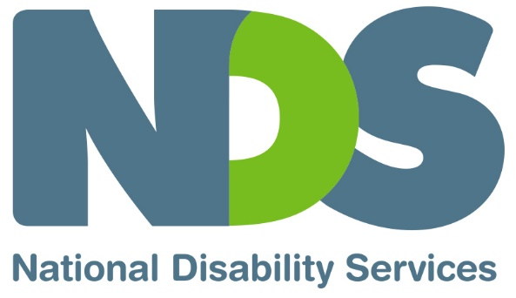

Slide 2

Introducing Quality Management
- What is meant by ‘quality management’ and ‘continuous quality improvement’
- Look at implementing a quality management system
- Indicators of a quality service

Slide 3

Quality Management
The action a provider takes to make sure that it always provides the best possible service for the people it supports by:
- understanding what it is doing well
- identifying where improvements are needed
- taking action to best meet the needs of participants

Slide 4

Quality Management is
- fundamental to a person-centred approach to service provision
- an essential part of improving outcomes for participants
- a requirement for service providers under the NDIS Practice Standards

Slide 5

NDIS Commission’s focus on Quality
- Quality management is incorporated into the NDIS Practice Standards
- The aim of the Commission’s requirements is to create a nationally consistent approach to improving the quality of disability supports
- Requirements are proportionate to the size and scale of the provider
- Rules that drive performance around quality related functions

Slide 6

Quality Management System
- Coordinated approach to managing and monitoring quality
- essential processes to manage, monitor and review the quality of service, for example:
  - compliance with Practice Standards: good practice
  - core organisational policies and procedures to guide good practice
  - monitoring compliance progress and outcomes
  - documentation and reporting

Slide 7

Indicators of a quality service
- Meets NDIS Practice Standards
- Receives positive feedback from the people it supports
- Improves outcomes for individuals

Slide 8

Monitoring Quality
Examples of indicators:
- numbers of participants successfully achieved outcomes
- levels of satisfaction with service received
- staff morale
- positive profile amongst stakeholders

Slide 9

Quality Management policy and procedures
- Principles that apply to quality management
- Processes and activities that will be used to track, report review and make improvements
- Responsibilities
- Internal reporting on quality improvement

Slide 10

Quality Management policy and procedures
Related areas of policy and procedures
- Risk management and compliance monitoring
- Complaints management
- Incident reporting
- Service delivery
- Organisational performance evaluation and reporting

Slide 11

Participant Feedback
Feedback from participants is the most important indicator of quality
- includes complaints, compliments, comments and information gathered through specific feedback collection
- tells you about satisfaction and the extent to which you have met their needs
- tells you about how your service is seen by participants

Slide 12

Participant Feedback
Participant feedback should be a two way process.
People providing feedback need to:
- know what will happen with the information provided
- feel safe providing negative feedback
- feel valued by seeing the impact of suggestions they have made or hearing about changes that have been made in response to their input

Slide 13

Continuous Improvement
Using the following information to ensure ongoing improvement to your practices and outcomes:
- Internal audits
- Complaints and feedback
- Incidents
- Staff suggestions

Slide 14

Documentation and reporting
Keeping written records is a critical part of quality management
Documentation provides:
- Guidance to staff and corporate governance body
- Tools for managing compliance and risk
- Information for tracking performance/improvement
- Process to monitor issues arising and ensure action is taken to make improvements
- Evidence for external auditors

Slide 15

Key Documentation
- Policies, procedures and other documents that guide how work is done
- Participant records that keep track of their plans and outcomes
- Records of service user feedback
- Records of the handling of any complaints, incidents, risk and investigations

Slide 16

Key quality monitoring and reporting documents
Compliance
- Compliance register
- Document control register
Monitoring and responding
- Incident and Complaints register
- CQI register
Track Quality Improvement
- Quality monitoring schedule (Internal audits)
- Performance reporting template

Slide 17

Compliance Register:
Identifies key legal, contractual or reporting requirements of the provider and documents when these have been checked and attended to.
Item | Key Requirements | Responsibility | Last Check | Action required | Completed
Example: Worker screening check | All staff have a current worker check | HR Manager | N/A | Establish process for current and future staff to demonstrate they meet the required check | July 2020
Others listed under the column headed ‘Item’ are:
- Incorporation
- Lease agreement
- Workplace Health and Safety
- Insurance cover
- Taxation
- Superannuation
- Financial audit
- Information security
- Legislation
- Other

Slide 18

Continuous quality improvement register:
Summarises improvement activity within the provider, keeping track of the issue, improvements to be made and responsibility for implementing action.
CQI ID | Date | Source | Issue | Action | Time Frame | Responsibility | Update or Closure | Any staff training required
Example:  CQI: 5/2019 | May 2019 | Complaints register | Participant details disclosed | Improve security on participant records | End May 2019 | Service Manager | 27 May 2019 | Blank

Slide 19

Performance reporting template:
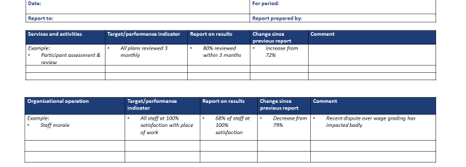

Slide 20
Quality Improvement | Target/performance indicator | Report on results | Change since previous report | Comment
Example: Compliance with NDIS Practice Standards | - All minimum standards met  - External review completed | Self-review against standards in Division 1 and 2 of CORE completed | Division 3 and 4 of CORE completed | Blank

Compliance report
- Item:
  - Risk management plan
  - Insurances
  - Workplace Health and Safety
  - Other legal requirements
  - Contracts
  - Service Agreements
  - Reporting
  - Standards
  - Incorporation
  - Other
- Compliance requirement
- due date
- date completed
- comment

Incident Report
- Date of Incident
- Description of incident
- Authority notified
- Insurer notified
- Other action taken
- Comment

Slide 21

Self-assessment tools
Quality Management Guide
NDS NDIS Practice Standards (CORE) Interpretive Guide
For web based quality management tools to assist service providers meet the NDIS Practice Standards: NDS Quality Management Portal
End of document.

