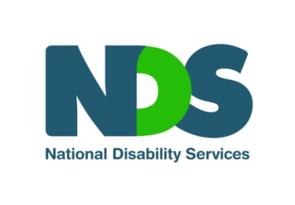

Podcast Show Notes
NDIS reviews and the role of the Administrative Appeals Tribunal (AAT)
This episode was hosted by Fiona Still, NDIS Sector Transition Manager at the NDS and featured our studio guest Darren O'Donovan, senior lecturer and director of engagement at La Trobe Law School and co-author of the AAT NDIS Decision Digest.
The topic of the episode was the Administrative Appeals Tribunal (AAT), an independent body that allows NDIS participants to appeal a decision made by the NDIA. Darren discussed what the AAT does, the experience of people who have pursued an appeal through the Tribunal, recent examples of AAT rulings, the lessons for NDIS planning meetings and tips for preparing for a review or to go to the AAT.
Below are the key terms and items that were referenced in the episode. Click on the hyperlinks to learn more:
- NDS Helpdesk
- Administrative Appeals Tribunal
- AAT NDIS Decision Digest
- NDIS website: Planning Operational Guideline
- NDIS website: Review of Decisions Operational Guideline
- DSS Advocacy Finder and Support to Access the Administrative Appeals Tribunal
- COAG Principles to Determine the Responsibilities of the NDIS and Other Service Systems
- Become an NDS member
End of document.

