Supporting Practice Leadership: A Collation of Resources
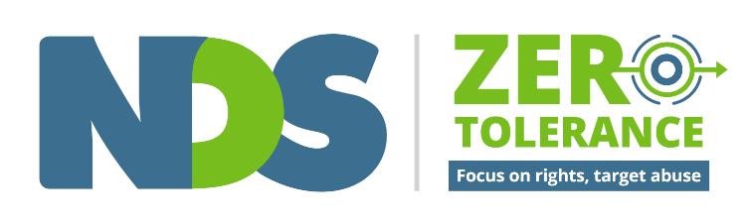
A practice leader is “an individual who develops, encourages and supports their staﬀ team to put into practice the vision of the organisation.” (Beadle-Brown, Bigby & Bould, 2015).

Supporting Practice Leadership Guide Table of Contents
Introduction
Focus on Quality of Life
Allocating and Organising Staff
Coaching staﬀ, providing feedback and modelling good practice
Supervision and Reflective Practice
Supporting Meaningful Activity and Relationships
Communication Support
Meal Time Assistance and Dysphagia
Fostering Healthy Eating
Supported Decision Making
Health and Wellbeing
Person Centred Active Support
Trauma Informed Support Films
Positive Behaviour Support
Fostering Positive Cultures
Supporting People who are Ageing
Supporting People from CALD Backgrounds
References

Introduction

Who is a Practice Leader?
A Practice Leader is “an individual who develops, encourages and supports their staff team to put into practice the vision of the organisation.” (Beadle-Brown, Bigby & Bould, 2015)
“Different organisational structures and job titles mean it can be difficult to identify who this primary practice leader is – whether team leader, service manager or location manager - but it is important that organisations are clear whose job it is, that the individual is aware that it is a key part of their role and that they do it.” United Response
Purpose of this Collation of Resources
This collation of resources has been developed to support Practice Leaders who supervise direct support staff in the disability sector to gain a better understanding of the array of resources that are available to support them to do their job well. A collection of practice guides, factsheets, film-based training resources, e-learning programs and templates have been collated and categorised.

Five Components of Practice Leadership
(Mansell, Beadle-Brown, Ashman, & Ockenden, 2004)
- Focusing leadership on staff support for service users’ quality of life;
- Allocation and organisation of staff support to meet service users’ needs and wants;
- Coaching staff in good practice through feedback and modelling of good practice;
- Regular reviewing of staff practices on an individual basis; and
- Reviewing the extent to which staff teams are enabling service users to be actively engaged in meaningful activities and relationships during regular team meetings.

Understanding Practice Leadership
Watch this short video, What is Practice Leadership? by Julie Beadle-Brown, which provides a good overview of the five components of Practice Leadership.
Take a look at this Practice Leadership Guide, developed by United Response UK and the Tizard Centre.

National Disability Practitioners
Practice Leaders are encouraged to join National Disability Practitioners (NDP), to access information, develop your career, and connect with NDP’s community of more than 15,000 members across Australia.

NDS Centre for Applied Disability Research (CADR)
A series of Research to Action Guides are available via the Centre for Applied Disability Research. These resources are developed to address the ‘research to practice’ gap by translating research and supporting evidence informed practice, informed choice and more broadly, innovation in the disability sector.

NDS Zero Tolerance Initiative
Zero Tolerance is an initiative led by NDS in partnership with the disability sector. It assists disability service providers to understand, implement and improve practices that safeguard the rights of people they support.
Built around a national, evidence based framework, Zero Tolerance is:
- a way for organisations to understand actions they can do to prevent and respond to abuse, neglect and violence of people with disability
- a clear message that abuse, neglect and violence are not okay
- a way of thinking about abuse as a human rights issue not a disability issue
- an organisational and personal commitment to act on:
  - anything that makes a person with disability be or feel unsafe;
  - anything that doesn’t support a person’s human rights; and
  - anything that we could be doing better.
A collection of resources have been developed to educate and train staff at all levels to understand their responsibilities in preventing and responding to abuse. Download the NDS Zero Tolerance Resource Guide to your desktop or smart phone to enable easy access to all the Zero Tolerance resources.

Disclaimer
The information provided in this guide and accompanying resources is intended for general use only. It is not a definitive guide to the law and best practice. It does not constitute formal advice, and does not take into consideration the particular circumstances and needs of your organisation. Every effort has been made to ensure the accuracy and completeness of this document at the date of publication. NDS cannot be held responsible and extends no warranties as to the suitability of the information in this document for any particular purpose and for actions taken by third parties.

Focus on Quality of Life

NDS Empowerment Circle
The NDS Empowerment Circle is a tool to help you think about how people can be more empowered in all areas of their life. This tool builds on work done by Schalock (2004) on Quality of Life domains and introduces a number of new life areas. It can be used to guide conversations about quality of life in reflective practice. (Developed by NDS Zero Tolerance Initiative, 2016)
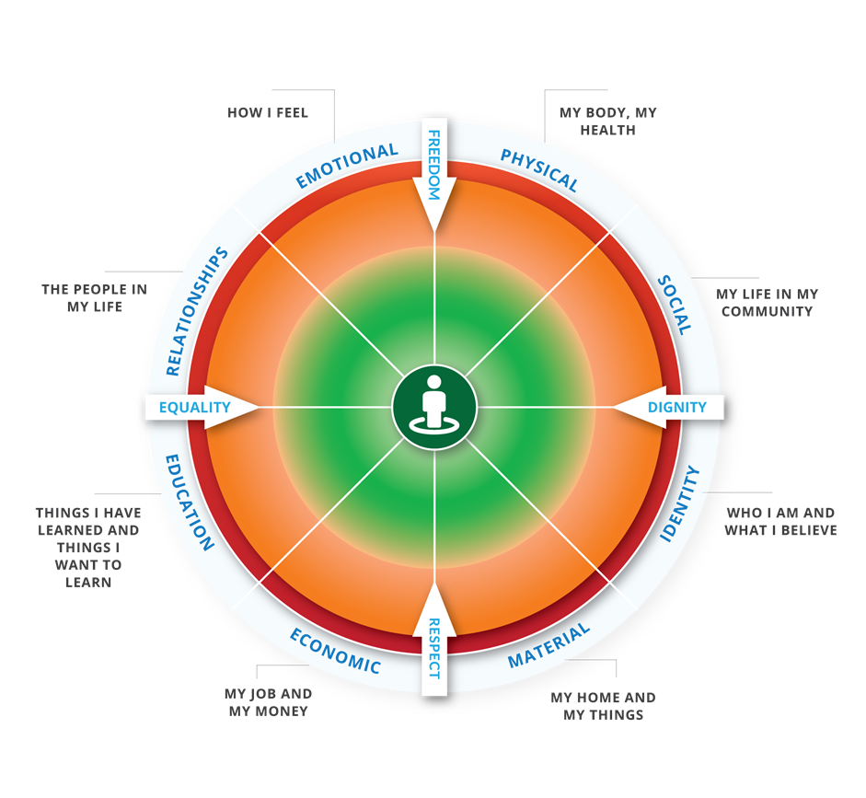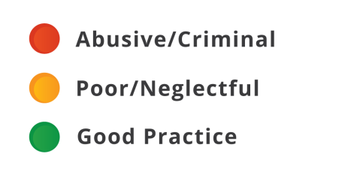
- Tool: NDS Empowerment Circle

The Empowerment Circle
The Empowerment Circle also helps staff and to consider and recognise poor or neglectful practice, abuse and crime. This short film provides and overview of how the tool can be used. (Developed by NDS Zero Tolerance Initiative, 2016)
- Film: Empowerment Circle

Foundations of Positive Behaviour Support film: Quality of Life
This film discusses the importance of getting to know and understand the people you are supporting, developing trusting and respectful relationships, and supporting people to feel empowered in all areas of their life. (Developed by NDS Zero Tolerance Initiative, 2020)
- Film: Foundations of Positive Behaviour Support

Foundations of Good Support
The Foundations of Good Support is a useful way of understanding the support we provide. It helps to identify what’s currently in place and where we need to focus our efforts to improve: enabling us to prioritise the most worthwhile strategies and focus our practice leadership effectively. (Developed by United Response UK)
- Practice Guide: Foundations of Good Support

Maslow’s Hierarchy of Needs
Maslow’s hierarchy of needs explains that people are unable to attend to higher needs such as
self-fulfilment or achieving a person’s potential if lower needs are not fulfilled, such as food and safety. (Source: Simply Psychology)
- Relevant Reading: Maslow’s hierarchy of needs

Measuring the Quality of Life of People with Disabilities and their Families: Scoping Study Final Report
The main aim of this scoping study is to inform how the quality of life of people with disabilities and their families should be measured. (Davidson et al., 2017)
- Relevant Reading: Scoping Study Final Report

Improving quality of life outcomes in supported accommodation for people with intellectual disability: What makes a difference?
Bigby, C., and J. Beadle-Brown, Improving quality of life outcomes in supported accommodation for people with intellectual disability: What makes a difference? 2016, Journal of Applied Research in Intellectual Disabilities; Available from: Wiley Online Library.
- Relevant Reading: Journal article: Improving quality of life outcomes
Decorative images omitted.

Allocating and Organising Staff

Working Together Well
This workbook draws on the priorities of support workers and people with disability from a research project about relationships and recognition. (Hepburn et al., 2018).
- Workbook: Working Together Well

Developing a Shift Plan
In services where a range of people are providing support, predictability and consistency usually require a written plan of who’s going to do what and with whom: sometimes called a shift plan. This booklet accompanies the Foundations of Good Support. (Developed by United Response UK)
“Structure, the deliberate arrangement of events, activities, routines, rituals, interactions and opportunities over time, makes the world a more predictable, accessible and safer place for the people we support.” United Response UK
- Practice Guide: Developing a Shift Plan

Goodness of Fit Survey
This survey seeks information from staff about the prospects of successfully implementing a behaviour support plan within their service setting. The survey is available within the Positive Practice Framework (State of Victoria DHHS, 2018) Appendix 27. Special Projects Team: Directorate of Learning Disability Services, Bro Morgannwg NHS Trust. (2010)
- Tool: Goodness of Fit Survey

Building Great Work Relationships
This short article discusses building relationships within teams, making work enjoyable and productive. (Source: MindTools)
- Relevant Reading: Building Great Work Relationships
Decorative images omitted.

Coaching staﬀ, providing feedback and modelling good practice

Practice Leadership and Role Modelling
This short video is about practice leadership and role modelling. (Developed by United Response and the Tizard Centre)
- Film: Practice Leadership and Role Modelling

Guide to Good Group Homes
This Guide summarises an extensive review of the research literature the Living with Disability (LiDs) Research Centre published in 2016. LiDs looked at the suggestions about what makes a difference to the quality of group homes and thus the quality of life of the people with intellectual disability who live there. (Bigby & Bould, 2017)
- Practice Guide: Guide to Good Group Homes

Practice Based Coaching Tools and Webinars
Practice-based coaching is a cyclical process for guiding practitioners’ use of evidence-based practices for promoting positive outcomes. Practice-based coaching involves the following components:
- collaborative partnerships
- shared goals and action planning
- focused observation
- reflection and feedback
(The National Center for Pyramid Model Innovations)
- Tool: Practice Based Coaching Tools and Webinars

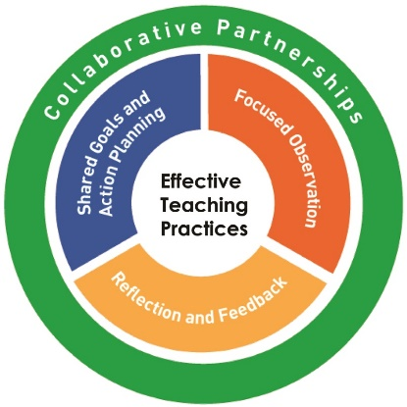
Image source: The National Center for Pyramid Model Innovations

Observation and Assessment Tool
The Observation and Assessment Tool accompanies the Foundations of Good Support guide and includes real life indicators of the extent to which each level of the foundations is, or is not, in place. (Developed by United Response UK)
- Tool: Observation and Assessment Tool

The GROW model of coaching and mentoring
This short article discusses the GROW model of coaching and mentoring and how to implement it.
- Relevant Reading: The GROW model of coaching and mentoring
Decorative images omitted.

Supervision and Reflective Practice

Person Centred Practice Across Cultures: Reflective Practice Workbook
This workbook describes how you can use reflective practice and critical thinking to better understand how your worldview impacts on and influences your behaviour and work practice. (Developed by futures Upfront, 2016)
- Workbook: Reflective Practice

Supervision and Safety
This advice has been developed to assist disability service providers on how to use management, supervision and training to reduce the risk of abuse, neglect and violence toward people with disability using their services. (NDS Zero Tolerance Initiative, 2015)
- Practice Guide: Zero Tolerance practice advice 2: Supervision and Safety

Reflective Practice: Enhancing Practice in Therapeutic Care
This practice guide has been developed to support Therapeutic Specialists to engage staff in critical Reflective Practice - the process of learning from experience in order to improve practice, whilst paying attention to staff’s emotional responses and assumptions underpinning their practice. (Macnamara & Mitchell, 2019)
- Practice Guide: Reflective Practice: Enhancing Practice in Therapeutic Care

Reflective Practice Booklet and Workshop
This booklet and associated workshop explores participants’ current perceptions of reflective practice and its usefulness in teaching and learning, explains the key components of reflective practice, uses a range of tools for reflective practice and identifies and applies strategies for reflective practice. (Developed by University of Waikato, 2015)
- Practice Guide: Reflective Practice

Creating a Culture of Caring for Staff
Initiatives on how to create a culture of caring for staff. (Developed by Planetree, 2018)
- Relevant Reading: Creating a Culture of Caring for Staff
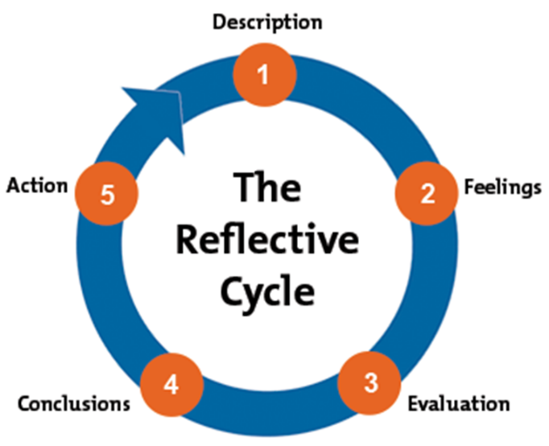
Image source: Gibbs, 1988

Facilitating Reflection: A manual for Leaders and Educators
This manual explores the facilitation of reflective practice. (Reed & Koliba, 1995)
- Practice Guide: Facilitating Reflection
Decorative images omitted.

Supporting Meaningful Activity and Relationships
Helen Sanderson’s Person Centred Planning Resources
These person centred thinking tools can be used to give structure to conversations and to support planning. They are a way to improve understanding, communication, collaboration and relationships. (Developed by Helen Sanderson Associates) Available at Helen Sanderson Associates.
- Tool: Person centred thinking tools

Supporting Inclusion
The purpose of this program is to create a space where disability support workers can think about what social inclusion means for people with intellectual disability, and learn or refresh some useful tools and strategies to support them and promote their social inclusion. (Bigby & Wiesel, 2015)
- Online Learning: Supporting Inclusion

Short Films by WAIS
These short films provide a great introduction to topics including: Human Rights; Diversity; Self-Direction; and Citizenship. (Developed by Western Australia’s Individualised Services)
- Film: Human Rights
- Film: Diversity
- Film: Self Direction
- Film: Citizenship

Enabling Risk: Putting Positives First
This resource has been designed for support workers, yet it is also important that practice leaders are aware of the essentials of enabling risk outlined in this resource as they play a significant role in creating the right environment for support workers to put risk enablement into practice. (Bigby, Douglas & Vassallo, 2018)
- Online Learning: Enabling Risk

SoSAFE! Program
Initiatives on how to create a culture of caring for staff. (Developed by Planetree, 2018)
- Tool: SoSAFE

Foundations of Good Support: Structure
Good structure enables people to anticipate what is happening, provides a shape to the day and an organised framework for support. This resource is part of the Foundations of Good Support. (Developed by United Response UK)
- Practice Guide: Structure

Circles of Support and Microboards
A range of resources relating to circles of support and micro-boards including factsheets, articles, practice guides, videos and training resources. (Developed by Inclusion Melbourne’s Designlab)
- Useful Resource: Cosam
Decorative images omitted.

Communication Support

Connecting Me Project
This Tool Kit has two parts. Part 1 of the Tool Kit details strategies and resources, which can be used when undertaking planning of individualised services using a co-design model with people with communication difficulties. Part 2 of the Tool Kit includes detailed factsheets, examples and templates of the communication aids referred to in Part 1 of the Tool Kit. (Developed by Scope’s Communication & Inclusion Resource Centre)
- Practice Guide: The 'Connecting Me' Tool Kit

Speak up and be Safe from Abuse: Communication toolkit and Resources
The Speak Up and Be Safe from Abuse communication toolkit is designed to support people with communication difficulties to identify and report abuse. (Developed by Scope’s Communication Inclusion Resource Centre)
- Tool: Speak Up and Be Safe from Abuse communication toolkit

Research to Action Guide: Communication: First Principles
This suite of resources produced by CADR includes a rapid review of the evidence and practice guides for practitioners, practice leaders, and people with complex communication support needs. (Anderson, 2016)
- Useful Resource: Communication: First Principles Guide

Disability Distress Assessment Tool (DIS DAT)
Designed to record signs of distress and illness, this tool is useful to gather information on a wide range of non-verbal communication relevant to all situations. (Northumberland Tyne & Wear NHS Trust and St. Oswald's Hospice, 2008)
- Tool: Disability Distress Assessment Tool

Disability Induction Program: Essential Skills
Modules on how to communicate clearly with a range of different abilities. (Developed by NDS, 2015)
- Online Learning: Essential Skills

Bridging Project
The Bridging Project focuses on ‘building bridges’ between specialist and community providers of mental health services in relation to people with complex communication needs. Resources include: an accessible booklet on grief and loss; and an accessible factsheets covering a range of mental health topics (Undertaken by Scope in collaboration with the Centre for Developmental Disability Health Victoria, Monash University)
- Factsheet: The Bridging Project

Resources for Families and Support Workers on Communication Changes
Factsheets on understanding the communication needs of people with acquired brain injury (ABI). (Developed by Acquired Brain Injury Outreach Service)
- Factsheet: Resources for Families and Support Workers on Communication Changes

Speech Pathology Australia Factsheet
Factsheets on communication impairment, alternative and assistive technology and communication and swallowing difficulties post stroke. (Developed by Speech Pathology Australia)
- Factsheet: Speech Pathology Australia

Better Communication
Strategies and resources to use with people with a communication difficulty, including simple communication boards for medical needs. (Developed by Queensland Government, 2015)
- Useful Resource: Better communication

PrAACtical AAC resources
Resources for people supporting a person using a communication device. (Developed by PrAACtical AAC)
- Useful Resource: PrAACtical AAC

Communicating with People with Mental Illness: The Public's Guide
Strategies for communicating effectively with people with mental illness. (Swink, 2010)
- Relevant Reading: Communicating with People with Mental Illness
Decorative images omitted.

Meal Time Assistance and Dysphagia
International Dysphagia Dietary Standards App
This useful App provides information about how to mix and test modified foods and drinks.
- IDDSI Apple App Store
- IDDSI Google Play Store

International Dysphagia Dietary Standards Website
Website providing information including handouts (multilingual) on each category of texture modified foods, and guidelines how to mix and test textures. (Source: International Dysphagia Dietary Standards Website)
“Mealtime speech pathology assessments and support plans are key tools to promote the safety and wellbeing of people with disability who experience dysphagia (swallowing difficulties). It is vital for disability support staff to receive training in how to recognise and respond to the signs of choking.” Disability Services Commissioner (2018–19)
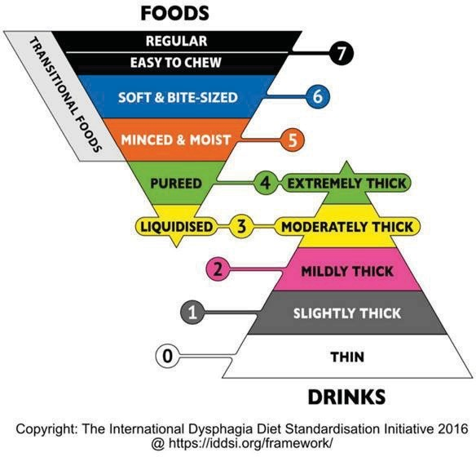
- Website: International Dysphagia Dietary Standards

Mealtime Management
This e-learning course helps to build an understanding of good practice in assessment and intervention when supporting a person with disability at mealtimes. (Developed by NSW Department of Communities and Justice)
- Online Learning: Mealtime Management.

Speech Pathology Australia factsheet
Factsheets on swallowing, swallowing difficulties, when to seek help, and the role of the speech pathologist in swallowing. (Developed by Speech Pathology Australia)
- Factsheet: Speech Pathology Australia

Mealtime Support Resources
Comprehensive guide for safe mealtimes, including modifying textures, giving medication and restrictive practices. (Developed by the State of Queensland, Centre of Excellence for Clinical Innovation and Behaviour Support, 2019)
- Useful Resource: Mealtime Support Resources
Decorative images omitted.

Fostering Healthy Eating

Eating well: Nutritional and Practical Guidelines
A resource about supporting children and adults with learning disabilities to eat well. (Developed by The Caroline Walker Trust)
- Practice Guide: Eating well

Nutrition and swallowing procedures
The Nutrition and Swallowing Procedures tools and templates provide resources to be completed when supporting a person with good nutrition and safe swallowing. (Developed by Family and Community Services, 2016)
- Tool: Nutrition and Swallowing Procedures

Dietitians Association of Australia
Find an Accredited Practising Dietitian for expert advice to support healthy eating for people with disability.
- Website: Dieticians Association of Australia

Go for 2 and 5 Website
Tips and recipes to support increasing fruit and vegetable intake.
- Website: Go for 2 and 5

Healthy Pantry
Information to build a healthy pantry. (Better Health Channel)
- Website: Healthy Pantry

Healthy eating
Information to support healthy eating. (Better Health Channel)
- Website: Healthy eating

Nutrition Australia Resources
Recipes, factsheets and healthy Eating programs. (Developed by Nutrition Australia)
- Useful Resource: Nutrition Australia
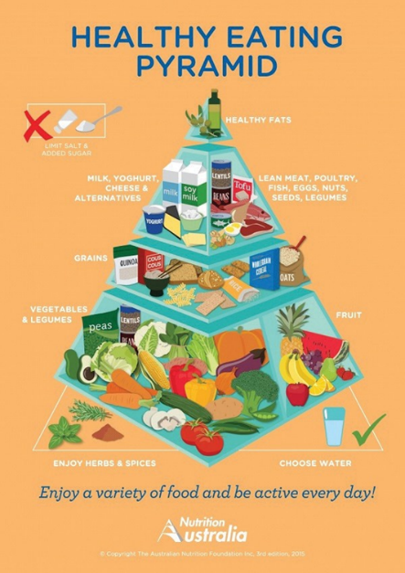
Image source: Nutrition Australia

Munch and Move Resources
Healthy eating and exercise tips for kids. (Developed by Munch and Move, 2020)
- Useful Resource: Munch and Move

Good Food Resources
A range of training resources to support healthy eating for people with disabilities living in supported accommodation. (Developed by Greystanes Disability Services)
- Useful Resource: Good Food Good Living

Australian Guide to Healthy Eating
The Australian Guide to Healthy Eating is a food selection guide, which visually represents the proportion of the five food groups recommended for consumption each day. (Developed by National Health and Medical Research Council)
- Useful Resource: Australian Guide to Healthy Eating

Improving Diet and Physical Activity Practices in Group Homes Serving Residents with Severe Mental Illness
Improving Diet and Physical Activity Practices in Group Homes Serving Residents with Severe Mental Illness. (Xiong, Ziegahn, Schuyler, Rowlett & Cassady, 2010)
- Relevant Reading: Journal article: Improving Diet and Physical Activity Practices

People with Disability Australia
People with disability in Australia brings together information from a range of national data sources to contribute to a greater understanding about disability in Australia. (Australian Institute of Health and Welfare)
- Relevant Reading: People with Disability Australia
Decorative images omitted.

Supported Decision Making

The La Trobe Support for Decision Making Practice Framework Learning Resource
This online learning resource assists people providing decision-making support to enable people to have choice and control in their lives. (Bigby, Douglas & Vassallo, 2019)
Image source: The La Trobe Support for Decision Making Practice Framework Learning Resource
- Online Learning: The La Trobe Support for Decision Making Practice Framework Learning Resource

The Link Between Supported Decision Making and Legal Capacity
In this short film, Michael Bach talks about how supported decision making can allow people with disabilities to take back control with the help of their families and communities. (Developed by Open Society Foundations)
- Film: Looking Differently at Disability and Decision Making

Decision Making Support for People with Cognitive Disability
This booklet sets out guidelines for disability workers to help people with cognitive disability make decisions. (Duffield, Koritsas, Watson, & Hagiliassis, 2016)
- Practice Guide: Decision Making Support for People with Cognitive Disability

Supported Decision Making: a guide for people living with dementia, family members and carers
This handbook focuses on how to support and help people living with dementia to make decisions about their lives. (Sinclair et al., 2018)
- Practice Guide: Supported Decision Making

Introduction to Supported Decision Making
This workshop has been designed as a one-day face-to-face program for disability services staff. Components of the workshop can be adapted for shorter stand-alone training sessions and can be delivered to a range of other audiences, including staff from mainstream services, people with a disability and their families. It may be of interest to practice leaders wanting to run in-house training of their own. (Developed by the NSW Public Guardian)
- Online Learning: Introduction to Supported Decision Making

It’s my choice toolkit, Inclusion Melbourne
This toolkit consists of five guides that support people with a disability, families and support providers to understand and explore the principles of choice. It also provides examples, worksheets and other practical tools to support people to develop their choice making abilities.
- Tool: The Principles of Choice
- Tool: A Guide for People with Disability, their Family, Friends and Advocates
- Tool: A Guide for Disability Support Providers
- Tool: Film and Discussion Guide
- Tool: A Knowledge Review
(Developed by Inclusion Melbourne)

Supported Decision Making resources, WA Individualised Services (WAIS)
A range of resources supporting a practical approach to supported decision-making including: Supported Decision-making guide in plain language and Easy Read versions, Supported Decision-making principles posters, recording decision-making template and short videos. (Developed by Western Australian Individualised Services)
- Useful Resource: Supported Decision Making

Relevant Reading
Douglas, J., & Bigby, C. (2018). Development of an evidence-based practice framework to guide support for decision making. Disability and Rehabilitation
- Relevant Reading: Journal article: Development of an evidence-based practice framework
Carney, T., Then, S., Bigby, C., Wiesel, I., Douglas, J., Smith, E., (2019) Realising ‘Will preferences & Rights’: Reconciling differences on best practice support for decision-making? Griffith Law Review
- Relevant Reading: Journal article: Will, preferences and rights
Decorative images omitted.

Health and Wellbeing

Enabling Health: Taking action to improve the health of people with a disability
An evidence-based, health promotion resource outlining actions that can be taken to address the socially produced causes of ill health experienced by people with a disability (VicHealth, 2014)
- Practice Guide: Enabling Health

The Guide: Accessible Mental Health Services for People with an Intellectual Disability
This Guide highlights practical steps, which can be taken to enhance communication, and cross-sector collaboration. Department of Developmental Disability Neuropsychiatry (2014).
- Practice Guide: Accessible Mental Health Services for People with an Intellectual Disability

Intellectual Disability Mental Health e-learning
Free e-learning resources to improve knowledge, skills and confidence; leading to better mental health and wellbeing for people with an intellectual disability. (Developed by IDMH, 2012)
- Online Learning: Intellectual Disability Mental Health e-learning

CID Health Factsheets
A series of health factsheets for people who support people with intellectual disability. (Developed by the Council for Intellectual Disability)
- Factsheet: CID Health

Saliva Control Factsheets
A series of handouts containing information about considerations when supporting a person with saliva control. (Developed by SCOPE)
- Factsheet: Saliva Control

Admission to Discharge Folder
This project was developed to improve the hospital experiences of people with cognitive impairment, their carers, families and disability support staff through improved communication and sharing of relevant and current information. (Developed by A2D, 2017)
- Useful Resource: Admission to Discharge Folder

Disability Distress Assessment Tool (DIS DAT)
Designed to record signs of distress and illness, this tool is useful to gather information on a wide range of non-verbal communication relevant to all situations. DisDAT Copyright: 2008 Northumberland Tyne & Wear NHS Trust and St. Oswald's Hospice
- Tool: Disability Distress Assessment Tool
Decorative images omitted.

Person Centred Active Support

Every Moment Has Potential
The resource provides an introduction to Person Centred Active Support: a way of working that enables everyone, no matter what their level of intellectual or physical disability, to make choices and participate in meaningful activities and social relationships. (Developed by Greystanes Disability Services and La Trobe University)
- Online Learning: Every Moment Has Potential

Active Support: An Essential Component of the Way We Work
This guide describes why active support is fundamental for all the people we support. It details the essential components and strategies that must be in place to ensure support is well-organised, effective and truly meeting the needs of the individual. (Developed by United Response UK and the Tizard Centre)
- Practice Guide: Active Support

Positive Behaviour Support and Active Support
Positive Behaviour Support and Active Support: Essential elements for achieving real change in services for people whose behaviour is described as challenging. Written by John Ockenden (United Response) with assistance from Bev Ashman (United Response), Julie Beadle-Brown (Tizard Centre, University of Kent) and Andrea Wiggins (The Avenues Group).
- Practice Guide: Positive Behaviour Support and Active Support

Active Support, La Trobe University
A collection of books, reports and resources collated by La Trobe University from various sources, authors and organisations.
- Useful Resource: Active Support

Active Support and Practice Leadership
Bigby, C., Bould, E., Iacono, I., & Beadle-Brown, J. (2019). Predicting good Active Support for people with intellectual disabilities in supported accommodation services: Key messages for providers, consumers and regulators. Journal of Intellectual and Developmental Disability
- Relevant Reading: Journal article: Predicting good Active Support for people with intellectual disabilities in supported accommodation services
Bigby, C., Bould, E., Iacono, T., Kavangh, S., Beadle-Brown, J. (2019) Factors that predict good Active Support in services for people with intellectual disabilities: A multilevel model. Journal of Applied Research in Intellectual Disabilities
- Relevant Reading: Journal article: Factors that predict good Active Support in services for people with intellectual disabilities
Decorative images omitted.

Trauma Informed Support Films
- Film 1: Understanding Trauma
- Film 2: What is Trauma Informed Support?
- Film 3: A Trauma Informed Approach to Positive Behaviour Support
- Film 4: How Can Organisations Embed a Trauma Informed Approach?
- Film 5: Building Networks of Support and Recognising Vicarious Trauma
The Trauma Informed Support films have been developed to assist support workers, providers, people with disability and their families to understand what trauma is, the impact it can have, and ways in which everyone in an organisation can provide trauma-informed support. A Facilitator’s Guide is also available. (Developed by National Disability Services, 2020)

Taking Time Framework
A trauma-informed framework for supporting people with intellectual disability (Jackson & Waters, 2015)
- Framework: Taking Time

Power, Threat, Meaning Framework
The Power, Threat, Meaning Framework summarises and integrates a great deal of evidence about the role of various kinds of power in people’s lives, the kinds of threat that misuse of power pose to us and the ways we have learnt to respond to those threats. (Developed by the British Psychological Society)
- Framework: Power, Threat, Meaning Framework

Trauma Informed Practice: Blue Knot Foundation Factsheet for workers in diverse service settings
Factsheet for workers in diverse service settings. (Developed by Blue Knot Foundation)
- Factsheet: Trauma Informed Practice for Workers

Blue Knot Foundation Factsheet for managers
Factsheet for managers: Trauma informed service delivery. (Developed by Blue Knot Foundation)
- Factsheet: Trauma Informed service delivery for Managers

A collection of resources, training and papers by MHCC
MHCC produces a wide range of resources to assist with building organisational capacity within the community managed mental health sector, as well as resources to support people with lived experience of mental health conditions, their carers and families. Resources include: Trauma Informed Leadership for Organisational Change: A Framework; Trauma Informed Care and Practice Organisational Toolkit; and Trauma Informed Events Checklist. (Developed by the Mental Health Coordinating Council)
- Useful Resource: Trauma-informed care and practice

Positive Behaviour Support

Practice Leadership Workshops for Behaviour Support Practitioners
- Webcast: Supporting teams to consistently implement positive behaviour support plans
- Webcast: Reflective Practice
- Webcast: Collecting meaningful data and measuring outcomes
- Webcast: Supporting people to be involved in all aspects of positive behaviour support
The relationship between Behaviour Support Practitioners and Practice Leaders is critical to the implementation of positive behaviour support. These recorded webcasts draw on contemporary research and discuss various topics linked to the PBS Capability Framework. (Developed by National Disability Services, 2019-2020)
Decorative images omitted.

Foundations of Positive Behaviour Support films
- Film: What is Positive Behaviour Support?
- Film: Quality of Life
- Film: Listening and Communicating
- Film: Being Aware of Sensory Needs and Preferences
- Film: Upholding the Values of Positive Behaviour Support
The Foundations of Positive Behaviour Support films provide an overview of positive behaviour support and discuss some of the foundational elements that are necessary for good positive behaviour support to occur. The films recognise that these foundational elements should be embedded into the support provided to everyone. (Developed by National Disability Services, 2020)

NDS Recognising Restrictive Practices Webcast
This webcast discusses a human rights based approach to supporting people, the NDS Zero Tolerance Framework and relevant resources, the importance of focussing on quality life, the misuse of restrictive practices, what the evidence says, practice leadership and reflective practice. (Developed by National Disability Services, 2020)
- Webcast: Recognising Restrictive Practices

Understanding Behaviour Support Practice Guide Age 9-18
This guide will assist support networks of children and young people aged 9 to18 years to address early stages of the development of behaviours of concern and to maintain capacity for effective support. (Dew et al., 2017)
- Practice Guide: Understanding Behaviour Support Practice Guide Age 9-18

Understanding Behaviour Support Practice Guide Age 0-8
This guide will assist support networks of young children aged 0 to 8 years to address early stages of the development of behaviours of concern and to maintain capacity for effective support. (Dew et al., 2017)
- Practice Guide: Understanding Behaviour Support Practice Guide Age 0-8

Behaviour Support & Safety Planning: A Guide for Service Providers
This Guide includes information that will support service providers to implement behaviour support and safety planning. (Developed by Community Living British Columbia)
- Practice Guide: Behaviour Support and Safety Planning

Positive Behaviour Support: Guidance for developing effective positive behaviour support plans
A guide to developing effective positive behaviour support plans. (Developed by United Response UK)
- Practice Guide: Positive Behaviour Support: Guidance for developing effective positive behaviour support plans

Positive Practice Framework
The Positive Practice Framework (PPF), is an online resource for behaviour support practitioners. (Developed by State of Victoria, Department of Health and Human Services, 2018)
- Framework: Positive Practice Framework
Decorative images omitted.

Fostering Positive Cultures
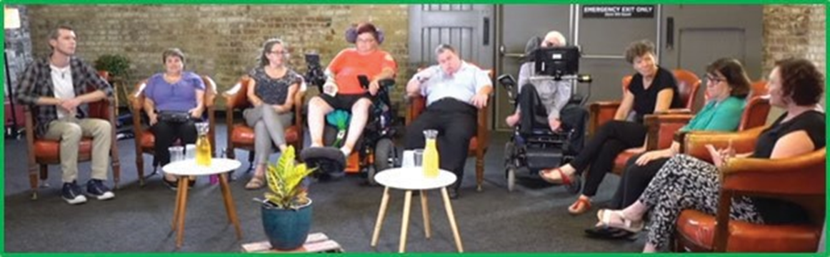
Image source: NDS Positive Cultures films

NDS Positive Cultures Films
- Film: Positive Cultures
- Film: Power and Control
- Film: Speaking Up
- Film: Listening Well
- Film: Everyday Opportunities
- Film: Structured Opportunities
- Film: The Right Supports
- Film: The Way We Use Language
Positive Cultures is a set of eight short films and a guide to help you have conversations in your organisation about creating cultures where every person feels valued, listened to and safe to speak up. Each film will help you to start a conversation about a different aspect of organisational culture. There are questions at the end of each film to help you to talk to each other. A Facilitator’s guide including an Easy English version are also available. (Developed by NDS, 2018)
NDS Safer Services Toolkit
The Safer Services Toolkit assists organisations to build their internal capability and promotes a fair culture focussed on continuous improvement. (Developed by National Disability Services in partnership with Curtin University)
- Tool: Safer Services Toolkit (click the link and scroll down)

Western Australia’s Individualised
Provider development resources covering topics including: Leading Cultural Change; Building Brilliant Teams; Re-thinking Organisations; Creating Clarity; Individual Service Design; and Co-production. (Developed by Western Australia’s Individualised Services)
- Useful Resource: Western Australia’s Individualised Services

Building Safe and Respectful Cultures Report
This Building Safe and Respectful Cultures pilot project aimed to learn more about the culture of services for people with disability and identify some practical approaches that might be both useful now and relevant for future development. (Robinson et al., 2019)
- Relevant Reading: Building Safe and Respectful Cultures Report

Staff Culture
Bigby, C., and J. Beadle-Brown, Culture in Better Group Homes for People With Intellectual Disability at Severe Level, 2016, Intellectual and Developmental Disabilities. 54: p. 316-331
- Relevant Reading: Culture in Better Group Homes for People With Intellectual Disability at Severe Levels
Bigby, C., M. Knox, J. Beadle-Brown, T. Clement, J. Mansell, Uncovering dimensions of informal culture in underperforming group homes for people with severe intellectual disabilities, 2012. Intellectual and Developmental Disabilities. 50(6): p. 452–467
- Relevant Reading: Uncovering dimensions of informal culture in underperforming group homes for people with severe intellectual disabilities
“Relationships are at the heart of developing safe and respectful cultures.” Robinson et al., 2019
Decorative images omitted.

Supporting People who are Ageing

Older Person Advocacy Network Information Page
Good overview and collection of resources on major aged care legislation, departments etc. (Source: Older Person Advocacy Network website)
- Useful resource: Older Person Advocacy Network Information Page

Ageing Well
Staying healthy and feeling your best is important at any age. These tips can help you cope with change and live life to the fullest. (Smith et al., 2019)
- Practice Guide: Ageing Well Help Guide

Aged Care Diversity Framework
This framework outlines:
- The common reasons why some people cannot access the aged care they need
- How we can remove these barriers
(Developed by: Aged Care Sector Committee Diversity Sub-group, December 2017. © 2017 Commonwealth of Australia as represented by the Department of Health)
- Framework: Aged Care Diversity Framework

BILD Resources: Supporting People who are Ageing
The BILD website features a range of resources regarding support for people who are ageing. A series of practice guides, webinars, videos, toolkits and templates are available. (Source: BILD website)
- Useful Resource: BILD resources
Decorative images omitted.

Supporting People from CALD Backgrounds
Working with Culturally and Linguistically Diverse Adolescents
The resource comprises three parts:
- Useful resource: Reports, policy papers and other resources;
- Useful resource: Intake/assessment with a young person from a CALD background; and
- Useful resource: Directory of key contacts for practitioners working with CALD adolescents.
(Developed by the Australian Institute of Family Studies)

Actions to Support Older CALD People: a Guide for Consumers
This guide helps older people from culturally and linguistically diverse (CALD) backgrounds to express their needs when speaking with aged care providers. It can also help people working in aged care to better understand CALD needs. (Developed by the Commonwealth of Australia as represented by the Department of Health, 2019
- Practice Guide: Actions to Support Older CALD People

Orientation to Cultural Responsiveness
This online learning resource is designed to orient staff to cultural diversity and introduce program leaders and practitioners to key issues. A handy resource when implementing diversity plans, it also includes information about VTMH and other services. Mental health service providers and a range of diversity organisations were consulted in design development. (Developed by Victorian Transcultural Mental Health)
- Online Learning: Orientation to Cultural Responsiveness
Decorative images omitted.

References
Anderson, K L. (2016) Communication: First Principles. Centre for Applied Disability Research. Available at Centre for Applied Disability Research website.
Beadle‐Brown, J., Bigby, C., & Bould, E. (2015). Observing practice leadership in intellectual and developmental disability services. Journal of Intellectual Disability Research, 59(12), 1081-1093.
Bigby, C. & Bould, E. (2017) Guide to Good Group Homes, Evidence about what makes the most difference to the quality of group homes. Centre for Applied Disability Research.
Bigby, C., Douglas, J.M., & Vassallo, S. (2018). Enabling Risk: Putting Positives First. An online learning resource for disability support workers. Retrieved from Enabling Risk website.
Bigby, C., Douglas, J., & Vassallo, S. (2019). The La Trobe Support for Decision Making Practice Framework. An online learning resource. Retreived from: The La Trobe Support for Decision Making Practice Framework website.
Bigby, C. & Wiesel, I. (2015). Supporting Inclusion. An online learning resource for disability support workers. Retrieved from Supporting Inclusion website.
Davidson, G., Irvine, R., Corman, M., Kee, F., Kelly, B., Leavey, G., & McNamee, C. (2017). Measuring the Quality of Life of People with Disabilities and their Families: Scoping Study Final Report. Department for Communities.
Dew, A., Jones, A., Cumming, T., Horvat, K., Dillon Savage, I., & Dowse, L. (2017). Understanding Behaviour Support Practice: Children and Young People (9–18 years) with Developmental Delay and Disability. UNSW Sydney.
Dew, A., Jones, A., Horvat, K., Cumming, T., Dillon Savage, I., & Dowse, L. (2017). Understanding Behaviour Support Practice: Young Children (0–8 years) with Developmental Delay and Disability. UNSW Sydney.
Department of Developmental Disability Neuropsychiatry (2014). Accessible Mental Health Services for People with an Intellectual Disability: A Guide for Providers. Department of Developmental Disability Neuropsychiatry ISBN 978-0-7334-3431-0.
Disability Services Commissioner (2018–19), A review of disability service provision to people who have died 2018–19, Melbourne: Disability Services Commissioner.
Duffield, L., Koritsas, S., Watson, J., & Hagiliassis, N. (2016). Decision-making support for people with cognitive disability: A guide for disability workers. Melbourne: Scope (Aust).
Gibbs, G. (1988). Learning by doing: A guide to teaching and learning methods. Further Education Unit.
Hepburn, J., Despott, N., Davy, L., Fisher, K.R., Robinson, S., Speeding, J, Poredos, S., Neale, K., West, R.,Laragy, C., (2018). Working Together Well: A Guide to Building a Stronger Working Relationship. Training Workbook, Inclusion Designlab: Melbourne. ISBN: 978-0-9954255-6-9.
Jackson, A. L., & Waters, S. E. (2015). Taking Time Framework: A trauma-informed framework for supporting people with intellectual disability. Melbourne, Australia: Berry Street.
Mansell, J., Beadle-Brown, J., Ashman, B., & Ockenden, J. (2004). Person-centred active support: A multi-media training resource for staff to enable participation, inclusion and choice for people with learning disabilities. Brighton, UK: Pavilion.
Macnamara, N. and Mitchell, J. (2019). Practice Guide: Reflective Practice: Enhancing Practice in Therapeutic Care. Centre for Excellence in Therapeutic Care: Sydney NSW.
Reed, J., & Koliba, hC., (1995) Facilitating Reflection: A Manual for Leaders and Educators. University of Vermont.
Robinson, S., Oakes, P., Murphy, M., Codognotto, M., Ferguson, P., Lee, F., Ward-Boas, W., Nicks, J. & Theodoropoulos, D. (2019) Building safe and respectful cultures in disability services for people with disability: Report. Victoria, Disability Services Commissioner.
Schalock, R. L. (2004). The concept of quality of life: what we know and do not know. Journal of intellectual disability research, 48(3), 203-216.
Sinclair C, Field S, Williams K, Blake M, Bucks R, Auret K, Clayton J, Kurrle S. Supporting decision-making: A guide for people living with dementia, family members and carers. Sydney: Cognitive Decline Partnership Centre, 2018.
Smith, M., Segal. J., White. M. (2019). Aging Well. (Source: HelpGuide)
Special Projects Team: Directorate of Learning Disability Services, Bro Morgannwg NHS Trust. (2010). A hitchhiker’s guide for the specialist behaviour team (operational guidance). Cardiff, Wales: Wales National Health Service.
VicHealth 2014, Enabling Health: Taking action to improve the health of people with a disability, Victorian Health Promotion Foundation (VicHealth), Melbourne.
Xiong, G., Ziegahn, L., Schuyler, B., Rowlett, A., & Cassady, D. (2010). Improving diet and physical activity practices in group homes serving residents with severe mental illness. Progress in community health partnerships: research, education, and action, 4(4), 279.
Acknowledgements:
National Disability Services would like to acknowledge the funding from the Victorian Government, which allowed this resource to be developed.
End of document.

