Aboriginal and Torres Strait Islander Employment: Guide and Toolkit



A Guide and Toolkit for disability service organisations to increase Aboriginal and Torres Strait Islander employment and workforce participation

NDS (National Disability Services) logo.

# Transcriber's note

Please note that the original document contain tables, charts and diagrams which have been modified for this version.

This document has been formatted using word processing document styles for semantic mark-up and in accordance with the “Guidelines for the Accessible E-text 2018” by Round Table on Information Access for People with Print Disabilities.

Please also note that the original page numbers of the sections have changed in this version due to the mark-up process.

This transcription was made on July 2019 by VisAbility Limited for the sole use of readers with print disabilities.

Contents

Aboriginal and Torres Strait Islander Employment: Guide and Toolkit 1

Acknowledgement of Country 6

Acknowledgement 7

Terminology and Protocols 9

Preface 11

NDS Aboriginal and Torres Strait Islander - Employment Guide and Toolkit Overview 12

Context 15

Benefits of employing Aboriginal and Torres Strait Islander Peoples 17

Social Impact 18

Business 18

Reputation 19

Workforce Diversity 19

**Stage 1: Organisational Readiness Organisational Readiness 20**

Organisational Readiness 20

An Overview 20

Foundations 23

Recognition, Respect and Engagement 23

Vision, Commitment and Governance 24

Organisations must know their ‘why’. 24

Strategy and Policy 24

RAP framework 25

Substantive Equality 27

Resourcing (Staffing and Financial) 28

Preparation of the Workplace 28

Aboriginal and Torres Strait Islander Cultural Capability Framework 29

Combatting Assumptions and Stereotypes (Unconscious Bias) 30

What is White Privilege? 31

Tackling Racism and Discrimination 31

Relationships and Partnerships 31

Suggestions 32

Culturally Safe Workplace (Cultural Protocols and Culturally Familiar Space) 33

Events of Significance 33

National Standards for Disability Services - Implementation for Aboriginal people with disability 34

Workforce (Composition, Development, Monitoring and Reporting) 35

Cultural Protocols 35

Create a culturally safe workplace by: 36

**Stage 2: Employment Strategies 36**

Employment 36

Attraction 38

Attracting Aboriginal and Torres Strait Islander Peoples to Your Organisation 38

Key considerations and strategies to attract Aboriginal and Torres Strait Islander candidates include: 38

Job Design 40

Advertising (Culturally Accessible Publications) 41

Aboriginal Employment Position and/ or Function 41

Advertisement 42

Recruitment 43

Involvement of Aboriginal and Torres Strait Islander peoples 43

Adapting your Employment Techniques 43

Pre-employment and On-Boarding 44

Retaining Employees 45

Workplace Support 45

Supervision 45

Retention Targets 46

Career Progression and Professional and Personal Development 46

Exit Interview 47

Job Satisfaction 47

Monitoring and Review 48

Key Definitions/Concepts 48

Resources used to inform the development of this Guide and Toolkit: 55

**Toolkit 56**

Aboriginal and Torres Strait Islander Cultural Capability Framework 57

Organisational Self-Assessment and Continuous Improvement Tool 61

Embedding Aboriginal and Torres Strait Islander Cultural Capability into your organisation 62

Five criteria 64

Instructions: 65

Key actions prior to the meeting: 65

At the meeting: 66

Stage 1 – Organisational Readiness 66

Stage 2 – Employment Strategies 85

Continuous Improvement Plan - Stage 1 Organisational Readiness 96

Aboriginal and Torres Strait Islander Employment Strategy (AES) Template 107

Aboriginal and Torres Strait Islander Peoples Employment Strategy (AES) Checklist 110

Aboriginal and Torres Strait Islander Employment Report 112

Policy Template 114

Diversity Statements 116

Events of Significance for Aboriginal and Torres Strait Islander peoples 117

# Acknowledgement of Country

National Disability Services (NDS) acknowledges Aboriginal and Torres Strait Islander peoples as the Traditional Custodians of the land. We acknowledge and respect their continuing connection with the land, and pay our respects to their Elders past, present and future.

‘Truth, justice and healing requires a deeper understanding of the complexity of Aboriginal and Torres Strait Islander culture pre-colonisation in order to appreciate what was disrupted or lost. ... stronger relationships built on trust, shared knowledge and respect are essential to creating a more prosperous and reconciled nation for all Australians.’

Source: Reconciliation Australia 2018 Australian Reconciliation Barometer

**About the Artwork:**

This is an Aboriginal artwork called Kurrkapi.

**Kurrkapi**

“This is the Kurrkapi tree that grows out in the desert, you can eat the nectar and it is good for shade.”

This artwork “Kurrkapi” on the cover of this Guide and Tookit was created by Lisa Uhl from Fitzroy Crossing at Mangkaja Arts Studio in the West Kimberley area of Western Australia. Lisa’s language group was Wangkatjungka and she lived all of her life in Fitzroy Crossing. With mesmerising effect, Lisa illustrated her love of country through her rhythmic, abstracted paintings, recalling the stories she was told by her Elders, more specifically by her mother Jukuja Dolly Snell (Dolly). Not uncommonly for people of her generation, Lisa never went to the country she inherited from her ancestors. Her works then, are a tapestry of anecdotally acquired knowledge, and an empirical experience referencing the expanse of the Kimberley. Lisa’s work has been shown locally and nationally in group and solo exhibitions.

It is a privilege for NDS to feature Lisa’s artwork on this important Aboriginal and Torres Strait Islander Employment Guide and Toolkit.

# Acknowledgement

NDS would like to acknowledge all the individuals and organisations who have contributed their time, enthusiasm and expertise to develop the NDS Aboriginal and Torres Strait Islander Employment Guide and Toolkit.

The principal authors of this document are:

* Romain Pignataro, Project Lead Workforce Aboriginal Employment Pathways, NDS
* Mandy Gadsdon, Business Owner, Collective Connections & Solutions (an Aboriginal owned business)

Members of the Aboriginal and Torres Strait Islander Advisory Network include:

* Jim Morrison, Executive Director, Yokai
* Tracey Ninyette, Director Strategic Projects, Department Lands and Heritage
* Pamela Thorley, WA State Lead Aboriginal & Torres Strait Islander Initiatives, Life Without Barriers
* Carolyn Davies, Principal Aboriginal Workforce Development Officer, Department of Justice
* Minyulo Bartlett, Aboriginal Employment Consultant, RISE Network
* Wendy Rose, CEO, Ethnic Disability Advocacy Centre
* Tracey Cullen, Manager Aboriginal Employment, Public Sector Commission
* Kieran Ryan, Senior Client Engagement Officer, North Metropolitan TAFE
* Kim Hansen, Manager, Jobs & Skill Centre, North Metropolitan TAFE
* Shanarla Dalgety, Aboriginal Student Mentor, North Metropolitan TAFE
* AJ Lowe, Senior Client Engagement Officer, North Metropolitan TAFE

NDS Member organisations include:

* Far North Community Services – Broome, Kimberley
* Empowering People In Communities (EPIC) – Karratha, Pilbara
* Life Without Barriers – Kalgoorlie, Goldfields
* Access to Leisure and Sport (ATLAS) – Geraldton, Midwest
* Senses Australia – Perth
* Interchange – Perth

This project has been funded by the WA State Government – Department of Communities.

## Disclaimer

Aboriginal and Torres Strait Islander peoples should be aware that this publication may contain images or names of people who have passed away.

This resource contains copyrighted material that must not be copied or used without obtaining permission from the copyright owner; this material will be noted as such in the document. All other information and templates may be copied with reference to National Disability Services.

Suggested reference: National Disability Services (2019), Perth, Western Australia

## Tip

With the permission and help of your local Aboriginal community, you may like to develop an Acknowledgement of Country in the local community language.

For example, the Perth NDS office is on Whadjuk Noongar Country (Perth Metro), and the following could be used:

Kaya, Nidja Whadjuk Noongar Boodjar. Ngalak kadadj ngaalang nedigar wer boordiya koora-koora wer yey!*

Translation:

Hello, this is Whadjuk Noongar Country. We acknowledge Ancestors and Elders from long ago until today.

Source: adapted from [Noongarboodjar: www.noongarboodjar.com.au](http://www.noongarboodjar.com.au/)

*Please note: always check with Elders if it is okay to speak in their language as it may be considered disrespectful.

# Terminology and Protocols

As a sign of respect and noting this Guide and Toolkit can be adapted and applied to other jurisdictions, the full term ‘Aboriginal and Torres Strait Islander peoples’ is used throughout this document.

The plural term ‘Peoples’ is used throughout this Guide and Toolkit in recognition that Aboriginal and Torres Strait Islander peoples have a collective or group identity, rather than an individual dimension to their lives. It also represents more appropriately the many diverse Aboriginal and Torres Strait Islander language groups across Australia.

Source: Australia Human Rights Commission 2010 The Community Guide to the UN Declaration on the Rights of Indigenous Peoples.

Whilst the word ‘Aborigine/s’ is grammatically correct, the term has negative connotations in Australia and should be avoided.

Abbreviation to ‘ATSI’ and ‘A & TSI’ should also be avoided when used to describe people as it may cause offence. However, when forming part of an acronym to describe such entities as organisations, abbreviations are used extensively, for example AIATSIS for the Australian Institute of Aboriginal and Torres Strait Islander Studies.

## Tip

A way to show respect for Aboriginal and Torres Strait Islander peoples and communities is to embed cultural protocols in your organisation’s policies and practices.

## Please note



There is a glossary included in the Toolkit to assist with interpretation of common words, concepts and other frequently used terms.

In any written communication, capital letters should always be used when writing the following:

* + Aboriginal and Torres Strait Islander
  + Aboriginal
  + Torres Strait Islander
  + Indigenous
  + First Nations
  + First Peoples
  + Traditional Owners
  + Traditional Custodians
  + Elders
  + Country

## Did you know?

A Welcome to Country can only be conducted by a Traditional Owner of a specific Country where the event is being held. Organisations should consider a Welcome to Country for official ceremonies, large gatherings or functions and important meetings with multiple stakeholders.

An Acknowledgement of Country can be performed by any event participants and does not require permission from anyone. The speaker does not need to be an Aboriginal and Torres Strait Islander person.

# Preface

NDS is Australia’s peak body for non-government disability service organisations, representing more than 1000 non-government service organisations across Australia. Collectively, NDS members operate several thousand services for Australians with all types of disability.

NDS is the only organisation that represents the full spectrum of disability service organisations across Australia and members range in size from small support groups to large multi-service organisations. NDS provides members with a strong voice, enabling the sector to collectively initiate change, influence outcomes and deliver the services needed to ensure the best possible quality of life for people with disability.

Nationally Aboriginal and Torres Strait Islander peoples represent a disproportionately high number of Australians with a disability. Today, Aboriginal and Torres Strait Islander Australians, including children, experience disability at almost twice the rate of other Australians. However, in 2019 a lower proportion of Aboriginal and Torres Strait Islander peoples with a disability are participants of the National Disability Insurance Scheme (NDIS). By building more culturally secure and responsive workplaces across the disability sector it is hoped that service responses and access to services they are entitled to through the NDIS will improve.

This Guide and Toolkit has been developed in a partnership between NDS in WA, six disability service organisations and an Aboriginal and Torres Strait Islander Advisory Network as a resource to guide and support Aboriginal and Torres Strait Islander employment and workforce participation across the disability sector. It provides a mix of information as well as tools to enhance the ability of organisations to improve how they go about increasing employment and workforce participation for Aboriginal and Torres Strait Islander employees in their workplace. Organisations are encouraged to make copies of the Guide and Toolkit widely available to employees, and other key stakeholders, including Aboriginal and Torres Strait Islander communities.

Through the implementation of this Guide and Toolkit organisations can play a role in in connecting employers and Aboriginal and Torres Strait Islander job seekers to meet Australia’s growing work opportunities in the disability sector and the NDIS more specifically. Locally responsive solutions are critical to address local issues. Each State and region has its own unique issues that are most effectively addressed by locally tailored responses and solutions. There are many good examples where employers have had great success in increasing their Aboriginal and Torres Strait Islander workforce and some of these are shared in this guide to give practical examples of what is possible. Partnerships, connections and authentic communication channels are needed.

Building an Aboriginal and Torres Strait Islander workforce makes good business sense. Aboriginal and Torres Strait Islander peoples are much more likely to use and engage with culturally responsive services where they feel culturally secure. This is our challenge as individual organisations and as a disability sector to step into the space and embrace working in a different way.

## NDS Aboriginal and Torres Strait Islander - Employment Guide and Toolkit Overview

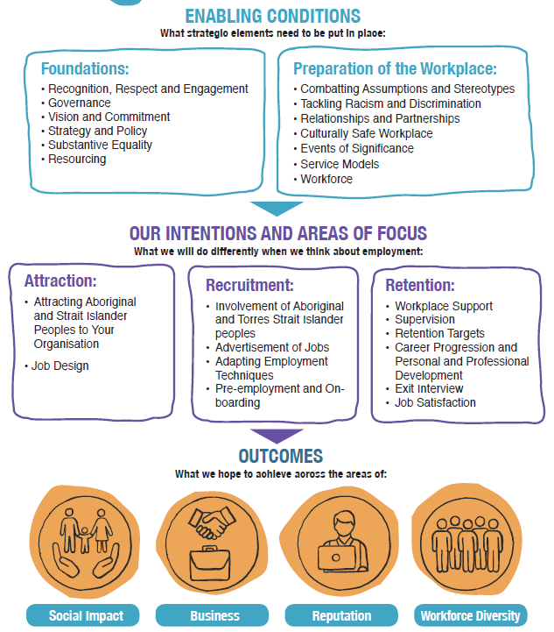

**Enabling Conditions - What strategic elements need to be put in place:**

**Foundations:**

* + Recognition, Respect and Engagement
  + Governance
  + Vision and Commitment
  + Strategy and Policy
  + Substantive Equality
  + Resourcing

**Preparation of the Workplace:**

* + Combatting Assumptions and Stereotypes
  + Tackling Racism and Discrimination
  + Relationships and Partnerships
  + Culturally Safe Workplace
  + Events of Significance
  + Service Models
  + Workforce

Arrow down to,

**Our Intentions and Areas of Focus -** What we will do differently when we think about employment:

**Attraction:**

* + Attracting Aboriginal and Strait Islander Peoples to Your Organisation
  + Job Design

**Recruitment:**

* + Involvement of Aboriginal and Torres Strait Islander peoples
  + Advertisement of Jobs
  + Adapting Employment Techniques
  + Pre-employment and On-boarding

**Retention:**

* + Workplace Support
  + Supervision
  + Retention Targets
  + Career Progression and Personal and Professional Development
  + Exit Interview
  + Job Satisfaction

Arrow down to,

**Outcomes**

What we hope to achieve across the areas of:

* Social Impact
* Business
* Reputation
* Workforce
* Diversity

# Context

The Australian Institute of Aboriginal and Torres Strait Islander Studies (AIATSIS) has developed the map below of Aboriginal and Torres Strait Islander Australia, showing the many and diverse language and social groups.

“Aboriginal and Torres Strait Islander groups were included on the map based on the published resources available between 1988 and 1994 which determine the cultural, language and trade boundaries and relationships between groups. The borders between groups are purposefully represented as slightly blurred. They do not claim to be exact.

The information on which the map is based is contested and may not be agreed to by some Traditional Custodians.

The map was produced before native title legislation and is not suitable for use in native title situations.”

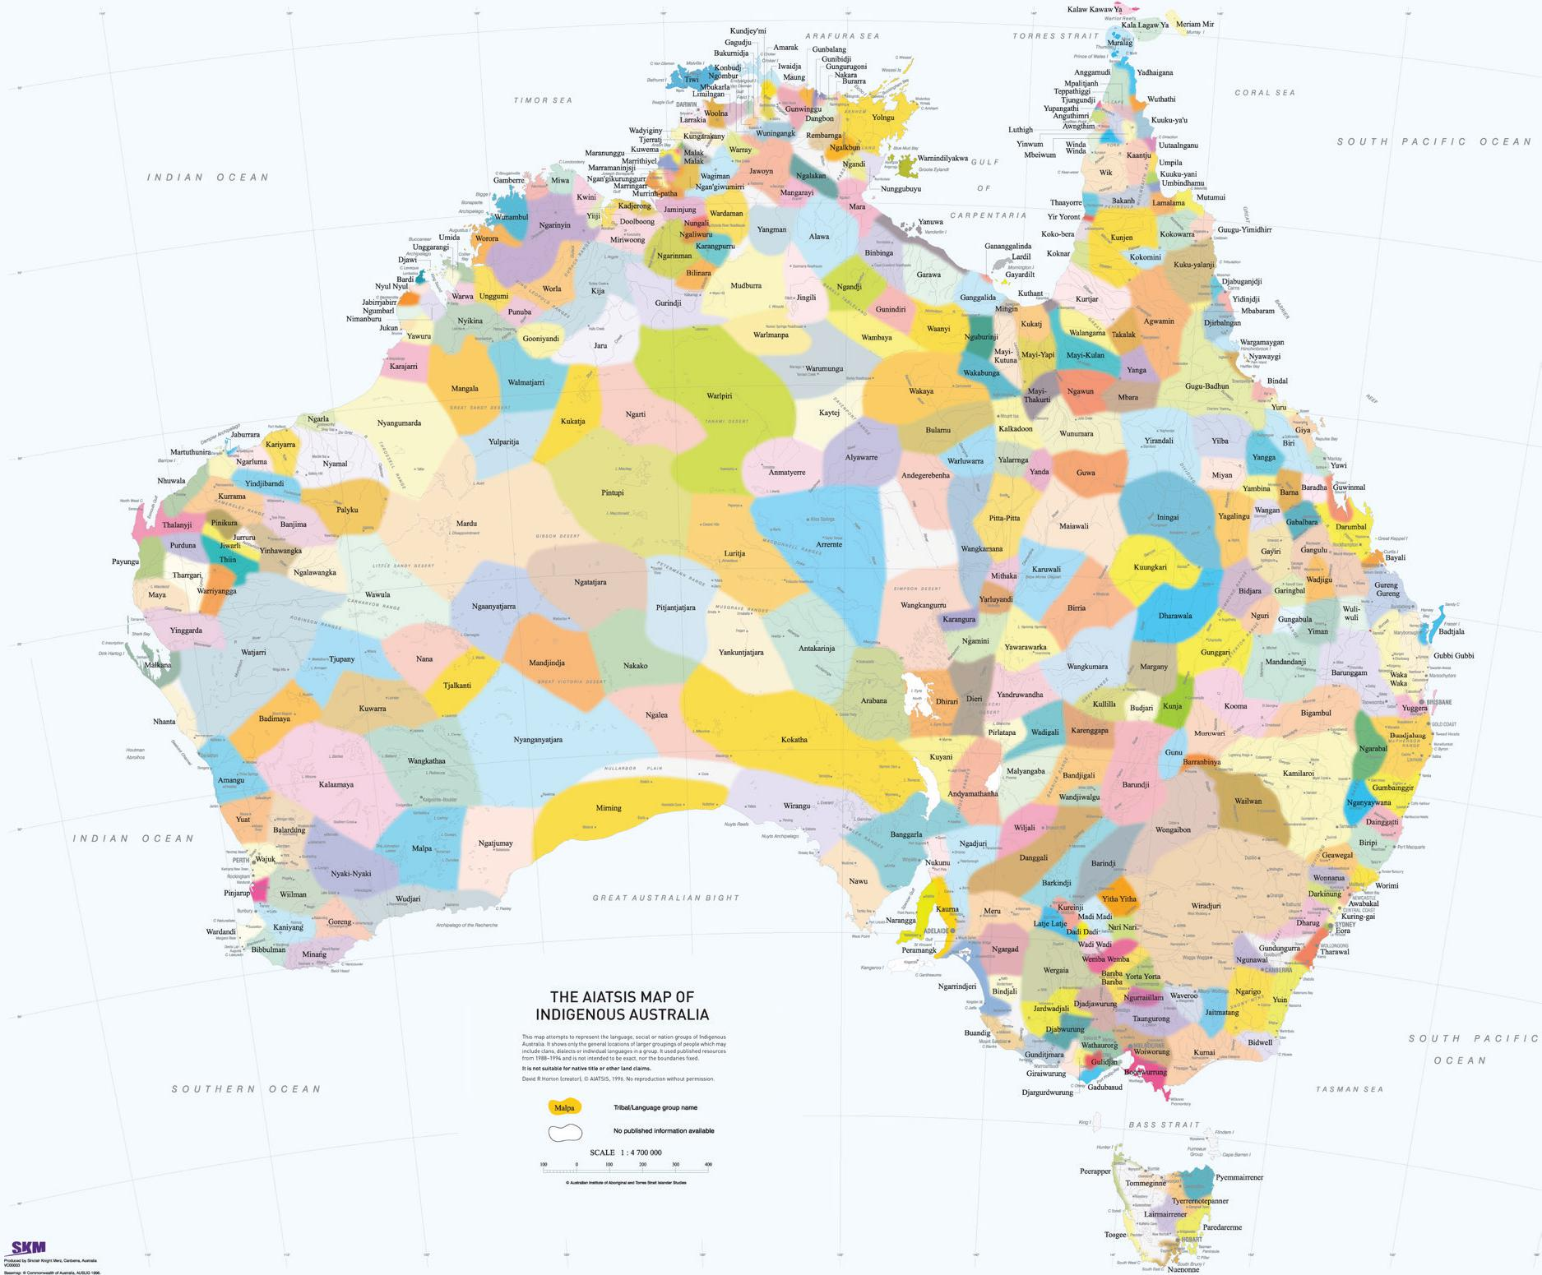

David R Horton (creator), © Aboriginal Studies Press, AIATSIS, and Auslig/Sinclair, Knight, Merz, 1996. No reproduction without permission.

([AIATSIS: https://aiatsis.gov.au/explore/articles/aiatsis-map-indigenous-australia)](https://aiatsis.gov.au/explore/articles/aiatsis-map-indigenous-australia))

Aboriginal and Torres Strait Islander peoples will access services where they feel they are able to have their needs met in a culturally responsive and secure manner. With an extremely low number of Aboriginal and Torres Strait Islander NDIS providers available, there are opportunities for mainstream providers to respond to the needs of Aboriginal and Torres Strait Islander peoples with disability.

In 2008, the Council of Australian Governments (COAG), the peak intergovernmental forum in Australia, set targets aimed at eliminating the gap in outcomes between Aboriginal and Torres Strait Islander Australians and non-Aboriginal and Torres Strait Islander Australians. Closing the Gap aims to improve the lives of Aboriginal and Torres Strait Islander peoples. The current Closing the Gap targets aim to:

| **Target** | **GAP** | **By when** | **WA Status (as at 2019)** |
| --- | --- | --- | --- |
| Halve the Gap | Employment outcomes | 2018 | Not on track |
| Close the Gap | Life expectancy | 2031 | On track |
| Halve the Gap | Mortality for Aboriginal and Torres Strait Islander children under five | 2018 | On track |
| Close the Gap | School attendance | 2018 | Not on track |
| Halve the Gap | Reading, writing and numeracy  achievements | 2018 | Not on track |
| Reach 95% | Aboriginal and Torres Strait Islander four-year olds enrolled in childhood education | 2025 | Not on track |
| Halve the Gap | Reading, writing and numeracy | 2018 | Not on track |

([Closing the Gap – Prime Minister’s Report 2019: https://ctgreport.pmc.gov.au/sites/default/files/ctg-report-2019.pdf?a=1](https://ctgreport.pmc.gov.au/sites/default/files/ctg-report-2019.pdf?a=1)).

According to the Department of the Prime Minister and Cabinet’s report on Closing the Gap, the employment rate for Aboriginal and Torres Strait Islander peoples has not improved over the past decade, falling from 48 per cent in 2006 to just under 47 per cent in 2016.

The economic benefits to be derived from increased employment of Aboriginal and Torres Strait Islander peoples is significant not only for the individuals employed but for the improved outcomes that can be realised for Aboriginal and Torres Strait Islander participants of services provided by fellow Aboriginal and Torres Strait Islander peoples. Aboriginal and Torres Strait Islander employment in the disability sector is low and using this Guide and Toolkit can support disability service providers to improve their performance in this important area and contribute to increased Aboriginal and Torres Strait Islander employment.

# Benefits of employing Aboriginal and Torres Strait Islander Peoples

There are multiple sources that speak to the benefits to be gained from employing Aboriginal and Torres Strait Islander peoples. The benefits of proactively seeking to employ Aboriginal and Torres Strait Islander peoples range from reputation gains to making a positive social impact where the organisation operates and improving service responses to cultural needs of people with disability.

## Social Impact



* Participating in a nation-wide movement of reconciliation to Closing the Gaps in employment for Aboriginal and Torres Strait Islander peoples.
* Offering employment opportunities to Aboriginal and Torres Strait Islander disadvantaged communities/groups.
* In regional areas, the connection with local communities can be strengthened and Aboriginal and Torres Strait Islander peoples can be more committed to working locally.
* Better meeting the cultural needs of Aboriginal and Torres Strait Islander peoples with a disability.

## Business



* Increasing cultural diversity at work encourages new perspectives and awareness of business opportunities and boosts workplace satisfaction.
* Accessing government funding and assistance with regards to training, recruiting and retaining Aboriginal and Torres Strait Islander employees.

## Reputation



* Representing the people accessing services and meeting their cultural expectations.
* Being known as an employer of choice and an organisation that is progressive, inclusive and socially responsible.
* Marketing your organisation as an employer of choice by promoting diversity in the workforce and enabling an inclusive work environment.
* Demonstrating strong corporate citizenship may assist in gaining a market edge and enhance the public reputation of your organisation.

## Workforce Diversity



* Bringing solutions to labour shortages especially in remote communities.
* Accessing talented people. Finding the right people, particularly when there are labour shortages. Cultural diversity boosts workplace satisfaction.
* Aboriginal and Torres Strait Islander communities are a growing source of a capable workforce.
* Pre-employment training provided for Aboriginal and Torres Strait Islander workers can be beneficial to non-Aboriginal and Torres Strait Islander workers and support knowledge sharing.
* Organisations will gain new skills and knowledge from training and working with Aboriginal and Torres Strait Islander employees.

Stage 1: Organisational Readiness Organisational Readiness

# Organisational Readiness

## An Overview

The Aboriginal and Torres Strait Islander Employment Guide and Toolkit has been developed to support disability service organisations to improve their performance in relation to employment and building and maintaining a strong Aboriginal and Torres Strait Islander workforce. In doing so, organisations will improve their ability to engage with and provide services for Aboriginal and Torres Strait Islander peoples with a disability, their families, carers and the community more broadly.

The table below provides an overview of an organisational self-assessment process including a continuous improvement plan that offers a robust way for organisations to self-reflect, self-assess and consider ways they might improve in order to build a strong and responsive Aboriginal and Torres Strait Islander workforce. The Self-Assessment and Continuous Improvement Plan in the Toolkit has been built on the solid foundations of an Aboriginal and Torres Strait Islander Cultural Capability Framework which is also included in the Toolkit.

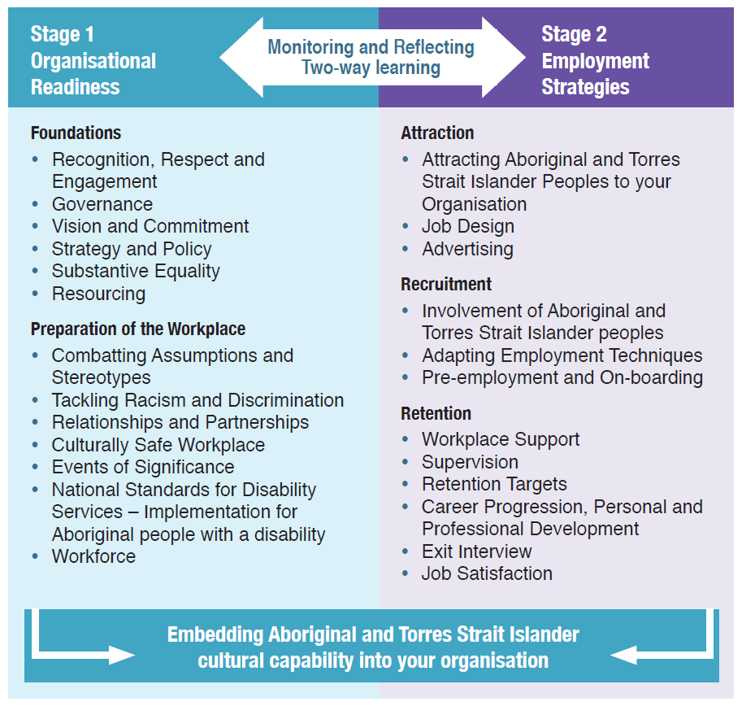

**Stage 1 Organisational Readiness**

**Foundations**

* Recognition, Respect and Engagement
* Governance
* Vision and Commitment
* Strategy and Policy
* Substantive Equality
* Resourcing

**Preparation of the Workplace**

* Combatting Assumptions and Stereotypes
* Tackling Racism and Discrimination
* Relationships and Partnerships
* Culturally Safe Workplace
* Events of Significance
* National Standards for Disability Services – Implementation for Aboriginal people with a disability
* Workforce

**Stage 2 Employment Strategies**

**Attraction**

* Attracting Aboriginal and Torres Strait Islander Peoples to your Organisation
* Job Design
* Advertising

**Recruitment**

* Involvement of Aboriginal and Torres Strait Islander peoples
* Adapting Employment Techniques
* Pre-employment and On-boarding

**Retention**

* Workplace Support
* Supervision
* Retention Targets
* Career Progression, Personal and Professional Development
* Exit Interview
* Job Satisfaction

Embedding Aboriginal and Torres Strait Islander cultural capability into your organisation

# Foundations

## Recognition, Respect and Engagement

Managers play a critical role in retaining employees and their leadership and culturally responsive management practices are paramount in ensuring Aboriginal and Torres Strait Islander employees feel supported, understood and listened to. All managers would benefit from appropriate local cultural competency training to support this. Establishing and nurturing a positive relationship with Aboriginal and Torres Strait Islander employees is essential and has far-reaching positive impacts.

Being aware of, understanding and responding to the many cultural and family obligations that Aboriginal and Torres Strait Islander employees have enables managers to more appropriately respond to these needs. An appreciation of the social structures that exist within Aboriginal and Torres Strait Islander communities, and the extent to which they vary from traditional western structures will assist in building a culturally responsive workplace.

An example that highlights this can be taken from parent relationships, whereby an Aboriginal and Torres Strait Islander child’s father and all paternal uncles are considered to be fathers. A child’s mother and all maternal aunties are considered to be mothers. As such, parental responsibilities such as legal consent, discipline and personal care can be shared between several parent figures, not just the child’s biological parents. In addition to this, cousins may be recognised as sisters and brothers, and close unrelated paternal/maternal figures may also be identified as uncles/ aunties.

Aboriginal and Torres Strait Islander employees may be required to attend numerous family and cultural commitments, for example funerals, and it is important that management is supportive of these, and assists people through such times.

Publicly demonstrating respect for Aboriginal and Torres Strait Islander cultural commitments can enhance the reputation of your organisation as an equal opportunity employer, and can have positive benefits.

## Vision, Commitment and Governance

As with other business-related initiatives, having a strong commitment and vision to a specific cause is paramount to success. When it comes to achieving outcomes in the area of Aboriginal and Torres Strait Islander employment and engagement, it is no different; a clear vision and communicated commitment are essential.

## Tip

A commitment to Aboriginal and Torres Strait Islander employment needs to extend beyond symbolism and intention, into practical actions that will embed the value of diversity within organisations.

Organisations can do this by having an inclusive approach to all employment, a diverse workforce and an appreciation of diversity.

# Organisations must know their ‘why’.

It is important for an organisation to understand and document the vision and aims for Aboriginal and Torres Strait Islander employment. Commitment must be long-term, visible and clearly defined to have a positive impact. The commitment can be communicated in a range of ways, for example through the organisation’s strategic plan, a diversity statement and other public and internal announcements.

Organisations could actively seek Aboriginal representation on their Board. This would support the Board to be more culturally inclusive and diverse; strengthening and integrating cultural and corporate governance.

## Strategy and Policy

For the purpose of this Employment Guide and Toolkit, the focus is around two main strategy documents:

* + A Reconciliation Action Plan (RAP); and
  + An Aboriginal and Torres Strait Islander Employment Strategy (AES)

A RAP contributes to advancing the five dimensions of reconciliation by supporting organisations to develop respectful relationships and create meaningful opportunities with Aboriginal and Torres Strait Islander peoples. Developing a RAP is a good way for organisations to identify their commitments and articulate the minimum requirements to meet them.

All RAPs are built across the three pillars of:

* + Relationships
  + Respect
  + Opportunities

The RAP Framework provides an overview of the different RAPs that can be developed by an organisation from Reflect through to Elevate.

For more information on how to start your RAP visit:  [Reconciliation Australia: www.reconciliation.org.au](https://www.reconciliation.org.au/)

## RAP framework

1. **Reflect RAP (12 months)**

**Scoping -** Organisations commit to a pre-determined setof generic actions to achieve over the year.

1. **Innovate RAP (two years)**

**Implementing** - Organisations focus on innovation: testing/piloting programs and strategies

1. Stretch RAP (three years)

**Embedding** - Organisations commit to a pre-determined set of generic actions to achieve over the year

**Elevate RAP (three years)**

**Leadership -** Work with Reconciliation Australia to advance reconciliation on a national level

Source: Adapted from Reconciliation Australia

There are a number of benefits for organisations to develop a RAP, for example:

* Embedding accountability and formalising commitment for reconciliation;
* Proactively improving network opportunities with Aboriginal and Torres Strait Islander peoples and organisations;
* Establishing respectful relationships and trust and an improved workplace culture;
* Working towards becoming an employer of choice for Aboriginal and Torres Strait Islander peoples; and
* Improved service delivery and responsiveness for Aboriginal and Torres Strait Islander peoples with disability.

Another strategic document that can be considered by organisations, which is more specific to employment is an AES.

An AES can be used to formalise the commitment to Aboriginal and Torres Strait Islander employment. It can be linked to RAP outcomes, strategic and business planning imperatives, and importantly, assist to identify actions and other ways to move forward in the area of Aboriginal and Torres Strait Islander employment. An AES can be a powerful starting point for bringing about organisational change to deliver improved outcomes around Aboriginal and Torres Strait Islander employment.

There is a template for an AES in the Toolkit for organisations to use as a starting point.

## Tip

In order to successfully implement an Aboriginal and Torres Strait Islander Employment Strategy, organisations will need to identify potential internal and external barriers.

## Did you know?

There are two types of equality to consider:

**Formal Equality** is a belief that, for fairness, people should be consistently or equally treated at all times.

**Substantive Equality** goes beyond the basics of recognising the equality of everyone and identifies differences among groups of people with the long-term goal of greater understanding.

## Substantive Equality

Substantive equality lays the foundations for building more equitable approaches. It provides equal opportunities for disadvantaged and marginalised people and groups in society.

Substantive equality recognises that:

* + Rights, entitlements, opportunities and access are not necessarily distributed equally throughout society;
  + Equal or the same application of rules to different groups can have unequal results; and
  + By being flexible in the way they deliver their services, organisations are able to better meet the diverse needs of different groups.

Special measures are provisions, often legislated, that may be used by organisations to embed substantive equality within and across their organisation. At a glance, below is how formal equality differs from substantive equality (equity).

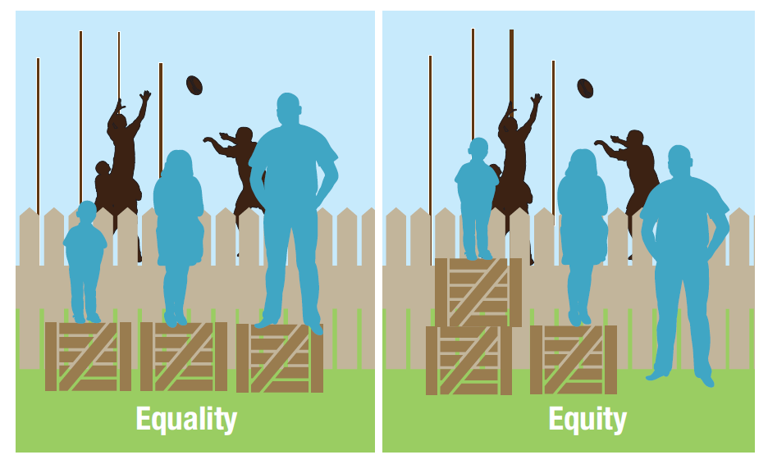

The illustration above depicts Equality vs Substantive Equality (Equity) for three people of different heights who are watching a football game from behind a fence.

In the Equality picture, all three are standing on a box of the same height. The smallest person cannot see over the fence.

In the Substantive Equality picture, the smallest person is standing on two boxes, the person of medium height is standing on one box, and the tallest person is standing on the ground. All three now have the same view of the game.

## Resourcing (Staffing and Financial)

Improving Aboriginal and Torres Strait Islander employment takes organisational commitment, effort and resources.

Some organisations may be in a position to have a function or position that is responsible for improving Aboriginal and Torres Strait Islander employment within their structure. However the reality for many organisations is that this function will be subsumed within a range of roles, particularly those with recruitment responsibility.

With sustained focus and effort, responsibility for the retention of Aboriginal and Torres Strait Islander employment can be a shared function across the organisation, without the requirement for a specific position or role.

**Gaining full cultural competency is a long-term commitment**

# Preparation of the Workplace

Workplace preparation is critical when creating a culturally safe workplace for Aboriginal and Torres Strait Islander employees; it is the fundamental building block upon which to build an Aboriginal and Torres Strait Islander workforce.

As per the organisational assessment, which asks organisations to reflect on their cultural competency, cultural competency assessments are also useful for non-Aboriginal and Torres Strait Islander employees. Whilst there are a number of tools available, Dr Tracy Westerman’s General Cultural Competency Profile ([GCCP: https://indigenouspsychservices.com.au/products-tests/gccp-2/](https://indigenouspsychservices.com.au/products-tests/gccp-2/)) which provides a measure of cultural competencies for employees working with Aboriginal and Torres Strait Islander peoples, is evidence based, provides a rigorous assessment available and is supported by research. The GCCP provides comprehensive feedback across four areas which enables individual employees and organisations to develop very targeted and specific strategies to improve cultural competency. The dimensions of feedback assessment through this Profile include:

1. Cultural Knowledge
2. Skills
3. Beliefs, Attitudes and Encounters
4. Organisational Cultural Competencies

## Did you know?

The WA Centre for Rural Health has developed a whole-of-organisation cultural awareness induction for students and health care providers. It is free of charge and can be incorporated into an existing induction program. The program, Cultural Orientation Plan for health professionals working with Aboriginal people, can be accessed through: [Courses: http://lms.wacrh.uwa.edu.au/login/index.php](http://lms.wacrh.uwa.edu.au/login/index.php)

## Aboriginal and Torres Strait Islander Cultural Capability Framework

The Aboriginal and Torres Strait Islander Cultural Capability Framework is the foundation document underpinning the Aboriginal and Torres Strait Islander Employment – Organisational Self-Assessment and Continuous Improvement Plan. The assessment is made across a continuum that encompasses the following stages as shown below:

* **Unaware:** Pre-contemplation **or** Not Thinking about it
* **Aware:** Contemplation **or** Thinking about it
* **Committed:** Preparation **or** Starting
* **Capable:** Action **or** Doing
* **Responsive:** Maintenance **or** Doing & Reviewing

## Combatting Assumptions and Stereotypes (Unconscious Bias)

For many Aboriginal and Torres Strait Islander peoples, some workplaces can be daunting and uncomfortable. This will largely depend on how culturally diverse, aware, committed, capable and responsive an organisation and their broader workforce is. Combatting assumptions, stereotypes and unconscious bias in the workplace is something that most Aboriginal and Torres Strait Islander peoples will have dealt with across their work life, and often more generally in their personal life.

White Privilege is a sociological term which has been used for decades to describe benefits and privileges ascribed to the dominant ethnicity in society based on skin colour, not social class. Discussing and raising the term ‘white privilege’ does not automatically mean a person with white skin is racist or prejudiced. It simply means that based on skin colour individuals and mainstream organisations will not have had to deal with negative stereotypes often apportioned to those with dark skin.

There are many types of stereotypes that can lead to and reinforce discriminatory attitudes and behaviours. For organisations working in the disability sector, the notion of ableism is understood. In a similar way that ableism comes with unconscious bias, so too does white privilege. White Privilege becomes visible when judgments and assessments of people and situations are based on the position of privilege or advantage they hold as the dominant social group.

Unconscious bias can lead to discrimination as it is built on unfair and often stereotypical assumptions about someone who is different to the dominant culture. In the workplace, unconscious bias may have an impact on recruitment, operations, workplace culture and many other aspects of the organisation. Workforce diversity levels the playing field and can serve as a positive challenge to unconscious bias, offering benefits including:

* improved understanding of the people whom receive services;
* increased productivity;
* greater innovation and creativity;
* broader and more diverse skill-set; and
* improved retention.

Acknowledging that white privilege exists is the first step to overcoming unconscious bias within the workplace. It provides opportunity to have frank and fulsome discussions and reflect on individual and organisational aspects that could be improved.

## What is White Privilege?

White privilege exists on an individual, cultural and institutional level and is a set of advantages experienced daily by the dominant culture or group that are not available to all people.

White privilege means you are born into the racial norm and confers a privilege where:

* your image is on television daily and you’re being represented;
* it is assumed that you lead a constructive life free from crime and welfare.

It’s about not having to assume your daily interactions with people have racial overtones. It’s having the freedom and luxury to fight racism one day and ignore it the next.

## Tackling Racism and Discrimination

Every employee has the right to attend work and be treated with respect irrespective of their cultural background. Actively tackling racism and discrimination should be a priority within all organisations.

Organisations should take a zero tolerance approach to racism and discrimination and at all times exhibit ethical and culturally aware attitudes and behaviours. All employees have a personal responsibility to behave appropriately, and organisations striving to address racism and discrimination will build culturally secure and responsive workplaces. Policies and guidelines that address racism and other discriminatory practices can cover a wide spectrum, for example, Diversity and Inclusion policies, Discrimination and Harassment policies, Social Media policies and an organisation’s Code of Conduct.

## Relationships and Partnerships

Community networks, partnerships and/ or advisory functions formed to work with Aboriginal and Torres Strait Islander peoples, communities and organisations are essential for organisations seeking to improve employment and service outcomes. Networks and partnerships can be formal or informal and may be underpinned by partnership agreements or memorandums of understanding (MOUs), or simply based on goodwill and solid working relationships that are respectful and productive.

Where networks and partnerships include an advisory and/or consultation function, these mechanisms can be both internal and external. For example, having an active Aboriginal and Torres Strait Islander advisory network, employment support group or policy advisory network and establishing community networks and partnerships will only be successful where there is strong community engagement.

Effective engagement with Aboriginal and Torres Strait Islander peoples, communities and organisations is underpinned by a range of factors, some of which include:

* recognition, respect and trust and having an appreciation of Aboriginal and Torres Strait Islander history, cultures, and an understanding of the social diversity and dynamics that exists within and across the individuals, communities and organisations you are working with;
* long-term respectful relationships based on trust and honesty, as well as being open and accessible and having transparent and ongoing communication and giving and receiving information in a two-way and genuine exchange;
* having a clear purpose for engagement, including how this will be of benefit to the social and emotional wellbeing of Aboriginal and Torres Strait Islander individuals, communities and organisations; and
* setting appropriate timeframes and not rushing things. Take time, be respectful and see the establishment of community networks and partnerships as a long-term investment in goodwill.

A committed and genuine approach in this area will establish strong Aboriginal and Torres Strait Islander networks and partnerships that will benefit all aspects of an organisation, from employees through to service outcomes for all people.

## Suggestions

* Develop relationships to facilitate partnership, reconciliation and two-way transfer of skills, knowledge and cultural understandings.
* Undertake ongoing consultation to inform service provision and practice, making strong connections with families and key community members so that cultural beliefs and values are respected.
* Develop effective referral pathways to Aboriginal and Torres Strait Islander services and supports.
* Have a cultural map of the locations serviced by your organisation showing connections with Aboriginal and Torres Strait Islander peoples, communities and organisations identified so you know who you need to talk to.

## Culturally Safe Workplace (Cultural Protocols and Culturally Familiar Space)

For a workplace to be culturally safe it should consider cultural safety in its broadest sense:

**“An environment that is spiritually, socially and emotionally safe, as well as physically safe for people; where there is no assault or challenge or denial of their identity, of who they are and what they need”**

[**Cultural Safety: http://www.intstudentsup.org/diversity/cultural_safety/**](http://www.intstudentsup.org/diversity/cultural_safety/)

Creating a culturally safe workplace is a key focus for organisational readiness in the Aboriginal and Torres Strait Islander Organisational Self-Assessment Tool and Continuous Improvement Plan.

Employment practices impact on how culturally safe an Aboriginal and Torres Strait Islander person will feel at work. Organisations can create a visually familiar workspace for Aboriginal and Torres Strait Islander employees.

It may be beneficial to involve employees in the development of these practices. For example, some organisations have worked with Aboriginal and Torres Strait Islander peoples to develop outside garden spaces where they can hold meetings or other events, coming together in a space that is co-designed and shared.

## Events of Significance

An effective way of demonstrating respect is to recognise and celebrate cultural days of significance for Aboriginal and Torres Strait Islander peoples in the workplace, in consultation with your Aboriginal and Torres Strait Islander workforce.

There is a schedule of important dates and their meanings included on page 65 in the Toolkit.

## National Standards for Disability Services - Implementation for Aboriginal people with disability

In 2014, the Western Australian Disability Services Commission developed a document titled National Standards for Disability Services – Implementation for Aboriginal and Torres Strait Islander peoples with disability.

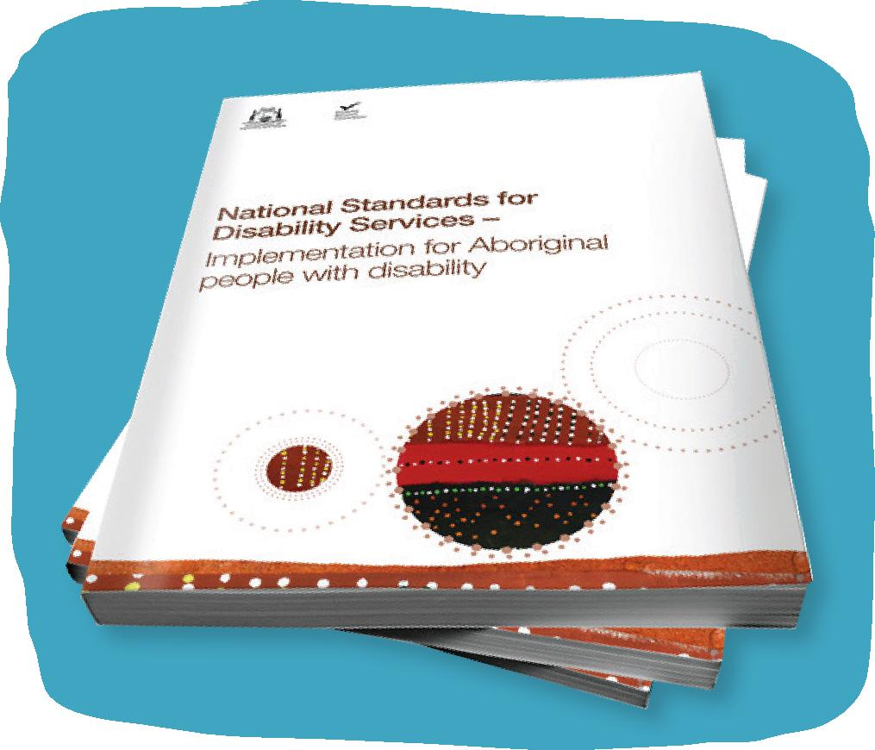

[National Standards for Disability Services – Implementation for Aboriginal and Torres Strait Islander peoples with disability: http://www.disability.wa.gov.au/Global/Publications/About%20us/corporate%20publications/National-Standards-for-Disability-Services-Implementation-for-Aboriginal-people-with-disability.pdf](http://www.disability.wa.gov.au/Global/Publications/About%20us/corporate%20publications/National-Standards-for-Disability-Services-Implementation-for-Aboriginal-people-with-disability.pdf)

This document provides a clear approach for service providers working with Aboriginal and Torres Strait Islander peoples with disability, their families and carers to work together to:

* comply with the National Standards for Disability Services (the Standards);
* develop and maintain high quality services that are person and family-centred;
* meet the cultural needs of Aboriginal and Torres Strait Islander peoples;
* take a collaborative approach with families and Aboriginal Community Controlled Organisations if requested: and
* ensure service responses are respectful, holistic and substantively equal.

Whilst the Standards may alter, the principles and guidance given through this document can be applied across a diverse range of service approaches. By taking this approach, service providers can enhance existing service models, meet the needs, demonstrate understanding, respect and cultural responsiveness within and amongst Aboriginal and Torres Strait Islander peoples. This would support an organisation to be responsive to cultural and language differences, location, living situations, family relationships and dynamics and many other cultural factors.

## Workforce (Composition, Development, Monitoring and Reporting)

Workforce development, including composition, monitoring and reporting, is a process that aims to build, attract and retain a skilled workforce to ensure capacity and capability for continued success.

Having the right employees in place to meet the operational requirements of the organisation is critical and this Aboriginal and Torres Strait Islander Employment Guide and Toolkit is focused on assisting organisations to do this. Workforce development planning should be reviewed regularly to ensure that the workforce composition meets the needs of people who use services provided by the organisation.

## Cultural Protocols

Cultural protocols can guide organisations to understand, respect and encourage culturally appropriate practices. To show respect to the original inhabitants of Australia, it is important to acknowledge Country and the Traditional Custodians of the land.

A Welcome to Country or Acknowledgement of Country demonstrates respect for the Traditional Custodians of the land or sea where the event is being held.

A Welcome to Country is a ceremony that can only be performed by Aboriginal and Torres Strait Islander Elders to formally welcome visitors to their local traditional land. It can take many forms such as giving a speech, singing and/or smoking ceremonies depending on the particular culture of the Elder.

A Welcome to Country is generally conducted for formal events such as conferences, ceremonies, public events and other large events. When it is not possible to arrange a Welcome to Country an Acknowledgement of Country is the minimum requirement.

An Acknowledgement of Country is a statement of recognition of the Traditional Owners of the land and can be given by any person, often the host or the Chair of the event.

## Create a culturally safe workplace by:

* Valuing diversity
* Building your cultural knowledge
* Improving how you communicate
* Embracing two-way learning

## Tip

It is recommended that organisations embed these protocols as part of standard practices in their workplace.

Stage 2: Employment Strategies

# Employment

“At Far North we are working to increase the number of Aboriginal employees as we know this leads to better outcomes for many of the people we support. We are supporting an Aboriginal man in a remote town who has faced some challenges in getting involved in community activities and events. We have employed a local Aboriginal support worker who knows the man and his family and speaks the same Aboriginal language. This has an immediate positive impact and will support the man to re-engage in the community to get involved in the men’s shed and other activities which would lead to improved well-being and quality of life. The employment of this local man has also led to improved community engagement for our organisation which will hopefully lead to improved outcomes for Aboriginal people with disability”

**Kathy Hough, CEO Far North Community Services, 2019.**

For organisations to become employers of choice for Aboriginal and Torres Strait Islander peoples, it is critical that they work towards becoming culturally responsive. This Guide has discussed the need for organisations to be reflective on their readiness to employ Aboriginal and Torres Strait Islander employees and provide adequate support to ensure good retention rates.

There are many benefits to be gained from employing Aboriginal and Torres Strait Islander employees at both a social and business level.

Engagement with the local community often improves and many access issues are broken down through having an increased Aboriginal and Torres Strait Islander workforce. Service delivery and improved outcomes are also realised as many Aboriginal and Torres Strait Islander peoples often prefer to receive a service from their fellow Aboriginal and or Torres Strait Islander peoples than a non-Aboriginal and Torres Strait Islander person.

As Kathy Hough, CEO of Far North Community Services indicates, the employment of Aboriginal and Torres Strait Islander peoples can lead to a range of positive outcomes for Aboriginal and Torres Strait Islander peoples with disability and service providers. To achieve results in relation to more effectively building engagement with Aboriginal and Torres Strait Islander peoples with disability and communities, Aboriginal and Torres Strait Islander employment must be viewed as only a part of a broader engagement strategy.

It is important to ensure Aboriginal and/or Torres Strait Islander employees are not relied upon to undertake all tasks relating to Aboriginal and Torres Strait Islander matters. This may place the person in an uncomfortable position and can contribute to reduced job satisfaction, engagement, or may detract from an organisation’s ability to be culturally secure and responsive. Should organisations fall into this practice there may be flow-on effects across the workforce including a limited ability for non-Aboriginal and Torres Strait Islander employees to become increasingly culturally aware and responsive.

By committing to Aboriginal and Torres Strait Islander employment, organisations recognise the unique skills, perspectives and contributions these employees will bring to the workplace. Benefits include improving service responses for all Aboriginal and Torres Strait Islander peoples and building the cultural responsiveness of the broader workforce.

By working together, acknowledging past, present and future barriers and opportunities, culturally safe and responsive working environments can be established.

There are three specific ways that organisations can improve their employment capability and increase their Aboriginal and Torres Strait Islander workforce:

1. **Attraction:**

Strategies to attract Aboriginal and Torres Strait Islander peoples to employment opportunities.

1. **Recruitment:**

Innovative and responsive recruitment strategies with a focus on engaging and employing Aboriginal and Torres Strait Islander employees.

1. **Retention:**

Strategies to retain employees and reduce employee turnover.

# Attraction

## Attracting Aboriginal and Torres Strait Islander Peoples to Your Organisation

It is important to recognise that strategies to attract Aboriginal and Torres Strait Islander candidates can differ from attracting other candidates. One of the key considerations in seeking to increase Aboriginal and Torres Strait Islander employment is for organisations to work on becoming culturally safe and responsive and supporting Aboriginal and Torres Strait Islander employees through policies and processes effectively ensuring substantive equality (equity) is realised across all areas.

Organisations should focus on their relationships and partnerships with a range of internal and external stakeholders to embed culturally secure and responsive workplace practices. Over time organisations will be recognised as accessible and welcoming and become an employer of choice for Aboriginal and Torres Strait Islander peoples.

## Key considerations and strategies to attract Aboriginal and Torres Strait Islander candidates include:

* Creating targeted learning and career development opportunities for Aboriginal and Torres Strait Islander employees
* Having a culturally secure workplace
* Advertising jobs in a way that values Aboriginal and Torres Strait Islander world views and ways of working
* Communicating and supporting flexible working arrangements
* Culturally responsive policies and employee benefits
* Actively engaging with and developing long-lasting relationships with local Aboriginal and Torres Strait Islander communities, organisations, employment providers and other key stakeholders such as Community Elders
* Building your reputation to be an employer of choice for Aboriginal and Torres Strait Islander peoples
* Recognising and celebrating cultural days for Aboriginal and Torres Strait Islander peoples with local Aboriginal and Torres Strait Islander peoples including Elders, organisations and corporations
* Using culturally appropriate wording and images that feature Aboriginal and Torres Strait Islander peoples and if possible, specific to the position being advertised Making the workplace culturally welcoming such as having Aboriginal and Torres Strait Islander artworks, plaques, flags and other items
* Drawing attention to the organisation’s commitment to reconciliation through a RAP and an Aboriginal and Torres Strait Islander Employment Strategy
* Making the workplace culturally welcoming such as having Aboriginal and Torres Strait Islander artworks, plaques, flags and other items
* Using non-mainstream media to advertise positions
* Establishing links with schools, training providers and universities through their career advisors or Aboriginal and Torres Strait Islander employees. Advertise vacancies through these channels or offer work experience to students or graduates
* Using existing professional networks to gain access to, and support applications from local Aboriginal and Torres Strait Islander communities
* Consulting with Aboriginal and Torres Strait Islander organisations to identify the most suitable qualifications and experience an appropriate Aboriginal and Torres Strait Islander applicant may require
* Identifying the minimum requirements for any employee to ensure that qualifications and experience requirements are not overstated in job description forms
* Communicating to potential employees the networks and support mechanisms that are in place to support them in their role
* Providing applicants with electronic and hard copy job application kits

## Job Design

Job descriptions often provide the first insight into an organisation and what a role will look like as they describe the general responsibilities, duties, reporting lines, qualifications, past experiences and skills required for a position.

They are very important documents in terms of first impressions, however putting emphasis on qualifications and prior experience may lead to some Aboriginal and Torres Strait Islander applicants thinking they are not suitable for a position. For some jobs, job descriptions might focus on the skills and abilities Aboriginal and Torres Strait Islander peoples can bring to a role. Where this is the case, organisations can always provide additional on-the-job training and consider what support might be provided for a person to progress toward meeting any qualification prerequisites that may be required.

## Tip

Advertising across a range of media is an effective way to attract Aboriginal and Torres Strait Islander peoples to your organisation. You may want to advertise on local Aboriginal and Torres Strait Islander media outlets and consider other methods such as local shopping precinct/areas which are visited by Aboriginal and Torres Strait Islander peoples.

## Note

Special measures vary between jurisdictions. For example, the relevant legislation in WA is the Equal Opportunity Act 1984.

It is good practice for organisations to consider linking their recruitment strategy to their RAP or AES.

## Advertising (Culturally Accessible Publications)

Creating culturally appropriate and accessible publications is essential for any recruitment campaign. It is important for organisations to review their methods of advertising to meet the needs of Aboriginal and Torres Strait Islander peoples. It is good practice for organisations to consult with Aboriginal and Torres Strait Islander peoples including employees and community members to develop more culturally appropriate and accessible advertising material and publications.

## Aboriginal Employment Position and/ or Function

There are many benefits to having an Aboriginal Employment Officer (AEO). This role can provide a targeted and productive way to improve Aboriginal and Torres Strait Islander employment outcomes, however not all organisations will have the resources to do this and where this is the case the AEO function could be incorporated into an existing role. The responsibilities of the AEO function vary from organisation to organisation, however some of the key duties could include:

* Be actively involved in Aboriginal and Torres Strait Islander employment initiatives;
* Provide support to new and existing Aboriginal and Torres Strait Islander employees;
* Provide input into, develop and drive implementation of an AES;
* Look at position descriptions and job design with managers in order to increase the Aboriginal and Torres Strait Islander workforce in a targeted way; and
* Be involved in an organisation’s RAP.

Ideally, an AEO would be an Aboriginal and Torres Strait Islander person working in the human resources area and would provide targeted advice, liaison with key stakeholders including the local Aboriginal and Torres Strait Islander community and help with a number of key human resource functions.

## Advertisement

Use plain English and avoid jargon and acronyms.

It is also good practice to consider the design of the advertisement, which could include Aboriginal and Torres Strait Islander images, artwork and photos.

If possible, having an Aboriginal and Torres Strait Islander person as a contact for job enquiries can assist Aboriginal and Torres Strait Islander candidates to feel more confident in making contact to find out more about a position. It is recommended that a nominated Aboriginal and Torres Strait Islander employee or representative review job related processes.

The following statement could be used on position statements and used in advertisements:

**“The organisation is committed to achieving a diverse workforce and strongly encourages applications from people with disability, Aboriginal and Torres Strait Islander peoples and people from culturally diverse backgrounds.”**

Targeted employment measures can be put in place by employers in order to address the employment gap between Aboriginal and Torres Strait Islander peoples and other Australians.

Recruitment strategies designed to increase the representation of Aboriginal and Torres Strait Islander peoples in the workplace are strongly supported by legislation which recognises that some groups, including racial groups, experience disadvantage and do not enjoy their human rights equally with others. The Targeted Recruitment of Aboriginal and Torres Strait Islander people Guidelines developed by the Australian Human Rights Commission can assist employers to implement special measures into their recruitment practices.

It is recommended that advertisements and selection documentation for any special measures reference both section 8(1) of the Racial Discrimination Act 1975 (Cth) and the appropriate State or Territory based legislation enabling the special measure. Wording for job advertisements can be sourced from the Commonwealth, State or Territory agency enabling the legislative practice surrounding special measures for employment.

## Tip

To learn more about ‘Special Measures’ you can access the Targeted Recruitment of Aboriginal and Torres Strait Islander people - A Guideline for Employers – available: https://www.humanrights.gov.au/sites/default/files/document/publication/AHRC_Targeted_recruitment_ATSI_people_guideline2015.pdf

# Recruitment

## Recruitment Tip

Provide additional support with an Aboriginal and/or Torres Strait Islander person by taking them through the interview process and offer pre-interview briefing session.

## Involvement of Aboriginal and Torres Strait Islander peoples

Offering an Aboriginal and Torres Strait Islander candidate the option to invite an Elder, community representative or family member to attend an interview with them is a culturally responsive practice organisations can consider. It is important for the employer to provide cultural awareness training for all employees involved in recruitment.

This will allow the interviewers to be sensitive and mindful around the language used and will enable rewording of questions to suit each candidate if this is required.

## Adapting your Employment Techniques

The recruitment stage is critical in ensuring that applicants are screened in and not out. Providing appropriate support to candidates who may require assistance is essential. In the recruitment stage support can be provided in the following ways:

* assistance completing pre-employment paperwork including job application, cover letter and resume;
* offer the option for the paperwork to be completed on hard copy instead of electronically; and
* assistance with requesting police and working with children checks (if required).

Adapting screening (where permitted) and interviewing techniques can help ensure all candidates have a fair go at getting a job.

Interviews can be undertaken in places where candidates feel more relaxed and comfortable; for example, in more informal settings to suit the candidate.

## Pre-employment and On-Boarding

As part of the recruitment process, most organisations provide an induction for their new employees. Preferably, new Aboriginal and Torres Strait Islander employees will be taken through the induction process with the support of an existing Aboriginal and Torres Strait Islander employee if this is possible.

This will enable the new employee to be shown around the service while being introduced to culturally appropriate mentors. An added benefit of this approach is that employees will begin their work with the organisation in a stress-free, supportive way that recognises and values their individuality, culture and personal needs.

Generally induction packages address the following:

* structure of the organisation;
* values and Mission of the organisation;
* key policies such as Code of Conduct as well as Diversity and Dress Code Standards;
* expectations of role, responsibility and reporting – note that meeting the expectations is required for all employees;
* learning and professional development opportunities;
* information about flexible work practices and work life balance options;
* contract and pay discussions;
* who to ring when absent;
* use of vehicles;
* mentoring and coaching process if applicable; and
* details of any relevant networks or support available.

Employees may need assistance with meeting the organisation’s pre-employment and on-boarding requirements. This process can often be daunting for employees who do not feel confident or comfortable as a result of a range of factors including literacy or English language skills, limited contact with a workplace, etc.

Offering assistance to Aboriginal and Torres Strait Islander employees, when required, can have a positive impact on your workplace and can help with retention.

# Retaining Employees

## Workplace Support

There are a number of initiatives to support Aboriginal and Torres Strait Islander peoples in the workplace. These include mentoring and buddy systems that are based on mutual respect, empathy and trust between the mentor and mentee. This supportive relationship can provide advice, support, encouragement and reciprocal learning.

These relationships are designed to help employees achieve their full potential, both professionally and personally, through their work experiences. There are also many other ways organisations can support their employees, many of which are mentioned throughout this Guide and Toolkit.

## Supervision

Providing culturally committed and responsive supervision for Aboriginal and Torres Strait Islander employees is critical. Whilst there are many models of supervision for employees, and organisations will often have their own policies and practices related to this, organisations considering culturally specific approaches for their Aboriginal and Torres Strait Islander employees may find this beneficial.

It is important for organisations and managers/supervisors to acknowledge and understand the significant differences in the cultural needs of Aboriginal and Torres Strait Islander employees in the workplace. When looking at developing culturally responsive supervision models, some areas for organisations to consider include:

* Who the supervisor should be based on their cultural capability;
* Are there Aboriginal and Torres Strait Islander terms, concepts or words that could replace the term supervision?; and
* Are cultural practices more aligned to individual supervision or peer/group models?

Organisations are encouraged to ask their Aboriginal and Torres Strait Islander employees, or work with advisory groups to improve practices in these areas.

## Retention Tips

Consider ways Aboriginal and Torres Strait Islander practices can be integrated into supervision practices and/or a framework.

Consider arranging for supervisors of Aboriginal and Torres Strait Islander employees to undergo targeted and accredited training for supervisors of Aboriginal and Torres Strait Islander employees (like the Westerman Cultural Competency Profile for supervisors for example).

## Tip

It is important to ensure the induction program is flexible and should be adapted to meet individual employee needs

## Retention Targets

Before an organisation considers setting retention targets, it is useful to develop a retention plan that clearly outlines goals to work towards in set timeframes. Setting and measuring employee retention rates allows organisations to keep a close eye on how they are going across a range of areas and identify opportunities for proactive continuous improvement.

Retention targets can be incorporated into human resource and Board reporting, particularly as it relates to the Aboriginal and Torres Strait Islander employees.

## Career Progression and Professional and Personal Development

Whilst every employee will have different professional and personal development goals and career progression aspirations, human resource policies need to be responsive so that employees can reach their full potential in their current and future roles. Offering opportunities for employees to improve is important as it sits side-by-side with organisational success. This is an area where managers and supervisors also have a responsibility to ensure they have good communication skills, understand the importance of teamwork, have the ability to manage conflict and have difficult but necessary conversations, etc. Set within a strong supervision framework, career progression and professional development opportunities can enhance employee job satisfaction and improve employee retention rates.

## Exit Interview

Exit interviews provide a good opportunity for organisations to gain valuable information and feedback on a range of areas such as workplace culture, processes, management and overall happiness in the workplace, along with constructive input. Collating data from exit interviews can assist organisations to be proactive in order to continuously improve employee retention over the longer term.

Aboriginal and Torres Strait Islander employees may not feel comfortable doing an in-person exit interview with their manager. It is suggested that organisations look to see if this can be done in an alternative manner, with an Aboriginal and Torres Strait Islander manager or other trusted colleague, or where this is not possible, with an external Aboriginal and Torres Strait Islander consultant.

Online exit interviews are not always the best way to gather information from employees departing as many will simply opt out and this is particularly the case for many Aboriginal and Torres Strait Islander employees.

## Tip

Try a ‘stay interview’ or ‘check-in’ – ask your employees how they are feeling at work, are there any areas they think need attention in order to retain employees, any hot spots that need addressing, etc.

## Job Satisfaction

An organisation can take collective responsibility for, and value the importance of, Aboriginal and Torres Strait Islander employment. Providing local cultural awareness training is one way that organisations can support all employees to gain a greater appreciation and understanding of some of the cultural complexities that exist for Aboriginal and Torres Strait Islander employees within the community where they live and work.

Managers play an essential role in job satisfaction for employees. Good leadership and culturally responsive management practices are paramount in ensuring Aboriginal and Torres Strait Islander employees feel supported, understood and listened to. All managers will benefit from appropriate local cultural competency training.

## Tip

Consider using an independent or third party to conduct exit interviews as employees leaving your organisation may feel more comfortable giving full and frank feedback.

# Monitoring and Review

The practical implementation and effectiveness of any Aboriginal and Torres Strait Islander Employment Strategy or approach should be regularly reviewed across the organisation.

Any feedback and suggestions for improvement should be used to inform the continuous improvement of the Strategy and what it is seeking to deliver. The success of this strategy may be determined by an increase in the recruitment and retention of Aboriginal employees, as well as an improvement in the support and satisfaction reported by employees.

Organisations can capture information on improvement and satisfaction through supervision, discussion, interviews, focus groups and surveys and should ensure the format and approach is accessible.

# Key Definitions/Concepts

| **Term** | **Definition** |
| --- | --- |
| Aboriginality  (Inclusive of Aboriginal and Torres Strait Islander peoples)  *Note: May also be referred to First Nations peoples and/ or First Peoples | According to s51 (25) of the High Court of Australia (1983): ‘An Aboriginal or Torres Strait Islander person is a person of Aboriginal or Torres Strait Islander descent who identifies as an Aboriginal or Torres Strait Islander (person) and is accepted as such by the community in which he or she lives’. |
| Aboriginal Community Controlled Organisation (ACCO) or Aboriginal Community Controlled Health Organisation (ACCHO) | An Aboriginal Community Controlled Organisation (ACCO) is “an incorporated Aboriginal organisation, initiated, based and governed by the local Aboriginal community to deliver holistic and culturally appropriate services to the Aboriginal community that controls it” (See [NACCHO website: Definitions: https://www.naccho.org.au/about/aboriginal-health/definitions/](https://www.naccho.org.au/about/aboriginal-health/definitions/)) |
| Aboriginal and/or Torres Strait Islander Elder | An Aboriginal and Torres Strait Islander Elder(s) is a highly respected person/people held in esteem by their communities for their wisdom, cultural knowledge and community service. They are responsible for making decisions within the community. |
| Aboriginal and Torres Strait Islander worldview | Many Aboriginal and Torres Strait Islander peoples consider all of the earth to be sacred and regard themselves as an integral part of this holistic and living landscape. They belong to the land and are at one in it with animals, plants, and ancestors whose spirits inhabit it. Traditional knowledge, in the form of narratives, place names, and ecological lore, bequeathed through oral tradition from generation to generation, embodies and preserves their relationship to the land. Aboriginal worldviews emphasise connectivity, relationality and inter-relatedness. |
| Capacity building | Capacity building is accessing opportunities and processes to enhance an organisation’s abilities to perform specific functions, solve problems, and set and achieve goals. |
| Community | There are many kinds of Aboriginal and Torres Strait Islander ‘communities’. They may be located in rural, remote or urban areas, often existing within an extended network of relationships. Some communities are defined by geographical location; others are communities of identity and interest that are physically dispersed across different locations. |
| Culturally appropriate | An approach to policy, practice and service delivery that is based on the positive acceptance of the cultural values and expectations of Aboriginal and Torres Strait Islander peoples or other culturally diverse peoples. |
| Cultural awareness | Is about the knowledge and understanding of cultural differences and history. It is about teaching/educating employees in the hope they deliver culturally appropriate services. |
| Cultural competence | Cultural competence is the ability to identify and challenge one’s own cultural assumptions, values and beliefs. It is about developing empathy and connected knowledge, the ability to see the world through another’s eyes, or at the very least to recognise that others may view the world through a different cultural lens. |
| Cultural dislocation | Refers to the removal, loss or inability of an individual to connect with their traditional heritage or culture. |
| Cultural humility | Cultural humility is a lifelong journey of self-reflection and learning. It involves listening without judgement and being open to learning from and about others. It involves learning about our own culture and our biases. Cultural humility is a building block for cultural safety. It is an overarching principle that is threaded through our learning and acts as the process by which change can occur. |
| Cultural safety | Is about creating an environment, which is safe for people; where there is no assault, challenge or denial of their identity, of who they are and what they need. It is about shared respect, shared meaning, share knowledge and experience of learning together with dignity and truly listening. |
| Cultural security | Starts from the position that the system takes primary responsibility for working with communities and employees to find ways of building Aboriginal and Torres Strait Islander culture appropriately into services to promote the best possible outcomes. |
| Cultural supervision | Cultural supervision can be for all employees. For Aboriginal and Torres Strait Islander employees it should provide a source of support in all areas of their work, in whatever work environment they are in; providing a place to discuss cultural ways of working and any issues particular to culture and community as it interfaces in the workplace. For non-Aboriginal and Torres Strait Islander employees it can help them to work in a more responsive manner, as well as growing cultural sensitivity and awareness. |
| Disability | A disability is any continuing condition that restricts everyday activities.  The Disability Services Act (1993) defines ‘disability’ as meaning a disability:   * which is attributable to an intellectual, psychiatric, cognitive, neurological, sensory or physical impairment or a combination of those impairments * which is permanent or likely to be permanent * which may or may not be of a chronic or episodic nature * which results in substantially reduced capacity of the person for communication, social interaction, learning or mobility and a need for continuing support services. |
| Disability Services Standards | National framework that defines minimum levels of Standards service quality as set in the Principles and Objectives of the Disability Services Act. |
| Disability Services Standards – Implementation for Aboriginal people with disability | This publication sets out guidelines to provide a self-development tool for disability sector organisations to assist them to interpret the National Standards for Disability Services from an Aboriginal and Torres Strait Islander perspective, and therefore lead to improvements in cultural sensitivity in service provision. |
| Disability Service Organisation (DSO) | A non-government disability service organisation |
| Engagement | Engagement is about a relatively sustained and systematic interaction. It is not a single process or set of activities. It is an ongoing process or conversation that builds trust and relationships. Engagement is seen as an interaction between groups of people working towards shared goals. |
| Equity | The state, quality, or ideal that recognises individuals and groups have different circumstances which may require different treatment so that obstacles and barriers are overcome and so that everyone may access the resources, opportunities, power and responsibility they need to lead full and healthy lives. |
| Holistic | A holistic approach is consistent with an ecological perspective where all people are living beings who interact with their environment. |
| Human Rights based | Human rights-based approaches are about turning human rights from purely legal instruments into effective policies, practices and practical realities. |
| Inclusion/Inclusivity | Based on the concepts of belonging, acceptance and recognition, inclusion and inclusivity entails the realisation of full and equal participation in economic, social, cultural and political institutions. |
| Partnerships | A partnership is a respectful and sustainable relationship based on trust and a shared vision of working together to improve long-term outcomes. Partnerships may be informal or formal and legal in nature. |
| Reconciliation | Reconciliation is about unity and respect between Aboriginal and Torres Islander peoples and non-Aboriginal and Torres Strait Islander peoples. It is about respect for Aboriginal heritage and valuing justice and equity for all Australians.  Reconciliation is about building better relationships between the wider Australian community and Aboriginal and Torres Strait Islander peoples for the benefit of all Australians. |
| Substantive equality | Substantive equality recognises that:   * Rights, entitlements, opportunities and access are not necessarily distributed equally throughout society; * Equal or the same application of rules to different groups can have unequal results; * Organisations need to be flexible in the way they deliver their services. In order to treat people equally services may need to be delivered differently. |
| Traditional Owner(s)/Traditional Custodian(s) | Senior person/people in the community, who are responsible for their traditional land and waters, are referred to as ‘Traditional Owners’. Traditional Owners may or may not live on their traditional lands but still have responsibility and cultural ownership of the place. |

# Resources used to inform the development of this Guide and Toolkit:

* [Australian Bureau of Statistics: https://www.abs.gov.au/ausstats/abs@.nsf/mf/4433.0.55.005](https://www.abs.gov.au/ausstats/abs@.nsf/mf/4433.0.55.005)
* [Australian Chamber of Commerce: https://www.australianchamber.com.au/](https://www.australianchamber.com.au/)
* Australian Human Rights Commission – Community Guide to the UN Declaration on the Rights of Indigenous Peoples: <https://www.humanrights.gov.au/our-work/aboriginal-and-torres-strait-islander-social-justice/publications/community-guide-un>
* [Australian Institute of Aboriginal and Torres Strait Islander Studies (AIATSIS): https://aiatsis.gov.au/explore/articles/aiatsis-map-indigenous-australia](https://aiatsis.gov.au/explore/articles/aiatsis-map-indigenous-australia)
* [Centre for Applied Disability Research: https://cadr.org.au/research-to-action-guides/culturally-proficient-service-delivery](https://cadr.org.au/research-to-action-guides/culturally-proficient-service-delivery)
* [Closing the Gap – Prime Minister’s Report 2019: https://ctgreport.pmc.gov.au/sites/default/files/ctg-report-2019.pdf?a=1](https://ctgreport.pmc.gov.au/sites/default/files/ctg-report-2019.pdf?a=1)
* [Department for Child Protection and Family Support (2016). Aboriginal Services and Practice Framework 2016-2018. Perth, Western Australia: Western Australian Government: https://www.dcp.wa.gov.au/Resources/Documents/ABORIGINAL%20SERVICES%20AND%20PRACTICE%20FRAMEWORK.pdf](https://www.dcp.wa.gov.au/Resources/Documents/ABORIGINAL%20SERVICES%20AND%20PRACTICE%20FRAMEWORK.pdf).
* [National Standards for Disability Services - Implementation for Aboriginal people with disability: http://www.disability.wa.gov.au/Global/Publications/About%20us/corporate%20publications/National-Standards-for-Disability-Services-Implementation-for-Aboriginal-people-with-disability.pdf](http://www.disability.wa.gov.au/Global/Publications/About%20us/corporate%20publications/National-Standards-for-Disability-Services-Implementation-for-Aboriginal-people-with-disability.pdf)
* [The General Cultural Competency Profile (GCCP): https://indigenouspsychservices.com.au/products-tests/gccp-2/](https://indigenouspsychservices.com.au/products-tests/gccp-2/)
* [Reconciliation Australia: https://www.reconciliation.org.au/](https://www.reconciliation.org.au/)
* [Workplace Cultural Diversity Tool: http://culturaldiversity.humanrights.gov.au/](http://culturaldiversity.humanrights.gov.au/)



Toolkit

[Download the A3 printable Toolkit sheets: https://www.nds.org.au/](https://www.nds.org.au/)

# Aboriginal and Torres Strait Islander Cultural Capability Framework

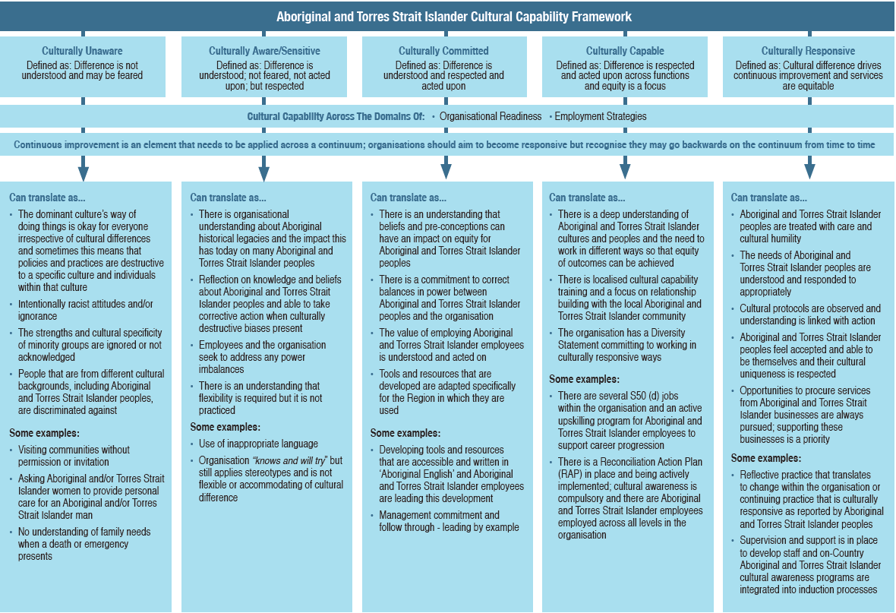

The hierarchical diagram above, titled **Aboriginal and Torres Strait Islander Cultural Capability Framework,** is described below.

The framework is divided into five categories:

* **Culturally Unaware.** Defined as: Difference is not understood and may be feared
* **Culturally Aware/Sensitive.** Defined as: Difference is understood; not feared, not acted upon; but respected
* **Culturally Committed.** Defined as: Difference is understood and respected and acted upon
* **Culturally Capable.** Defined as: Difference is respected and acted upon across functions and equity is a focus
* **Culturally Responsive.** Defined as: Cultural difference drives continuous improvement and services are equitable

Each of these categories flows to the following two elements:

* **Cultural Capability Across The Domains Of:** Organisational Readiness, Employment strategies
* **Continuous improvement is an element that needs to be applied across a continuum; organisations should aim to become responsive but recognise they may go backwards on the continuum from time to time**

Each of the five categories is then explained further:

**Culturally Unaware:**

Can translate as...

* The dominant culture’s way of doing things is okay for everyone irrespective of cultural differences and sometimes this means that policies and practices are destructive to a specific culture and individuals within that culture
* Intentionally racist attitudes and/or ignorance
* The strengths and cultural specificity of minority groups are ignored or not acknowledged
* People that are from different cultural backgrounds, including Aboriginal and Torres Strait Islander peoples, are discriminated against

Some examples:

* Visiting communities without permission or invitation
* Asking Aboriginal women to provide personal care for an Aboriginal and or Torres Strait Islander woman to provide personal care for an Aboriginal and or Torres Strait Islander man
* No understanding of family needs when a death or emergency presents

**Culturally Aware/Sensitive:**

Can translate as...

* There is organisational understanding about Aboriginal historical legacies and the impact this has today on many Aboriginal and Torres Strait Islander peoples
* Reflection on knowledge and beliefs about Aboriginal and Torres Strait Islander peoples and able to take corrective action when culturally destructive biases present
* Staff and the organisation seek to address any power imbalances
* There is an understanding that flexibility is required but it is not practiced

Some examples:

* Use of inappropriate language
* Organisation “knows and will try” but still applies stereotypes and is not flexible or accommodating of cultural difference

**Culturally Committed:**

Can translate as...

* There is an understanding that beliefs and pre-conceptions can have an impact on equity for Aboriginal and Torres Strait peoples
* There is a commitment to correct balances in power between Aboriginal and Torres Strait Islander peoples and the organisation
* The value of employing Aboriginal and Torres Strait Islander peoples is understood and acted on
* Tools and resources that are developed are adapted specifically for the Region in which they are used

Some examples:

* Developing tools and resources that are accessible and written in ‘Aboriginal English’ language and Aboriginal and Torres Strait Islander employees are leading this development
* Management commitment and follow through - leading by example

**Culturally Capable:**

Can translate as...

* There is a deep understanding of Aboriginal and Torres Strait Islander culture and peoples and the need to work in different ways so that equity of outcomes can be achieved
* There is localised cultural capability training and a focus on relationship building with the local Aboriginal and Torres Strait Islander community
* The organisation has a Diversity statement committing to working in culturally responsive ways

Some examples:

* There are several S50 (d) jobs within the organisation and an active upskilling program for Aboriginal and Torres Strait Islander employees to support career progression
* There is a Reconciliation Action Plan (RAP) in place and being actively implemented; cultural awareness is compulsory and there are Aboriginal and Torres Strait Islander employees employed across all levels in the organisation

**Culturally Responsive:**

Can translate as...

* Aboriginal and Torres Strait Islander peoples are treated with care with cultural humility
* The needs of Aboriginal and Torres Strait Islander peoples are understood and responded to appropriately
* Cultural protocols are observed and understanding is linked with action
* Aboriginal and Torres Strait Islander peoples feel accepted and able to be themselves and their cultural uniqueness is respected
* Opportunities to procure services from Aboriginal and Torres Strait Islander businesses are always pursued; supporting these businesses is a priority

Some examples:

* Reflective practice that translates to change within the organisation or continuing practice that is culturally responsive as reported by Aboriginal and Torres Strait Islander peoples
* Supervision and support is in place to develop employees and on-Country Aboriginal and Torres Strait Islander cultural awareness programs are integrated into induction processes

# Organisational Self-Assessment and Continuous Improvement Tool

## Objective

To create a Continuous Improvement Plan by undertaking an Organisational Self-Assessment that will assist organisations to identify their strengths, areas for improvement and actions required as related to Aboriginal and Torres Strait Islander employment.

This tool consists of 25 elements across two stages.

## **Embedding Aboriginal and Torres Strait Islander Cultural Capability into your organisation**

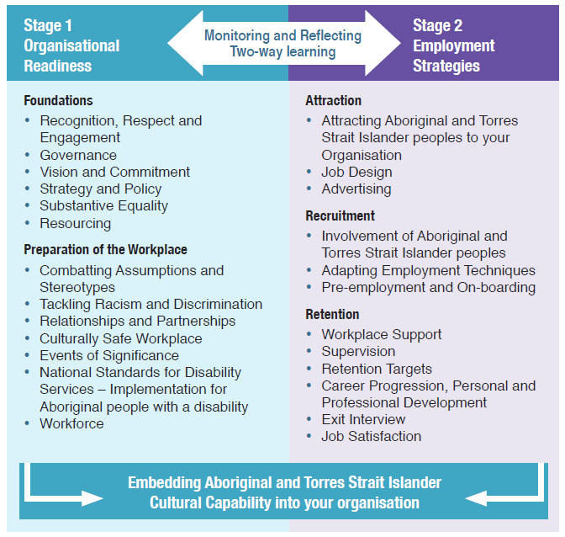

The diagram above details two stages of **embedding Aboriginal and Torres Strait Islander Cultural Capability into your organisation**:

* Stage 1: Organisational Readiness
* Stage 2: Employment Strategies

These stages are connected by a double-headed arrow labelled **Monitoring and Reflecting, Two-way learning**. There are bulleted lists under each of the stages as follows.

**Stage 1: Organisational Readiness:**

**Foundations**

* Recognition, Respect and Engagement
* Governance
* Vision and Commitment
* Strategy and Policy
* Substantive Equality
* Resourcing

**Preparation of the Workplace**

* Combatting Assumptions and Stereotypes
* Tackling Racism and Discrimination
* Relationships and Partnerships
* Culturally Safe Workplace
* Events of Significance
* National Standards for Disability Services – Implementation for Aboriginal people with a disability
* Workforce

**Stage 2: Employment Strategies:**

**Attraction**

* Attracting Aboriginal and Torres Strait Islander peoples to your Organisation
* Job Design
* Advertising

**Recruitment**

* Involvement of Aboriginal and Torres Strait Islander peoples
* Adapting Employment Techniques
* Pre-employment and On-boarding

**Retention**

* Workplace Support
* Supervision
* Retention Targets
* Career Progression, Personal and Professional Development
* Exit Interview
* Job Satisfaction

## Five criteria

An organisation can determine where they are in relation to five criteria, which appear below. Each criteria has a statement to define its meaning within the context of this self-assessment.

| **Criteria** | **Definition** |
| --- | --- |
| **Unaware:** Pre-contemplation or Not Thinking about it | Difference is not understood and may be feared |
| **Aware:** Contemplation or Thinking about it | Difference is understood; not feared; not acted upon; but respected |
| **Committed:** Preparation or Starting | Difference is understood, respected and acted upon |
| **Capable:** Action or Doing | Difference is respected and acted upon across functions and equity is a focus |
| **Responsive:** Maintenance or Doing & Reviewing | Cultural difference drives continuous improvement and services are equitable |

## Instructions:

Robust conversations with employees may occur when you are completing the assessment. This can secure employee buy-in, raise consciousness, and get people thinking in a deep way around the ways they work. This self-assessment will take two to three hours to complete. Some of the practices listed may not be applicable or relevant to your organisation and in this case, just note that they are not applicable.

This tool is intended to support continuous improvement but does not include every single organisational practice. It is also not intended to replace existing measures to monitor best practice, including any specific organisational accreditation processes.

## Key actions prior to the meeting:

1. Identify a facilitator for this process with experience and necessary knowledge. The facilitator will need to be familiar with the NDS Aboriginal and Torres Strait Islander Employment Guide and Toolkit.
2. Choose who will participate in this exercise including Aboriginal and Torres Strait Islander employees and non-Aboriginal and Torres Strait Islander employees, representing the different areas of your organisation such as human resources, service delivery teams, managers or team leaders, your executive team and Board members to bring a broader range of expertise, insight and perspective to the process. Check with Aboriginal and Torres Strait Islander employees to ensure they are comfortable undertaking this exercise before you start.
3. The facilitator of the meeting will provide copies of the document, alternative formats (if required), and any other relevant information. This will give everybody time to prepare and ask questions.

## At the meeting:

1. From the five criteria presented within each element, circle the description that best represents the level at which your organisation is currently operating. It does not have to match the example exactly. If in doubt, choose the previous criteria. It may be useful to use this tool in conjunction with the NDS Aboriginal and Torres Strait Islander Employment Guide and Toolkit.
2. Once you complete the assessment, analyse the results to identify specific organisational strengths along with areas for targeted improvement and actions across the elements.
3. Add any identified actions to your organisation’s Continuous Improvement Plan.
4. Consider linking in the identified actions with other organisational documentation such as an Operational/ Strategic Plan, Aboriginal and Torres Strait Islander Employment Strategy (AES) and Reconciliation Action Plan (RAP).

## Stage 1 – Organisational Readiness

### Stage 1: Foundations

#### Recognition, Respect and Engagement

| **Criteria Level** | **Description** |
| --- | --- |
| Unaware: Pre-contemplation or Not Thinking about it | We are not sure what this has to do with Aboriginal and Torres Strait Islander employment |
| Aware: Contemplation or Thinking about it | We think this might be important for us to think about in order to better support Aboriginal and Torres Strait Islander employment. |
| Committed: Preparation or Starting | We have started to think about what this might mean for Aboriginal and Torres Strait Islander peoples and why it might be important in terms of employment and supporting Aboriginal and Torres Strait Islander employees in the workplace. |
| Capable: Action or Doing | We understand that recognition and respect are critical and we have integrated them into our governance, policy and practice as we recognise how it links with improving Aboriginal and Torres Strait Islander employment and being an employer of choice for Aboriginal and Torres Strait Islander peoples. |
| Responsive: Maintenance or Doing & Reviewing | We actively demonstrate recognition and respect and work in partnership with Aboriginal and Torres Strait Islander peoples so that this is reflected in everything that we do. We regularly revisit how we remain responsive in this area and see the direct link it has with improving Aboriginal and Torres Strait Islander employment within our organisation. |

#### Governance

| **Criteria Level** | **Description** |
| --- | --- |
| Unaware: Pre-contemplation or Not Thinking about it | We are not sure why having an Aboriginal and Torres Strait Islander on the Board is a matter for us to consider or how governance can impact this area. |
| Aware: Contemplation or Thinking about it | We are aware that other similar organisations have Aboriginal and Torres Strait Islander representation on their Board and higher level feedback mechanisms and that there is some thinking that this approach at a governance level can improve Aboriginal and Torres Strait Islander employment outcomes. |
| Committed: Preparation or Starting | We have made a decision to pro-actively seek the right Aboriginal and Torres Strait Islander representation and embed feedback mechanisms for our Board as we now understand that this approach from a governance perspective needs to drive the organisation’s vision and strategy, which includes a proactive approach to Aboriginal and Torres Strait Islander employment. |
| Capable: Action or Doing | Our Board has Aboriginal and Torres Strait Islander representation and as a result of this has seen positive improvements in operational aspects, including employment as the leadership of the organisation is far more culturally aware and we are building on our responsiveness in this area. |
| Responsive: Maintenance or Doing & Reviewing | Our Board composition is diverse; cultural and corporate governance are integrated. We strive for continuous improvement in this area as we see the direct linkages it has with improvements in our Aboriginal and Torres Strait Islander workforce, and outcomes for Aboriginal and Torres Strait Islander peoples with disability. We know that we need to continually monitor our progress in this area as people come and go from the organisation across all levels. |

#### Vision and Commitment

| **Criteria Level** | **Description** |
| --- | --- |
| Unaware: Pre-contemplation or Not Thinking about it | We don’t have a vision or commitment in relation to Aboriginal and Torres Strait Islander employment. |
| Aware: Contemplation or Thinking about it | We think a vision in relation to Aboriginal and Torres Strait Islander employment might be useful. |
| Committed: Preparation or Starting | We are starting to develop our vision and commitment in relation to Aboriginal and Torres Strait Islander employment. |
| Capable: Action or Doing | We have a clear vision and commitment around Aboriginal and Torres Strait Islander employment. |
| Responsive: Maintenance or Doing & Reviewing | Our organisation has a strong vision and commitment around Aboriginal and Torres Strait Islander employment and is fully committed to increasing meaningful employment opportunities across levels for Aboriginal and Torres Strait Islander peoples. |

#### Strategy and Policy (Reconciliation Action Plan (RAP) and Aboriginal and Torres Strait Islander Employment Strategy (AES))

| **Criteria Level** | **Description** |
| --- | --- |
| Unaware: Pre-contemplation or Not Thinking about it | We don’t have any specific statements of diversity or specific policies or strategies addressing cultural capability, a RAP, etc. and this is not on our leadership team’s agenda. |
| Aware: Contemplation or Thinking about it | Our leadership team is looking into the development of specific policies and/or strategies to address cultural capability, including the exploration of a RAP. |
| Committed: Preparation or Starting | Our strategic intent reflects a commitment to working with the Aboriginal and Torres Strait Islander community and employing Aboriginal and Torres Strait Islander employees and we are reviewing our policies in this area, including the development of a RAP (may already have one in place as well). |
| Capable: Action or Doing | Our strategic intent reflects a commitment to working with the Aboriginal and Torres Strait Islander community and we are working on an AES, have a RAP in place and are actively seeking to embed our organisations vision in this area. |
| Responsive: Maintenance or Doing & Reviewing | Our strategic approach reflects a commitment to working with the Aboriginal and Torres Strait Islander community. We have an AES, clear targets, and a reporting framework and we are progressing through the RAP levels. We actively monitor our performance in this area to drive continuous improvement. |

#### Substantive Equality

| **Criteria Level** | **Description** |
| --- | --- |
| Unaware: Pre-contemplation or Not Thinking about it | We treat everyone the same and believe that equality is the same as equity when it comes to employment matters. |
| Aware: Contemplation or Thinking about it | We understand that things are not equal for everyone, however we’re not really sure what this means in practice and how it relates to Aboriginal and Torres Strait Islander employment. |
| Committed: Preparation or Starting | We are committed to looking into what equity is and what the concept of substantive equality is; we want to be able to meet the needs of Aboriginal and Torres Strait Islander peoples with disability and understand this may mean changing some of our employment practices. |
| Capable: Action or Doing | We understand substantive equality and we are updating policies and practices to build a more equitable organisation, accounting for difference as a strength and making sure we meet the needs of all Aboriginal and Torres Strait Islander employees by doing things differently in order to provide the same opportunities. |
| Responsive: Maintenance or Doing & Reviewing | We not only understand that in order to treat people equally you need to treat them differently, but we strive for our practices to reflect this. We continuously reflect on this in order to improve how we work and deliver services, keeping substantive equality ‘front of mind’ in all that we do. |

#### Resourcing (staffing and financial)

| **Criteria Level** | **Description** |
| --- | --- |
| Unaware: Pre-contemplation or Not Thinking about it | We don’t have resources allocated to Aboriginal and Torres Strait Islander employment. |
| Aware: Contemplation or Thinking about it | We are considering the need to allocate resources to improve our performance in relation to Aboriginal and Torres Strait Islander employment. |
| Committed: Preparation or Starting | We have integrated resources and approaches to improve our performance in relation to Aboriginal and Torres Strait Islander employment in line with our vision. |
| Capable: Action or Doing | We have a specific resource allocated to improve our performance in relation to Aboriginal and Torres Strait Islander employment. |
| Responsive: Maintenance or Doing & Reviewing | We have a position or function that focusses on Aboriginal and Torres Strait Islander employment in our organisation and it has improved our performance in this area. |

### Stage 1: Preparation of the Workplace

#### Combatting Assumptions and Stereotypes (Unconscious Bias)

| **Criteria Level** | **Description** |
| --- | --- |
| Unaware: Pre-contemplation or Not Thinking about it | We’re not sure why as an organisation we would need to know what our employees’ assumptions around Aboriginal and Torres Strait Islander peoples are; how does that impact the work that we do, including our Aboriginal and Torres Strait Islander workforce? |
| Aware: Contemplation or Thinking about it | We are beginning to understand that we might have a role as an organisation to address some of the assumptions and stereotypes that our employees have about Aboriginal and Torres Strait Islander peoples. |
| Committed: Preparation or Starting | We are aware that assumptions and stereotypes form an unconscious bias amongst some of our employees and that we need to address this as it relates to Aboriginal and Torres Strait Islander peoples as we understand it can have a negative impact on all aspects of our organisation including Aboriginal and Torres Strait Islander employment and service outcomes. |
| Capable: Action or Doing | As part of our mandatory cultural awareness training we address the area of unconscious bias so that we can address it and become a far more culturally aware organisation. We take our role in supporting employees to combat and address any negative biases toward Aboriginal and Torres Strait Islander peoples very seriously and do not tolerate it. We provide opportunities for our non-Aboriginal and Torres Strait Islander peoples and Aboriginal and Torres Strait Islander employees to learn from each other. |
| Responsive: Maintenance or Doing & Reviewing | We know that taking proactive steps to address negative unconscious bias amongst our workforce is critical if we are to be an employer of choice for Aboriginal and Torres Strait Islander peoples and provide good outcomes through our service delivery. We constantly revisit this area and understand diversity in the workplace cannot be achieved if we don’t address unconscious bias and the stereotypes that come with this and have the potential to negatively impact our organisation. |

#### Tackling Racism and Discrimination

| **Criteria Level** | **Description** |
| --- | --- |
| Unaware: Pre-contemplation or Not Thinking about it | What people think outside of work is not the business of our organisation. |
| Aware: Contemplation or Thinking about it | We understand that racist attitudes linked with unconscious bias can impact on our ability to employ Aboriginal and Torres Strait Islander peoples, deliver services and engage with the Aboriginal and Torres Strait Islander community. |
| Committed: Preparation or Starting | We are actively looking at strategies to address all forms of racism - from individually held beliefs and unconscious bias to systemic forms of racism and discrimination across our organisation. |
| Capable: Action or Doing | We acknowledge that many Aboriginal and Torres Strait Islander peoples are impacted by and through racism and discrimination. We address this across our organisation as we understand it impacts not only on Aboriginal and Torres Strait Islander employment, but the way we deliver services and the way we engage and interact with the community more broadly. |
| Responsive: Maintenance or Doing & Reviewing | We actively monitor our policies and practices for systemic racism and do not tolerate it in any form within the workplace. We embed substantive equality across all areas of our organisation, work to address unconscious bias and positively discriminate where we are able to (like S50d positions.) We conduct annual climate surveys to monitor our performance in this area. |

#### Relationships and Partnerships

| **Criteria Level** | **Description** |
| --- | --- |
| Unaware: Pre-contemplation or Not Thinking about it | We don’t engage with the Aboriginal and Torres Strait Islander community or have any advisory groups and are unaware of local language groups, Elders and significant Traditional Owners in the community as we don’t see what this has to do with Aboriginal and Torres Strait Islander employment. |
| Aware: Contemplation or Thinking about it | We are thinking about building our relationship with the Aboriginal and Torres Strait Islander community to improve our local network. This includes establishing an Aboriginal and Torres Strait Islander advisory group as we think this would be beneficial in supporting improved Aboriginal and Torres Strait Islander employment outcomes. |
| Committed: Preparation or Starting | We have a developing relationship with the Aboriginal and Torres Strait Islander community which may include local language groups, Elders and Traditional Owners, an Aboriginal and Torres Strait Islander advisory group. We may be working on an AES and/ or a RAP with the community as a key partner in this work. |
| Capable: Action or Doing | We have an established relationship with the Aboriginal and Torres Strait Islander community including local language groups, Elders and Traditional Owners, an AES and/or RAP in place with clear targets. Our Aboriginal and Torres Strait Islander advisory group is very active and influential, including positively driving and impacting Aboriginal and Torres Strait Islander employment outcomes. |
| Responsive: Maintenance or Doing & Reviewing | We have an established relationship with the Aboriginal and Torres Strait Islander community, progressing well with employment and culturally responsive work practices. Our relationship with the community is a key strength of our organisation and are now seeking to develop potential partnerships with Aboriginal Community Controlled Organisations (ACCOs). We track and report on our progress in this area to the Board and other stakeholders (internal and external). |

#### Culturally Safe Workplace (Cultural Protocols and Culturally Familiar Space)

| **Criteria Level** | **Description** |
| --- | --- |
| Unaware: Pre-contemplation or Not Thinking about it | What are cultural protocols and what is a culturally safe workplace? |
| Aware: Contemplation or Thinking about it | We know that different cultures have protocols and we think there may be things we can do to make our workplace ‘feel’ a bit more culturally accessible but we’re not sure what the next steps are. We will follow up and check this with our Aboriginal and Torres Strait Islander advisory group. |
| Committed: Preparation or Starting | We know that cultural protocols exist and we are talking to our Aboriginal and Torres Strait Islander employees and networks and looking into how we might reflect these in the workplace. We are going to look into what some of the things that we could do to make our workspace more culturally welcoming could be; maybe art, flags, etc? |
| Capable: Action or Doing | Cultural protocols are embedded in our policies and reflected through our practice. They are important to how we do our work with Aboriginal and Torres Strait Islander peoples with disability. Our employees and Aboriginal and Torres Strait Islander advisory network tell us our organisation is culturally safe. We have also identified resources to purchase some Aboriginal and Torres Strait Islander artwork from local artists, flags and mats to make our workplace more culturally welcoming. |
| Responsive: Maintenance or Doing & Reviewing | Cultural protocols are really important and we have them to guide us in how we work. We constantly reflect on them and ask our Aboriginal and Torres Strait Islander peoples with disability and employees for feedback to continuously improve our work in the Aboriginal and Torres Strait Islander community. We have purchased items to make our workspace more culturally welcoming and we have asked our Aboriginal and Torres Strait Islander employees and Aboriginal and Torres Strait Islander peoples with disability what else we can do to make the space more welcoming and comfortable. |

#### Events of Significance

| **Criteria Level** | **Description** |
| --- | --- |
| Unaware: Pre-contemplation or Not Thinking about it | We don’t know when events of significance are for Aboriginal and Torres Strait Islander peoples, or what they are. |
| Aware: Contemplation or Thinking about it | We are aware there are days of significance for Aboriginal and Torres Strait Islander peoples but are not sure when they are and we don’t always recognise them. |
| Committed: Preparation or Starting | We have days of significance for Aboriginal and Torres Strait Islander peoples on our calendar and sometimes recognise them. |
| Capable: Action or Doing | We always recognise days of significance for Aboriginal and Torres Strait Islander peoples and see them as a great opportunity to join with the community. |
| Responsive: Maintenance or Doing & Reviewing | We recognise events of significance for Aboriginal and Torres Strait Islander peoples in a meaningful way for all employees. Events are led by Aboriginal and Torres Strait Islander employees. |

#### Service Model/s incorporate the National Standards for Disability Services – Implementation for Aboriginal people with a disability

| **Criteria Level** | **Description** |
| --- | --- |
| Unaware: Pre-contemplation or Not Thinking about it | We have difficulty getting good outcomes for Aboriginal and Torres Strait Islander peoples with disability but don’t see what our service model/s approaches have to do with this. We are unaware of the Standards as they relate to Aboriginal and Torres Strait Islander peoples. |
| Aware: Contemplation or Thinking about it | We don’t get good outcomes for Aboriginal and Torres Strait Islander peoples with disability and wonder whether our ‘standard’ service model/s have something to do with this? We have come across the Standards and will look at them. |
| Committed: Preparation or Starting | We think we need to change the way we work with Aboriginal and Torres Strait Islander peoples with disability to get better outcomes, including reviewing our service model/s to be more culturally responsive. Maybe our Aboriginal and Torres Strait Islander advisory group could help us with this. The Standards are really helping us to reflect and consider how we work in this area. |
| Capable: Action or Doing | We have worked with our Aboriginal and Torres Strait Islander advisory group and employees to make our service model/s more culturally informed. This is helping us get better outcomes for Aboriginal and Torres Strait Islander peoples with disability and positively impacting our Aboriginal and Torres Strait Islander workforce. The Standards are helping us improve how we work with Aboriginal and Torres Strait Islander people with a disability. |
| Responsive: Maintenance or Doing & Reviewing | We deliver and regularly review our culturally informed service model/s, regularly assessing against the Standards to ensure our organisation continues to remain on track in this area. Outcomes for Aboriginal and Torres Strait Islander peoples with disability are continuing to improve and Aboriginal and Torres Strait Islander employees report they feel much better working in this way. Our retention of Aboriginal and Torres Strait Islander employees also continues to improve and we think it is a result of our organisation supporting culturally secure work practices. |

#### Workforce (Composition, Development, Monitoring and Reporting)

| **Criteria Level** | **Description** |
| --- | --- |
| Unaware: Pre-contemplation or Not Thinking about it | We don’t monitor Aboriginal and Torres Strait Islander employment, have a low, or non-existent Aboriginal and Torres Strait Islander workforce and don’t see the point in offering local cultural awareness training for employees. |
| Aware: Contemplation or Thinking about it | We have some Aboriginal and Torres Strait Islander employees and have started to look at our workforce composition, monitor our Aboriginal and Torres Strait Islander employment, and offer generic local cultural awareness for employees if they want to do it. |
| Committed: Preparation or Starting | We have demonstrated our commitment to Aboriginal and Torres Strait Islander employment, have a growing Aboriginal and Torres Strait Islander workforce, continue to monitor Aboriginal and Torres Strait Islander employment in this area and offer both generic and locally adapted cultural awareness training to all employees. |
| Capable: Action or Doing | We continue to grow our Aboriginal and Torres Strait Islander workforce, have monitoring systems in place and report regularly on Aboriginal and Torres Strait Islander employment. Generic and locally adapted local cultural awareness training is mandatory for all employees and we offer regular opportunities for cultural immersion as guided by our Aboriginal and Torres Strait Islander advisory group. |
| Responsive: Maintenance or Doing & Reviewing | We continue to grow our Aboriginal and Torres Strait Islander workforce across all levels of the organisation. We have monitoring systems in place so that we can report and monitor Aboriginal and Torres Strait Islander employment and retention. All employees have cultural competency training as a standard and it is regularly reviewed as part of their supervision plans All employees feel safe to ask for help when they are unsure of cultural protocols around any area that impacts their work. |

## Stage 2 – Employment Strategies

### Stage 2: Attraction

#### Attracting Aboriginal and Torres Strait Islander people to your organisation

| **Criteria Level** | **Description** |
| --- | --- |
| Unaware: Pre-contemplation or Not Thinking about it | There is no need to review advertisement methods to attract Aboriginal and Torres Strait Islander applicants. |
| Aware: Contemplation or Thinking about it | We may need to review the way we seek to attract Aboriginal and Torres Strait Islander applicants. |
| Committed: Preparation or Starting | We are identifying positions in the organisation where it would be advantageous to attract Aboriginal and Torres Strait Islander applicants. |
| Capable: Action or Doing | We use Section 50(d) of the Equal Employment Opportunity (EEO) Act or other internal processes to target Aboriginal and Torres Strait Islander applicants. |
| Responsive: Maintenance or Doing & Reviewing | We have decided to use Section 50(d) and Section 51 of the West Australian Equal Employment Opportunity (EEO) Act or other internal processes to target Aboriginal and Torres Strait Islander applicants. |

#### Job Design: (Use of S50(d) of the EEO Act, etc.)

| **Criteria Level** | **Description** |
| --- | --- |
| Unaware: Pre-contemplation or Not Thinking about it | We design all our jobs the same and don’t differentiate their content, or social/personal requirements why would we need to? |
| Aware: Contemplation or Thinking about it | We think there may be some merit in looking at the content, as well as the social and personal requirements of our jobs in order to make them more responsive to meeting the needs of Aboriginal and Torres Strait Islander peoples. |
| Committed: Preparation or Starting | We have started to look at the design of our jobs – their content, tasks required, duties and responsibilities, as well as specific characteristics that relate to Aboriginal and Torres Strait Islander employees for example using S50 (d) of the EEO Act, etc. |
| Capable: Action or Doing | We have reviewed and updated the design of our jobs so that their content, tasks required, duties and responsibilities, as well as specific characteristics that relate to Aboriginal and Torres Strait Islander peoples are reflected. |
| Responsive: Maintenance or Doing & Reviewing | We regularly review the design of our jobs and clearly differentiate their content, social and personal requirements to meet the needs of Aboriginal and Torres Strait Islander people. We now have some jobs that S50(d) where Aboriginality is a genuine job requirement as permitted under the EEO Act. |

#### Advertising

| **Criteria Level** | **Description** |
| --- | --- |
| Unaware: Pre-contemplation or Not Thinking about it | All our advertisement methods are the same. What’s wrong with that? |
| Aware: Contemplation or Thinking about it | We’ve noticed that it may be beneficial that some of our advertisements are written, accessed and published in different ways for different target groups; We have decided to look into this further. |
| Committed: Preparation or Starting | We think we should have some of our advertisements adapted to be more accessible for Aboriginal and Torres Strait Islander peoples we will start the process to have this done. |
| Capable: Action or Doing | We have worked with Aboriginal and Torres Strait Islander employees, community members and Aboriginal and Torres Strait Islander peoples to ask them what works for them in terms of our advertisement methods we have started to change some of our documents. |
| Responsive: Maintenance or Doing & Reviewing | In order to meet the needs of Aboriginal and Torres Strait Islander peoples, we regularly consult with Aboriginal and Torres Strait Islander peoples to ensure our advertisement methods are culturally appropriate. We always seek feedback to identify areas of improvement. |

### Stage 2: Recruitment

#### Involvement of Aboriginal and Torres Strait Islander peoples

| **Criteria Level** | **Description** |
| --- | --- |
| Unaware: Pre-contemplation or Not Thinking about it | None of our employment processes involve Aboriginal and Torres Strait Islander peoples or consider any cultural factors. |
| Aware: Contemplation or Thinking about it | It may be useful to involve Aboriginal and Torres Strait Islander peoples or consider cultural factors in our employment processes. |
| Committed: Preparation or Starting | We are reviewing our employment processes to incorporate Aboriginal and Torres Strait Islander representation in recruitment practices (such as interview processes). |
| Capable: Action or Doing | Our employment processes incorporate Aboriginal and Torres Strait Islander representation in recruitment practices. |
| Responsive: Maintenance or Doing & Reviewing | Our employment processes incorporate Aboriginal and Torres Strait Islander representation across all areas from job design through to recruitment practices. Any other advice is accepted. |

#### Advertisement of jobs

| **Criteria Level** | **Description** |
| --- | --- |
| Unaware: Pre-contemplation or Not Thinking about it | All jobs are advertised in the same way. |
| Aware: Contemplation or Thinking about it | Maybe we should advertise jobs to attract Aboriginal and Torres Strait Islander employees in a different way. |
| Committed: Preparation or Starting | We have started to look at using targeted employment measures like Section 50 (d) of the EEO Act, local radio etc. |
| Capable: Action or Doing | We have a mix of mainstream and Section 50 (d) positions and our recruitment practices have changed to attract more Aboriginal and Torres Strait Islander employees. |
| Responsive: Maintenance or Doing & Reviewing | We use both Section 50 (d) and Section 51. Our job descriptions are oriented at attracting Aboriginal and Torres Strait Islander employees and our recruitment practices are culturally informed. |

#### Adapting Employment Techniques

| **Criteria Level** | **Description** |
| --- | --- |
| Unaware: Pre-contemplation or Not Thinking about it | Our employment techniques are the same for all employees and we don’t see why they would need to be adapted. |
| Aware: Contemplation or Thinking about it | We understand that it might be beneficial to adapt our employment techniques to get the best outcomes for Aboriginal and Torres Strait Islander peoples. |
| Committed: Preparation or Starting | We are reviewing our employment techniques such as our interview and screening processes. |
| Capable: Action or Doing | In order to ensure that all applicants are screened in and not out, we have adapted our employment techniques to respond to the needs and circumstances of Aboriginal and Torres Strait Islander peoples. |
| Responsive: Maintenance or Doing & Reviewing | We have different employment techniques to suit the applicants and we regularly review our techniques to ensure they are culturally informed. |

#### Pre-employment and On Boarding

| **Criteria Level** | **Description** |
| --- | --- |
| Unaware: Pre-contemplation or Not Thinking about it | Our on-boarding process is the same for all employees. Candidates are not supported with administrative elements. |
| Aware: Contemplation or Thinking about it | We are aware that our pre-employment and on-boarding processes may need to change to meet the needs of Aboriginal and Torres Strait Islander employees. |
| Committed: Preparation or Starting | Our on-boarding process is being reviewed to meet the needs of Aboriginal and Torres Strait Islander employees. |
| Capable: Action or Doing | Our on-boarding process has been modified and now meets the needs of Aboriginal and Torres Strait Islander candidates and employees from their first contact with the organisation. |
| Responsive: Maintenance or Doing & Reviewing | We have well-embedded culturally responsive practices in relation to pre-employment and on-boarding processes and continuously strive for continuous improvement in this area. |

### Stage 2: Retention

#### Workplace Support (Mentoring, EAP, coaching, buddy system etc.)

| **Criteria Level** | **Description** |
| --- | --- |
| Unaware: Pre-contemplation or Not Thinking about it | We have not thought about the need to offer workplace support. |
| Aware: Contemplation or Thinking about it | We have considered offering workplace support but are still exploring what this could mean. |
| Committed: Preparation or Starting | We have recently introduced workplace support in some form and will continue to explore ways we can support our Aboriginal and Torres Strait Islander workforce. |
| Capable: Action or Doing | We have found by offering workplace support that our employees are feeling more supported and that it is having a positive impact on workplace culture and retention. |
| Responsive: Maintenance or Doing & Reviewing | Employees are fully engaged in workplace support that is offered. All support systems are well embedded in our policies and practices and we strive for continuous improvement. |

#### Supervision

*Refer to Guide for cultural competency assessments and tools available and recommended

| **Criteria Level** | **Description** |
| --- | --- |
| Unaware: Pre-contemplation or Not Thinking about it | We don’t see a need to have differentiated supervision practices for Aboriginal and Torres Strait Islander employees and non-Aboriginal and Torres Strait Islander employees. |
| Aware: Contemplation or Thinking about it | We think it might be beneficial to differentiate supervision practices for Aboriginal and Torres Strait Islander employees and non-Aboriginal and Torres Strait Islander employees. |
| Committed: Preparation or Starting | We are committed to ensuring our supervision policies and practices are culturally responsive and adapted to support Aboriginal and Torres Strait Islander employees we have committed to using recognised cultural competency assessment tools. |
| Capable: Action or Doing | We are able to provide culturally responsive supervision and support to Aboriginal and Torres Strait Islander employees using recognised cultural competency assessments, tools and training. |
| Responsive: Maintenance or Doing & Reviewing | All aspects of supervision are regularly reviewed in order to remain culturally responsive and supportive for Aboriginal and Torres Strait Islander employees. |

#### Retention Targets

| **Criteria Level** | **Description** |
| --- | --- |
| Unaware: Pre-contemplation or Not Thinking about it | We have not looked at specific retention strategies for different cultures in our workplace. |
| Aware: Contemplation or Thinking about it | We have started to discuss retention strategies to improve the retention rate of Aboriginal and Torres Strait Islander employees. |
| Committed: Preparation or Starting | We have developed some retention strategies and discussed targets for the retention of Aboriginal and Torres Strait Islander employees. |
| Capable: Action or Doing | Our retention strategies are improving the retention rate of Aboriginal and Torres Strait Islander employees. |
| Responsive: Maintenance or Doing & Reviewing | Our retention strategies for Aboriginal and Torres Strait Islander employees are working and we are meeting our retention targets. |

#### Career Progression, Personal and Professional Development and opportunities for growth

| **Criteria Level** | **Description** |
| --- | --- |
| Unaware: Pre-contemplation or Not Thinking about it | All employees are treated equally and we don’t give special preference to anyone. |
| Aware: Contemplation or Thinking about it | We are starting to think that it would be a good thing to offer targeted personal and professional development to Aboriginal and Torres Strait Islander employees. |
| Committed: Preparation or Starting | We can see that there is great benefit in offering targeted personal and professional development to our Aboriginal and Torres Strait Islander employees to support their career progression and aspirations. |
| Capable: Action or Doing | Our professional development policies and supervision systems support targeted personal and professional development and career progression for Aboriginal and Torres Strait Islander employees. |
| Responsive: Maintenance or Doing & Reviewing | Our proactive approach to personal and professional development for Aboriginal and Torres Strait Islander employees to support their career progression is achieving great outcomes in terms of representation across the workforce and employees earning promotions based on their improved performance. |

#### Exit Interview

| **Criteria Level** | **Description** |
| --- | --- |
| Unaware: Pre-contemplation or Not Thinking about it | We don’t conduct exit interviews unless an employee requests one. |
| Aware: Contemplation or Thinking about it | We think an exit interview might help us find out why Aboriginal and Torres Strait Islander employees are leaving. |
| Committed: Preparation or Starting | We have started to systematically seek to conduct an exit interview for Aboriginal and Torres Strait Islander and non-Aboriginal and Torres Strait Islander employees. |
| Capable: Action or Doing | We actively seek exit interviews with Aboriginal and Torres Strait Islander and non-Aboriginal and Torres Strait Islander employees. |
| Responsive: Maintenance or Doing & Reviewing | We use the information from exit interviews with Aboriginal and Torres Strait Islander employees to improve our employment processes. |

#### Job Satisfaction

| **Criteria Level** | **Description** |
| --- | --- |
| Unaware: Pre-contemplation or Not Thinking about it | We don’t see why job satisfaction should be looked at differently for Aboriginal and Torres Strait Islander and non-Aboriginal and Torres Strait Islander employees. |
| Aware: Contemplation or Thinking about it | We have started to recognise that job satisfaction may be different for Aboriginal and Torres Strait Islander peoples. |
| Committed: Preparation or Starting | We have taken a different approach to measuring job satisfaction for our Aboriginal and Torres Strait Islander employees. |
| Capable: Action or Doing | We are able to measure job satisfaction differently for Aboriginal and Torres Strait Islander employees. |
| Responsive: Maintenance or Doing & Reviewing | We have systems in place to effectively measure job satisfaction for Aboriginal and Torres Strait Islander employees. We actively seek feedback from our Aboriginal and Torres Strait Islander employees to ensure cultural needs are taken into consideration when looking at job satisfaction. Our Aboriginal and Torres Strait Islander employees feel valued, recognised and are able to contribute to the organisation in a meaningful way. |

## Continuous Improvement Plan - Stage 1 Organisational Readiness

### Element: Recognition, Respect and Engagement

**Timeline to progress from current criteria to next criteria**

Current status: (Write your answer)

Desired status: (Write your answer)

Timeline: (Write your answer)

**Evidence of Practice**: (Write your answer)

**Identified gap/area for improvement:** (Write your answer)

**Action(s) to address identified gaps:** (Write your answer)

**Responsibility:** (Write your answer)

### Element: Governance

**Timeline to progress from current criteria to next criteria**

Current status: (Write your answer)

Desired status: (Write your answer)

Timeline: (Write your answer)

**Evidence of Practice**: (Write your answer)

**Identified gap/area for improvement:** (Write your answer)

**Action(s) to address identified gaps:** (Write your answer)

**Responsibility:** (Write your answer)

### Element: Vision and Commitment

**Timeline to progress from current criteria to next criteria**

Current status: (Write your answer)

Desired status: (Write your answer)

Timeline: (Write your answer)

**Evidence of Practice**: (Write your answer)

**Identified gap/area for improvement:** (Write your answer)

**Action(s) to address identified gaps:** (Write your answer)

**Responsibility:** (Write your answer)

### Element: Strategy and Policy (RAP and AES)

**Timeline to progress from current criteria to next criteria**

Current status: (Write your answer)

Desired status: (Write your answer)

Timeline: (Write your answer)

**Evidence of Practice**: (Write your answer)

**Identified gap/area for improvement:** (Write your answer)

**Action(s) to address identified gaps:** (Write your answer)

**Responsibility:** (Write your answer)

### Element: Substantive Equality

**Timeline to progress from current criteria to next criteria**

Current status: (Write your answer)

Desired status: (Write your answer)

Timeline: (Write your answer)

**Evidence of Practice**: (Write your answer)

**Identified gap/area for improvement:** (Write your answer)

**Action(s) to address identified gaps:** (Write your answer)

**Responsibility:** (Write your answer)

### Element: Resourcing (staffing and financial)

**Timeline to progress from current criteria to next criteria**

Current status: (Write your answer)

Desired status: (Write your answer)

Timeline: (Write your answer)

**Evidence of Practice**: (Write your answer)

**Identified gap/area for improvement:** (Write your answer)

**Action(s) to address identified gaps:** (Write your answer)

**Responsibility:** (Write your answer)

### Element: Combat Assumptions and Stereotypes (Unconscious Bias)

**Timeline to progress from current criteria to next criteria**

Current status: (Write your answer)

Desired status: (Write your answer)

Timeline: (Write your answer)

**Evidence of Practice**: (Write your answer)

**Identified gap/area for improvement:** (Write your answer)

**Action(s) to address identified gaps:** (Write your answer)

**Responsibility:** (Write your answer)

### Element: Tackling Racism and Discrimination

**Timeline to progress from current criteria to next criteria**

Current status: (Write your answer)

Desired status: (Write your answer)

Timeline: (Write your answer)

**Evidence of Practice**: (Write your answer)

**Identified gap/area for improvement:** (Write your answer)

**Action(s) to address identified gaps:** (Write your answer)

**Responsibility:** (Write your answer)

### Element: Relationships and Partnerships

**Timeline to progress from current criteria to next criteria**

Current status: (Write your answer)

Desired status: (Write your answer)

Timeline: (Write your answer)

**Evidence of Practice**: (Write your answer)

**Identified gap/area for improvement:** (Write your answer)

**Action(s) to address identified gaps:** (Write your answer)

**Responsibility:** (Write your answer)

### Element: Culturally Safe Workplace (Cultural Protocols and Culturally Familiar Space)

**Timeline to progress from current criteria to next criteria**

Current status: (Write your answer)

Desired status: (Write your answer)

Timeline: (Write your answer)

**Evidence of Practice**: (Write your answer)

**Identified gap/area for improvement:** (Write your answer)

**Action(s) to address identified gaps:** (Write your answer)

**Responsibility:** (Write your answer)

### Element: Events of Significance

**Timeline to progress from current criteria to next criteria**

Current status: (Write your answer)

Desired status: (Write your answer)

Timeline: (Write your answer)

**Evidence of Practice**: (Write your answer)

**Identified gap/area for improvement:** (Write your answer)

**Action(s) to address identified gaps:** (Write your answer)

**Responsibility:** (Write your answer)

### Element: Services Model/s incorporate the National Standards for Disability Services – Implementation for Aboriginal people with a disability

**Timeline to progress from current criteria to next criteria**

Current status: (Write your answer)

Desired status: (Write your answer)

Timeline: (Write your answer)

**Evidence of Practice**: (Write your answer)

**Identified gap/area for improvement:** (Write your answer)

**Action(s) to address identified gaps:** (Write your answer)

**Responsibility:** (Write your answer)

### Element: Workforce (Composition, Development, Monitoring and Reporting)

**Timeline to progress from current criteria to next criteria**

Current status: (Write your answer)

Desired status: (Write your answer)

Timeline: (Write your answer)

**Evidence of Practice**: (Write your answer)

**Identified gap/area for improvement:** (Write your answer)

**Action(s) to address identified gaps:** (Write your answer)

**Responsibility:** (Write your answer)

## Continuous Improvement Plan - Stage 2 Organisational Employment Strategies

### Element: Attracting Aboriginal and Torres Strait Islander peoples to your organisation

**Timeline to progress from current criteria to next criteria**

Current status: (Write your answer)

Desired status: (Write your answer)

Timeline: (Write your answer)

**Evidence of Practice**: (Write your answer)

**Identified gap/area for improvement:** (Write your answer)

**Action(s) to address identified gaps:** (Write your answer)

**Responsibility:** (Write your answer)

### Element: Job Design (based on Aboriginal and Torres Strait Islander peoples with disability and candidate needs)

**Timeline to progress from current criteria to next criteria**

Current status: (Write your answer)

Desired status: (Write your answer)

Timeline: (Write your answer)

**Evidence of Practice**: (Write your answer)

**Identified gap/area for improvement:** (Write your answer)

**Action(s) to address identified gaps:** (Write your answer)

**Responsibility:** (Write your answer)

### Element: Advertising (Culturally Accessible Publication)

**Timeline to progress from current criteria to next criteria**

Current status: (Write your answer)

Desired status: (Write your answer)

Timeline: (Write your answer)

**Evidence of Practice**: (Write your answer)

**Identified gap/area for improvement:** (Write your answer)

**Action(s) to address identified gaps:** (Write your answer)

**Responsibility:** (Write your answer)

### Element: Involvement of Aboriginal and Torres Strait Islander peoples

**Timeline to progress from current criteria to next criteria**

Current status: (Write your answer)

Desired status: (Write your answer)

Timeline: (Write your answer)

**Evidence of Practice**: (Write your answer)

**Identified gap/area for improvement:** (Write your answer)

**Action(s) to address identified gaps:** (Write your answer)

**Responsibility:** (Write your answer)

### Element: Adapting employment techniques

**Timeline to progress from current criteria to next criteria**

Current status: (Write your answer)

Desired status: (Write your answer)

Timeline: (Write your answer)

**Evidence of Practice**: (Write your answer)

**Identified gap/area for improvement:** (Write your answer)

**Action(s) to address identified gaps:** (Write your answer)

**Responsibility:** (Write your answer)

### Element: Pre-employment techniques

**Timeline to progress from current criteria to next criteria**

Current status: (Write your answer)

Desired status: (Write your answer)

Timeline: (Write your answer)

**Evidence of Practice**: (Write your answer)

**Identified gap/area for improvement:** (Write your answer)

**Action(s) to address identified gaps:** (Write your answer)

**Responsibility:** (Write your answer)

### Element: Pre-employment and On-boarding

**Timeline to progress from current criteria to next criteria**

Current status: (Write your answer)

Desired status: (Write your answer)

Timeline: (Write your answer)

**Evidence of Practice**: (Write your answer)

**Identified gap/area for improvement:** (Write your answer)

**Action(s) to address identified gaps:** (Write your answer)

**Responsibility:** (Write your answer)

### Element: Workplace Support

**Timeline to progress from current criteria to next criteria**

Current status: (Write your answer)

Desired status: (Write your answer)

Timeline: (Write your answer)

**Evidence of Practice**: (Write your answer)

**Identified gap/area for improvement:** (Write your answer)

**Action(s) to address identified gaps:** (Write your answer)

**Responsibility:** (Write your answer)

### Element: Supervision

**Timeline to progress from current criteria to next criteria**

Current status: (Write your answer)

Desired status: (Write your answer)

Timeline: (Write your answer)

**Evidence of Practice**: (Write your answer)

**Identified gap/area for improvement:** (Write your answer)

**Action(s) to address identified gaps:** (Write your answer)

**Responsibility:** (Write your answer)

### Element: Retention Targets

**Timeline to progress from current criteria to next criteria**

Current status: (Write your answer)

Desired status: (Write your answer)

Timeline: (Write your answer)

**Evidence of Practice**: (Write your answer)

**Identified gap/area for improvement:** (Write your answer)

**Action(s) to address identified gaps:** (Write your answer)

**Responsibility:** (Write your answer)

### Element: Career Progression and Professional Development

**Timeline to progress from current criteria to next criteria**

Current status: (Write your answer)

Desired status: (Write your answer)

Timeline: (Write your answer)

**Evidence of Practice**: (Write your answer)

**Identified gap/area for improvement:** (Write your answer)

**Action(s) to address identified gaps:** (Write your answer)

**Responsibility:** (Write your answer)

### Element: Exit Interview

**Timeline to progress from current criteria to next criteria**

Current status: (Write your answer)

Desired status: (Write your answer)

Timeline: (Write your answer)

**Evidence of Practice**: (Write your answer)

**Identified gap/area for improvement:** (Write your answer)

**Action(s) to address identified gaps:** (Write your answer)

**Responsibility:** (Write your answer)

### Element: Job Satisfaction

**Timeline to progress from current criteria to next criteria**

Current status: (Write your answer)

Desired status: (Write your answer)

Timeline: (Write your answer)

**Evidence of Practice**: (Write your answer)

**Identified gap/area for improvement:** (Write your answer)

**Action(s) to address identified gaps:** (Write your answer)

**Responsibility:** (Write your answer)

# Aboriginal and Torres Strait Islander Employment Strategy (AES) Template

**Drivers for change**

* Protect and promote human rights
* Substantive equality
* Increase participation in NDIS
* Reconciliation
* Close The Gap outcomes
* Compliance with National Standards for Disability Services

**Objectives**

Name the specific objectives of the AES and what employment and percentage goals the organisation has.

**Strategic Framework**

Do Aboriginal employment goals sit alongside other organisational imperatives like gender balance, age balance, diversity targets, etc?

How does the AES intersect with the Strategic, Operational and Business Plans?

**Stakeholder input**

RAP Committee, community members, employee through surveys, etc.

**Reporting**

Regular reporting is critical in this area in order to track progress and measure outcomes against goals set. Reporting should be embedded into Board reports and strategies reviewed regularly to see if they remain effective.

**Putting the AES into action**

Use the sample AES as a template to develop an AES. It can be modified to suit organisational need. Keep the template simple to make it more accessible to all employees.

## Attraction and Recruitment

List here the activities you will undertake - graduate programs, traineeships, Identified (S50D) positions, etc.

**Activities/initiatives:(**Write your answer)

**Responsibility:** (Write your answer)

**By when:** (Write your answer)

**Outcomes:** (Write your answer)

## Retention

List here the activities you will undertake - Cultural leave, training and development, peer support, mentoring, etc.

**Activities/initiatives:(**Write your answer)

**Responsibility:** (Write your answer)

**By when:** (Write your answer)

**Outcomes:** (Write your answer)

## Career Development

List here the activities you will undertake - training and development, mentoring, leadership coaching, higher duty opportunities, etc.

**Activities/initiatives:(**Write your answer)

**Responsibility:** (Write your answer)

**By when:** (Write your answer)

**Outcomes:** (Write your answer)

## Workplace leadership and culture

List here the activities you will undertake - RAP, Acknowledgement of Country at meetings and on email signatures, cultural awareness training, etc.

**Activities/initiatives:**

Leadership team to do full day cultural awareness training

All staff to complete base level cultural and diversity awareness programs

(Write your answer)

**Responsibility:** (Write your answer)

**By when:** (Write your answer)

**Outcomes:** (Write your answer)

## Community partnerships

List here the activities you will undertake - RAP, partnering opportunities and subcontracting, purchasing through Supply Nation certified businesses, etc.

**Activities/initiatives:(**Write your answer)

**Responsibility:** (Write your answer)

**By when:** (Write your answer)

**Outcomes:** (Write your answer)

# Aboriginal and Torres Strait Islander Peoples Employment Strategy (AES) Checklist

## Stage: Planning

**Suggested actions**

* The guiding framework is documented
* The AES is linked to corporate documents (workforce plan, equity targets, RAP, etc.)
* Are employment data or surveys available as a starting point?
* Organisation understands current workplace experience for Aboriginal and Torres Strait Islander employees?
* Organisation knows the factors that impact on Aboriginal and Torres Strait Islander employment?
* Organisation has a rationale for the AES – what you want to do, why, and what your targets are
* Organisation has considered other tools and initiatives to support the AES (RAP, etc.)
* Progress of strategies is monitored (could be a standing item of RAP committee)

## Stage: Development

**Suggested actions**

* Organisation Champions are identified and their role supported
* Existing Aboriginal and Torres Strait Islander employees are engaged to provide input and assist with strategies
* Leadership team is engaged – using the snapshot report and key messages from the organisation Champions
* Managers and supervisors are engaged – using the snapshot report and key messages from the organisation Champions and leadership team
* There is an organisation working group (consider the RAP group if it includes Aboriginal employees, leadership team, managers, Champions, etc.)
* AES is drafted and includes:
  + Rationale
  + Challenges
  + Goals
  + Strategies (attraction, recruitment, career pathways, etc.)
  + Engage employees (staff meetings, all of office emails, etc.) to communicate key messages and commitments
  + Develop reporting framework with identified performance measures and timelines

## Stage: Implementation

* Progress of strategies is monitored (could be a standing item of RAP committee)
* Outcomes of strategies are analysed
* Results are communicated to key stakeholders, celebrating achievements and highlighting areas for improvement
* AES is reviewed and amended on an annual basis

# Aboriginal and Torres Strait Islander Employment Report

**Purpose:** This report template is designed to assist organisations to track their progress in Aboriginal and Torres Strait Islander employment and identify any areas that need improvement.

**Target:** Assess how the organisation is performing against targets in the areas of:

* Recruitment (engagement)
  + Retention (based on attrition)
  + voluntary separation
  + involuntary
* As a percentage of the total workforce
* Location (if you have more than one location) *Table can be amended to show data by location and then totalled for organisation profile.

**Representation over time:** Track this data over time to identify any patterns or trends and see where more effort may be required; i.e. if retention is good then recruitment may need to be an area of focus, etc.

Fill out the table below with your organisation’s figures as of 1st January each year.

| **Organisaton Name**  **(1 January 20XX)** | **2019** | **2020** | **2021** | **2022** |
| --- | --- | --- | --- | --- |
| Total employees |  |  |  |  |
| Aboriginal and Torres Strait Islander employees |  |  |  |  |
| Aboriginal and Torres Strait Islander recruitment (engagement) |  |  |  |  |
| Retention |  |  |  |  |
| Voluntary separation |  |  |  |  |
| Involuntary separation |  |  |  |  |
| Aboriginal and Torres Strait Islander attrition (employees leaving) |  |  |  |  |
| Aboriginal and Torres Strait Islander employment profile % |  |  |  |  |
| Target % |  |  |  |  |

**Performance:** Having a visual representation of performance can assist to tell you at a glance if you need to pay more attention to your performance in this area

For example:

On track (shade in **green**)

Below target (shade in **orange**)

Under performing (shade in **red**)

# Policy Template

This Policy Template can be used and adapted as required. The section ‘Cultural Basis and Context’ and/or ‘Diversity Statement’ captures organisational commitment and provides clarity to staff and stakeholders about the importance of working with Aboriginal and Torres Strait Islander peoples, and more broadly, cultural inclusivity.

**Policy #:** (write the Policy Number)

**Policy Template (name here):** (write the Policy Name)

**Applies to:** (indicate who the policy applies to)

**Version:** (indicate which version of the policy it is, e.g.Version 1)

**Specific responsibility:** (indicate who is responsible for the policy)

**Area:** (indicate which area the policy falls under)

**Date approved:** (indicate when the policy was approved)

**Next review date:** (indicate when the policy is to be reviewed)

**Policy context:** (write your answer)

**Standards or other external requirements:** (write your answer)

**Legislation or other requirements:** (write your answer)

**Contractual obligations:** (write your answer)

**Policy Statement**

Indicate the specific guideline, regulation, requirement or modification to people’s behaviour or the organisation’s operations that the policy is trying to create.

**Application and Scope**

Describe who the policy affects and which actions or things the policy will affect. The applicability and scope may expressly include or exclude certain people, organisations, behaviours or activities from the policy requirements.

**Cultural Basis and Context**

Set out the cultural values, norms, behaviours or goals and principles the policy recognises and is supporting, protecting, regulating or limiting, and explain why.

**or**

**Diversity Statement**

Explains the organisations commitment to diversity and would include values related to diversity, experiences working with diverse populations, future plans related to inclusivity and how the organisation ensures substantive equality is built into everything it does.

**Purpose Statement**

Indicate the motivating reasons and history that led to the creation of the policy and its desired effect.

**Implementation Roles and Responsibilities**

Indicate which people or sections of the organisation are responsible for carrying out particular work/roles to implement the policy.

**Professional Development Statement (Optional)**

Detail if additional capacity or professional development is required to put policy into practice.

**Definitions (Optional)**

Provide clear meanings for terms and concepts found in the policy document.

**Related Documents:**

Document Name:

Document Number:

**Review and approval:**

Frequency:

Risk:

Specific Responsibility:

Approval:

**Review and version tracking:**

Version:

Date Approved:

Approved by:

Review Due Date:

# Diversity Statements

An effective diversity statement provides an organisation with the opportunity to communicate their commitment to diversity with the broader community within which they operate. Diversity statements enable organisations to share their experiences, their genuine commitments and the actions they choose to take in order to build a more inclusive workplaces, and communities.

To write an effective diversity statement organisations should try to limit the statement to one page or less and cover the following areas:

* **Tell your story** – what is your employee mix, your workplace location, partnerships you have with diversity groups like Aboriginal and Torres Strait Islander peoples, whether you have a RAP, AES, etc.
* **Focus on accepted understandings and perceptions** – talk about the issues that are impacting the community from a diversity perspective; talk about unconscious bias, talk about racial oppression and negative stereotyping and the impact this has on Aboriginal and Torres Strait Islander peoples and other minority groups within and across the community.
* **Discuss white privilege** – focus on writing about what you know as an organisation; talk honestly about your experiences with racism, your position of white privilege, etc. Be transparent.
* **Write about things you have done and you are committed to** – talk about the things you are already doing to improve outcomes for minority groups; the programs you have developed or the strategies you have implemented like an AES, or a RAP, etc.
* **Let people know what you expect of your employees** – include in all job applications, or applications from managers and supervisors, a requirement for prospective employees to outline their own diversity statement and/or commitment to diversity. Include it in your job adverts

# Events of Significance for Aboriginal and Torres Strait Islander peoples

| **Date** | **Title** | **Meaning** |
| --- | --- | --- |
| January 26 | Australia Day (Survival/Invasion Day) | Australia Day for many Australians is a day that celebrates the disembarking of the First Fleet at Sydney Cove and the subsequent settlement that would be the colony of NSW and eventually Australia. For many Aboriginal and Torres Strait Islander Australians, this day represents the start of a history of invasion, dispossession, removals, cultural destruction and loss of sovereign rights. For the above reason and more, many Aboriginal and Torres Strait islander people refer to Australia Day as Invasion Day. |
| February 13 | Anniversary of the National Apology | On this day in 2008, then Prime Minister, the Hon Kevin Rudd MP, moved a motion of apology to Aboriginal Australians with specific reference to the Stolen Generations. The Apology passed with bipartisan support from the Parliament and received a standing ovation from the House of Representatives as well as the public gallery. The anniversary of this significant event is remembered each year with a range of activities across the country and communities. |
| March 21 | Harmony Day | Harmony Day is an Australian Government initiative that started in 1999 and is aimed at creating and promoting harmony, embracing cultural diversity and addressing racism. Harmony Day focuses on building relationships between people and is primarily a community based education program intended to increase our understanding and appreciation for the community we live in. Harmony Day is held on 21 March which is also the United Nations International day for the Elimination of Racial Discrimination. |
| May 26 | National Day of Healing (National Sorry Day) | National Sorry Day was established by the National Sorry Day Committee on 26 May 1998, a year after the “Bringing them Home Report” was tabled in Federal Parliament. The report was produced by the National Inquiry into the Separation of Aboriginal and Torres Strait Islander children from their families. There were 54 recommendations made in the report on a range of issues including establishing a community based National Sorry Day Committee. The primary aim of Sorry Day is to acknowledge the hurt and distress felt by many Aboriginal and Torres Strait Islander people, as a result of Government removal policies and practices. |
| May 26 - June 3 | National Reconciliation Week | National Reconciliation Week is held each year between 26 May and 3 June and was established in 1996. The main aim of Reconciliation Week is to acknowledge and celebrate the rich history and culture of Aboriginal and Torres Strait Islander Australians to discuss reconciliation and to consider ways to address disadvantage faced by Aboriginal and Torres Strait Islander people. |
| June 3 | Mabo Day  (Named Mabo Judgement because it was Eddie’s name that appeared first on the legal documents). | Mabo Day is the day that marks the anniversary of the historic Native Title case on 3 June 1992 when the High Court recognised Native Title existed for the Meriam Mir People of Murray Island in the Torres Strait. The case was brought to court by Eddie Mabo. This judgement was significant for Aboriginal and Torres Strait Islander peoples as the judgement legally dismissed the idea of “Terra Nullius.” The case also recognised that Aboriginal and Torres Strait Islander people have rights to claiming Crown lands and potentially pastoral leases as Traditional Owners.  There was also recognition that Aboriginal and Torres Strait Islander people have traditional laws and customs that assert rights over lands and waters which have continued after colonisation and can be recognised by the common law. |
| First full week in July | NAIDOC Week  National Aboriginal and Islanders Day Observance Committee | NAIDOC stands for the National Aborigines and Islanders Day Observance Committee. It started as a single day of celebration but is now celebrated over a week. NAIDOC Week is held in early July (usually the first full week) each year and celebrates Aboriginal and Torres Strait Islander people’s culture, history and achievements.  The week provides opportunities for all Australians to participate in celebrating Aboriginal communities along with promoting a better understanding of Aboriginal Torres Strait Islander peoples.  Throughout Australia local community celebrations are organised by community groups or organisations, government agencies, local councils, school and workplaces. It is also worthy to note that some communities choose to celebrate NAIDOC week in September. |
| 4 August | National Aboriginal and Islander Children’s Day | NAICD was established in 1988 by the Secretariat of National Aboriginal and Islander Child Care (SNAICC). Each year there is a theme to highlight a significant issue, concern or hope for Aboriginal and Torres Strait Islander Children. |
| 9 August | International Day of the World’s Indigenous People | The International Day of the World’s Indigenous People was first proclaimed by the United Nations General Assembly in December 1994, to be celebrated every year during the international Decade of the World’s Indigenous People (1995 – 2004). |
| September (no set date) | Deadly Awards | Vibe Australia has been hosting the Deadly Awards since 1995. The awards include Aboriginal and Torres Strait Islander music, sport, entertainment and community awards. They promote Aboriginal and Torres Strait Islander achievement as a marketable and growing force within Australia. |





[NDS website: www.nds.org.au](https://www.nds.org.au/)