The Empowerment Circle
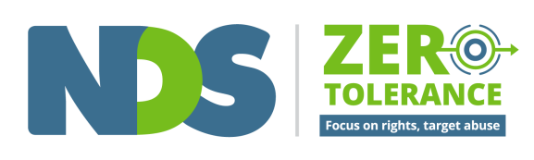

Description
The Empowerment Circle is a circle diagram, with a person at the centre in a dark green circle.
The circle is colour shaded divided into three zones (represented in rings from the green centre shading into orange and finally red on the outside of circle):
These colours represent:
- Green for good or positive practice (centre)
- Orange for poor or neglectful practice (middle)
- Red for abusive or criminal practice (outer)
The circle is also divided into eight sections, like slices of a pizza. Each section represents one area of people’s lives: Physical; Emotional; Social; Identity; Material; Economic; Education; and Relationships.
Four white arrows, labelled ‘Freedom’, ‘Respect’, ‘Equality’ and ‘Dignity’ are placed on the outer edge of the four quarters of the circle pointing towards the centre of the circle, representing the idea that the closer we are to the middle, the more we are using and enjoying our human rights.

What is the Empowerment Circle?
The Empowerment Circle is a tool to help you think about how people can be more empowered in all areas of their life. We know that abuse, neglect and poor practice can happen in every area of a person's life. The Empowerment Circle will help you think about ways to support people to be more empowered in each of these areas through good practice.

About the Empowerment Circle
The Empowerment Circle asks us to think about a person's whole life by focusing on eight life areas. This tool builds on work done by Robert Schalock (2004) on Quality of Life domains and introduces a number of new life areas.
When we think about abuse, neglect and violence towards people with disability, we must not only consider criminal and reportable incidents, but also all of the everyday experiences of poor practice, neglect and misuse of power that people experience.
The Empowerment Circle is a visual representation of this.
The red outer edge of the circle represents abusive and criminal practice. The orange shading represents layers of poor practice and disempowerment. The green area represents good practice, with the person in the middle representing empowerment and control overall areas of their own life.
The arrows of freedom, respect, equality and dignity are human rights markers that remind us to keep working to achieve these rights.

You can use the Empowerment Circle:
- To work with a person to identify things to do to support them to be more empowered
- To understand what we mean when we talk about abuse, neglect and violence in the context of a person's whole life
- To reflect on your own life
- In team meetings
- In training
- In reflective practice
- To reduce the use of restrictive practices
- One slice at a time

References and links
Understanding Abuse eLearning Program, films, worksheets and guide for supervisors: https://www.nds.org.au/zero-tolerance- framework/understanding-abuse
Schalock, R. (2004). The concept of quality of life: what we know and do not know. Journal of Intellectual Disability Research. 48:3, 203-216.
The Empowerment Circle was developed by James Bannister and Liz Collier for the NDS Zero Tolerance Initiative.
© NDS 2016
End of document.

