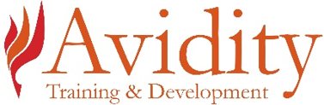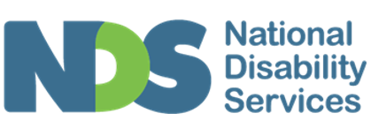

NDS Disability Support - Pre-employment Program Expression of Interest Form

Details of program

Dates
- 28 and 29 May 2024
- 4 and 5 June 2024
- 11 and 12 June 2024
- 18 and 19 June 2024
- 25 and 26 June 2024
- 2 and 3 July 2024

Times - all sessions
10:00 am to 2:30pm AEST

Venue
St Helens
Please email this completed form to admin@avidity.com.au

Personal details
Question | Answer
Given Name
Surname
Contact Number
Over 18 years (answer yes or no)
Contact Email

Your suitability
The following details are required to assess your suitability for Disability Support work. If you cannot provide the documentation listed in this form, you may not be eligible for this program.
Question | Answer
- Are you fully vaccinated for COVID-19, including booster/s (three vaccinations)? (answer yes or no)
Please provide a copy of your vaccination certificate.
- Do you have a current Working with Vulnerable People Card? (answer yes or no)
Please provide a copy.
- Do you have a current Police Check (within 3 months)? (answer yes or no)
Please provide a copy.
If no, you may be required to complete this to do work placement.
- Do you have a current driver’s licence? (answer yes or no)
Please provide a copy.
- Do you have access to a reliable vehicle? (answer yes or no)
- Do you have the physical capacity perform manual handling tasks? (answer yes or no)
- Availability for work experience days/times:
- How did you find out about the program?
- Referral person contact details (if applicable):

Applicant Signature
Applicant Signature | Date
Please email this completed form to admin@avidity.com.au
This document remains the property of the Avidity Group Pty Ltd ©

