Slide 1

Practice Leadership Workshops for Behaviour Support Practitioners

Reflective Practice – Workshop 2
Facilitator: Dave Relf
National Practice Lead – Zero Tolerance Initiative

Slide 2
A note before we start
Today we’ll be reflecting on our work and our practice. If something comes up through this process:
- It’s OK to have a break if you need to
- Think about who you can talk to if you need extra support
- Lifeline: 13 11 14
- Beyond Blue: 1300 224 636
- Employee Assistance Program

Slide 3

Future Workshops

Practice Leadership Workshops for Behaviour Support Practitioners
- Implementing positive behaviour support
- Reflective Practice
- Collecting meaningful data and measuring outcomes
- Supporting the person (and their support network) to be involved in the development of their own plan.

Slide 4

Outcomes of today’s discussions
- To understand what reflective practice is
- What does the evidence say about the benefits of Reflective Practice?
- To share and discuss why reflective practice is important for Positive Behaviour Support
- Explore types and models of reflective practice
- Discuss ways to engage staff teams in reflective practice
- Mindfulness
- Facilitating reflective practice
- To reflect on how we’re currently reflecting
- Provision of tools, resources and further reading

Slide 5

Defining Reflective Practice
“A generic term for those intellectual and affective activities in which individuals engage to explore their experiences in order to lead to a new understanding and appreciation.”
Boud, 1985 in Mann, et al. 2009

Slide 6

What is Reflective Practice?
- Evaluating your first-hand experience of an event, process or activity, then;
- Analysing the reasons for the things that have gone well and less well, then;
- Learning from the experience to improve or refine your performance if a similar situation arises again.

Slide 7

A moment for reflection
- Please open your envelopes and take 3 minutes to reflect on the questions on the card in silence.
- After three minutes, you be asked to share your thoughts with the person next to you.
- Please listen actively while your partner is sharing and then share your responses.

Slide 8
- Think about a particular experience that you have had in your career that was both rewarding and challenging.
- What happened?
- How were you feeling at the time?
- What did you learn from that experience?

Slide 9

Benefits of Reflective Practice
- Challenging and questioning our values, beliefs, cultural understandings and behaviours and how these influence our work practice
- Scrutinising our assumptions and stereotypes
- Building your knowledge and experience (and sharing it with others)
- Promoting your learning by developing your understanding of how you can better respond to certain situations; and
- Learning from successes and mistakes.

Slide 10

Issues with reflective practice?
- Does anyone have any concerns with reflective practice?
- Overly structured (recipe following)
- Can be too focussed on intellectualising situations
- Memory is fallible
- Reluctance to talk about thoughts and feelings.

Slide 11

The Evidence for Reflective Practice
Supported by evidence | Not yet supported by evidence
Reflection leads to deeper understanding | Reflection leads to self understanding
Reflection is most effective when shared | Reflection results in better outcomes for the people we support.
Ability to reflect can develop over time | Blank
Mann, et al. 2009

Slide 12

Reflective Practice for PBS outcomes
How have you used reflective practice when working with a team or individuals who are implementing Positive Behaviour Support?
- Reduction/elimination of restrictive practices
- Team building
- What’s working/what’s not working?
- Strategy development
- With practice leaders
- Role modelling reflection with the people we support.

Slide 13
Types of Reflective Practice
- Reflection in Action: When you reflect while you are doing a particular action
- Reflection on Action: All of the reflective practice that occurs after an event. (Shohn, 1990)
- The anticipation of challenging situations also stimulates reflection. (Mann et al., 2009)

Slide 14

The Reflective Practice cycle
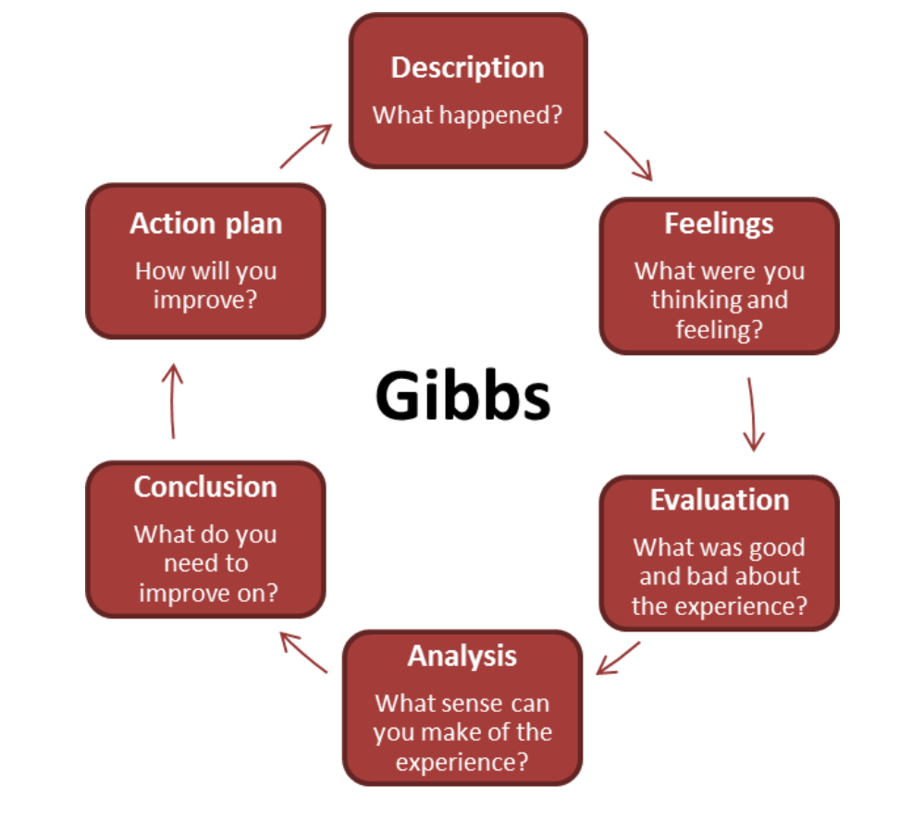

Slide 15

Gibbs Model of Reflection

Step 1) Description
- Describe what happened (be factual)
- Don’t draw any conclusions
- Set the scene and provide some context

Step 2) Feelings
- Describe what you were thinking and feeling?
- Don’t evaluate those feelings, simply state what they were.

Step 3) Evaluation
- What was good and bad about the experience?
- Determine what went well and what didn’t go so well

Slide 16

Gibbs Model of Reflection

Step 4) Analysis
- What do you think might have helped or hindered the situation?
- Explore options, what tools might have been helpful?

Step 5) Conclusion
- It’s now time to draw some conclusions
- What else could you have done?

Step 6) Action Plan
- Create a plan based on your conclusions
- Commit and take action on your plan

Slide 17

Critical Incident Debriefing
- Critical Incident debriefing which supports the emotional wellbeing of staff should be conducted separately to Reflective Practice.
- Strategies designed to provide emotional support for staff should be separated from the responsibility to provide organisational learning from the incident (Baker, 2017).
- Adequate debriefing needs to be of sufficient duration and not too soon after the event, and carried out by trained experienced debriefers (Hawker et al, 2011).

Slide 18

How to engage teams in reflective practice?
- What are some of the barriers?
- Can reflective practice be taught/learned?
- Short
- Shared
- Structured
- Build trust and rapport
- Think, pair, share.

Slide 19

HALTS

Personal Reflection
The way you feel when you come into work has an impact on the way you provide support. Which of the following affects you most often?
What strategies can you put in place?
- Hungry
- Angry
- Late
- Tired
- Sensitive

Slide 20

Mindfulness
- Paying attention
- In the present moment
- On purpose
- Without judgement

Evidence to support mindfulness
Singh et al. (2009) found evidence that training in mindfulness was beneficial to both staff and the individuals with intellectual disabilities they supported in reducing the use of physical restraints and PRN (as required) medication for behaviours of concern.
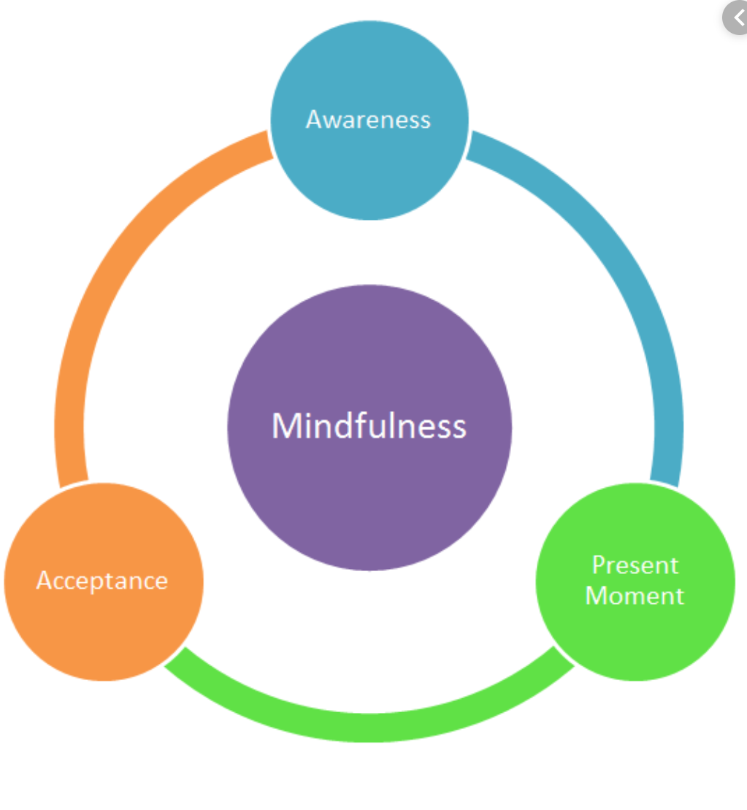

Slide 21

Facilitating reflective practice
A facilitator should be: "a neutral mediator whose job is to provide information and accommodate the exchange of dialogue among participants”
- Understand the difference between leading and facilitating
  - Leadership is something you do to a group, while facilitation is something you do with a group.
- As with any skill, the ability to facilitate effectively will develop through experience, feedback, observation, and reflection.

Slide 22

Facilitation tips
- Create a safe space
- Managing dual roles
- The facilitator is not the expert
- Everyone can learn
- Be somewhat informal
- Be empathetic
- Maintain a sense of humour
- Stay interested in group discussion
- Be real, direct, and genuine
Decorative image omitted.

lide 23

Communication
Do’s | Don’ts
Use open-ended questions | Refute people’s ideas
Ask for specifics and examples | Put people on the spot
Paraphrase and summarise | Downplay thoughts, feelings
Acknowledge contributions | Force people to speak
Redirect questions to groups | Blank
Be creative | Blank
Take some risks by posing provocative questions | Blank

Slide 24

4 + 1 Questions
- How can we encourage more reflective practice to occur within teams within the sector?
- How can we, as practitioners, build more reflective practice into our own work life?

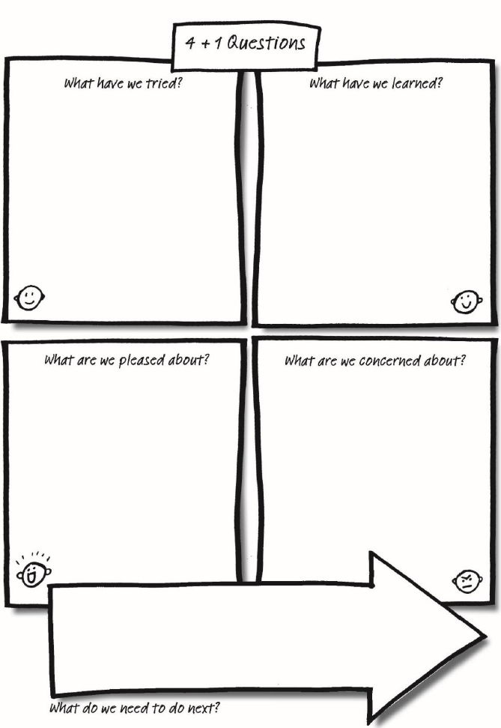

Slide 25

Helpful resources
- Person Centred Practice Across Cultures Reflective Practice Workbook
- Gibbs reflective practice model
- 4 + 1 Questions (Helen Sanderson)
- The Reflective Supervision Toolkit Daphne Hewson and Michael Carroll
- Facilitating Reflection – A manual (Reed & Koliba,1995)
- What tools are others using to support reflective practice and supervision?

Slide 26

The PBS Capability Framework

Knowledge: CPD and Supervision

Core Behaviour Support Practitioner
- Understand the importance of self-directed lifelong learning, including a commitment to ongoing professional development
- Understand the importance of behaviour skills training
- Understand the importance of incorporating learning from supervision into practice

Skills: CPD and Supervision

Core Behaviour Support Practitioner
- Set professional development goals
- Conduct an annual professional development plan that is regularly reviewed and updated (which includes goals related to skills and knowledge within this framework)
- Participate in supervision to identify personal and professional goals and take steps to achieve them
- Prioritise, prepare for and engage actively in supervision
- Openly express and discuss needs and expectations related to supervision
- Openly identify and discuss practice issues which are challenging and skills and knowledge that need developing
- Work to develop trust within the supervision relationship
- Take responsibility for seeking help when required
- Regularly review the supervision process and provide honest feedback

Service provider and implementing provider considerations across all practitioner levels
- Encourage a culture of continuous improvement of the workforce, including supervision and professional development planning
- Create policies and procedures which establish aims, structures and processes for supervision
- Provide access to (internal or external) staff who can provide high quality behaviour support supervision
- Allow staff time to engage in supervision
- Clearly articulate the modalities of supervision available to staff (including any compulsory components)
- Provide clear information about professional development for staff, including compulsory training, time allowances to attend professional development and any budgetary considerations

Slide 27

The PBS Capability Framework

Knowledge: CPD and Supervision

Proficient or Above Proficient Behaviour Support Practitioner
- Understand the relevant skills to be a supervisor
- Maintain up-to-date knowledge of the regulatory context and evidence based practice

Skills: CPD and Supervision

Proficient or Above Proficient Behaviour Support Practitioner
- Facilitate a culturally safe and respectful environment
- Set expectations of supervision relationships
- Allocate time to develop trust and rapport with supervisee
- Use a supervision contract
- Maintain supervision documentation
- Provide supervision in the agreed format
- Be available (as agreed) for support between formal supervision sessions, especially for newer behaviour support practitioners
- Provide timely, specific and constructive feedback
- Evaluate the effectiveness of supervision
- Facilitate reflective practice
- Use debriefing sessions as part of supervision
- Share knowledge of the regulatory context and evidence based practices with supervisees

Slide 28

Principles of the PBS Capability Framework

Principles
- Legally and ethically sound practice
- Culturally competent practice
- Reflective practice
- Evidence-based practice and data-driven decision-making
- Recognition that behaviours of concern are often the result of interactions between the person and their environment, and may be affected by multiple factors
- Acknowledgement of a lifespan perspective and that as people grow and develop, they face different challenges
- Commitment to the principle of supported decision-making.

Slide 29

References and further reading
Baker, P. A. (2017). Attending to debriefing as post-incident support of care staff in intellectual disability challenging behaviour services: An exploratory study. International Journal of Positive Behavioural Support, 7(1), 38-44.
Gibbs, G. (1988). Learning by doing: A guide to teaching and learning methods. Further Education Unit.
Hawker, D M, Durkin, J and Hawker, D S (2011) ëTo debrief or not to debrief our heroes: That is the questioní, Clinical Psychology and Psychotherapy, 18(6), 453–463.
Mann, K., Gordon, J., & MacLeod, A. (2009). Reflection and reflective practice in health professions education: a systematic review. Advances in health sciences education, 14(4), 595.
Reed, J., & Koliba, C., (1995) Facilitating Reflection: A Manual for Leaders and Educators. University of Vermont.
Schon, D. (1990). Educating the reflective practitioner: Toward a new design for teaching and learning in the professions. San Francisco, CA: Jossey-Bass.
Singh et al. (2009) found evidence that training in mindfulness was beneficial to both staff and the individuals with intellectual disabilities they supported in reducing the use of physical restraints and PRN (as required) medication for behaviours of concern.
End of document.

