Safer Services Together
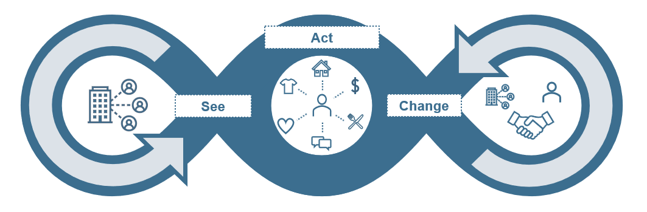

Organisations, workers and people with disability making services safer, together.

Please note: The Safer Services toolkit was funded by Lotterywest in 2018 and reviewed by the NDS Quality and Safeguards Sector Readiness Project in January 2024 and funded by the WA Department of Communities. This resource is general in nature and is provided as a guide only. NDS believes that the information contained in this publication is correct at the time of publishing, however, NDS reserves the right to vary any of this publication without further notice. The information provided in this publication should not be relied upon instead of other legal, medical, financial, or professional advice. Please always refer to online documents for the latest versions including the NDIS Practice Standards and advice to providers on the Code of Conduct.
End of document.

